Table of Contents

UNITED STATES

SECURITIES AND EXCHANGE COMMISSION

Washington, D.C. 20549

Form 10-K

- Annual Report Pursuant to Section 13 or 15(d) of the Securities Exchange Act of 1934

For the fiscal year ended: March 31, 2025

or

- Transition Report Pursuant to Section 13 or 15(d) of the Securities Exchange Act of 1934

 |  |  |  | Commission file number: 001-37761
 |  |  | Vistagen Therapeutics, Inc.
 |  |  |  | (Exact name of registrant as specified in its charter)
 |  | Nevada |  |  |  |  | 20-5093315
 | (State or other jurisdiction of |  |  |  |  |  |  | (I.R.S. Employer
 | incorporation or organization) |  |  |  |  |  |  | Identification No.)
 |  |  |  | 343 Allerton Avenue
 |  |  |  | South San Francisco, California 94080
 |  |  | (650) 577-3600
 | (Address, including zip code, and telephone number, including area code, of registrant’s principal executive office)
 |  |  |  | Securities registered pursuant to Section 12(b) of the Act
 | Title of each class |  |  |  | Trading Symbol(s) |  |  | Name of each exchange on which registered
Common Stock, par value $0.001 per share |  |  |  |  | VTGN |  |  |  | The Nasdaq Capital Market
 |  |  |  | Securities registered pursuant to Section 12(g) of the Act
 |  |  |  |  | None
Indicate by check mark if the registrant is a well-known seasoned issuer, as defined in Rule 405 of the Securities Act. |  |  |  |  |  |  | Yes o No x
Indicate by check mark if the registrant is not required to file reports pursuant to Section 13 or 15(d) of the Act. Yes |  |  |  |  |  |  | o No x

Indicate by check mark whether the registrant (1) has filed all reports required to be filed by Section 13 or 15(d) of the Securities Exchange Act of 1934 during the preceding 12 months (or for such shorter period that the registrant was required to file such reports), and (2) has been subject to such filing requirements for the past 90 days. Yes x No o

Indicate by check mark whether the registrant has submitted electronically every Interactive Data File required to be submitted pursuant to Rule 405 of Regulation S-T (§232.405 of this chapter) during the preceding 12 months (or for such shorter period that the registrant was required to submit such files). Yes x No o

Indicate by check mark whether the registrant is a large accelerated filer, an accelerated filer, a non-accelerated filer, a smaller reporting company, or an emerging growth company. See the definitions of “large accelerated filer,” “accelerated filer,” “smaller reporting company,” and “emerging growth company” in Rule 12b-2 of the Exchange Act.

Large accelerated filer o Accelerated filer o

Non-accelerated filer x Smaller reporting company x

Emerging Growth company o

If an emerging growth company, indicate by check mark if the registrant has elected not to use the extended transition period for complying with any new or revised financial accounting standards provided pursuant to Section 13(a) of the Exchange Act. o

Indicate by check mark whether the registrant has filed a report on and attestation to its management’s assessment of the effectiveness of its internal control over financial reporting under Section 404(b) of the Sarbanes-Oxley Act (15 U.S.C. 7262(b)) by the registered public accounting firm that prepared or issued its audit report. Yes o No x

If securities are registered pursuant to Section 12(b) of the Act, indicate by check mark whether the financial statements of the registrant included in the filing reflect the correction of an error to previously issued financial statements. Yes o No x

Indicate by check mark whether any of those error corrections are restatements that required a recovery analysis of incentive-based compensation received by any of the registrant’s executive officers during the relevant recovery period pursuant to §240.10D-1(b). Yes o No x

Indicate by check mark whether the registrant is a shell company (as defined in Rule 12b-2 of the Act). Yes o No x

The aggregate market value of the common stock of the registrant held by non-affiliates of the registrant on September 30, 2024, the last business day of the registrant’s second fiscal quarter, was approximately $81.2 million.

As of June 10, 2025, there were 29,157,733 shares of the registrant’s common stock, $0.001 par value per share, outstanding.

i

Table of Contents
 |  |  | TABLE OF CONTENTS
 |  | Item No. |  | Page No.
PART I
1. |  |  | Business | 1
 |  | 1A. | Risk Factors | 27
 |  | 1B. | Unresolved Staff Comments | 79
 |  | 1C. | Cyber Security | 73
2 |  |  | Properties | 74
3 |  |  | Legal Proceedings | 80
4 |  |  | Mine Safety Disclosures | 80
PART II
5 |  |  | Market for Registrant’s Common Equity, Related Stockholder Matters and Issuer Purchases of Equity Securities | 81
6 |  |  | [Reserved] | 81
7 |  |  | Management’s Discussion and Analysis of Financial Condition and Results of Operations | 82
 |  | 7A. | Quantitative and Qualitative Disclosures About Market Risk | 90
8 |  |  | Financial Statements and Supplementary Data | 91
9 |  |  | Changes in and Disagreements with Accountants on Accounting and Financial Disclosure | 117
 |  | 9A. | Controls and Procedures | 117
 |  | 9B. | Other Information | 117
 |  | 9C. | Disclosure Regarding Foreign Jurisdictions that Prevent Inspections | 124
PART III
10 |  |  | Directors, Executive Officers and Corporate Governance | 118
11 |  |  | Executive Compensation | 118
12 |  |  | Security Ownership of Certain Beneficial Owners and Management and Related Stockholder Matters | 118
13 |  |  | Certain Relationships and Related Transactions, and Director Independence | 118
14 |  |  | Principal Accountant Fees and Services | 118
PART IV
15 |  |  | Exhibits and Financial Statement Schedules | 119
16 |  |  | Form 10-K Summary | 126
EXHIBIT INDEX |  |  |  | 119
SIGNATURES |  |  |  | 123

ii

Table of Contents

Forward-Looking Statements

Certain statements in this Annual Report on Form 10-K (Annual Report or Report) may constitute “forward-looking statements” for purposes of the federal securities laws, including the safe harbor provisions of Section 27A of the Securities Act of 1933, as amended (the Securities Act), and Section 21E of the Securities Exchange Act of 1934, as amended (the Exchange Act), that involve substantial risks and uncertainties. Our forward-looking statements include, but are not limited to, statements regarding our or our management team’s expectations, hopes, beliefs, intentions or strategies regarding the future. In addition, any statements that refer to projections, forecasts or other characterizations of future events or circumstances, including any underlying assumptions, are also forward-looking statements. The words “anticipate,” “believe,” “can,” “contemplate,” continue,” “could,” “estimate,” “expect,” “future,” “intends,” “may,” “might,” “plan,” “possible,” “potential,” “predict,” “project,” “should,” “strategy,” “target,” “will,” “would,” or the negative of these terms or similar expressions may identify forward-looking statements, but the absence of these words does not mean that a statement is not forward-looking. Forward-looking statements in this Annual Report may include, for example, statements about:

- the period over which we anticipate our available financial resources will enable us to fund our operating expense;

- our ability to obtain additional funding for our operations, including funding necessary to complete further development, approval and, if approved, commercialization of our product candidates;

- the format, objectives, strategy, likelihood of success, and cost of our preclinical studies and clinical trials and other product development activities, including the design of our preclinical studies and clinical trials;

- the timing of initiation of our preclinical studies and clinical trials;

- our ability to recruit, enroll and randomize suitable patients in our clinical trials;

- the timing of completion of our preclinical studies and clinical trials and related preparatory work;

- our ability to collect and interpret preclinical and clinical data;

- the timing and outcome of regulatory interactions, including whether preclinical studies and clinical trials meet the criteria to enable early-stage clinical development or support registration of our product candidates;

- the potential attributes and benefits of our product candidates;

- our ability to obtain and, if obtained, maintain regulatory approval for our product candidates, and any related restrictions, limitations or warnings on the label of an approved product candidate;

- the potential for our business development efforts to optimize the potential value of our neuroscience pipeline;

- our ability to compete with other companies currently marketing or engaged in the development of treatments for the indications that we pursue or are pursuing for our product candidates;

- our ability to obtain and maintain intellectual property protection for our product candidates and the duration of such protection;

- our ability to contract with and rely on third-parties to assist in conducting our preclinical studies and clinical trials and manufacturing our product candidates;

- the size and growth potential of the markets for our product candidates, and our ability to serve those markets, either on our own or in partnership with others;

- the rate and degree of market acceptance of our product candidates, if approved;

- the pricing and reimbursement of our product candidates, if approved;

- regulatory changes, including regulatory personnel, and developments in the U.S. and foreign countries;

- the impact of laws, regulations, accounting standards, regulatory requirements, judicial decisions and guidance issued by authoritative bodies;

iii

Table of Contents

- our ability to attract and retain key scientific, medical, commercial and management personnel;

- our estimates regarding expenses, future revenue, and needs for additional financing;

- our future financial performance;

- our ability to recognize the anticipated benefits of our License and Collaboration Agreement with AffaMed Therapeutics, Inc. (including our ability to receive future payments thereunder) and any other future financing or business development transactions;

- the effect of adverse market or macroeconomic conditions, including, among others, inflation, interest rates and economic uncertainty, market volatility resulting from global political or economic developments, war, international hostilities and terrorism, any future public health epidemics or outbreaks of infectious disease, the residual post-COVID environment and other factors on any of the foregoing or other aspects of our business operations, including but not limited to our preclinical studies, clinical trials and other product development activities, healthcare systems and the global economy as a whole; and

- other risks and uncertainties, including those listed under Part I, Item 1A of this Annual Report titled “Risk Factors.”

The forward-looking statements contained in this Annual Report are based on current expectations and beliefs concerning future developments and their potential effects on us. There can be no assurance that future developments affecting us will be those that we have anticipated. These forward-looking statements involve a number of risks, uncertainties (some of which are beyond our control) or other assumptions or important factors that may cause actual results or performance to be materially different from those expressed or implied by these forward-looking statements. These risks and uncertainties include, but are not limited to, those factors described in the sections titled “Risk Factors” and “Management’s Discussion and Analysis of Financial Condition and Results of Operations,” set forth in this Annual Report. Should one or more of these risks or uncertainties materialize, or should any of our assumptions prove incorrect, actual results may vary in material respects from those projected in these forward-looking statements. There may be additional risks that we consider immaterial, or which are unknown. It is not possible to predict or identify all such risks. We do not undertake any obligation to update or revise any forward-looking statements, whether as a result of new information, future events or otherwise, except as may be required under applicable securities laws.

You should read this Annual Report completely and with the understanding that our actual future results may be materially different from what we expect. We qualify all of our forward-looking statements by these cautionary statements.

This Annual Report contains summaries of certain provisions contained in some of the documents described herein, but reference is made to the actual documents for complete information. All of the summaries are qualified in their entirety by the actual documents. Copies of some of the documents referred to herein have been filed as exhibits to this Annual Report. Unless the context otherwise requires, reference in this Annual Report to the terms “Vistagen,” “the Company,” “we,” “us,” “our,” and similar designations refer to Vistagen Therapeutics, Inc., a Nevada corporation, and where appropriate, our consolidated subsidiaries.

This Annual Report may contain references to trademarks, trade names and service marks belonging to other entities. Solely for convenience, trademarks, trade names and service marks referred to in this Annual Report may appear without the ® or TM symbols, but such references are not intended to indicate, in any way, that the applicable licensor will not assert, to the fullest extent under applicable law, its rights to these trademarks and trade names. We do not intend our use or display of other companies’ trade names, trademarks or service marks to imply a relationship with, or endorsement or sponsorship of us by, any other companies.

We may from time to time provide estimates, projections and other information concerning our industry, the general business environment, and the markets for certain diseases or disorders, including estimates regarding the potential size of those markets and the estimated incidence and prevalence of certain medical conditions. Information that is based on estimates, forecasts, market research, projections, or similar methodologies is inherently subject to uncertainties, and actual circumstances, events or numbers, including actual disease prevalence rates and market size, may differ materially from the information reflected in this Annual Report. Unless otherwise expressly stated, we obtained the industry, market and competitive position data from our internal estimates and research, or from independent market research, industry and general publications and surveys, governmental agencies and publicly available information in addition to research, surveys and studies conducted by third parties that have not been independently verified which may, in the future, prove not to have been accurate.

iv

Table of Contents

PART I

All brand names or trademarks appearing in this Annual Report are the property of their respective holders. Unless the context requires otherwise, references in this report to “Vistagen,” the “Company,” “we,” “us,” and “our” refer to Vistagen Therapeutics, Inc., a Nevada corporation. All references to future quarters and years in this Annual Report refer to calendar quarters and calendar years, unless reference is made otherwise.

Item 1. Business

Overview

We are a late clinical-stage biopharmaceutical company leveraging a deep understanding of nose-to-brain neurocircuitry to develop and commercialize a new class of non-systemic intranasal product candidates called pherines. Our broad and diverse neuroscience pipeline currently consists of five clinical-stage pherine product candidates, each with a novel mechanism of action (MOA) and positive clinical data in their targeted indication(s). Pherines specifically and selectively bind to peripheral receptors in human nasal chemosensory neurons, and are designed to rapidly activate nose-to-brain neurocircuits believed to regulate brain areas without requiring systemic absorption or uptake into the brain to achieve desired therapeutic benefits.

Our most advanced intranasal pherine product candidate is fasedienol, which is being investigated in our U.S. registration-directed PALISADE Program for the acute treatment of social anxiety disorder (SAD). In August 2023, we received and reported positive topline results from our PALISADE-2 Phase 3 trial of fasedienol for the acute treatment of SAD. The ongoing clinical trials in our PALISADE Program include our PALISADE-3 and PALISADE-4 Phase 3 trials, which are designed similarly to PALISADE-2, and a small exploratory Phase 2 repeat dose study (the Repeat Dose Study). Topline data for PALISADE-3 are expected in the fourth quarter of 2025 and topline results for PALISADE-4 and the Repeat Dose Study are expected in the first half of 2026. We believe either PALISADE-3 or PALISADE-4, if successful, together with the positive results reported from PALISADE-2, may establish substantial evidence of the effectiveness of fasedienol in support of a potential New Drug Application (NDA) submission to the U.S. FDA for the acute treatment of SAD. The FDA has granted Fast Track designation for the investigation of fasedienol for the acute treatment of SAD. Fasedienol has the potential to be the first FDA-approved acute treatment for SAD and provide significant advantages relative to the current standard of care.

We have also reported positive results from an exploratory Phase 2A clinical trial for each of our next most advanced pherine product candidates, itruvone for treatment of major depressive disorder, and PH80 for both vasomotor symptoms (hot flashes) due to menopause and premenstrual dysphoric disorder, as well as a pilot Phase 2A study of PH15 for improvement of psychomotor impairment due to mental fatigue and an exploratory Phase 2A study of PH284 for treatment of cancer cachexia. See “Our Neuroscience Product Candidates” below.

We are passionate about developing transformative treatment options with potential to meet clear and growing unmet needs and bring meaningful relief to patients underserved by the current standard of care for multiple highly prevalent indications, all while delivering long term value to our shareholders.

1

Table of Contents

Our Neuroscience Product Candidates
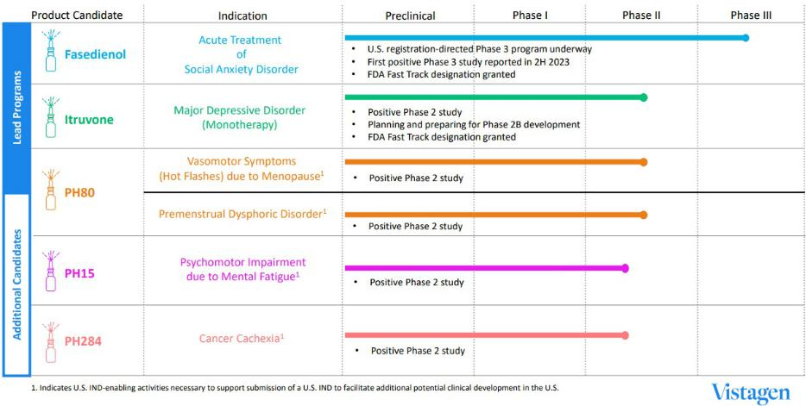

Fasedienol

Overview of Social Anxiety Disorder

Social anxiety disorder (SAD) is a highly prevalent, serious, and life-threatening psychiatric mental health disorder affecting over 30 million adults in the U.S. With onset typically early in life, usually during adolescence, SAD persists for many years thereafter, with a reported mean duration of about 20 years. While often a long-term disorder, SAD can manifest acutely when triggered by anxiety-provoking social and performance situations. In those situations, individuals with SAD experience extreme anxiety, distress, fear, and impairment due to their fear of embarrassment, judgment, humiliation, negative evaluation, and scrutiny. The disorder can significantly disrupt family and social life, diminish self-esteem, and hinder work performance. People with SAD may struggle to form social or vocational relationships, which can lead to feelings of powerlessness and shame. The profound anxiety associated with SAD often results in avoidance of everyday interactions and opportunities in academic, social and vocational settings. This avoidance can lead to loneliness, a lack of personal and professional achievements and relationships, as well as economic difficulties, ultimately impacting various aspects of daily life and adding to societal burden. The pervasive effects of SAD often lead to depression and a sense of hopelessness, transforming what is sometimes perceived as extreme shyness into a debilitating mental illness. SAD has a lifetime comorbidity rate of approximately 81% with other serious psychiatric disorders, and individuals with SAD face an increased risk of serious and life-threatening co-morbid depression, substance abuse, suicidal ideation and suicide.

Fasedienol for the Acute Treatment of Social Anxiety Disorder

Fasedienol, our lead clinical-stage product candidate, is a synthetic neuroactive intranasal pherine in an ongoing U.S. registration-directed Phase 3 clinical development program for the acute treatment of anxiety in adults with SAD. Fasedienol's MOA is fundamentally differentiated from all FDA-approved anti-anxiety medications. When administered intranasally in microgram-level doses, neurocircuitry-focused fasedienol activates receptors of peripheral nasal chemosensory neurons connected to subsets of neurons in the olfactory bulbs that, in turn, connect to neural circuits in the limbic amygdala involved in the pathophysiology of SAD, and potentially other acute anxiety disorders. Neurocircuitry-focused fasedienol is pharmacologically active without requiring apparent systemic absorption or direct binding on neurons in the brain to achieve its rapid-onset anxiolytic effects. Fasedienol does not exert effects on certain cellular receptors that are associated with known drug abuse liability potential (for example, dopamine and opiate receptors) when activated by certain other pharmaceutical compounds for neuropsychiatric and neurological disorders. Unlike benzodiazepines, fasedienol does not potentiate GABA-A receptors. Because of its innovative non-systemic neurocircuitry-focused MOA, we believe fasedienol has the potential to achieve rapid-onset anxiolytic effects for individuals with SAD on an acute, as-

2

Table of Contents

needed basis, with a significantly reduced risk of unwanted side effects and safety concerns, such as potential drug-drug interactions, abuse, misuse, and addiction, associated with certain current oral and other systemically absorbed neuropsychiatric pharmaceuticals that act directly on neurons in the brain and are sometimes prescribed off-label for the acute treatment of SAD.

Fasedienol's U.S. Registration-directed PALISADE Program

There is no FDA-approved pharmacological therapy for the acute treatment of SAD. We believe fasedienol has the potential to allow individuals affected by SAD to engage in stressful or previously avoided social or performance situations with fewer or less severe symptoms. Because of its rapid-onset non-systemic proposed MOA and pharmacological effect, a key and substantial difference between fasedienol and all other available therapies approved by the FDA is that fasedienol is being developed with potential to be the first FDA-approved acute treatment of SAD. Acute treatment with fasedienol has the potential to reduce the wave of anxiety usually experienced by SAD patients before engaging in and during a feared and anxiety-provoking social or performance situation.

We have aligned with the FDA that a clinic-based public speaking challenge and the Subjective Units of Distress Scale (SUDS) are the appropriate study design and primary efficacy endpoint, respectively, to measure anxiety immediately related to the specific stressor, and is the most appropriate and efficient path for our U.S. registration-directed PALISADE Program, which is focused on fasedienol’s potential to become the first FDA-approved acute treatment of anxiety for adults with SAD. The Phase 3 clinical trials in our PALISADE Program are randomized, double-blind, placebo-controlled, U.S. multi-center clinical trials designed to evaluate the efficacy, safety, and tolerability of a single dose of fasedienol to relieve anxiety symptoms in adult patients with SAD during a simulated, anxiety-provoking public speaking challenge conducted in a clinical setting, as measured using the patient-rated SUDS as the primary efficacy endpoint. Two of the Phase 3 trials in our PALISADE Program were previously concluded; PALISADE-1, reported in 2022, did not meet its primary endpoint, and PALISADE-2, reported in 2023, successfully met its primary efficacy endpoint, and as further described below, two Phase 3 trials, PALISADE-3 and PALISADE-4, are ongoing. Our PALISADE Program also includes open-label extension safety studies, the ongoing small Phase 2 Repeat Dose Study, certain standard preclinical studies, and a small human factor study.

In August 2023, we received and reported positive topline results from our PALISADE-2 Phase 3 trial of fasedienol for the acute treatment of anxiety in adults with SAD. PALISADE-2 met its primary efficacy endpoint, which was the difference in mean SUDS scores during the public speaking challenge at baseline (Visit 2) and treatment (Visit 3) for subjects treated with fasedienol versus placebo at Visit 3. Fasedienol-treated patients demonstrated a greater mean change from baseline (least-squares (LS) mean = -13.8) compared to placebo (LS mean = -8.0), for a statistically significant, and we believe clinically relevant, difference between groups of -5.8 (p=0.015). PALISADE-2 also met its secondary endpoint, demonstrating a statistically significant difference in the proportion of clinician-assessed responders between fasedienol and placebo as measured by the Clinical Global Impressions – Improvement (CGI-I) scale. Responders were identified as those who were rated "very much less anxious" or "much less anxious" and 37.7% of fasedienol-treated patients were rated as responders, as compared to 21.4% of those treated with placebo (p=0.033). The trial also met an important exploratory patient-reported endpoint with a statistically significant difference in the proportion of patient-assessed responders between fasedienol and placebo as measured by the Patient’s Global Impression of Change (PGI-C) scale. Responders were identified as those who self-rated "very much less anxious" or "much less anxious" on the PGI-C and 40.6% of fasedienol-treated patients were rated as responders, as compared to 18.6% of those treated with placebo (p=0.003). Our PALISADE-2 Phase 3 trial also met an additional exploratory endpoint with a statistically significant difference in the proportion of patients in each treatment group with a 20-point or greater improvement in patient-assessed SUDS score from baseline (Visit 2) to treatment (Visit 3). Of the fasedienol-treated patients, 35.7% demonstrated this statistically significant improvement in SUDS score, as compared to 18.6% in the placebo-treated group (p=0.020). Fasedienol was observed to be well-tolerated with no serious adverse events (SAEs), and the treatment-emergent adverse event (TEAE) profiles were comparable between fasedienol and placebo. Overall, no TEAEs, except for pyrexia in the placebo group (2.49%), was more prevalent than 2.0%.

To complement our successful PALISADE-2 Phase 3 trial, we launched our PALISADE-3 and PALISADE-4 Phase 3 trials 2024. Like PALISADE-2, PALISADE-3 and PALISADE-4 are U.S. multi-center, randomized, double-blind, placebo-controlled Phase 3 studies designed to evaluate the efficacy, safety, and tolerability of the acute administration of fasedienol to relieve anxiety symptoms in adults with SAD after a single dose of fasedienol during a simulated, anxiety-provoking public speaking challenge conducted in a clinical setting, as measured using the patient-reported SUDS as the primary efficacy endpoint. In addition, both PALISADE-3 and PALISADE-4 have an open-label extension for a period of up to 12 months. We initiated the Repeat Dose Study in early 2025. This study is a small U.S. multi-center, randomized, double-blind, placebo-controlled, three-arm exploratory Phase 2 clinical trial designed to evaluate repeated dosing (up to

3

Table of Contents

two doses within ten minutes) of fasedienol in adult patients with SAD during a single, simulated, anxiety-provoking public speaking challenge in a clinical setting. The Repeat Dose Study also includes an open-label extension study for a period of up to 12 months.

We believe either PALISADE-3 or PALISADE-4, if successful, together with PALISADE-2, may establish substantial evidence of the effectiveness of fasedienol in support of a potential New Drug Application (NDA) submission to the FDA for the acute treatment of anxiety in adults with SAD.

The FDA has granted Fast Track designation for the investigation of fasedienol for the acute treatment of SAD.

Itruvone

Overview of Major Depressive Disorder

Depression is a serious medical condition and a global public health concern that can arise at any time during a person's life. According to the World Health Organization (WHO), depression is the leading cause of disability worldwide, affecting over 250 million people. Statistics reported by the U.S. National Institute of Mental Health (NIMH) indicate that approximately 21 million adults in the U.S., or approximately 8.4% of all adults in the U.S., experienced at least one major depressive episode in 2020. While many individuals will experience a depressed mood at some point during their lifetime, major depressive disorder (MDD) is different. MDD is the chronic, pervasive feeling of utter unhappiness and suffering, which impairs daily functioning. During a typical depressive episode, an individual experiences depressed mood, loss of interest and enjoyment, and reduced energy leading to diminished activity and impaired daily functioning for at least two weeks and often much longer. Symptoms of MDD can include a lack of pleasure in activities, changes in appetite resulting in weight fluctuations, insomnia or excessive sleeping, psychomotor agitation, loss of energy or increased fatigue, feelings of worthlessness or inappropriate guilt, difficulty thinking, concentrating or making decisions, and thoughts of death or suicide and attempts at suicide. MDD is the psychiatric diagnosis most commonly associated with suicide.

For many people, depression cannot be controlled for any length of time without treatment. However, approximately two out of every three people with depression do not experience adequate therapeutic benefits from their initial treatment with a standard antidepressant. Furthermore, the likelihood of achieving remission of depressive symptoms decreases with each successive treatment attempt. Even after multiple treatment attempts with current antidepressants, about one-third of individuals with depression still do not find a sufficiently effective therapy.

Inadequate response to current treatments is among the key reasons MDD is one of the leading public health concerns in the U.S., creating a significant unmet medical need for new agents with fundamentally differentiated MOAs and differentiated safety.

Itruvone for the Treatment of Major Depressive Disorder

Itruvone is our investigational neurocircuitry-focused non-systemic pherine product candidate with transformative potential as a stand-alone treatment of MDD. Itruvone’s potential for rapid-onset activity in nasal chemosensory receptors at a low microgram-level dose without requiring systemic absorption or direct binding on neurons in the brain to achieve antidepressant effects, and its favorable safety data observed in all studies completed to date, is fundamentally differentiated from all current pharmacological therapies for depression. Unlike other antidepressants which rely on single or double-receptor occupancy in the brain, itruvone activates neural circuits that regulate the amygdala, hypothalamus, entorhinal area and hippocampus, prefrontal cortex, locus coeruleus, and raphe nucleus, all involved in the pathophysiology of depression. The scope of itruvone's neural circuit activation, and potential impact on the brain, appears, in studies completed to date, to be wider, faster and safer than can be achieved with current therapies targeting binding to any specific brain receptor. We believe non-systemic itruvone has the potential to treat MDD without causing the side effects and safety concerns that may be associated with current systemic antidepressant therapies, including, among others, drug-drug interactions, sexual side effects, sedation, weight gain and suicidal ideation.

In a randomized, double-blind, placebo-controlled parallel design exploratory Phase 2A clinical trial of itruvone as a stand-alone treatment for MDD, the results of which were published in the peer-reviewed British Journal of Pharmaceutical and Medical Research, at a 6.4 microgram dose administered intranasally twice daily for eight weeks, itruvone significantly reduced depressive symptoms in as early as one week based on the 17-item Hamilton Depression Scale (HAM-D-17) scores compared to placebo (p=0.022). Itruvone was well-tolerated and did not cause psychological side effects (such as dissociation or hallucinations), sexual side effects, weight gain, or other safety concerns that may be associated with other approved pharmacological therapies for MDD. The trial was sponsored by Pherin Pharmaceuticals, Inc. (Pherin), which is

4

Table of Contents

now our wholly-owned subsidiary, and was conducted in Mexico prior to our acquisition of Pherin in February 2023. Positive data from our June 2023 U.S. Investigational New Drug (IND) enabling Phase 1 trial of itruvone demonstrated that there were no reported treatment-related SAEs or discontinuations due to adverse events in the trial. Overall, itruvone was well-tolerated and continued to demonstrate the favorable safety data in all clinical trials completed to date. As a result, building on the positive results from Phase 2A clinical development of itruvone in MDD, we are currently planning for potential U.S. Phase 2B clinical development of itruvone under our U.S. IND as a novel, non-systemic stand-alone treatment for MDD.

The U.S. FDA has granted Fast Track designation for the investigation of itruvone for the treatment of MDD.

PH80

Overview of Vasomotor Symptoms (Hot Flashes) due to Menopause

Vasomotor symptoms (VMS), comprising of hot flashes and night sweats, are the most common symptoms of the menopausal transition, affecting 60% to 80% of menopausal women and approximately 40% of women in perimenopause. On average, hot flashes last seven to nine years and, for up to one-third of women, can last more than 10 years. VMS can be described as a sudden, intense feeling of warmth spreading through the upper body and face, flushed appearance with red, blotchy skin, rapid heartbeat, and perspiration on the upper body. Each episode typically lasts between one and five minutes and may be accompanied by sweating, chills, and anxiety. Although there is substantial individual variability in the frequency and severity of VMS, there is universal agreement that VMS negatively impacts physical, emotional, social, and occupational well-being, and can significantly diminish the overall quality of life and work productivity for those who experience them. VMS can cause new-onset sleep interruptions and deprivation, with night sweats commonly interrupting sleep and causing difficulty in returning to sleep. Such sleep problems are associated with reduced productivity and an increased risk of job loss for these affected individuals. VMS are also often accompanied by various comorbidities, including new onset anxiety, depression, and cognitive dysfunction, which can further exacerbate functional impairment. While there are FDA-approved therapies for the treatment of moderate to severe VMS, many women cannot take or choose not to take currently available hormonal and/or other systemic products due to contraindications and safety concerns, such as cardiovascular disorders, dementia, breast cancer, and liver toxicity. Treatment of VMS is complicated by fear of these safety risks associated with systemic hormonal therapy and the recently approved non-hormonal, neurokinin 3 receptor (NK3R) antagonist.

PH80 for the Treatment of Vasomotor Symptoms (Hot Flashes) due to Menopause

PH80 is our investigational non-hormonal, non-systemic, neurocircuitry-focused pherine product candidate with a novel, rapid-onset proposed MOA that is fundamentally differentiated from all currently approved treatments for VMS (hot flashes) due to menopause. With more than one million U.S. women entering menopause every year, the number of symptomatic women with VMS who could potentially benefit from a novel, non-hormonal, non-systemic, as-needed treatment such as PH80 is substantial.

Rapid activation of peripheral nasal chemosensory neurons via self-administration of low microgram doses of PH80 rapidly stimulates a subgroup of neuromicrocircuits (glomeruli) in the olfactory bulbs (OBs) that are connected to the limbic amygdala and hypothalamus, which are involved in the regulation of the autonomic nervous system and thermoregulatory areas of the hypothalamus. Notably, in vitro studies show that PH80 does not engage steroid receptors; an in vivo study in mice showed no estrogenic and/or androgenic activity and no changes in weight of the uterus or seminal vesicles after intranasal administration. Additionally, an in vitro study has demonstrated that PH80 does not exert effects on receptor targets with known abuse potential.

We are developing PH80 as a novel, non-hormonal, non-systemic, as-needed treatment of moderate to severe VMS (hot flashes) due to menopause, and potentially additional women’s health-focused indications. A randomized, double-blind, placebo-controlled exploratory Phase 2A clinical study of PH80 that was designed to explore the efficacy, safety, and tolerability of intranasal administration of PH80 for the management of menopausal hot flashes in women was conducted in a real-world setting in Mexico and was sponsored by Pherin prior to our acquisition of Pherin in February 2023. In the study, PH80 (0.8 µg/50 µL) was self-administered by subjects intranasally, with two sprays in each nostril (total dose = 3.2µg) up to four times daily, as needed for four consecutive weeks. One additional dose was allowed at night if subjects were awakened by hot flashes. Through the course of the study, subjects recorded the number, severity, disruption in function, and sweating related to hot flashes. PH80 induced a significant reduction in the daily number of hot flashes compared to placebo at the end of the first week of treatment, and the improvement was maintained through each treatment week until the end of the treatment period. At baseline, subjects reported a mean daily number of hot flashes of 7.7 (PH80, n=18) and 8.0 (placebo, n=18). After one week of treatment, the number of hot flashes dropped to 2.8 (PH80) and 6.4 (placebo) (p<.001), and after four weeks of treatment, the number of hot flashes dropped to 1.5 (PH80) and 5.1 (placebo)

5

Table of Contents

(p<.001). PH80 treatment also significantly reduced the severity, disruption in function, and sweating related to hot flashes during the treatment period, as compared with placebo.

PH80 was well-tolerated with no SAEs, and the adverse event profiles were comparable between PH80 and placebo. All 36 subjects completed four weeks of treatment and no subject discontinued participation in the study as a result of adverse events.
We are currently conducting customary nonclinical manufacturing-related studies necessary to support our planned submission of our U.S. IND to facilitate further Phase 2 clinical development of PH80 in the U.S. as a novel non-hormonal, non-systemic treatment of moderate to severe VMS (hot flashes) due to menopause and potentially additional women’s health indications.

Overview of Premenstrual Dysphoric Disorder

According to the National Institutes of Health (NIH), 5% to 8% of menarcheal individuals have moderate-to-severe symptoms that can cause significant distress and functional impairment, suggestive of premenstrual dysphoric disorder (PMDD), a severe, sometimes disabling extension of premenstrual syndrome (PMS). PMDD symptoms usually begin in the luteal phase (approximately seven to ten days before a person’s period starts) and continue for the first few days of the period. Like PMS, PMDD can cause bloating, breast tenderness, fatigue, and changes in sleep and eating habits, but distinctively, it can also cause extreme mood shifts that can disrupt daily life and damage relationships. The cause of PMDD is not clearly understood, but it is thought that neurotransmitter systems may trigger PMDD. Brain areas that regulate emotion and behavior are studded with receptors for estrogen, progesterone, and other sex hormones. These hormones affect the functioning of neurotransmitter systems that influence mood and thinking, possibly triggering PMDD. Treatment of PMDD is aimed at preventing or minimizing symptomology.

PH80 for Premenstrual Dysphoric Disorder

An exploratory Phase 2A clinical study of PH80 for management of the symptoms of PMDD, including negative mood and physical and behavioral symptoms, in subjects with a regular menstrual cycle and at least a one-year history of PMDD, was conducted by Pherin in a real-world setting in Mexico prior to our acquisition of Pherin in February 2023. In this randomized, double-blind, placebo-controlled exploratory Phase 2A study, PH80 demonstrated a statistically significant improvement versus placebo in management of the symptoms of PMDD, including negative mood and physical and behavioral symptoms. The initial study visit occurred after the onset of symptoms. All subjects were administered a placebo nasal spray, and those who showed no symptom improvement were eligible to return for the second visit, which occurred after the onset of symptoms during the next menstrual cycle. At the second study visit, subjects were randomized to receive a single dose of 0.9 µg PH80 nasal spray or placebo in the clinic. PH80 demonstrated statistically and clinically significant improvement versus placebo in symptoms of PMDD using the subject-rated Penn Daily Symptom Report (DSR) as early as Day 4 and continuing to Day 6 (p=0.008). PH80 also demonstrated statistically and clinically significant improvement versus placebo at Day 6 on the clinician-rated Premenstrual Tension Scale (PMTS) total score (p=0.006).

PH80 was well-tolerated with no SAEs. The most common TEAE was headache, reported by 17% in the placebo group and 7% in the PH80 group. No other TEAE occurred more than once per subject.

PH15

Overview of Cognitive and Psychomotor Impairment due to Mental Fatigue

Numerous disorders, such as shift work disorder, sleep apnea, and narcolepsy, can lead to debilitating sleep deprivation and mental fatigue. The prevalence of these disorders is high. For example, moderate to severe sleep apnea affects approximately 20% of adult men and 10% of postmenopausal women. The potential consequences of mental fatigue from sleep deprivation are troubling, with higher rates of accidents and increased risk of dementia. Individuals affected by mental fatigue require improved treatment options with a differentiated safety profile, one without the potential for abuse liability or negative and treatment-limiting side effects and safety concerns that may lead to self-treatment and subsequent substance use disorders.

PH15 for Improvement of Cognitive and Psychomotor Impairment due to Mental Fatigue

PH15 is our investigational pherine product candidate with a novel, rapid-onset neurocircuitry-focused proposed MOA that is differentiated from the MOA of all currently approved treatments to improve psychomotor or cognitive impairment caused by mental fatigue. PH15’s proposed MOA targets nasal receptors that activate olfactory-to-amygdala and olfactory-to-hippocampus neural circuits in the limbic system that are known to be associated with psychomotor activity and

6

Table of Contents

cognition, without requiring systemic absorption or direct action on neurons in the brain. PH15 has demonstrated excellent safety data in all clinical trials completed to date.

In a randomized, double-blind, placebo-controlled, crossover Phase 2A pilot study designed to explore the efficacy, safety, and tolerability of intranasal administration of PH15 on psychomotor performance as measured by reaction time in sleep-deprived participants, PH15 demonstrated a statistically significant improvement in reaction time compared to placebo and caffeine in the sleep-deprived study participants. This study of PH15 was sponsored by Pherin and conducted at the National Institute of Psychiatry, Sleep Disorders Clinic in Mexico City, Mexico prior to our acquisition of Pherin in February 2023.

In the Phase 2A pilot study, ten participants were randomly administered PH15 (multiple 1.6 µg doses, total dose of 9.6 µg), placebo (nasal spray and oral), or caffeine (single 400 mg oral dose administered one hour before the session) in sequential sleep deprivation study sessions spaced one week apart. During each sleep deprivation session, participants received blinded treatments before the start of each of four testing periods, at 6:00 p.m., 9:00 p.m., midnight, and 3:00 a.m. The participants’ reaction times to both isochronous (regular interval) and stochastic (random interval) “flash” light stimuli were computer-measured during each testing period as participants responded to the luminous stimuli. During both isochronous and stochastic reaction time tests, administration of 1.6 µg PH15 nasal spray induced a significantly faster mean reaction time compared to placebo nasal spray across all time points (p<0.001). PH15 also demonstrated a statistically significant improvement in reaction time compared to oral caffeine (p<0.001) for both reaction time tests during the testing periods at midnight and 3:00 a.m. when subjects were most fatigued.

PH15 was well-tolerated in this study, with no SAEs reported. The adverse event profiles of PH15 and placebo were comparable, with brief nasal itching in one PH15-dosed participant and three placebo-dosed subjects. Participants on oral caffeine, however, experienced palpitations, euphoria, dry mouth, stomachache, and polyuria.

We are currently evaluating the potential Phase 2 development path forward for PH15 and the manufacturing, nonclinical and clinical program required to support submission of a U.S. IND to facilitate further potential Phase 2 development of PH15 in the U.S.

PH284

Overview of Cancer Cachexia

Cachexia, also known as wasting syndrome, is a complex metabolic syndrome that causes a gradual loss of muscle and body weight. Cachexia is associated with chronic diseases like cancer, AIDS, heart failure, chronic obstructive pulmonary disease, anorexia nervosa, multiple sclerosis, tuberculosis, and anemia. The current definition of cancer cachexia is a loss of 5% or more of body weight over the preceding six months, accompanied by any of a handful of other symptoms, including fatigue and reduced strength. According to the National Cancer Institute, cachexia is estimated to occur in up to 80% of people with advanced cancer, depending on the type of cancer and how well they respond to cancer treatment. Cachexia is thought to directly cause up to 30% of cancer deaths, often because of heart or respiratory failure related to muscle loss. Maintaining nutritional support and alleviating cachexia has the potential to improve the underlying condition of cancer. Currently, there are no effective medical interventions or approved drugs proven to alleviate cachexia.

PH284 for Cancer Cachexia

PH284 is our investigational pherine product candidate with a novel, rapid-onset, neurocircuitry-focused proposed MOA that is fundamentally differentiated from the MOA of all current treatments for the loss of appetite associated with chronic disorders, such as cancer or heart disease. PH284 is thought to act by regulating olfactory to mediobasal-hypothalamus neural circuits involved in appetite control.

In a double-blind, placebo-controlled exploratory Phase 2A study designed to evaluate the efficacy, safety, and tolerability of intranasal administration of PH284 in female patients diagnosed with cachexia (induced by chronic loss of appetite) due to terminal cancer (n=40), PH284 (0.4 µg/50 µL) was administered intranasally, one spray in each nostril (total daily dose = 3.2µg), four times daily before meals (breakfast, mid-morning snack, lunch, and dinner). From Day 1 through Day 4, all subjects were administered placebo 30 minutes prior to each meal. Beginning on Day 5 through Day 11 subjects were randomized in a 1:1 fashion to receive either PH284 or placebo. Patients measured Subjective Feeling of Hunger (SFH) ten minutes before each meal. PH284, as compared to placebo, induced a cumulative effect on mean SFH scores, with scores increasing from breakfast to lunch and lunch to dinner throughout the treatment period. Specifically, prior to dinner on Day 7 of treatment, PH284 subjects reported a 71% improvement in SFH versus baseline, while placebo subjects reported a less

7

Table of Contents

than 1% improvement. No unusual changes in body weight were observed in either the PH284 or placebo groups, though on average, there was a small gain in body weight for PH284 versus a small loss in placebo. PH284 demonstrated no serious adverse events, and adverse events reported for the PH284 group were similar to those reported in the placebo-treated group. All the adverse events reported were attributed to the underlying medical condition (cancer) and were not deemed to be related to the administration of PH284 or placebo. PH284 has demonstrated an excellent safety profile in all clinical trials completed to date. This study of PH284 was sponsored by Pherin and conducted at the National Institute of Oncology and National Institute of Nutrition in Mexico City, Mexico prior to our acquisition of Pherin in February 2023.

Vistagen is currently evaluating the potential path forward for PH284, including an assessment of the manufacturing, nonclinical and clinical program required to support a U.S. IND application for potential further Phase 2 clinical development of PH284 for the treatment of cancer cachexia or other appetite-related disorders.

AV-101

AV-101 for NMDAR-related Neurological Disorders

AV-101 (4-Cl-KYN) is our novel, oral prodrug candidate that targets the NMDAR (N-methyl-D-aspartate receptor), an ionotropic glutamate receptor in the brain. Abnormal NMDAR function is associated with numerous neurological diseases and disorders. The active metabolite of AV-101, 7-chloro-kynurenic acid (7-Cl-KYNA), is a potent and selective full antagonist of the glycine binding site of the NMDAR that inhibits the function of the NMDAR. Unlike ketamine and many other NMDAR antagonists, 7-Cl-KYNA is not an ion channel blocker. In clinical and nonclinical testing completed to date, AV-101 has demonstrated good oral bioavailability and an excellent pharmacokinetic (PK) profile. No binding of AV-101 or 7-Cl-KYNA to off-site targets was identified by an extensive receptor screening study. Moreover, in all clinical trials completed to date, AV-101 has been safe and very well-tolerated with no psychological side effects or safety concerns and no treatment-related SAEs that are often observed with classic channel-blocking NMDAR antagonists such as ketamine and amantadine. Nonclinical results also indicate that chronic administration of 4-Cl-KYN induces hippocampal neurogenesis, a hallmark of drugs that have anti-depressive effects, and increases endogenous levels of KYNA, which also is a functional NMDAR glycine site antagonist.

Based on observations and findings from preclinical studies, we believe AV-101 has the potential to become a new oral treatment alternative for multiple neuroscience disorders, including levodopa-induced dyskinesia (LID) and neuropathic pain (NP) among others. We are currently assessing whether there is a path forward for potential collaborative Phase 2A clinical development of AV-101 for one or more additional neurological disorders involving the NMDAR receptor. The U.S. FDA has granted Fast Track designation for the investigation of AV-101 for the treatment of neuropathic pain and for the adjunctive treatment of MDD.

Intellectual Property

We strive to protect the proprietary know-how and technology that we believe is important to our business, including seeking and maintaining patents intended to cover our product candidates and related pharmaceutical compositions, their therapeutic methods of use, including treatment and prognostic methods, as well as processes for their manufacture, and any other aspects of our discoveries and inventions that are commercially important to the development of our business.

We may also rely on trade secrets to protect aspects of our business that are not amenable to, or that we do not consider appropriate for, patent protection. We also utilize know-how, continuing technological innovation and in-licensing opportunities to develop and maintain our proprietary position. We seek to obtain domestic and international patent protection in appropriate markets, and endeavor to timely file patent applications for any new commercially valuable inventions.

To protect our rights to our proprietary technology, we require all employees, as well as our external collaborators, consultants and CROs when feasible, to enter into agreements that require disclosure and assignment to us of ideas, developments, discoveries and inventions made by these employees, consultants, and CROs in the course of their service to us.

We plan to continue to expand our intellectual property portfolio by filing patent applications related to pharmaceutical compositions, methods of use, including treatment and patient selection, formulations, nasal administration devices, and manufacturing processes created or identified from the ongoing development of our product candidates.

8

Table of Contents

Patents

We own granted patents and pending patent applications in the U.S. and in certain foreign countries. As of March 31, 2025, these patent properties consist of the following:

Fasedienol for the Acute Treatment of SAD

The granted U.S. patents relate to the use of fasedienol for the acute treatment of SAD and nominally will expire either in 2025 or 2028 and foreign patents will nominally expire in 2026, subject to patent term extensions that may be available in the U.S. and in certain foreign countries. We expect regulatory and data exclusivity (discussed below) will be available upon product approval of fasedienol in the U.S. and certain foreign countries.

Itruvone for the Treatment of MDD

The granted U.S. and foreign patents relate to the use of itruvone to treat MDD and nominally will expire in 2033, subject to patent term extensions that may be available in the U.S. and certain foreign countries. We expect regulatory and data exclusivity will be available upon product approval of itruvone in the U.S. and certain foreign countries.

PH80 for the Treatment of Vasomotor Symptoms (Hot Flashes) Due to Menopause and Other Indications

The granted U.S. and foreign patents and corresponding pending foreign patent applications relate to the use of PH80 to treat vasomotor symptoms (hot flashes) due to menopause. Patents that have been or may yet be granted will expire in 2029. Because of the development timeline for this indication, it is unlikely that patent term extensions will be available in the U.S. or foreign countries. However, we expect regulatory and data exclusivity will be available upon product approval of PH80 in the U.S. and certain foreign countries.

We filed a non-provisional U.S. national phase patent application and a Patent Cooperation Treaty (PCT) patent application relating to the use of PH80 to treat dysmenorrhea in April 2025. Patents that may be granted on such patent applications nominally will expire in 2045, subject to patent term extensions that may be available in the U.S. and certain foreign countries. We expect regulatory and data exclusivity will be available upon approval of PH80 for this indication in the U.S. and certain foreign countries.

PH15 for the Improvement of Psychomotor and Cognitive Impairment due to Mental Fatigue

We filed a non-provisional U.S. national phase patent application and a PCT patent application relating to the use of PH15 to improve psychomotor and cognitive impairment due to mental fatigue in 2024. Patents that may be granted on such patent applications nominally will expire in 2044, subject to patent term extensions that may be available in the U.S. and certain foreign countries. Regulatory and data exclusivity may be available upon product approval of PH15 for this indication in the U.S. and certain foreign countries.

Nasal Spray Device for Administration of Pherines

We filed a non-provisional U.S. national phase patent application and a PCT patent application relating to nasal spray devices intended to improve the administration of pherines (including, for example, fasedienol, itruvone, PH80, and PH15 discussed above) in April 2025. Patents that may be granted on such patent applications nominally will expire in 2045, subject to patent term extensions that may be available in the U.S. and certain foreign countries.

AV-101 for the Potential Treatment of LID, NP, and Other Disorders

- Multiple granted U.S. patents relate collectively to the use of AV-101 to treat depression, LID and neuropathic pain;

- Pending U.S. patent applications, and foreign granted patents and pending foreign patent applications relate collectively to the use of AV-101 to treat various disorders, including depression, LID, NP, tinnitus and obsessive-compulsive disorder;

- Pending U.S. and foreign patent applications relate to the prognostic identification of high and low responders to the treatment of various neurological disorders with AV-101; and

- Granted U.S. patents, and granted foreign patents and pending foreign patent applications relate to the manufacture of AV-101.

9

Table of Contents

The various U.S. and foreign patents related to AV-101 nominally expire between 2034 and 2040, depending on the subject matter claimed in each patent, subject to patent term extensions that may be available in the U.S. and certain foreign countries. Regulatory and data exclusivity may be available upon product approval of AV-101 in the U.S. and certain foreign countries.

Patent Term Adjustments and Extensions

The base term of a U.S. patent is 20 years from the filing date of the earliest filed non-provisional patent application from which the patent claims priority. The term of a U.S. patent can be lengthened by patent term adjustment, in case of certain administrative delays at the U.S. Patent and Trademark Office (PTO). In some cases, the term of a U.S. patent may be shortened by a terminal disclaimer that reduces its term to align with that of a related patent.

Depending upon the timing, duration, and specifics of the FDA approval, if any, of our drug candidates, some of our U.S. patents may be eligible for limited patent term extension under the Drug Price Competition and Patent Term Restoration Act of 1984, commonly referred to as the Hatch-Waxman Amendments. The Hatch-Waxman Amendments permit a patent restoration term of up to five years to offset the patent term lost during product development and the FDA regulatory review process. However, patent term restoration cannot extend the remaining term of a patent beyond a total of 14 years from the product’s approval date. The patent term restoration period is generally one-half the time between the effective date of an IND and the submission date of an NDA (testing phase), plus the time between the submission date of an NDA and the approval of that application (approval phase). The FDA may reduce this patent term restoration period if it finds that an applicant did not act with due diligence during the testing phase or the approval phase. Only one patent related to an approved drug is eligible for the extension, and an application for the extension must be submitted prior to the expiration of the patent.

The U.S. PTO, in consultation with the FDA, reviews and approves the application for any patent term extension or restoration. In the future, if circumstances permit, we intend to apply for extension or restoration of patent term for our applicable patents, if any, to extend patent life beyond their nominal expiration dates depending on the length of the clinical trials and other factors that affect the filing date of the relevant NDA. In the future, if and when our pharmaceutical products receive FDA approval, we expect to apply for available patent term extensions on patents related to those products, their methods of use, or methods of manufacture.

Some foreign jurisdictions, including various countries in Europe and Japan, have similar patent term extension provisions, which allow for the extension of the term of a patent that covers a drug approved by the applicable foreign regulatory agency.

Data Exclusivity

Some of our products may also be entitled to certain data exclusivity (that is not patent-related) under the Federal Food, Drug and Cosmetic Act (FDCA) and its related regulations. The FDCA provides a five-year period of non-patent data exclusivity within the U.S. to the first applicant to obtain approval for an NDA for a new chemical entity (NCE). An NCE is a new chemical entity if the FDA has not previously approved any other new drug containing the same active moiety, which is the molecule responsible for the pharmacological action of the drug substance. During the data exclusivity period, an abbreviated NDA (ANDA), or a 505(b)(2) NDA submitted by another company may not be approved by the FDA for another drug containing the same active moiety, regardless of whether the drug is intended for the same indication as the original innovator drug or for another indication, where the applicant does not own or have a legal right of reference to all the data that served as the basis of granting the original NDA.

However, an ANDA or a 505(b)(2) NDA application may be submitted to the FDA for evaluation after four years from the original NDA approval if the innovator NDA holder does not have a patent covering the product listed with the FDA Orange Book or if the application contains a certification of patent invalidity or non-infringement to one of the patents listed with the FDA Orange Book. The FDCA also provides three years of data exclusivity for a full NDA, or supplement to an existing NDA if new clinical investigations, other than bioavailability studies, that were conducted or sponsored by the applicant are deemed by the FDA to be essential to the approval of the application, for example, for new indications, dosages or strengths of an existing drug. Three-year exclusivity prevents the FDA from approving ANDAs and 505(b)(2) applications that rely on the information that served as the basis of granting the new full or supplemental NDA. This three-year exclusivity covers only the modification for which the drug received approval on the basis of the new clinical investigations and does not prohibit the FDA from approving ANDAs for drugs containing the active moiety for the original indication or condition of use. Five-year and three-year exclusivity will not delay the submission or approval of a full NDA. However, an applicant submitting a full NDA would be required to conduct or obtain a right of reference to all of the nonclinical studies and adequate and well-controlled clinical trials necessary to demonstrate safety and efficacy.

10

Table of Contents

Trade Secrets

In addition to patents, we may rely on trade secrets to develop and maintain our competitive position. We protect trade secrets, if any, and also know-how, by establishing confidentiality agreements and invention assignment agreements with our employees, consultants, scientific advisors, contractors (including where appropriate, our CROs) and partners. These agreements provide that all confidential information developed or made known during the course of an individual’s or entity’s employment or other contractual relationship with the Company must be kept confidential during and after the relationship. These agreements also generally provide that all relevant inventions resulting from work performed for us or relating to our business and conceived or completed during the period of employment or assignment, as applicable, shall be our exclusive property. In addition, we take other appropriate precautions, such as physical and technological security measures, to guard against the misappropriation of our proprietary information by third parties.

Trademarks

We also own a registered trademark in the U.S. for “VISTAGEN,” for “biotechnology services” in international class 42, which was renewed in 2021. We have a U.S. registration application pending for VISTAGEN in international class 10 for “human and veterinary preparations for medical uses.”

Strategic Transactions and Relationships

Given the depth of clinical development across our neuroscience pipeline and potential additional preclinical candidates from our pherine platform, we have the potential to pursue multiple strategic development and commercialization partnerships across our pipeline to efficiently unlock potential incremental value of our product candidate portfolio. Any such partnership considerations will be designed to amplify our ongoing or past internal research and development activities, which may efficiently advance key development and regulatory milestones for our product candidates.

In addition, we believe that our highly selective outsourcing of certain research, development, legal, manufacturing and regulatory advisory activities gives us flexible access to a broad range of capabilities and expertise at a lower overall cost than developing and maintaining such capabilities and expertise internally on a full-time basis. In particular, we retain third parties for certain accounting, legal, manufacturing, nonclinical development, clinical development, and regulatory affairs support.

We have entered into, and plan to seek multiple additional global and regional strategic relationships focused on the development and/or commercialization of our product candidates in key pharmaceutical markets in the U.S. and worldwide.

Commercial Agreements

We have customary clinical supply agreements with multiple contract development and manufacturing organizations (CDMOs) and customary agreements with multiple CROs to assist us with the advancement and management of our nonclinical (including manufacturing) and clinical development programs. Each of our commercial agreements is non‑exclusive, and we have no material contractual obligations under such agreements, except to the extent we order supplies or request services to be performed under specific work orders that we generate with such third parties from time to time.

Material License Agreements

Exclusive License and Collaboration Agreement with AffaMed Therapeutics, Inc. (formerly EverInsight Therapeutics, Inc.)

In June 2020, we entered into a license and collaboration agreement (the EverInsight License Agreement) with EverInsight Therapeutics Inc., a company incorporated under the laws of the British Virgin Islands (EverInsight), pursuant to which we granted EverInsight an exclusive license to develop, manufacture and commercialize fasedienol for multiple anxiety-related disorders in Greater China (Mainland China, Hong Kong, Macau and Taiwan), South Korea and Southeast Asia (Indonesia, Malaysia, Philippines, Thailand and Vietnam) (collectively, the Territory). Subsequent to entering into the EverInsight License Agreement, in October 2020, EverInsight merged with AffaMed Therapeutics, Inc. (AffaMed), which as a combined, complementary entity is focusing on developing and commercializing therapeutics to address ophthalmologic and neurological disorders in Greater China and beyond. Accordingly, we refer to EverInsight and the EverInsight License Agreement as AffaMed and the AffaMed Agreement, respectively. We retained development, manufacturing and commercialization rights for fasedienol in the rest of the world.

11

Table of Contents

Under the terms of the AffaMed Agreement, we received an upfront payment of $5.0 million in August 2020. We may also receive up to an additional $172 million in milestone payments upon AffaMed’s achievement of certain developmental, regulatory and sales milestone events related to fasedienol. In addition, we are entitled to receive certain royalties on net sales, if any, of fasedienol in the Territory following receipt of any required regulatory approval. However, AffaMed’s achievement of any of such developmental, regulatory and sales milestone events, or commercial sales of fasedienol in the Territory, cannot be guaranteed. AffaMed has the right to sublicense to affiliates and third parties in the Territory. AffaMed is responsible for all costs related to developing, obtaining regulatory approval of and commercializing fasedienol in the Territory. A joint development committee has been established between the Company and AffaMed to coordinate and review the development, manufacturing and commercialization plans with respect to fasedienol in the Territory. Unless earlier terminated due to certain material breaches of the contract, or otherwise, the AffaMed Agreement will expire on a jurisdiction-by-jurisdiction basis until the latest to occur of expiration of the last valid claim under a licensed patent of fasedienol in such jurisdiction, the expiration of regulatory exclusivity in such jurisdiction or ten years after the first commercial sale of fasedienol in such jurisdiction.

Exclusive Negotiation Agreement with Fuji Pharma Co., LTD.

On September 1, 2023, we entered into an Exclusive Negotiation Agreement (the Negotiation Agreement) with Fuji Pharma Co., Ltd. (Fuji Pharma), a Tokyo Stock Exchange-listed, Japan-based pharmaceutical company. Pursuant to the terms and conditions of the Negotiation Agreement, we agreed, for a limited period of time, to negotiate exclusively with Fuji Pharma a potential exclusive license agreement, to develop and commercialize our PH80 product candidate in Japan (the Potential Definitive Agreement). The Negotiation Agreement provides for an exclusive negotiation period beginning on the date of formal written notice being received by Fuji Pharma that we have selected a contract development and manufacturing organization to conduct certain toxicology studies for the product candidate (Payment Event), and terminating on the later to occur of (i) fourteen (14) months from the date of the Payment Event or (ii) ninety (90) days from the date that the FDA accepts an IND application for PH80 for the treatment of vasomotor symptoms (hot flashes) due to menopause (Exclusive Negotiation Period).

As consideration for the Exclusive Negotiation Period, we received from Fuji Pharma a payment of $1.5 million (Purchase Price). The Purchase Price is non-refundable, except upon a material breach of the Negotiation Agreement by us, however, should we and Fuji Pharma enter into the Potential Definitive Agreement, the Purchase Price will be credited against any upfront fee due in connection with the execution of such agreement. Neither we nor Fuji Pharma are obligated to enter into the Potential Definitive Agreement, and if we and Fuji Pharma have not entered into the Potential Definitive Agreement on or before the end of the Exclusive Negotiation Period, either party may terminate any further negotiations.

Manufacturing and Supply

Manufacturing of the drug substance and drug product for our product candidates is performed by contract development and manufacturing organizations (CDMOs) who must comply with current good manufacturing practice (cGMP) regulations. Our product candidates are comprised of synthetic small molecules that are manufactured through a series of organic chemistry steps starting with commercially available organic chemical raw materials. We do not currently own or operate, nor do we plan to own or operate, manufacturing facilities for the production of our drug substances and drug product candidates for nonclinical, clinical or commercial use. We conduct manufacturing and analytical testing activities under individual project work orders with independent CDMOs to supply all of our nonclinical and clinical trial needs. We conduct periodic quality audits of each of the CDMO’s facilities to ensure that they are fully compliant with cGMPs. We believe that all of our existing CDMOs are, or will be, capable of providing sufficient quantities of both drug substance and drug product to meet our nonclinical and clinical development needs, as well as our commercial needs. New CDMOs may be added to our supply chain strategy in the future to ensure that our nonclinical, clinical and, subject to NDA approval, commercial manufacturing and testing needs are met.

By design, we do not currently have any fixed contractual arrangements in place with any CDMOs, for either long-term supply or redundant supply of drug substances or drug product for our pherine product candidates. If our pherine product candidates are approved for commercial distribution, we intend to execute long-term commercial supply agreement(s) with our CDMOs to produce our future commercial supplies on our behalf. We plan to mitigate potential commercial supply risks for any products that are approved in the future through inventory management and through exploring additional back-up manufacturers, both in the U.S. and outside the U.S., to provide drug substance and/or drug product.

Competition

Our industry is highly competitive and subject to rapid and significant technological change. The large size and expanding scope of the neuroscience markets, especially the high unmet need in large and growing global markets for anxiety and depression disorders, make them attractive therapeutic areas for biopharmaceutical businesses. While we believe that our employees and consultants, scientific knowledge, technology, and development experience provide us with competitive

12

Table of Contents

advantages, we face potential competition from many different sources, including major pharmaceutical, specialty pharmaceutical, and biotechnology companies, academic institutions and governmental agencies, and public and private research institutions. Several of these entities have robust drug pipelines, readily available capital, and large and established research and development and commercial organizations. Any product candidates that we successfully develop and commercialize will compete with existing therapies and new therapies that may become available in the future. Many of our competitors may have significantly greater financial resources and expertise in research and development, manufacturing, preclinical testing, conducting clinical trials, obtaining regulatory approvals, and marketing approved products than we do. Mergers and acquisitions in the pharmaceutical, biotechnology, and diagnostic industries may result in even more resources being concentrated among a smaller number of our competitors. These competitors also compete with us in recruiting and retaining qualified scientific and management personnel and establishing clinical trial sites and patient registration for clinical trials, as well as in acquiring technologies complementary to, or necessary for, our programs. Small or early-stage companies may also prove to be significant competitors, particularly through collaborative arrangements with large and established companies. The key competitive factors affecting the success of all of our product candidates, if approved, are likely to be their efficacy, safety, tolerability, convenience, price, the level of branded and generic competition, and the availability of reimbursement from government and other third‑party payers.

Social Anxiety Disorder

Currently there is no FDA-approved acute treatment of SAD, and we are aware of no company developing a potential acute treatment of SAD that is a nasal spray and involves the same neurocircuitry-focused MOA as fasedienol. We are aware of companies that are or may be developing therapies targeting acute treatment in the SAD market, including, among others, Neuphoria, Vanda Pharmaceuticals, and PureTech. In addition, we may face competition to fasedienol for treatment of anxiety in adult and adolescent patients with SAD from generic antidepressants as well as off-label use of generic benzodiazepines and generic beta blockers even though no drug in either of those generic drug classes have been systematically developed for treatment of SAD, acute or otherwise, and thus no drug in either of such generic drug classes has been FDA-approved for the acute treatment of SAD. Although there are three generic oral antidepressants approved by the FDA for the treatment of SAD, they are not approved for the acute treatment of SAD, do not achieve rapid-onset therapeutic effects and are associated with undesirable side effects. Cognitive behavioral therapy is also an important treatment approach to SAD that may be used along with or instead of pharmacological treatments, including antidepressants, benzodiazepines, beta blockers, fasedienol and other drug candidates in clinical development.

Major Depressive Disorder

Patients with MDD are typically treated with a variety of oral antidepressant medications or oral atypical antipsychotics. These treatments often include generic antidepressants such as: fluoxetine (Prozac), previously marketed by Eli Lilly and Company; sertraline (Zoloft) and venlaxafine (Effexor), both previously marketed by Pfizer, Inc.; paroxetine (Paxil) and bupropion (Wellbutrin), both previously marketed by GlaxoSmithKline (now GSK), and brexpiprazole (Rexulti) previously marketed by Otsuka America. Treatments may also include currently marketed proprietary branded medications indicated for MDD such as: Trintellix, which is marketed by Takeda Pharmaceuticals America, Inc and H. Lundbeck A/S; Viibryd and Vraylar, which are marketed by Abbvie, Auvelity, which is marketed by Axsome Therapeutics, and Caplyta, which is marketed by Intra-Cellular Therapies, recently acquired by Johnson & Johnson. Although currently there are no FDA-approved therapies for MDD with the neurocircuitry-focused MOA of itruvone, we are aware of numerous companies that are developing and commercializing or have commercialized therapies targeting the MDD market, including, among others, Axsome Therapeutics, Relmada Therapeutics, Xenon, Johnson & Johnson, Usona Institute, Boehringer Ingelheim, and Sirtsei Pharmaceuticals. Additionally, with respect to MDD, we expect that itruvone will have to compete with a variety of non-pharmacological alternatives for treatment of MDD, such as psychotherapy and electroconvulsive therapy.

Vasomotor Symptoms (hot flashes) due to Menopause

We are aware of various current pharmacotherapies for vasomotor symptoms (hot flashes) due to menopause, including hormonal therapy (estrogen with or without progesterone, or a synthetic progestin), gabapentins, certain antidepressants, clonidine, as well as Veozah, marketed by Astellas Pharma, and a similar product candidate, elinzanetant, a non-hormonal, NK3 receptor antagonist, in late-stage development by Bayer.

Other Indications

We are still assessing our potential competition for PH15 to improve cognitive and/or psychomotor impairment and PH284 for cancer cachexia.

13

Table of Contents

Government Regulation and Product Approval

Government authorities in the U.S., at the federal, state, and local level, and in other countries and supranational regions, extensively regulate, among other things, the research, development, testing, manufacture, quality, packaging, storage, recordkeeping, labeling, advertising, promotion, distribution, marketing, import, and export of pharmaceutical products such as those we are developing. In addition, healthcare regulatory bodies in the U.S and around the world impose a range of requirements related to the payment for pharmaceutical products, including laws intended to prevent fraud, waste, and abuse of healthcare dollars. This includes, for example, requirements that manufacturers of pharmaceutical products participating in Medicaid and Medicare comply with mandatory price reporting, discount, rebate requirements, and other cost control measures, as well as anti-kickback laws and laws prohibiting false claims. Some states also have enacted fraud, waste, and abuse laws that parallel (and in some cases apply more broadly than) federal laws, and in some cases price transparency requirements.

FDA Regulation

In the U.S., the FDA regulates drugs under the FDCA and its implementing regulations. The process required by the FDA before product candidates may be marketed in the U.S. generally involves the following:

- completion of preclinical laboratory tests, animal studies, and formulation studies in compliance with the FDA’s Good Laboratory Practice (GLP) regulations;

- submission to the FDA of an IND, which must become effective before human clinical trials may begin;

- approval by an independent Institutional Review Board (IRB) or ethics committee for each clinical site, or through a centralized process, before each trial may be initiated;

- performance of adequate and well‑controlled human clinical trials in accordance with Good Clinical Practice regulations (GCPs) to evaluate the safety and efficacy of the product candidate for its intended use;

- compilation of required information and submission to the FDA of a NDA after completion of pivotal clinical trials;

- satisfactory completion of an FDA advisory committee review, if applicable;

- satisfactory completion of an FDA inspection of the manufacturing facility or facilities at which the product candidate is produced to assess compliance with cGMPs, and to assure that the facilities, methods, and controls are adequate to preserve the drug candidate’s identity, strength, quality, and purity;

- satisfactory completion of potential FDA inspection of selected clinical investigation sites to assess compliance with GCPs; and

- FDA review and approval of the NDA to permit commercial marketing of the product for particular indications for use in the U.S.

Preclinical Studies and IND Submission

Once a product candidate is nominated for further development, it enters the preclinical testing stage. Preclinical studies include laboratory evaluation of drug substance chemistry, pharmacology, toxicity, and drug product formulation, as well as animal studies. Prior to commencing the first clinical trial with a product candidate, an IND sponsor must submit the results of the preclinical tests, together with manufacturing information and analytical data, among other things, to the FDA as part of an IND. An IND is a request for allowance from the FDA to administer an investigational drug product to humans. An IND will also include a protocol detailing, among other things, the objectives of the clinical trial, the parameters to be used in monitoring safety, and the effectiveness criteria to be evaluated, if the trial includes an efficacy evaluation. Some preclinical testing will generally continue even after the IND is submitted.

An IND becomes effective 30 days after receipt by the FDA, unless the FDA, within the 30‑day time period, notifies the applicant of safety and/or product quality concerns or questions related to one or more proposed clinical trials and places the trial on a clinical hold. In such a case, the IND sponsor and the FDA must resolve any outstanding concerns before the clinical trial can begin. Clinical holds also may be imposed by the FDA at any time before or during trials due to safety concerns or noncompliance with applicable requirements, and in either case, the proposed trial or trials may not begin or

14

Table of Contents

continue until the FDA notifies the IND sponsor that the hold has been lifted. As a result, submission of an IND may not result in FDA authorization to commence a clinical trial.

Clinical Trials

Clinical trials involve the administration of the investigational drug to human subjects under the supervision of qualified investigators in accordance with GCP requirements, which include, among other things, the requirements that all research subjects provide their informed consent in writing for their participation in any clinical trial, as well as review and approval of the study by an IRB or ethics committee. Investigators must also provide certain information to the clinical trial sponsors to allow the sponsors to make certain financial disclosures to the FDA. Clinical trials are conducted under protocols detailing, among other things, the objectives of the trial, dosing procedures, subject selection and exclusion criteria and the safety and effectiveness criteria to be evaluated. A protocol for each clinical trial, and any subsequent protocol amendments, must be submitted to the FDA as part of the IND. While the IND is active, progress reports summarizing the results of the clinical trials and nonclinical studies performed since the last progress report, among other information, must be submitted at least annually to the FDA, and written IND safety reports must be submitted to the FDA and investigators for serious and unexpected suspected adverse events, findings from other studies suggesting a significant risk to humans exposed to the same or similar drugs, findings from animal or in vitro testing suggesting a significant risk to humans, and any clinically important increased incidence of a serious suspected adverse reaction compared to that listed in the protocol or investigator brochure.

In addition, an IRB or ethics committee at each study site participating in the clinical trial, or a central IRB, as applicable, must review and approve the plan for each protocol before a clinical trial commences. The applicable IRB or ethics committee must also approve certain information regarding the trial and the consent form that must be provided to each trial subject or his or her legal representative, among other responsibilities. The FDA or the sponsor may suspend a clinical trial at any time on various grounds, including a finding that the research subjects or patients are being exposed to an unacceptable health risk. Similarly, an IRB or ethics committee can suspend or terminate approval of a clinical trial at its institution if the clinical trial is not being conducted in accordance with the IRB’s requirements or if the drug has been associated with unexpected serious harm to patients. In addition, some clinical trials are overseen by an independent group of qualified experts organized by the sponsor, known as a data safety monitoring board or committee. Depending on its charter, this group may determine whether a trial may move forward at designated checkpoints based on access to certain data from the trial. There are also requirements governing the reporting of ongoing clinical studies and clinical study results to public registries, including ClinicalTrials.gov.

The manufacture of investigational drugs for the conduct of human clinical trials (and their active pharmaceutical ingredients) is subject to cGMP requirements. Investigational drugs and active pharmaceutical ingredients imported into the U.S. are also subject to regulation by the FDA relating to their labeling and distribution. Further, the export of investigational drug products outside of the U.S. is subject to regulatory requirements of the receiving country as well as U.S. export requirements under the FDCA.

In general, for purposes of NDA approval, human clinical trials are typically conducted in three sequential phases, which may overlap or be combined.

- Phase 1 —the product candidate is initially introduced into healthy human volunteers or subjects with the target disease or condition, and tested for safety, dosage tolerance, absorption, metabolism, distribution, and excretion. If possible, Phase 1 trials may also be used to gain an initial indication of effectiveness.

- Phase 2—the product candidate is evaluated in limited subject populations with a specified disease or condition to evaluate preliminary efficacy, identify optimal dosages, dosage tolerance and schedule, possible adverse effects and safety risks.

- Phase 3—the product candidate is evaluated in adequate and well‑controlled clinical trials in expanded patient populations, generally at geographically dispersed clinical trial sites, to generate enough data to provide substantial evidence of clinical efficacy and to further test for safety. Phase 3 trials are intended to establish the overall risk‑benefit profile of the product, and to provide adequate information for the labeling of the product. Typically, two successful Phase 3 trials are required by the FDA for product approval.

The FDA may also require, or companies may conduct, additional clinical trials for the same indication after a product is approved. These clinical trials, sometimes referred to as, Phase 4 studies are often conducted to gain additional experience from the treatment of patients in the intended therapeutic indication and may be required by the FDA as a condition of approval of the NDA.

15

Table of Contents

Concurrent with clinical trials, companies usually complete additional animal studies and must also develop additional information about the chemistry and physical characteristics of the product candidate as well as finalize a process for manufacturing the product in commercial quantities in accordance with cGMPs. The manufacturing process must be capable of consistently producing quality batches of the product candidate and, among other things, the manufacturer must develop methods for testing the identity, strength, quality, potency, and purity of the final product. Additionally, appropriate packaging must be selected and tested, and stability studies must be conducted to demonstrate that the product candidate does not undergo unacceptable deterioration over its shelf life.

NDA Submission, Review by the FDA, and Marketing Approval

Assuming successful completion of the required clinical and preclinical testing, the results of product development, including chemistry, manufacturing, and control (CMC) information, results from non-clinical studies and clinical trial results, including negative or ambiguous results as well as positive findings, are all submitted to the FDA, along with the proposed labeling, as part of an NDA requesting approval to market the product for one or more indications. In most cases, the submission of an NDA is subject to a substantial application user fee, authorized every five years by Congress under the Prescription Drug User Fee Act (PDUFA). In addition, if the product candidate is approved, program fees must be paid on an annual basis. Waivers of application user fees may be obtained under certain limited circumstances. For example, product candidates that are designated as orphan drugs, which are further described below, are not subject to application user fees unless the application includes an indication other than the orphan indication.

In addition, under the Pediatric Research Equity Act (PREA) an NDA or supplement to an NDA for a new active ingredient, indication, dosage form, dosage regimen, or route of administration must contain data that are adequate to assess the safety and effectiveness of the drug for the claimed indications in all relevant pediatric subpopulations, and to support dosing and administration for each pediatric subpopulation for which the product is deemed safe and effective. Under PREA, NDAs and certain supplements must contain a pediatric assessment unless the sponsor has received a deferral or waiver. The sponsor or FDA may request a deferral of pediatric clinical trials for some or all of the pediatric subpopulations. A deferral may be granted for several reasons, including a finding that the drug is ready for approval for use in adults before pediatric clinical trials are complete or that additional safety or effectiveness data needs to be collected before the pediatric clinical trials begin. The FDA must send a non-compliance letter to any sponsor that fails to submit the required assessment, keep a deferral current or fails to submit a request for approval of a pediatric formulation.

The FDA may require submission of a risk evaluation and mitigation strategy (REMS) in connection with an NDA to ensure that the benefits of the drug outweigh its risks. If the FDA concludes a REMS is needed, the sponsor of the NDA must submit a proposed REMS plan, which could include medication guides, physician communication plans, and elements to assure safe use, such as restricted distribution methods, patient registries, or other risk minimization tools. An assessment of the REMS must also be conducted at set intervals. A REMS may also be required by the FDA following product approval if the FDA determines that implementation of a REMS is necessary to ensure that the benefits of the drug continue to outweigh its risks.

Once an NDA has been submitted, the FDA conducts a preliminary review of the application within the first 60 days after submission, before accepting it for filing. If the FDA determines that the NDA is not sufficiently complete to permit a substantive review, the application must be resubmitted with additional information requested by the FDA. The resubmitted application is also subject to review before the FDA accepts it for filing. Once the submission is accepted for filing, the FDA begins an in‑depth substantive review of the NDA. The FDA reviews an NDA to determine, among other things, whether a product is safe and effective for its intended use and whether its manufacturing is cGMP-compliant to assure and preserve the product’s identity, strength, quality and purity.

The FDA has agreed to a set of performance goals and procedures under PDUFA to review 90% of all applications within ten months from the 60-day filing date for its initial review of a standard NDA for a New Molecular Entity (NME). For non-NME standard applications, the FDA has set the goal of completing its review of 90% of all applications within ten months from the submission receipt date. Such deadlines are referred to as the PDUFA date. The review process and the PDUFA goal date may also be extended for a three-month period if the FDA requests, or the NDA sponsor otherwise provides, substantial additional information or clarifications deemed a “major amendment” to the application.

The FDA may refer an application for a novel drug to an advisory committee. An advisory committee is typically a panel that includes clinicians and other experts, which review, evaluate, and make a recommendation as to whether the application should be approved and under what conditions. The FDA is not bound by the recommendations of an advisory committee, but it considers such recommendations carefully when making decisions.

Before approving an NDA, the FDA typically will inspect the facility or facilities where the product and/or its drug substance is manufactured. The FDA will not approve an application unless it determines that the manufacturing processes and facilities, including contract manufacturers and subcontractors, are in compliance with cGMP requirements and

16

Table of Contents

adequate to ensure consistent production of the product within the required specifications. Additionally, before approving an NDA, the FDA may inspect one or more clinical trial sites to assure compliance with GCPs.

After evaluating the NDA and all related information, including the advisory committee recommendation, if any, and after the FDA conducts any inspections of the manufacturing facilities and clinical trial sites, the FDA may issue an approval letter, or, in some cases, a Complete Response Letter (CRL). An approval letter authorizes commercial marketing of the drug for specific indications and with specific prescribing information which was reviewed in connection with the NDA. A CRL indicates that the review cycle of the application is complete, and the application is not ready for approval in its current form. A CRL describes the specific deficiencies that the FDA identified in the NDA and describes the conditions that must be met to secure final approval of a resubmitted NDA. The deficiencies identified may be minor, for example, requiring labeling changes, or major, for example, requiring the sponsor to conduct additional clinical trials. If a CRL is issued, the applicant may either resubmit the NDA, addressing all of the deficiencies identified in the letter; withdraw the application; or request an opportunity for a hearing. If the sponsor resubmits the NDA, the FDA has the goal of reviewing 90% of resubmitted applications in either two or six months (from receipt) depending on the content of the resubmission.

Even with the submission of additional information, the FDA ultimately may decide that the resubmitted application does not satisfy the regulatory criteria for approval. If and when the issues identified in a CRL have been addressed and resolved to the FDA’s satisfaction, the FDA may issue an approval letter. Even if the FDA approves a product, it may limit the approved indications for use of the product, require that contraindications, warnings, or precautions be included in the product labeling, including a boxed warning, require that post‑approval studies be conducted to further assess a drug’s safety and efficacy, require testing and surveillance programs to monitor the product after commercialization, or impose other conditions, including distribution restrictions or other risk management mechanisms under a REMS, any of which can materially affect the potential market and profitability of the product.

Special FDA Expedited Review and Approval Programs

The FDA has various programs, including Fast Track designation, Breakthrough Therapy designation, priority review, and accelerated approval which are intended to expedite or simplify the process for the development and FDA review of certain investigational products that are intended for the treatment of serious or life-threatening diseases or conditions.

To be eligible for a Fast Track designation, the FDA must determine, based on the request of a sponsor, that a product candidate is intended to treat a serious or life-threatening disease or condition and demonstrates the potential to address an unmet medical need for the disease or condition. The sponsor of a Fast Track product candidate has opportunities for more frequent interactions with the applicable FDA review team during product development and, once an NDA is submitted, the application may be eligible for Priority Review. With regard to a Fast Track product candidate, the FDA may consider for review sections of the NDA on a rolling basis before the complete application is submitted, if the sponsor provides a schedule for the submission of the sections of the NDA, the FDA agrees to accept sections of the NDA and determines that the schedule is acceptable, and the sponsor pays any required user fees upon submission of the first section of the NDA.

A sponsor may also request designation of a product candidate as a “Breakthrough Therapy.” A Breakthrough Therapy-designated product candidate is defined as a drug that is intended, alone or in combination with one or more other drugs or biologics, to treat a serious or life-threatening disease or condition, where preliminary clinical evidence indicates that the drug may demonstrate substantial improvement over existing therapies on one or more clinically significant endpoints, such as substantial treatment effects observed early in clinical development. Drugs designated as Breakthrough Therapies are eligible for the Fast Track designation features as described above, intensive guidance on an efficient drug development program beginning as early as Phase 1 trials, and a commitment from the FDA to involve senior managers and experienced review staff in a proactive collaborative, cross disciplinary review.

Any product candidate submitted to the FDA for approval, including a product candidate with a Fast Track designation or Breakthrough Therapy designation, may also be eligible for other types of FDA programs intended to expedite development and review, such as Priority Review. The FDA may grant Priority Review to NDAs for drugs that are intended to treat serious conditions and, if approved, would provide significant improvements in the safety or effectiveness of the treatment, diagnosis, or prevention of serious conditions. When an NDA is granted Priority Review, the PDUFA goal for the FDA is to review an NDA within six months, rather than the standard review of ten months, of the 60‑day filing date for NMEs and within six months of the submission receipt date for non‑NMEs.

In addition, a product candidate may be eligible for accelerated approval. Specifically, drugs intended to treat serious or life-threatening diseases or conditions may be eligible for accelerated approval upon a determination that the product candidate has an effect on a surrogate endpoint that is reasonably likely to predict clinical benefit, or on a clinical endpoint that can be measured earlier than irreversible morbidity or mortality, that is reasonably likely to predict an effect on irreversible morbidity or mortality or other clinical benefit, taking into account the severity, rarity, or prevalence of the condition and the availability or lack of alternative treatments. As a condition of approval, the FDA generally requires that

17

Table of Contents

a sponsor of a drug receiving accelerated approval perform adequate and well-controlled confirmatory clinical trials, and may require that such confirmatory trials be underway prior to granting accelerated approval. Drugs receiving accelerated approval may be subject to expedited withdrawal procedures if the sponsor fails to conduct the required confirmatory trials in a timely manner or if such trials fail to verify the predicted clinical benefit. In addition, the FDA currently requires as a condition of accelerated approval pre-approval of promotional materials, which could adversely impact the timing of the commercial launch of the product.

Fast Track Designation, Breakthrough Therapy Designation, priority review, and accelerated approval do not change the standards for approval but may expedite the development or approval process. Even if a product qualifies for one or more of these programs, the FDA may later decide that the product no longer meets the conditions for qualification or decide that the time period for FDA review or approval will not be shortened.

Orphan Drug Designation

Under the Orphan Drug Act, the FDA may grant orphan designation to a drug intended to treat a rare disease or condition, which is a disease or condition that affects fewer than 200,000 individuals in the U.S. or, if it affects more than 200,000 individuals in the U.S., there is no reasonable expectation that the cost of developing and making a drug product available in the U.S. for this type of disease or condition will be recovered from sales of the product. Orphan designation must be requested before submitting an NDA. After the FDA grants orphan designation, the identity of the therapeutic agent and its potential orphan use are disclosed publicly by the FDA. Orphan designation does not convey any advantage in or shorten the duration of the regulatory review and approval process.

If a product that has orphan designation subsequently receives the first FDA approval for the disease or condition for which it has such designation, the product is entitled to orphan drug exclusivity, which means that the FDA may not approve any other applications to market the same drug for the same disease or condition for seven years, except in limited circumstances, such as a showing of clinical superiority to the product with orphan exclusivity or inability to manufacture the product in sufficient quantities. The designation of such drug also entitles a party to financial incentives such as opportunities for grant funding towards clinical trial costs, tax advantages and user-fee waivers. However, competitors may receive approval of different products for the disease or condition for which the orphan product has exclusivity or obtain approval for the same product but for a different disease or condition for which the orphan product has exclusivity. In addition, if an orphan designated product receives marketing approval for a disease or condition broader than what is designated, it may not be entitled to orphan exclusivity.

FDA Regulation of Combination Products

Certain product candidates may be comprised of components, such as drug components and device components, which would normally be regulated under different types of regulatory authorities, and frequently by different centers at the FDA. These products are known as combination products. Under the FDCA and its implementing regulations, the FDA is charged with assigning a center with primary jurisdiction, or a lead center, for review of a combination product. The designation of a lead center generally eliminates the need to receive approvals from more than one FDA component for combination products, although it does not preclude consultations by the lead center with other components of the FDA. The determination of which center will be the lead center is based on the “primary mode of action” of the combination product. Thus, if the primary mode of action of a drug-device combination product is attributable to the drug product, the FDA center responsible for premarket review of the drug product would have primary jurisdiction for the combination product.

A combination product with a drug primary mode of action generally would be reviewed and approved pursuant to the drug approval processes under the FDCA. In reviewing the NDA for such a product candidate, however, FDA reviewers in the drug center could consult with their counterparts in the device center to ensure that the device component of the combination product met applicable requirements regarding safety, effectiveness, durability and performance. In addition, under FDA regulations, drug-device combination products are subject to cGMP requirements applicable to both drugs and devices, including the Quality System Regulation, currently applicable to medical devices.

Post‑Approval Requirements

Any product manufactured or distributed pursuant to FDA approvals are subject to pervasive and continuing regulation by the FDA, as well as other federal and state agencies, including, among other things, requirements related to manufacturing, recordkeeping, and reporting, including adverse experience reporting, drug shortage reporting, and other periodic reporting; drug supply chain security surveillance and tracking requirements; product sampling and distribution; advertising; marketing; promotion; certain electronic records and signatures; licensure in certain states for the manufacturing and distribution of drug products; and post-approval obligations imposed as a condition of approval, such as additional clinical trials, REMS, and surveillance to assess safety and effectiveness after commercialization.

18

Table of Contents

After approval, most changes to the approved product, such as adding new indications or other labeling claims are subject to prior FDA review and approval. There are also continuing annual prescription drug program user fee requirements for any approved products. In addition, drug manufacturers and other entities involved in the manufacture and distribution of approved drugs are required to register their establishments with the FDA and certain state agencies and list their drug products, and are subject to periodic announced and unannounced inspections by the FDA and these state agencies for compliance with cGMP and other requirements, which impose certain procedural and documentation requirements upon the NDA holder and any third‑party manufacturers.

Changes to the manufacturing process are strictly regulated and often require prior FDA approval or notification before being implemented. FDA regulations also require investigation and correction of any deviations from cGMP and product specifications and impose reporting and documentation requirements upon the sponsor and any third‑party manufacturers that the sponsor may decide to use. Accordingly, manufacturers must continue to expend time, money, and effort in the area of production and quality control to maintain cGMP compliance.

The FDA also strictly regulates marketing, labeling, advertising, and promotion of products that are placed on the market. A company can make only those claims relating to safety and efficacy, purity, and potency that are approved by the FDA. Physicians, in their independent professional medical judgment, may prescribe legally available products for unapproved indications that are not described in the product’s labeling and that differ from those tested and approved by the FDA. Pharmaceutical companies, however, are required to promote their drug products only for the approved indications and in accordance with the provisions of the approved label. The FDA and other agencies actively enforce the laws and regulations prohibiting the promotion of off‑label uses, and a company that is found to have improperly promoted off‑label uses may be subject to significant liability, including, but not limited to, criminal and civil penalties under the FDCA and False Claims Act, exclusion from participation in federal healthcare programs, mandatory compliance programs under corporate integrity agreements, debarment, and refusal of government contracts.

Later discovery of previously unknown problems with a product, including adverse events of unanticipated severity or frequency, or with manufacturing processes, or failure to comply with regulatory requirements at any point before or after product approval, may result in significant regulatory actions. Such actions may include:

- refusal to approve pending applications or supplements to approved applications;

- refusal to approve pending applications or supplements to approved applications;

- suspension, revocation, or withdrawal of an approval;

- imposition of a clinical hold or termination of clinical trials;

- warning letters, untitled letters, or mandated modification of promotional materials or labeling;

- provision of corrective information, issuance of safety alerts, imposition of post‑market requirements, including the need for additional testing, imposition of distribution or other restrictions under a REMS;

- product recalls, product seizures or detentions;

- refusal to allow imports or exports;

- total or partial suspension of production or distribution;

- FDA debarment, injunctions, fines, consent decrees, corporate integrity agreements, debarment from receiving government contracts and new orders under existing contracts;

- exclusion from participation in federal and state healthcare programs, restitution, disgorgement; or

- civil or criminal penalties including fines and imprisonment.

Non-Patent Exclusivity

The FDCA provides five years of non-patent data exclusivity for a drug product approved as a new chemical entity (NCE). An NCE is a drug that contains no active moiety that has been approved by the FDA in any other NDA. An active moiety is the molecule or ion excluding those appended portions of the molecule that cause the drug to be an ester, salt, including a salt with hydrogen or coordination bonds, or other noncovalent derivatives, such as a complex, chelate, or clathrate, of the

19

Table of Contents

molecule, responsible for the therapeutic activity of the drug substance. During the NCE exclusivity period, the FDA may not accept for review an ANDA or an NDA submitted under Section 505(b)

- NDA that contains the previously approved active moiety. An ANDA or 505(b)(2) application, however, may be submitted one year before NCE exclusivity expires if the application contains a certification of patent invalidity or non-infringement to one of the patents listed with the FDA by the innovator NDA holder.

The FDCA alternatively provides three years of non-patent exclusivity to the holder of an NDA, including a 505(b)(2) NDA or supplement to an existing NDA, when the application contains reports of new clinical investigations (NCIs), other than bioavailability studies, conducted by the sponsor that were essential to approval of the application. Changes to an approved drug product that affect its active ingredient(s), strength, dosage form, route of administration or conditions of use may qualify for this exclusivity. During the NCI exclusivity period, FDA may not approve an ANDA or 505(b)
- NDA by another company for the condition of approval of the drug to which the exclusivity applies. NCE and NCI exclusivities will not delay the submission or approval of a full NDA; however, an applicant submitting a full NDA would be required to conduct or obtain a right of reference to all of the preclinical studies and adequate and well‑controlled clinical trials necessary to demonstrate safety and efficacy.

Pediatric exclusivity is a regulatory exclusivity in the United States that provides for the attachment of an additional six months of marketing protection to the term of any existing regulatory and statutory exclusivity, including the non‑patent exclusivity periods described above as well as applicable patent terms. This six‑month exclusivity may be granted if an NDA sponsor submits pediatric data that fairly respond to a “written request” from the FDA for such data. The data do not need to show the product to be effective in the pediatric population studied; rather, if the clinical trial is deemed to fairly respond to the FDA’s request, the additional protection is granted. If reports of requested pediatric studies are submitted to and accepted by the FDA within the required time frames, whatever statutory or regulatory periods of exclusivity or Orange Book listed patent protection cover the drug are extended by six months. Pediatric exclusivity is not a patent term extension, but it effectively extends the period during which the FDA cannot make an ANDA or 505(b)(2) application approval effective as a result of regulatory exclusivity or listed patents. Moreover, pediatric exclusivity attaches to all formulations, dosage forms, and indications for products with existing marketing exclusivity or patent life that contain the same active moiety as that which was studied.

Fraud and Abuse, and Transparency Laws and Regulations

Following product approval, our business activities, including but not limited to research, sales, promotion, marketing, distribution, medical education, sponsorships, relationships with prescribers and other referral sources, and other activities will be subject to regulation by numerous federal and state regulatory and law enforcement authorities in the United States in addition to the FDA, including potentially the Department of Justice, the Department of Health and Human Services and its various divisions (including the Centers for Medicare & Medicaid Services (CMS), the Office of Inspector General (OIG), and the Health Resources and Services Administration (HRSA)), the Department of Veterans Affairs (VA), the Department of Defense (DOD), and certain state and local governmental authorities. Sales, marketing and business arrangements in the healthcare industry are also subject to extensive laws and regulations intended to prevent fraud, kickbacks, self-dealing and other abusive practices. These laws and regulations may restrict or prohibit a wide range of pricing, discounting, marketing and promotion, sales commission, customer incentive programs, patient assistance programs, and other business arrangements. We must comply with numerous healthcare laws, including but not limited to, anti‑kickback and false claims laws and regulations as well as transparency laws and regulations with respect to drug pricing and payments and other transfers of value made to healthcare professionals, which are described below.

The federal Anti-Kickback Statute prohibits, among other things, any person or entity, from knowingly and willfully offering, paying, soliciting, or receiving any remuneration, directly or indirectly, overtly or covertly, in cash or in kind, to induce or in return for purchasing, leasing, ordering, or arranging for or recommending the purchase, lease, furnishing, or order of any item or service reimbursable under Medicare, Medicaid, or other federal healthcare programs, in whole or in part. The term “remuneration” has been interpreted broadly to include anything of value. The Anti-Kickback Statute has been interpreted to apply to arrangements between pharmaceutical manufacturers on one hand and prescribers, purchasers, formulary managers, and beneficiaries on the other. There are certain statutory exceptions and regulatory safe harbors protecting some common activities from prosecution. The exceptions and safe harbors are drawn narrowly, and practices that involve remuneration that may be alleged to be intended to induce prescribing, purchases, or recommendations may be subject to scrutiny if they do not qualify for an exception or safe harbor. Failure to meet all of the requirements of a particular applicable statutory exception or regulatory safe harbor, however, does not make the conduct per se illegal under the Anti-Kickback Statute. Instead, the legality of the arrangement will be evaluated on a case-by-case basis based on a cumulative review of all of its facts and circumstances to determine whether one purpose of an arrangement involving remuneration is to induce referrals of federal healthcare-covered business. In addition, a person or entity does not need to have actual knowledge of the statute or specific intent to violate it in order to have committed a violation.

20

Table of Contents

The Federal Civil False Claims Act (FCA) prohibits, among other things, any person or entity from knowingly presenting, or causing to be presented, a false or fraudulent claim for payment to, or approval by, the federal government, knowingly making, using, or causing to be made or used a false record or statement material to a false or fraudulent claim to the federal government, or avoiding, decreasing, or concealing an obligation to pay money to the federal government. A claim includes “any request or demand” for money or property presented to the U.S. government. The civil FCA has been used to assert liability on the basis of kickbacks and other improper referrals, improperly reported government pricing metrics such as Best Price or Average Manufacturer Price, or submission of inaccurate information required by government contracts, improper promotion of off-label uses not expressly approved by the FDA in a drug’s label, and allegations as to misrepresentations with respect to the products supplied or services rendered. Several pharmaceutical and other healthcare companies have further been sued under these laws for allegedly providing free product to customers with the expectation that the customers would bill federal programs for the product. Civil FCA actions may be brought by the government or may be brought by private individuals on behalf of the government, called “qui tam” actions. If the government decides to intervene in a qui tam action and prevails in the lawsuit, the individual will share in the proceeds from any fines or settlement funds. If the government declines to intervene, the individual may pursue the case alone, subject to governmental review and certain approvals. Qui tam complaints are filed under seal, and the cases may progress for a number of years before a complaint is unsealed and a manufacturer becomes aware of its existence. Since 2004, these FCA lawsuits against pharmaceutical companies have increased significantly in volume and breadth, leading to several substantial civil and criminal settlements. For example, civil FCA liability may be imposed for Medicare or Medicaid overpayments arising out of claims that were filed by providers but alleged to have been caused by manufacturers’ incentives, impermissible discounts, or overpayments caused by understated rebate amounts. FCA enforcement may also arise from claims filed as the result of manufacturing marketing materials that contained inaccurate statements or provided certain reimbursement guidance.

The government may further prosecute conduct constituting a false claim under the criminal FCA. The criminal FCA prohibits the making or presenting of a claim to the government knowing such claim to be false, fictitious, or fraudulent and, unlike the civil FCA, requires proof of intent to submit a false claim.

The federal Health Insurance Portability and Accountability Act of 1996 (HIPAA) also created federal criminal statutes that prohibit knowingly and willfully executing, or attempting to execute, a scheme to defraud or to obtain, by means of false or fraudulent pretenses, representations, or promises, any of the money or property owned by, or under the custody or control of, a healthcare benefit program, regardless of whether the payer is public or private, knowingly and willfully embezzling or stealing from a health care benefit program, willfully obstructing a criminal investigation of a health care offense, and knowingly and willfully falsifying, concealing, or covering up by any trick or device a material fact or making any materially false statements in connection with the delivery of, or payment for, healthcare benefits, items, or services relating to healthcare matters. In addition, similar to the Anti-Kickback Statute, a person or entity no longer needs to have actual knowledge of the statute or specific intent to violate it.

The civil monetary penalties statute is another potential statute under which biopharmaceutical companies may be subject to enforcement. Among other things, the civil monetary penalties statue imposes fines against any person who is determined to have presented, or caused to be presented, claims to a federal healthcare program that the person knows, or should know, is for an item or service that was not provided as claimed or is false or fraudulent. In addition, the civil monetary penalties statute, subject to certain exceptions, prohibits, among other things, the offer or transfer of remuneration, including waivers of copayments and deductible amounts (or any part thereof), to a Medicare or state healthcare program beneficiary if the person knows or should know it is likely to influence the beneficiary’s selection of a particular provider, practitioner or supplier of services reimbursable by Medicare or a state healthcare program.

The exclusion statute requires the exclusion of entities and individuals who have been convicted of federal- program related crimes or health care felony fraud or controlled substance charges. The statute also permits the exclusion of those that have been convicted of any form of fraud, the anti-kickback statute, for obstructing an investigation or audit, misdemeanor controlled substance charges, those whose health care license has been revoked or suspended, and those who have filed claims for excessive charges or unnecessary services. If a company were to be excluded, its products would be ineligible for coverage and reimbursement from any federal programs, including Medicare and Medicaid, and no other entity participating in those programs would be permitted to enter into contracts with the manufacturer. Further, employment or contracting with an individual or entity that has been excluded from participation in federal healthcare programs could serve as a basis to invalidate claims for items or services submitted by that entity and to exclude that entity from participation in such programs as well. In order to preserve access to beneficial drugs, the government may elect to exclude officers and key employees of manufacturers, rather than excluding the organization. Such enforcement actions would prohibit the manufacturer from engaging those individuals, which could adversely affect operations, and could result in significant reputational harm.

The federal Physician Payments Sunshine Act requires certain manufacturers of drugs, devices, biologics and medical supplies for which payment is available under Medicare, Medicaid or the Children’s Health Insurance Program, with

21

Table of Contents

specific exceptions, to report annually to CMS information related to payments or other transfers of value made to physicians (defined to include doctors, dentists, optometrists, podiatrists and chiropractors), certain other healthcare professionals such as physician assistants and nurse practitioners, and teaching hospitals, and applicable manufacturers and applicable group purchasing organizations to report annually to CMS ownership and investment interests held by physicians and their immediate family members.

Many states have also adopted laws similar to each of the above federal laws, which may be broader in scope and apply to items or services reimbursed by any third‑party payer, including commercial insurers, and some have transparency laws that require reporting price increases and related information. Certain states also require implementation of commercial compliance programs and compliance with the pharmaceutical industry’s voluntary compliance guidelines and the applicable compliance guidance promulgated by the federal government, or otherwise restrict payments or the provision of other items of value that may be made to healthcare providers and other potential referral sources; impose restrictions on marketing practices; or require drug manufacturers to track and report information related to payments, gifts, and other items of value to physicians and other healthcare providers. These laws may affect our future sales, marketing, and other promotional activities by imposing administrative and compliance burdens.

Because of the breadth of these laws and the narrowness of the statutory exceptions and regulatory safe harbors available under such laws, it is possible that certain business activities could be subject to challenge under one or more such laws. The scope and enforcement of each of these laws is uncertain and subject to rapid change in the current environment of healthcare reform, especially in light of the lack of applicable precedent and regulations. Federal and state enforcement bodies have recently increased their scrutiny of interactions between pharmaceutical companies and providers and patients, which has led to a number of investigations, prosecutions, convictions and settlements in the healthcare industry. Ensuring that business arrangements with third parties comply with applicable healthcare laws, as well as responding to possible investigations by government authorities, can be time- and resource-consuming and can divert management’s attention from the business, even if investigators ultimately find that no violation has occurred.

Violation of any of the laws or regulations described above or any other applicable laws include significant penalties and other enforcement actions, including criminal and significant civil monetary penalties, damages, fines, disgorgement, imprisonment, exclusion from participation in government healthcare programs, corporate integrity agreements, debarment from receiving government contracts or refusal of new orders under existing contracts, reputational harm, diminished profits and future earnings, and the curtailment or restructuring of our operations, any of which could adversely affect our ability to operate our business and our results of operations.

To the extent that any of our products are sold in a foreign country, we may be subject to similar foreign laws and regulations, which may include, for instance, applicable post‑marketing requirements, including safety surveillance, anti‑fraud and abuse laws, and implementation of corporate compliance programs and reporting of payments or transfers of value to healthcare professionals.

Coverage and Reimbursement

Sales of any product depend, in part, on the extent to which such product will be covered by third-party payors, such as federal, state, and foreign government healthcare programs, commercial insurance and managed healthcare organizations, and the level of reimbursement for such product by third-party payors. Decisions regarding the extent of coverage and amount of reimbursement to be provided are made on a plan-by-plan basis. These third-party payors are increasingly reducing reimbursements for medical products, drugs, and services. In addition, the U.S. government, state legislatures, and foreign governments have continued implementing cost-containment programs, including price controls, restrictions on coverage and reimbursement and requirements for substitution of generic products. Adoption of price controls and cost-containment measures, and adoption of more restrictive policies in jurisdictions with existing controls and measures, could further limit sales of any product. Decreases in third-party reimbursement for any product or a decision by a third-party payor not to cover a product could reduce physician usage and patient demand for the product and also have a material adverse effect on sales.

Government authorities and other third-party payors are developing increasingly sophisticated methods of cost containment, such as including price controls, restrictions on coverage and reimbursement and requirements for substitution of less expensive products. Government and other third-party payors are increasingly challenging the prices charged for health care products, examining the cost-effectiveness of new products, in addition to their safety and efficacy, and limiting or attempting to limit both coverage and the level of reimbursement. Further, no uniform policy requirement for coverage and reimbursement exists among third-party payors in the U.S., which causes significant uncertainty related to the insurance coverage and reimbursement of newly approved products. Therefore, coverage and reimbursement can differ significantly from payor to payor and health care provider to health care provider. As a result, the coverage determination process is often time-consuming and costly and may require the provision of scientific and clinical support for the use of

22

Table of Contents

new products to each payor separately, with no assurance that coverage and adequate reimbursement will be applied consistently or obtained in the first instance.

There may also be significant delays in obtaining coverage and reimbursement for newly approved products, and coverage may be more limited than the purposes for which the product is approved by the FDA. Moreover, eligibility for coverage and reimbursement does not imply that a product will be paid for in all cases or at a rate which the health care providers who purchase those products will find cost-effective. We expect pricing pressures in connection with the sale of any of our drug candidates due to the trend toward managed healthcare, the increasing influence of health maintenance organizations, and additional legislative changes.

We cannot be sure that coverage and reimbursement will be available for any product that we commercialize and, if reimbursement is available, what the level of reimbursement will be. Coverage and reimbursement may impact the demand for, or the price of, any drug candidate for which we obtain marketing approval. If coverage and reimbursement are not available or reimbursement is available only to limited levels, we may not successfully commercialize any drug candidate for which we obtain marketing approval.

Healthcare Reform

The U.S. and some foreign jurisdictions are considering or have enacted a number of legislative and regulatory proposals designed to change the healthcare system in ways that could affect our ability to sell our products profitably. Among policy makers and payers in the U.S. and elsewhere, there is significant interest in promoting changes in healthcare systems with the stated goals of containing healthcare costs, improving quality, and expanding access. In the U.S., the pharmaceutical industry has been a particular focus of these efforts and has been significantly affected by major legislative initiatives.

For example, in March 2010, the ACA was enacted in the U.S. and substantially changed the way healthcare is financed by both the government and private insurers. The ACA contains provisions that may reduce the profitability of drug products. Among other things, the ACA established an annual, nondeductible fee on any entity that manufactures or imports specified branded prescription drugs and biologic agents; extended manufacturers’ Medicaid rebate liability to covered outpatient drugs dispensed to individuals who are enrolled in Medicaid managed care organizations; expanded eligibility criteria for Medicaid programs; expanded the entities eligible for discounts under the 340B drug pricing program; and increased the statutory minimum rebates a manufacturer must pay under the Medicaid Drug Rebate Program. Since its enactment, there have been executive, judicial and Congressional challenges to certain aspects of the ACA. On June 17, 2021, the U.S. Supreme Court dismissed the most recent judicial challenge to the ACA brought by several states without specifically ruling on the constitutionality of the ACA. Thus, the ACA will remain in place in its current form.

In addition, other legislative and regulatory changes have been proposed and adopted in the U.S. since the ACA was enacted. These changes included an aggregate reduction in Medicare payments to providers, which went into effect on April 1, 2013 and will remain in effect through 2032, unless additional Congressional action is taken. In addition, the American Taxpayer Relief Act of 2012, which further reduced Medicare payments to several providers, including hospitals, imaging centers and cancer treatment centers, and increased the statute of limitations period for the government to recover overpayments to providers from three to five years. On March 11, 2021, the American Rescue Plan Act of 2021 was signed into law, which eliminated the statutory Medicaid drug rebate cap, beginning January 1, 2024. The rebate was previously capped at 100% of a drug’s AMP.

Most recently, on August 16, 2022, President Biden signed the Inflation Reduction Act of 2022 (the IRA) into law. Among other things, the IRA requires manufacturers of certain drugs to engage in price negotiations with Medicare, with prices that can be negotiated subject to a cap (with resulting prices for the initial ten drugs first effective in 2026); imposes rebates under Medicare Part B and Medicare Part D to penalize price increases that outpace inflation (first due in 2023); redesigns the Medicare Part D benefit (beginning in 2024); and replaces the Medicare Part D coverage gap discount program with a new discounting program (beginning in 2025). The IRA permits the Secretary of the Department of Health and Human Services (HHS) to implement many of these provisions through guidance, as opposed to regulation, for the initial years. HHS has issued guidance, and is expected to continue to issue guidance, even while multiple lawsuits challenging the IRA negotiation requirement remain pending. The impact of the IRA on the pharmaceutical industry and our business cannot yet be fully determined but is likely to be significant. However, because our anticipated patient demographic for our product candidates, if approved, is unlikely to include a significant number of Medicare beneficiaries, we do not expect that the IRA will directly impact our ability to commercialize our drug candidates.

At the state level, individual states in the U.S. have increasingly passed legislation and implemented regulations designed to control pharmaceutical and biological product pricing, including price or patient reimbursement constraints, discounts, restrictions on certain product access and marketing cost disclosure and transparency measures, and, in some cases, designed to encourage importation from other countries and bulk purchasing. Some third-party payors also require pre-

23

Table of Contents

approval of coverage for new or innovative devices or therapies before they will reimburse healthcare providers that use such therapies.

We expect that these initiatives, as well as other healthcare reform measures that may be adopted in the future, as well as the trend toward managed healthcare and increasing influence of managed care organizations, may result in more rigorous coverage criteria and lower reimbursement, and in additional downward pressure on the price that we receive for any approved product. Any reduction in reimbursement from Medicare or other government-funded programs may result in a similar reduction in payments from private payors. The implementation of current and future cost containment measures or other healthcare reforms may adversely affect our operations and prevent us from being able to generate revenue, attain profitability or commercialize our drug candidates.

24

Table of Contents

The Foreign Corrupt Practices Act

The Foreign Corrupt Practices Act (FCPA) prohibits any U.S. individual or business from paying, offering, or authorizing payment or offering of anything of value, directly or indirectly, to any foreign official, political party, or candidate for the purpose of influencing any act or decision of the foreign entity in order to assist the individual or business in obtaining or retaining business. The FCPA has been applied to the marketing of drugs and the conduct of clinical trials outside the U.S. The FCPA also obligates companies whose securities are listed in the U.S. to comply with accounting provisions requiring the company to maintain books and records that accurately and fairly reflect all transactions of the corporation, including international subsidiaries, and to devise and maintain an adequate system of internal accounting controls for international operations. Activities that violate the FCPA, even if they occur wholly outside the U.S., can result in criminal and civil fines, imprisonment, disgorgement, oversight, and debarment from government contracts.

Data Privacy and Security Regulation

Numerous state and federal laws, regulations and standards govern the collection, use, access to, confidentiality and security of health-related and other personal information, and could apply now or in the future to our operations or the operations of our partners. Such laws and regulations include data breach notification laws, health information privacy and security laws and consumer protection laws. Privacy and security laws, regulations, and other obligations are constantly evolving, may conflict with each other to complicate compliance efforts, and can result in investigations, proceedings, or actions that lead to significant civil and/or criminal penalties and restrictions on data processing.

Foreign Regulation

To the extent we choose to develop or sell any products outside of the U.S., we will be subject to a variety of foreign regulatory requirements of other countries regarding safety and efficacy and governing, among other things, the collection and use of health-related and other personal information, clinical trials, marketing authorization, commercial sales, and distribution of our products. For example, in the European Union (EU) we must obtain authorization of a clinical trial application in each member state in which we intend to conduct a clinical trial. In addition, certain foreign laws govern the privacy and security of personal data, including health-related data and clinical trial data. Whether or not we obtain U.S. FDA approval for a product, we would need to obtain the necessary approvals by the comparable regulatory authorities of foreign countries before we can commence clinical trials or marketing of the product in those countries. The approval process varies from country to country and can involve additional product testing and additional administrative review periods. The time required to obtain approval in other countries might differ from and be longer than that required to obtain U.S. FDA approval. The requirements governing the conduct of clinical trials, product licensing, pricing, and reimbursement vary greatly from country to country. Regulatory approval in one country does not ensure regulatory approval in another, but a failure or delay in obtaining regulatory approval in one country may negatively impact the regulatory process in others. As in the U.S., post‑approval regulatory requirements, such as those regarding product manufacture, marketing, or distribution, would apply to any product that is approved outside the U.S.

Human Capital and Employees

We believe that our people are one of our greatest assets. With colleagues who can contribute unique viewpoints and diverse perspectives to all aspects of the business, we believe that our culture can be more collaborative, more accepting of difference and more prepared for overall success as we seek to develop groundbreaking therapies for psychiatric and neurological disorders.

As of May 31, 2025, we employed 56 full-time employees and one part-time employee. 40 full-time employees work in research and development and laboratory support services, and 16 full-time employees work in management, corporate development and communications, legal, human resources, general and administrative roles. Staffing for other functional areas is achieved through our broad and diverse network of strategic relationships with multiple CROs, CDMOs, and other third-party service providers and consultants. These service providers and consultants provide us with support services on a flexible, real-time, as-needed basis, including services related to, among others, payroll, information technology, legal, investor and public relations, manufacturing, product development, regulatory affairs and FDA program management to complement our internal resources in these areas.

We have never had a work stoppage, and none of our employees is represented by a labor organization or under any collective bargaining agreement. We consider our employee relations to be good.

25

Table of Contents

Available Information

We file reports and other information with the U.S. Securities and Exchange Commission (SEC), as required by the Securities Exchange Act of 1934, as amended (the Exchange Act). We make available free of charge through our website (http://www.vistagen.com) our annual reports on Form 10-K, quarterly reports on Form 10-Q, current reports on Form 8-K and any amendments to those reports filed or furnished pursuant to Sections 13(a) and 15(d) of the Exchange Act. We make these reports available through our website as soon as reasonably practicable after we electronically file such reports with, or furnish such reports to, the SEC.

In addition, we regularly use our website to post information regarding our business, product development programs and governance, and we encourage investors to use our website, particularly the information in the section entitled “Investors,” as a source of information about us. The foregoing references to our website are not intended to, nor shall they be deemed to, incorporate information on our website into this Annual Report on Form 10-K by reference.

26

Table of Contents

Item 1A. Risk Factors

Summary

Investing in our securities involves a high degree of risk. You should carefully consider the risks and uncertainties described below, together with the other information in this Annual Report, including our Consolidated Financial Statements and the related notes included in this Annual Report and in the section titled “Management’s Discussion and Analysis of Financial Condition and Results of Operations,” before deciding whether to invest in our securities. The occurrence of one or more of the events or circumstances described in these risk factors, alone or in combination with other events or circumstances, may have a material adverse effect on our business, reputation, revenue, financial condition, results of operations and future prospects, in which event the market price of our common stock could decline, and you could lose part or all of your investment. Unless otherwise indicated, reference in this section and elsewhere in this Report to our business being adversely affected, negatively impacted or harmed will include an adverse effect on, or a negative impact or harm to, the business, reputation, financial condition, results of operations, revenue and our future prospects. The material and other risks and uncertainties summarized elsewhere in this Report and described below are not intended to be exhaustive and are not the only ones we face. Additional risks and uncertainties not presently known to us, or that we currently deem immaterial, may also impair our business operations. This Report also contains forward-looking statements that involve risks and uncertainties. Our actual results could differ materially from those anticipated in the forward-looking statements as a result of a number of factors, including the risks described below. See the section titled “Cautionary Note Regarding Forward-Looking Statements.”

- failures of ongoing or future nonclinical or clinical trials of our product candidates, or material delays in the completion and/or commencement of our ongoing or planned nonclinical or clinical trials, could result in increased costs to us and could delay, prevent or limit our ability to generate revenue and continue our business;

- we have incurred significant net losses since inception, and we will continue to incur substantial operating losses for the foreseeable future;

- we are a clinical-stage biopharmaceutical company with no approved products or revenues from product sales, and limited experience developing and commercializing new product candidates, which makes it difficult to assess our future viability;

- we depend heavily on the success of our product candidates, and we cannot be certain that we will be able to obtain regulatory approval for, or successfully commercialize, any of our current or future product candidates;

- we are focused on neuroscience drug development, a field that has seen very limited success. The ability to successfully develop product candidates in this field is extremely difficult and is subject to a number of unique challenges;

- the successful completion of nonclinical studies and/or clinical trials in any of our product candidate development programs may not be sufficient to cause the FDA to approve any NDA that we may submit, or cause any other agency to provide regulatory approval of any of our product candidates, and, even if approved, does not ensure acceptance of such product candidates by clinicians leading to a revenue stream to support our operations;

- we have experienced rapid growth since early 2021. If we fail to effectively manage our growth, we may not be able to execute on our business objectives;

- we rely on third party collaborators to assist in conducting our nonclinical studies and clinical trials and if they do not perform satisfactorily, we may not be able to obtain regulatory approval or commercialize our product candidates, or such approval or commercialization may be delayed, and our business could be substantially harmed;

- we require substantial additional financing to execute our business plan, including further nonclinical and clinical development, contract manufacturing and potential commercialization of our product candidates;

- raising additional capital in equity-based financing transactions will cause substantial dilution to our existing stockholders, may restrict our operations or require us to relinquish rights to our product candidates, and may require us to seek stockholder approval to authorize additional shares of our common stock;

27

Table of Contents

- if we are unable to retain or attract key management and scientific personnel, we may be unable to successfully produce, develop, and commercialize our product candidates;

- we operate in highly competitive and rapidly changing industries, which may result in others discovering, developing or commercializing competing products before or more successfully than we do;

- nonclinical and clinical drug development is a lengthy and expensive process, with an uncertain outcome. Our nonclinical and clinical programs have experienced delays and may experience additional delays or may never advance, which would adversely affect our ability to obtain regulatory approvals or commercialize our product candidates on a timely basis or at all, which could have an adverse effect on our business;

- we face significant competition, and if we are unable to compete effectively, we may not be able to achieve or maintain significant market penetration or improve our results of operations;

- we depend heavily on the success of our product candidates, and we cannot be certain that we will be able to obtain regulatory approval for, or successfully commercialize, any of our current or future product candidates;

- we face significant competition, and if we are unable to compete effectively, we may not be able to achieve or maintain significant market penetration or improve our results of operations;

- if we are unable to adequately protect our proprietary technology and product candidates, or obtain and maintain issued patents that are sufficient to protect our product candidates, others could compete against us more directly, which would have a material adverse impact on our business, results of operations, financial condition and prospects;

- Reduction in staffing, large staff turnover and/or inadequate funding for the FDA or other government agencies could hinder those agencies from performing normal business functions on which the operation of our business may rely, which could negatively impact our business; and

- other risks and uncertainties, including those described below.

If we are unable to effectively manage the impact of these and other risks, our ability to operate and execute our strategic business plan would be substantially impaired. In turn, the value of our securities would be materially reduced.

Risks Related to Our Business

The successful development of pharmaceutical products is highly uncertain.

Successful development of pharmaceutical products is highly uncertain and is dependent on numerous factors, many of which are beyond our control. Product candidates that appear promising in the early phases of development may fail to reach the market for several reasons, including:

- delays or difficulties in enrollment and completion of any of our clinical trials;

- clinical trial results may show the product candidates to be less effective than expected (for example, a clinical trial could fail to meet its primary or key secondary endpoint(s)) or have an unacceptable safety or tolerability profile;

- failure to receive the necessary regulatory approvals or a delay in receiving such approvals, which, among other things, may be caused by patients who fail the trial screening process, slow enrollment in clinical trials, patients dropping out of trials, patients lost to follow-up, length of time to achieve trial endpoints, additional time requirements for data analysis, review of IND, NDA or similar foreign applications, preparation, discussions with the FDA or foreign regulatory authorities, an FDA or foreign regulatory authority request for additional preclinical or clinical data (such as long-term toxicology studies) or unexpected safety or manufacturing issues;

- the FDA or other equivalent non-U.S. regulatory authorities may find the chemistry, manufacturing and controls, or (CMC) data insufficient to support the quality of our product candidates;

- preclinical study results may show the product candidate to be less effective than desired or to have harmful side effects;

- post-marketing approval requirements; or

28

Table of Contents

- the proprietary rights of others and their competing products and technologies that may prevent our product candidates from being commercialized.

The length of time necessary to complete clinical trials and submit an application for marketing approval for a final decision by a regulatory authority varies significantly from one product candidate to the next and from one country or jurisdiction to the next and may be difficult to predict.

Even if we are successful in obtaining marketing approval, commercial success of any approved products will also depend in large part on the availability of coverage and adequate reimbursement from third-party payors, including government payors such as the Medicare and Medicaid programs and managed care organizations in the U.S. or country-specific governmental organizations in foreign countries, which may be affected by existing and future healthcare reform measures designed to reduce the cost of healthcare. Third-party payors could require us to conduct additional studies, including post-marketing studies related to the cost effectiveness of a product, to qualify for reimbursement, which could be costly and divert our resources. If government and other healthcare payors were not to provide coverage and adequate reimbursement for our products once approved, market acceptance and commercial success would be reduced.

In addition, if any of our product candidates receive marketing approval, we will be subject to significant regulatory obligations regarding the submission of safety and other post-marketing information and reports and registration, and will need to continue to comply (or ensure that our third-party providers comply) with current cGMPs and similar foreign requirements, and GCPs for any clinical trials that we conduct post-approval. In addition, there is always the risk that we, a regulatory authority or a third party might identify previously unknown problems with a product post-approval, such as adverse events of unanticipated severity or frequency. Compliance with these requirements is costly, and any failure to comply or other issues with our product candidates post-approval could adversely affect our business, financial condition and results of operations.

Our business is highly dependent on the success of our product candidates. If we are unable to successfully complete clinical development, obtain regulatory approval for or commercialize one or more of our product candidates, or if we experience delays in doing so, our business will be materially harmed.

To date, as an organization, we have not completed the development of any of our product candidates. Our future success and ability to generate revenue from our product candidates is dependent on our ability to successfully develop, obtain regulatory approval for and commercialize one or more of our product candidates. All of our product candidates will require substantial additional investment for clinical development, regulatory review and approval in one or more jurisdictions. If any of our product candidates encounters safety or efficacy problems, development delays or regulatory issues or other problems, our development plans and business would be materially harmed.

Our nonclinical and clinical programs have experienced delays and may experience additional delays or may never advance, which would adversely affect our ability to obtain regulatory approvals or commercialize our product candidates on a timely basis or at all, which could have an adverse effect on our business. We may not have the financial resources to continue development of or commercialize our product candidates if we experience any issues that further delay or prevent regulatory approval of, or our ability to commercialize, our product candidates, including:

- our inability to demonstrate to the satisfaction of the FDA or comparable foreign regulatory authorities that our product candidates are safe and effective;

- insufficiency of our financial and other resources to complete the necessary preclinical studies, clinical trials and regulatory submissions or necessary to fund pre-commercial and commercial activities to establish sales, marketing and distribution capabilities needed to successfully commercialize an approved product;

- negative or inconclusive results from our preclinical studies, clinical trials or the clinical trials of others for product candidates similar to ours, leading to a decision or requirement to conduct additional preclinical studies, clinical trials or abandon a program;

- product-related adverse events experienced by subjects in our clinical trials, including unexpected toxicity results, or by individuals using drugs or therapeutic biologics similar to our product candidates;

- delays in submitting an IND or comparable foreign applications or delays or failure in obtaining the necessary approvals or allowances from regulators to commence a clinical trial or a suspension or termination, or hold, of a clinical trial once commenced;

29

Table of Contents

- conditions imposed by the FDA or comparable foreign regulatory authorities regarding the scope or design of our clinical trials;

- poor effectiveness of our product candidates observed during clinical trials;

- better than expected performance of control arms, such as placebo groups, which could lead to negative or inconclusive results from our clinical trials;

- delays in enrolling subjects in our clinical trials;

- high drop-out rates of subjects from our clinical trials;

- inadequate supply or quality of product candidates or other materials necessary for the conduct of our clinical trials;

- higher than anticipated clinical trial or manufacturing costs;

- unfavorable FDA or comparable regulatory authority inspection and review of our clinical trial sites;

- failure of our third-party contractors or investigators to comply with regulatory requirements or the clinical trial protocol or otherwise meet their contractual obligations in a timely manner, or at all;

- delays and changes in regulatory requirements, policies and guidelines, including the imposition of additional regulatory oversight around clinical testing generally or with respect to our therapies in particular; or

- varying interpretations of data by the FDA and comparable foreign regulatory authorities.

We are a clinical-stage biopharmaceutical company with no recurring revenues from product sales or approved products. We are not profitable and have incurred losses in each period since our inception. We expect to continue to incur significant losses for the foreseeable future, and we expect these losses to increase as we continue our research and development of, and seek regulatory approvals for, and commercialization of our product candidates.

We are a clinical-stage biopharmaceutical company. We have no products approved for commercial sale and have generated no revenue from product sales to date. We will continue to incur significant research and development and other expenses related to our preclinical and clinical development and ongoing operations. As a result, we are not profitable and have incurred losses in each period since our inception. Net losses and negative cash flows have had, and will continue to have, an adverse effect on our stockholders’ equity and working capital. Our net losses totaled $51.4 million and $29.4 million for the years ended March 31, 2025 and 2024, respectively. We expect to continue to incur significant losses for the foreseeable future, and we expect these losses to increase as we continue our research and development of, and seek regulatory approvals for, and commercialization of our product candidates.

We anticipate that our expenses will increase substantially if, and as, we:

- advance our product candidates through clinical development, including as we advance these candidates into and through later-stage clinical trials;

- seek regulatory approvals for any product candidates that successfully complete clinical trials;

- hire additional clinical, quality control, medical, scientific and other technical personnel to support the clinical development of our product candidates;

- experience an increase in headcount as we expand our research and development organization and market development and pre-commercial planning activities;

- undertake any pre-commercial and commercial activities to establish sales, marketing and distribution capabilities;

- advance our preclinical-stage product candidates into clinical development; and

- maintain, expand and protect our intellectual property portfolio.

Biopharmaceutical product development entails substantial upfront capital expenditures and significant risk that any potential product candidate will fail to demonstrate adequate efficacy or an acceptable safety profile, gain regulatory

30

Table of Contents

approval, secure market access and reimbursement, and become commercially viable, and therefore any investment in us is highly speculative. Accordingly, before making an investment in us, you should consider our prospects, factoring in the costs, uncertainties, delays and difficulties frequently encountered by companies in clinical development, especially clinical-stage biopharmaceutical companies such as ours. Any predictions you make about our future success or viability may not be as accurate as they would otherwise be if we had a longer operating history or a history of successfully developing and commercializing pharmaceutical products. We may encounter unforeseen expenses, difficulties, complications, delays and other known or unknown factors in achieving our business objectives.

Additionally, our expenses could increase beyond our expectations if we are required by the FDA or other regulatory authorities to perform preclinical studies or clinical trials in addition to those that we currently anticipate, or if there are any delays in establishing appropriate manufacturing arrangements for or in completing our clinical trials or the development of any of our product candidates.

We have never generated revenue from product sales and may never be profitable.

Our ability to become and remain profitable depends on our ability to generate revenue or execute other business development arrangements. We do not expect to generate significant revenue, if any, unless and until we are able to obtain regulatory approval for, and successfully commercialize, one or more product candidates we are developing or may develop. Successful commercialization will require achievement of many key milestones, including demonstrating sufficient evidence of safety and efficacy in clinical trials, obtaining regulatory approval for these product candidates, manufacturing, marketing and selling those products for which we may obtain regulatory approval, satisfying any post-marketing requirements and obtaining reimbursement for our products from private insurance or government payors. Because of the uncertainties and risks associated with these activities, we are unable to accurately and precisely predict the timing and amount of revenues, the extent of any further losses or if or when we might achieve profitability. We may never succeed in these activities, and even if we do, we may never generate revenues that are significant enough for us to achieve profitability. Even if we do achieve profitability, we may not be able to sustain or increase profitability on a quarterly or annual basis.

Our failure to become and remain profitable may depress the market price of our common stock and could impair our ability to raise capital, expand our business, diversify our product offerings or continue our operations. If we continue to incur losses as we have since our inception, investors may not receive any return on their investment and may lose their entire investment.

We will need substantial additional financing to execute our business plan, and if we are unable to raise capital when needed, we could be forced to delay, reduce or terminate our research and development programs, pre-commercialization or commercialization efforts.

Our operations have consumed substantial amounts of cash since inception. As in prior periods we expect to continue to spend substantial amounts of cash to continue the preclinical and clinical development of our product candidates. These expenditures will include costs associated with general and administrative costs, facilities costs, research and development, manufacturing, conducting nonclinical experiments and clinical trials, obtaining regulatory approvals and commercialization, should the FDA approve any of our product candidates for sale. We will need to raise substantial additional capital to complete certain of our currently planned preclinical and clinical development programs, including future late-stage clinical trials. If we are able to gain marketing approval for any product candidates that we develop, we will require significant amounts of additional capital in order to launch and commercialize such product candidates. As the outcome of our ongoing research and development activities, including the outcome of future anticipated preclinical studies and clinical trials, is highly uncertain, we cannot reasonably estimate the actual amounts of additional capital necessary to successfully complete the development and commercialization of any product candidate we develop. We do not expect to generate sustainable positive operating cash flows until, and unless, we obtain approval from the FDA and other regulatory authorities and successfully commercialize one or more of our product candidates.

As a result of these and other factors, we will need to seek additional capital to meet our future operating plans and requirements, including capital necessary to develop, obtain regulatory approval for, and commercialize fasedienol and our other product candidates, and may seek additional capital in the event there exists favorable market conditions or strategic considerations, even if we believe we have sufficient funds for our current or future operating plans and requirements.

Our future need for additional funding depends on many factors, including:

- the number and characteristics of future product candidates we pursue and their development requirements;

- the scope, progress, results and costs of researching, developing and commercializing our product candidates and any other additional product candidates we may develop and pursue in the future;

31

Table of Contents

- the timing of, and the costs involved in, obtaining marketing approvals for our product candidates and any other additional product candidates we may develop and pursue in the future;

- subject to receipt of regulatory approval, the costs of commercialization activities for our product candidates, to the extent such costs are not the responsibility of any future collaborators, including the costs and timing of establishing product sales, marketing, distribution and manufacturing capabilities;

- subject to receipt of regulatory approval, revenue, if any, received from commercial sales of our product candidates or any other additional product candidates we may develop and pursue in the future;

- the cost of formulating and manufacturing our product candidates;

- the extent to which we establish and maintain strategic partnerships, licensing or other collaborative arrangements necessary for the development and commercialization of our product candidates, on favorable financial terms, if at all;

- subject to regulatory approval, market acceptance of our product candidates;

- the effect of competing technological and market developments;

- our headcount growth and associated costs as we expand our research and development, market development, pre-commercial and commercial activities;

- the costs of preparing, filing and prosecuting patent applications, maintaining and protecting our intellectual property rights, including enforcing and defending intellectual property related claims; and

- the costs of operating as a public company.

As of March 31, 2025 and 2024, the Company had cash, cash equivalents, and marketable securities of $80.5 million and $119.2 million. As of June 17, 2025, the issuance date of the consolidated financial statements as of and for the year ended March 31, 2025, there is uncertainty about whether the Company’s combined cash, cash equivalents, and marketable securities will be sufficient to fund operations beyond twelve months from the issuance date of these consolidated financial statements and therefore the Company concluded that substantial doubt existed about the Company’s ability to continue as a going concern.

The terms of any future financing may adversely affect the holdings or the rights of our stockholders and the issuance of additional securities, whether equity or debt, by us, or the possibility of such issuance, may cause the market price of our shares to decline. For example, the sale of additional equity securities and the conversion, exchange or exercise of certain of our outstanding securities will dilute all of our stockholders. The incurrence of debt could result in increased fixed payment obligations, and we could be required to agree to certain restrictive covenants, such as limitations on our ability to incur additional debt, limitations on our ability to acquire, sell or license intellectual property rights and other operating restrictions that could adversely impact our ability to conduct our business. We may also seek funds through arrangements with collaborative partners in certain territories, including the U.S., or at an earlier stage than otherwise would be desirable or aligned with our business plan, and we may be required to relinquish rights to some of our technologies or product candidates or otherwise agree to terms unfavorable to us, any of which may have a material adverse effect on our business, operating results and prospects.

When necessary, if we are unable to obtain additional funding on a timely basis and on acceptable terms, we may be required to significantly curtail, delay or terminate one or more of our research or product development programs, our pre-commercialization efforts or be unable to continue or expand our operations or otherwise capitalize on our business opportunities, as desired, which could materially affect our business, financial condition and results of operations.

Due to the significant resources required for the development of our pipeline, and depending on our ability to access capital, we must prioritize the development of certain product candidates over others. Moreover, we may fail to expend our limited resources on product candidates or indications that may have been more profitable or for which there is a greater likelihood of success.

Currently, we are developing or have development plans in place for the five clinical-stage pherine product candidates currently in our neuroscience pipeline. We seek to maintain a process of prioritization and optimal capital allocation to maintain an appropriate balance between the development of our most advanced product candidates and indications and

32

Table of Contents

ensuring the development of additional potential product candidates and indications, on our own or with strategic collaborators.

Due to the significant resources required for the development of our product candidates, we must decide which product candidates and indications to pursue and advance and the amount of resources to allocate to each. Our decisions concerning the allocation of research, development, collaboration, management and financial resources toward particular product candidates, therapeutic areas or indications may not lead to the development of viable commercial products and may divert resources away from better opportunities. If we make incorrect determinations regarding the viability or market potential of any of our product candidates or misread trends in the pharmaceutical industry, in particular for psychiatric and neurological disorders, our business, financial condition and results of operations could be materially and adversely affected. As a result, we may fail to capitalize on viable commercial products or profitable market opportunities, be required to forego or delay pursuit of opportunities with other product candidates or other disorders that may later prove to have greater commercial potential than those we choose to pursue, or relinquish valuable rights to such product candidates through collaboration, licensing or royalty arrangements in cases in which it would have been advantageous for us to invest additional resources to retain sole development and commercialization rights.

Raising additional capital may cause substantial dilution to our stockholders, restrict our operations or require us to relinquish significant rights to our technologies or product candidates.

We expect our expenses to increase in connection with our planned operations. Unless and until we can generate a substantial amount of revenue from our product candidates, we expect to finance our future cash needs through public or private equity offerings, debt financings, royalty-based financing, collaborations, licensing arrangements or other sources, or any combination of the foregoing. In addition, we may seek additional capital due to favorable market conditions or strategic considerations, even if we believe that we have sufficient funds for our current or future operating plans.

To the extent that we raise additional capital through the sale of common stock, convertible securities or other equity securities, the ownership interest of our stockholders may be substantially diluted, and the terms of these securities could include liquidation or other preferences and anti-dilution protections that could adversely affect the rights of our common stockholders. In addition, royalty-based financing or debt financing, if available, may result in our relinquishing significant rights to valuable future revenue streams or fixed payment obligations and may involve agreements that include restrictive covenants that limit our ability to take specific actions, such as incurring additional debt, making capital expenditures, creating liens, redeeming stock or declaring dividends, that could adversely impact our ability to conduct our business. In addition, securing financing could require a substantial amount of time and attention from our management team and may divert a disproportionate amount of our attention away from day-to-day activities, which may adversely affect our management team’s ability to oversee the development and commercialization of our product candidates, if approved.

If we raise additional capital through collaborations, strategic alliances or marketing, distribution or licensing arrangements, or royalty-based financings with third parties, we may have to relinquish valuable rights to our technologies, future revenue streams, research programs or product candidates, or grant licenses on terms that may not be favorable to us. If we are unable to raise additional capital when needed, we may be required to delay, limit, reduce or terminate our research, product development or future commercialization efforts, grant rights to develop and market product candidates that we would otherwise prefer to develop and market ourselves, obtain capital through arrangement with collaborators on terms unfavorable to us or pursue other strategies, all of which could adversely affect the holdings or the rights of our stockholders.

Risks Related to Product Development, Regulatory Approval

The regulatory approval processes of the FDA and comparable foreign regulatory authorities are lengthy, time-consuming and inherently unpredictable, and if we are ultimately unable to obtain regulatory approval for our product candidates, our business will be substantially harmed.

We are not permitted to commercialize, market, promote or sell any product candidate in the U.S. without obtaining regulatory approval from the FDA. Foreign regulatory authorities impose similar requirements. The time required to obtain approval by the FDA and comparable foreign authorities is inherently unpredictable, but typically takes many years following the commencement of clinical trials and depends upon numerous factors, including substantial discretion of the regulatory authorities and such factors may vary among jurisdictions. For instance, jurisdictions outside of the U.S., such as China, the European Union (EU) or Japan, may have different requirements for regulatory approval, which may require us to conduct additional clinical, nonclinical or chemistry, manufacturing and control studies. In addition, approval policies, regulations, or the type and amount of clinical data necessary to gain approval may change during the course of a product candidate’s clinical development. To date, we have not submitted a NDA to the FDA or similar drug approval submissions to comparable foreign regulatory authorities for any product candidate. We must complete additional preclinical studies

33

Table of Contents

and clinical trials to demonstrate the safety and efficacy of our product candidates in humans before we will be able to seek or obtain these approvals.

Nonclinical studies and clinical trials are expensive, difficult to design and implement, can take many years to complete and are inherently uncertain as to outcome. We cannot guarantee that any nonclinical studies or clinical trials will be conducted as planned or completed on schedule, if at all. The clinical development of our product candidates is susceptible to the risk of failure inherent at any stage of development, including failure to demonstrate efficacy in a clinical trial or across a broad population of patients, the occurrence of adverse events that are severe or medically or commercially unacceptable, failure to comply with protocols or applicable regulatory requirements and determination by the FDA or any comparable foreign regulatory authority that a product candidate may not continue development or is not approvable. It is possible that even if any of our product candidates have a beneficial effect, that effect will not be detected throughout the required phase of clinical evaluation as a result of one or more of a variety of factors, including the size, duration, design, measurements, conduct or analysis of our clinical trials. Conversely, as a result of the same factors, our clinical trials may indicate an apparent positive effect of such product candidate that is greater than the actual positive effect, if any. Similarly, in our clinical trials we may fail to detect toxicity of, or intolerability caused by, such product candidate, or mistakenly believe that our product candidates are toxic or not well tolerated when that is not in fact the case. Serious adverse events or other adverse events, as well as tolerability issues, could hinder or prevent market acceptance of the product candidate at issue.

This lengthy approval process, as well as the unpredictability of nonclinical studies and clinical trial results, may result in our failing to obtain regulatory approval to market any product candidate we develop, which would substantially harm our business, results of operations and prospects. The FDA and other comparable foreign authorities have substantial discretion in the approval process and determining when or whether regulatory approval will be granted for any product candidate that we develop. Even if we believe the data collected from future clinical trials of our product candidates are promising, such data may not be sufficient to support approval by the FDA or any other regulatory authority.

In addition, even if we were to obtain approval, regulatory authorities may approve any of our product candidates for fewer or more limited indications than we request, may not approve the price we intend to charge for our products, may grant approval contingent on the performance of costly post-marketing clinical trials or may approve a product candidate with a label that does not include the labeling claims necessary or desirable for the successful commercialization of that product candidate. Any of the foregoing scenarios could materially harm the commercial prospects for our product candidates.

The FDA or comparable foreign regulatory authorities may disagree with our regulatory plan for our product candidates.

In order to obtain FDA approval of our product candidates, we must, among other things, demonstrate substantial evidence of the effectiveness of such product candidates. FDA has generally considered this demonstration of substantial evidence of the effectiveness to require data gathered from at least two adequate and well-controlled clinical trials of the product candidate in the relevant patient population, or in some cases, one adequate and well-controlled trial plus other confirmatory evidence. Adequate and well-controlled clinical trials typically involve a large number of patients, have significant costs and take years to complete. The FDA or other regulatory authorities may disagree with us about whether a clinical trial is adequate and well-controlled or may request that we conduct additional nonclinical studies or clinical trials prior to granting any regulatory approval. In addition, there is no assurance that the doses, endpoints and trial designs that we intend to use for our ongoing and/or future clinical trials, including trials developed based on feedback from the FDA or other regulatory agencies or those that have been used for the approval of similar drugs, will be acceptable for future approvals. For example, while we have designed our U.S. registration-directed PALISADE program for fasedienol for the acute treatment of SAD after receiving input and feedback from the FDA, there can be no assurance that the design of our planned clinical trials will be satisfactory to the FDA or that the FDA will not require us to modify our trials or conduct additional clinical trials, or that completing these trials will result in regulatory approval. Even if our ongoing and/or future clinical trials achieve their primary efficacy endpoint, there can be no assurance that the FDA will find them sufficient to support approval. Moreover, there are limited precedents for trial design, trial endpoints and regulatory pathway for the acute treatment of SAD and certain other therapeutic indications we are pursuing through the development of our product candidates, including fasedienol for the acute treatment of SAD, itruvone for the treatment of MDD and PH80 for the management of VMS (hot flashes) associated with menopause, which may make clinical development and regulatory approval for those product candidates more challenging.

Our clinical trial results may not support approval of our product candidates. In addition, our product candidates could fail to receive regulatory approval, or regulatory approval could be delayed, for many reasons, including the following:

- the FDA or comparable foreign regulatory authorities may disagree as to the design or implementation of our clinical trials; 34

Table of Contents

- the FDA or comparable foreign regulatory authorities may not file or accept our NDA or marketing application for substantive review;

- the FDA or other equivalent non-U.S. regulatory authorities may find the chemistry, manufacturing and controls, or data insufficient to support the quality of our product candidates;

- the FDA or comparable foreign regulatory authorities may disagree with the dosing regimen, design or implementation of our clinical trials;

- we may be unable to demonstrate to the satisfaction of the FDA or comparable foreign regulatory authorities that our product candidates are safe and effective for any of their proposed indications;

- the results of our clinical trials may not meet the level of statistical significance required by the FDA or comparable foreign regulatory authorities for approval;

- we may be unable to demonstrate that our product candidates’ clinical and other benefits outweigh their safety risks;

- the FDA or comparable foreign regulatory authorities may disagree with our interpretation of data from our preclinical studies or clinical trials;

- the data collected from clinical trials of our product candidates may not be sufficient to the satisfaction of the FDA or comparable foreign regulatory authorities to support the submission of a NDA or other comparable submission in foreign jurisdictions or to obtain regulatory approval in the U.S. or elsewhere;

- the FDA or comparable foreign regulatory authorities may find deficiencies with or fail to approve the manufacturing processes or facilities of third-party manufacturers with which we contract for clinical and commercial supplies; and

- the approval policies or regulations of the FDA or comparable foreign regulatory authorities may significantly change in a manner rendering our clinical data insufficient for approval.

We are dependent on third parties having accurately generated, collected, interpreted and reported data from certain preclinical studies and clinical trials that were previously conducted for our product candidates.

We have acquired our pherine product candidates from Pherin, now our wholly-owned subsidiary, and Pherin undertook research and development of such product candidates prior to our acquisitions. We had no involvement with or control over the preclinical and clinical development of our pherine product candidates prior to acquiring or licensing them from Pherin. Therefore, we are dependent, in part, on Pherin’s prior research and development efforts in accordance with the applicable protocols, legal and regulatory requirements, and scientific standards utilized by them; having accurately reported the results of all preclinical studies and clinical trials conducted with respect to such product candidates and having correctly collected and interpreted the data from these studies and trials. These risks also apply to any product candidates that we may acquire or in-license in the future, if any. If these activities were not compliant, accurate or correct, the clinical development, regulatory approval or commercialization of our pherine product candidates will be adversely affected.

If our clinical trials fail to replicate results from earlier preclinical studies or clinical trials conducted by us or third parties, we may be unable to successfully develop, obtain regulatory approval for or commercialize our product candidates.

The results observed from earlier preclinical studies or early-stage clinical trials of our product candidates, including positive results, may not necessarily be predictive of the results of ongoing or future clinical trials. Furthermore, our product candidates may not be able to demonstrate similar activity or adverse event profiles as other product candidates that we believe may have similar profiles. In addition, in our planned future clinical trials, we may utilize clinical trial designs or dosing regimens that have not been tested in prior clinical trials.

Moreover, there is a high failure rate for drugs candidate proceeding through clinical trials and there can be no assurance that any of our clinical trials will ultimately be successful. We, and many other companies in the pharmaceutical and biotechnology industries, have suffered significant setbacks in late-stage clinical trials after achieving positive results in earlier-stage development, such as the failure of our PALISADE-1 Phase 3 clinical trial of fasedienol to meet its primary endpoint, and we cannot be certain that we will not face similar setbacks in the future. In addition to the risk of ongoing or

35

Table of Contents

planned clinical trials failing to meet primary endpoints, setbacks may also be caused by, among other things, preclinical findings made while clinical trials were underway or safety or efficacy observations made in preclinical studies and clinical trials, including previously unreported adverse events. Such failures or setback may have a material adverse effect on our ability to develop, obtain regulatory approval for or ultimately commercialize any of our product candidates.

We may incur unexpected costs or experience material delays in completing, or ultimately be unable to complete, the contract manufacturing, nonclinical and clinical development and commercialization of our product candidates.

To obtain the requisite regulatory approvals to commercialize any of our product candidates, we must demonstrate through extensive nonclinical studies and clinical trials that our product candidates are safe and effective in humans. We have experienced, and may further experience delays in completing our contract manufacturing, clinical trials or nonclinical studies and initiating or completing additional clinical trials or nonclinical studies, including as a result of regulators not allowing or delay in allowing clinical trials to proceed under an IND or similar approval we need to initiate a clinical trial. We may also experience numerous unforeseen events during our clinical trials that could delay or prevent our ability to receive marketing approval or commercialize the product candidates we develop, including:

- regulators, IRBs, or other reviewing bodies such as ethics committees may not authorize us or our investigators to commence a clinical trial, or to conduct or continue a clinical trial at a prospective or specific trial site;

- we may not reach agreement on acceptable terms with prospective contract research organizations (CROs) and clinical trial sites, the terms of which can be subject to extensive negotiation and may vary significantly among different CROs and trial sites;

- we may experience further challenges or delays in recruiting principal investigators or study sites to lead our clinical trials;

- the number of subjects or patients required for clinical trials of our product candidates may be larger than we anticipate, enrollment in these clinical trials may be insufficient or materially slower than we anticipate, and the number of clinical trials being conducted at any given time may be high and result in fewer available patients for any given clinical trial, or patients may drop out of these clinical trials at a higher rate than we anticipate;

- our third-party contractors, including contract development and manufacturing organizations (CDMOs), CROs, clinical research sites or other third-parties acting on our behalf or in connection with our studies, may fail to comply with regulatory requirements or meet their contractual obligations to us in a timely manner, or at all;

- we may have to amend clinical trial protocols submitted to regulatory authorities or conduct additional studies to reflect changes in regulatory requirements or guidance, which may be required to resubmit to an institutional review board (IRB) and regulatory authorities for re-examination;

- regulators or other reviewing bodies may find deficiencies with, fail to approve or subsequently find fault with the manufacturing processes or facilities of third-party manufacturers with which we enter into agreements for clinical and commercial supplies, or the supply or quality of any product candidate or other materials necessary to conduct clinical trials of our product candidates may be insufficient, inadequate or not available at an acceptable cost, or we may experience interruptions in supply; and

- the potential for approval policies or regulations of the FDA or the applicable foreign regulatory agencies to significantly change in a manner rendering our clinical data insufficient for approval.

Regulators or IRBs of the institutions in which clinical trials are being conducted may suspend, limit or terminate a clinical trial, or data monitoring committees may recommend that we suspend or terminate a clinical trial, due to a number of factors, including failure to conduct the clinical trial in accordance with regulatory requirements or our clinical protocols, inspection of the clinical trial operations or trial site by the FDA or other regulatory authorities resulting in the imposition of a clinical hold, safety issues or adverse side effects, failure to demonstrate a benefit from using a drug, changes in governmental regulations or administrative actions or lack of adequate funding to continue the clinical trial. Negative or inconclusive results from our clinical trials or preclinical studies could mandate repeated or additional clinical trials and, to the extent we choose to conduct clinical trials in other indications, could result in changes to or delays in clinical trials of our product candidates in such other indications. We do not know whether any clinical trials that we conduct will demonstrate efficacy and safety results adequate to obtain regulatory approval to market our product candidates for the indications that we are pursuing. If later-stage clinical trials do not produce favorable results, our ability to obtain regulatory approval for and commercialize our product candidates will be adversely impacted.

36

Table of Contents

Our failure to successfully initiate and complete required nonclinical studies and clinical trials and to demonstrate the efficacy and safety necessary to obtain regulatory approval to market our product candidates would significantly harm our business. Our product candidate development costs will also increase substantially if we experience delays in testing or regulatory approvals and we may be required to obtain additional funds to complete necessary nonclinical studies or clinical trials. We cannot assure you that our nonclinical studies or clinical trials will begin as planned or be completed on schedule, if at all, or that we will not need to restructure or otherwise modify our trials after they have begun. Significant clinical trial delays also could shorten any periods during which we may have the exclusive right to commercialize our product candidates or allow our competitors to bring products to market before we do and impair our ability to successfully commercialize our product candidates, which may harm our business and results of operations. In addition, many of the factors that cause, or lead to, delays of nonclinical studies or clinical trials may ultimately lead to the denial of regulatory approval of our product candidates.

Our clinical development activities could be materially delayed or otherwise adversely affected by difficulties enrolling and randomizing patients in our clinical trials.

We have, and may continue to experience difficulties in patient enrollment and randomization in our clinical trials for a variety of reasons, including the stringent entry criteria for our clinical trials. The timely completion of clinical trials requiring rigorous adherence to clinical trial protocols depends, among other things, on our ability to enroll and randomize a sufficient number of patients who qualify for and remain in the trial until its conclusion.

Patient enrollment and randomization is affected by many factors, including:

- the patient eligibility criteria defined in the protocol;

- the size and nature of the patient population required for analysis of the trial’s primary endpoints;

- the severity of the disease or condition under investigation;

- the proximity of patients to trial sites;

- the design of the trial;

- our ability to recruit, train and retain clinical trial investigators and clinical research site staff with the appropriate competencies and experience through the duration of the trial;

- competing clinical trials and clinicians’ and patients’ perceptions as to the potential advantages and risks of the product candidate being studied in relation to other available therapies, including any drugs that may be approved for the indications that we are investigating;

- patient recruitment or referral practices of centralized recruiting firms, clinical trial sites and physicians;

- the ability to monitor patients adequately during and after treatment in the trial;

- our ability to obtain and maintain patient consents; and

- the risk that patients enrolled in our clinical trials will drop out of the trials before completion.

We may also experience challenges in recruiting principal investigators and patients to participate in ongoing and future clinical trials for our product candidates if we are unable to sufficiently demonstrate the potential of such product candidates to them. In addition, our clinical trials may compete with other clinical trials for product candidates that are in the same therapeutic areas as our product candidates, and this competition will reduce the number and types of patients available to us, because some patients who might have opted to enroll in our trials may instead opt to enroll in a trial being conducted by one of our competitors. Since the number of qualified clinical investigators is limited, we may conduct some of our clinical trials at the same clinical trial sites that some of our competitors use, which will reduce the number of patients who are available for our clinical trials in such clinical trial site. Furthermore, if significant adverse events or other side effects are observed in any of our clinical trials, we may have difficulty recruiting patients to our trials and patients may drop out of our trials. Finally, business disruptions, including those relating to natural disasters (including as a result of climate change), geopolitical incidents, pandemics or macroeconomic conditions, may disrupt our clinical trials.

Our inability to enroll and randomize a sufficient number of patients for our clinical trials would result in significant delays or might require us to abandon one or more clinical trials or our development efforts altogether. Material delays in patient

37

Table of Contents

enrollment and randomization may result in increased costs, affect the timing or outcome of ongoing or planned clinical trials and the public disclosure of trial results, product candidate development and approval process and jeopardize our ability to raise additional capital and seek and obtain the regulatory approval required to commence product sales and generate revenue, which could prevent completion of these trials, adversely affect our ability to advance the development of our product candidates, cause the value of the Company to decline and limit our ability to obtain additional financing if needed.

Changes in methods of product candidate manufacturing or formulation may result in additional costs or delay.

As product candidates proceed through preclinical studies and clinical development trials towards potential approval and commercialization, it is common that various aspects of the development program, such as the vendors used to manufacture drug product or manufacturing methods and formulation, are altered along the way in an effort to optimize processes and results. Such changes carry the risk that they will not achieve these intended objectives. Any of these changes could cause our product candidates to perform differently and affect the results of planned clinical trials or other future clinical trials conducted with the materials manufactured using altered processes. Such changes may also require additional testing, FDA or comparable foreign regulatory authorities' notification or approval. This could delay or prevent completion of clinical development, require conducting bridging clinical trials or the repetition of one or more clinical trials, increase clinical trial costs, delay or prevent approval of our product candidates and jeopardize our ability to commence sales and generate revenue.

Even if we complete the necessary preclinical studies and clinical trials, the marketing approval process is expensive, time-consuming and uncertain and may prevent us from obtaining approvals for the commercialization of our product candidates.

Any product candidate we develop, and the activities associated with its development and commercialization, including its design, testing, manufacture, safety, efficacy, recordkeeping, labeling, storage, approval, advertising, promotion, sale, and distribution, are subject to comprehensive regulation by the FDA and other regulatory authorities in the U.S. and by comparable authorities in other countries. Failure to obtain marketing approval for a product candidate will prevent us from commercializing the product candidate in a given jurisdiction. We have not received approval to market any product candidates from regulatory authorities in any jurisdiction and it is possible that none of the product candidates we are developing or may seek to develop in the future will ever obtain regulatory approval.

We have no experience in submitting and supporting the applications necessary to gain marketing approvals and expect to rely on third-party CROs and regulatory consultants to augment our internal personnel and assist us in this process. Securing regulatory approval requires the submission of extensive preclinical and clinical data and supporting information to the various regulatory authorities for each therapeutic indication to establish the product candidate’s safety and efficacy. Securing regulatory approval also requires the submission of extensive information about the product manufacturing process to, and inspection of manufacturing facilities by, the relevant regulatory authority. Any product candidates we develop may not be effective, may be only moderately effective, or may prove to have undesirable or unintended side effects, toxicities or other characteristics that may preclude its obtaining marketing approval or prevent or limit commercial use.

The process of obtaining marketing approvals, both in the U.S. and abroad, is expensive, may take many years if additional clinical trials are required, if approval is obtained at all, and can vary substantially based upon a variety of factors, including the type, complexity, and novelty of the product candidates involved. Changes in marketing approval policies during the development period, changes in or the enactment of additional statutes or regulations, or changes in regulatory personnel and review processes for each submitted product application, may cause delays in the approval or rejection of an application. The FDA and comparable authorities in other countries have substantial discretion in the approval process and may refuse to accept any application or may decide that our data are insufficient for approval and require additional preclinical, clinical or other studies. In addition, varying interpretations of the data obtained from preclinical and clinical testing could delay, limit, or prevent marketing approval of a product candidate. Any marketing approval that we may ultimately obtain could be limited or subject to restrictions or post-approval commitments that render the approved product not commercially viable.

If we experience delays in obtaining approval or if we fail to obtain approval of any product candidates we may develop, the commercial prospects for those product candidates may be harmed, and our ability to generate revenues will be materially impaired.

38

Table of Contents

Interim, topline and preliminary data from our nonclinical studies or clinical trials that we may announce or publish from time to time may change as more patient data becomes available and are subject to audit and verification procedures that could result in material changes in the final data.

From time to time, we may publish or publicly disclose interim, topline or preliminary data from our nonclinical studies or clinical trials. These publications or disclosures are based on a preliminary analysis of then-available data, and the results and related findings and conclusions are subject to change following a more comprehensive review of the data related to the particular study or trial. We also make assumptions, estimations, calculations and conclusions as part of our analyses of data, and we may not have received or had the opportunity to fully and carefully evaluate all data. As a result, the interim, topline, or preliminary results that we report may differ from future results of the same studies or trials, or different conclusions or considerations may qualify such results, once additional data have been received and fully evaluated.

Interim data from clinical trials that we may complete are subject to the risk that one or more of the clinical outcomes may materially change as patient enrollment continues and more patient data become available. Preliminary or topline data also remain subject to audit and verification procedures that may result in the final data being materially different from the preliminary data we previously published. As a result, interim and preliminary data should be viewed with caution until the final data are available. Adverse differences between preliminary or interim data and final data could significantly harm our reputation and business prospects. Further, disclosure of such data by us or by our competitors could result in volatility in the price of our common stock.

In addition, the information we choose to publicly disclose regarding a particular study or clinical trial is based on what is typically extensive information, if we publicly disclose certain information, you or others may not agree with what we determine is material or otherwise appropriate information to include in our disclosure, and any information we determine not to disclose may ultimately be deemed significant with respect to future decisions, conclusions, strategies, views, activities or otherwise regarding a particular product candidate or our business.

If we do not achieve our projected development and commercialization goals in the timeframes we announce and expect, the development and commercialization of our product candidates may be delayed, and our business and results of operations may be harmed.

For planning purposes, we sometimes estimate the timing of the accomplishment of various scientific, clinical, regulatory and other product development activities or objectives. These milestones may include our expectations regarding the commencement or completion of scientific studies and clinical trials, the submission of regulatory filings, the timing of regulatory review or approvals, or initiation of commercialization activities or objectives. From time to time, we may publicly announce the expected timing of some of these milestones, such as the completion of an ongoing clinical trial of a product candidate, the initiation of other clinical programs, receipt of marketing approval or a commercial launch of a product. The achievement of many of these milestones may be outside of our control. All of these milestones are based on a variety of assumptions which, if not realized as expected, may cause the timing of achievement of the milestones to vary considerably from our estimates, including:

- our available capital resources or capital constraints we experience;

- the rate of progress, costs and results of our clinical trials and research and development activities, including the extent of scheduling conflicts with participating clinicians, collaborators and trial participants;

- our ability to identify, enroll and randomize patients who meet clinical trial eligibility criteria;

- our receipt of approvals by the FDA and other regulatory authorities and the timing thereof;

- other actions, decisions or rules issued by regulators;

- our ability to access sufficient, reliable and affordable supplies of materials used to manufacture our product candidates;

- the efforts of our collaborators with respect to the development and commercialization of our product candidates; and

- the securing of costs related to, and timing issues associated with, product manufacturing as well as sales and marketing activities.

39

Table of Contents

If we fail to achieve announced milestones in the timeframes we expect, the development and commercialization of our product candidates may be delayed, and our business and results of operations may be harmed.

We depend heavily on the success of one or more of our current product candidates and we cannot be certain that we will be able to obtain regulatory approval for or commercialize any of our product candidates.

We are not permitted to market our product candidates in the U.S. until we receive approval of a NDA from the FDA, or in any foreign countries until we receive the requisite approval from such countries. Obtaining FDA approval of a NDA is a complex, lengthy, expensive and uncertain process. The FDA may refuse to permit the filing of our NDA, delay, limit or deny approval of a NDA for many reasons, including, among others:

- if we submit a NDA and it is reviewed by a FDA advisory committee, the FDA may have difficulties scheduling an advisory committee meeting in a timely manner or the advisory committee may recommend against approval of our application or may recommend that the FDA require, as a condition of approval, additional nonclinical or clinical studies, limitations on approved labeling or distribution and use restrictions;

- a FDA advisory committee may recommend, or the FDA may require, a Risk Evaluation and Mitigation Strategies (REMS) safety program as a condition of approval or post-approval;

- a FDA advisory committee or the FDA or applicable regulatory agency may determine that there is insufficient evidence of overall effectiveness or safety in a NDA and require additional clinical studies;

- the FDA or the applicable foreign regulatory agency may determine that the manufacturing processes or facilities of third-party contract manufacturers with which we contract do not conform to applicable requirements, including cGMPs; or

- the FDA or applicable foreign regulatory agency may change its approval policies or adopt new regulations.

Any of these factors, many of which are beyond our control, could jeopardize our ability to obtain regulatory approval for and commercialize any current or future drug product candidate we may develop. Any such setback in our pursuit of regulatory approval for any product candidate would have a material adverse effect on our business and prospects.

In addition, all of our pherine product candidates will be subject to regulation as combination products, which means that they are composed of both a drug product and device product. Although we do not contemplate doing so, if marketed individually, each component would be subject to different regulatory pathways and reviewed by different centers within the FDA. As drug-device combination candidates, each will require review and coordination by FDA’s drug and device centers prior to approval, which may delay approval. In the U.S., a combination product with a drug primary mode of action generally would be reviewed and approved pursuant to the drug approval processes under the Federal Food, Drug and Cosmetic Act of 1938. In reviewing the NDA application for such a product, however, FDA reviewers in the drug center could consult with their counterparts in the device center to ensure that the device component of the combination product met applicable requirements regarding safety, effectiveness, durability and performance. Under FDA regulations, combination products are subject to cGMP requirements applicable to both drugs and devices, including the Quality System regulations applicable to medical devices. Problems associated with the device component of the combination product candidate may delay or prevent approval.

Our product candidates may cause undesirable side effects or have other properties that could delay or prevent their regulatory approval, limit the commercial profile of an approved label, or result in significant negative consequences following regulatory approval, if obtained.

Undesirable side effects caused by any of our product candidates could cause us or regulatory authorities to interrupt, delay or halt clinical trials and could result in a more restrictive label or the delay or denial of regulatory approval by the FDA or comparable foreign regulatory authorities. We may also observe safety or tolerability issues with our product candidates in ongoing or future clinical trials. Many compounds that initially showed promise in clinical or earlier-stage testing are later found to cause undesirable or unexpected side effects that prevent further development of the compound. Results of future clinical trials of our product candidates could reveal a high and unacceptable severity and prevalence of side effects or unexpected characteristics, despite a favorable tolerability profile observed in earlier-stage testing. Moreover, clinical trials of our product candidates are conducted in carefully defined sets of patients who have agreed to enter into clinical trials. Consequently, it is possible that our clinical trials may indicate an apparent positive effect of a product candidate that is greater than the actual positive effect, if any, or alternatively fail to identify undesirable side effects.

40

Table of Contents

If unacceptable side effects arise in the development of our product candidates, we, the FDA or comparable foreign regulatory authorities, the IRBs, or independent ethics committees at the institutions in which our trials are conducted, could suspend, limit or terminate our clinical trials, or the independent safety monitoring committee could recommend that we suspend, limit or terminate our trials, or the FDA or comparable foreign regulatory authorities could order us to cease clinical trials or deny approval of our product candidates for any or all targeted indications. Treatment-emergent side effects that are deemed to be drug-related could delay recruitment of clinical trial subjects or may cause subjects that enroll in our clinical trials to discontinue participation in our clinical trials. In addition, these side effects may not be appropriately recognized or managed by the treating medical staff. We may need to train medical personnel using our product candidates to understand the side effect profiles for our clinical trials and upon any commercialization of any of our product candidates. Inadequate training in recognizing or managing the potential side effects of our product candidates could result in harm to patients that are administered our product candidates. Any of these occurrences may adversely affect our business, financial condition and prospects significantly.

Additionally, if any of our product candidates receives regulatory approval, and we or others later identify undesirable side effects caused by such product, a number of potentially significant negative consequences could result. For example, the FDA could require us to adopt a REMS, to ensure that the benefits of treatment with such product candidate outweigh the risks for each potential patient, which may include, among other things, a communication plan to health care practitioners, patient education, extensive patient monitoring or distribution systems and processes that are highly controlled, restrictive and more costly than what is typical for the industry. We may also be required to engage in similar actions, such as patient education, certification of health care professionals or specific monitoring, if we or others later identify undesirable side effects caused by any product. Other potentially significant negative consequences associated with adverse events include:

- we may be required to suspend marketing of a product, or we may decide to remove such product from the marketplace;

- regulatory authorities may withdraw or modify their approvals of our product;

- we may be required to conduct post-marketing studies;

- we may be required to change the way our product is administered;

- we could be subject to fines, injunctions, or the imposition of criminal or civil penalties, or be sued and held liable for harm caused to subjects or patients;

- our product may become less competitive, and

- our reputation may suffer.

Any of these events could diminish the usage or otherwise limit the commercial success of our product candidates and prevent us from achieving or maintaining market acceptance of our product candidates, if approved by the FDA or other regulatory authorities.

If any of our product candidates are ultimately regulated as controlled substances, we, our CDMOs, as well as future distributors, prescribers, and dispensers will be required to comply with additional regulatory requirements which could delay the marketing of our product candidates, and increase the cost and burden of manufacturing, distributing, dispensing, and prescribing our product candidates.

Before we can commercialize our product candidates in the U.S. or any market outside the U.S., the U.S. Drug Enforcement Administration (DEA) or its foreign counterpart may need to determine whether such product candidates will be considered to be a controlled substance, taking into account the recommendation of the FDA or its foreign counterpart, as the case may be. This may be a lengthy process that could delay our marketing of a product candidate and could potentially diminish any regulatory exclusivity periods for which we may be eligible, which would increase the cost associated with commercializing such products and, in turn, may have an adverse impact on our results of operations. Although we currently do not know whether the DEA or any foreign counterpart will consider any of our current or future product candidates to be controlled substances, we cannot yet give any assurance that such product candidates will not be regulated as controlled substances.

If any of our product candidates are regulated as controlled substances, depending on the DEA controlled substance schedule in which the product candidates are placed or that of its foreign counterpart, we, our CDMOs, and any future distributors, prescribers, and dispensers of the scheduled product candidates may be subject to significant regulatory requirements, such as registration, security, recordkeeping, reporting, storage, distribution, importation, exportation,

41

Table of Contents

inventory, quota and other requirements administered by the DEA or a foreign counterpart of the DEA as the case may be. Moreover, if any of our product candidates are regulated as controlled substances, we and our CDMOs would be subject to initial and periodic DEA inspection. If we or our CDMOs are not able to obtain or maintain any necessary DEA registrations or comparable foreign registrations, we may not be able to commercialize any product candidates that are deemed to be controlled substances or we may need to find alternative CDMOs, which would take time and cause us to incur additional costs, delaying or limiting our commercialization efforts.

Because of their restrictive nature, these laws and regulations could limit commercialization of our product candidates, should they be deemed to contain controlled substances. Failure to comply with the applicable controlled substance laws and regulations can also result in administrative, civil or criminal enforcement. The DEA or its foreign counterparts may seek civil penalties, refuse to renew necessary registrations, or initiate administrative proceedings to revoke those registrations. In some circumstances, violations could result in criminal proceedings or consent decrees. Individual states also independently regulate controlled substances.

We have concentrated a significant portion of our research and development efforts on the treatment of neuropsychiatric and neurological disorders, a field that faces certain challenges in drug development.

We have focused a significant portion of our research and development efforts on addressing neuropsychiatric and neurological disorders. Efforts by pharmaceutical companies in this field have faced certain challenges in drug development. In particular, many neuropsychiatric disorders such as SAD and MDD rely on subjective assessments by clinicians and subjective patient-reported outcomes as key efficacy endpoints. This makes them more difficult to evaluate than indications with more objective endpoints. Furthermore, these indications are often subject to a placebo effect, which may make it more challenging to isolate the beneficial effects of our neuropsychiatric product candidates. There can be no guarantee that we will successfully overcome these challenges with our neuropsychiatric product candidates or that we will not encounter other challenges in the development of our other product candidates.

Even if any of our product candidates receives regulatory approval, it may fail to achieve the degree of market acceptance by physicians, patients, third-party payors and others in the medical community necessary for commercial success, in which case we may not generate significant revenues or become profitable.

We have never commercialized a product, and even if any of our product candidates is approved by the appropriate regulatory authorities for marketing and sale, it may nonetheless fail to achieve sufficient market acceptance by physicians, patients, third-party payors and others in the medical community. Certain of the indications for our product candidates have well-established standards of care that physicians, patients and payors are familiar with and, in some cases, are available generically. Even if our product candidates are successful in registrational clinical trials, they may not be successful in displacing these current standards of care, if any, if we are unable to demonstrate superior efficacy, safety, ease of administration and/or cost-effectiveness. For example, physicians may be reluctant to take their patients off their current medications and switch their treatment regimen to our product candidates. Further, patients often acclimate to the treatment regimen that they are currently taking and do not want to switch unless their physicians recommend switching products or they are required to switch due to lack of coverage and adequate reimbursement. Even if we are able to demonstrate our product candidates’ safety and efficacy to the FDA and other regulators, safety or efficacy concerns in the medical community may hinder market acceptance.

Efforts to educate the medical community and third-party payors on the benefits of our product candidates may require significant resources, including management time and financial resources, and may not be successful. For example, even if fasedienol ultimately receives regulatory approval, we may have difficulty in convincing the medical community that fasedienol has the potential to deliver promising therapeutic benefits above and beyond antidepressants. If any product candidate is approved but does not achieve an adequate level of market acceptance, we may not generate significant revenues and we may not become profitable. The degree of market acceptance of our product candidates, if approved for commercial sale, will depend on a number of factors, including:

- the efficacy and safety of the product;

- the potential advantages of the product compared to any competitive therapies;

- the prevalence and severity of any side effects;

- whether the product is designated under physician treatment guidelines as a first-, second- or third-line therapy;

- our ability, or the ability of any future collaborators, to offer the product for sale at competitive prices;

42

Table of Contents

- the product’s convenience and ease of administration compared to alternative treatments;

- the willingness of the target patient population to try, and of physicians to prescribe, the product;

- limitations or warnings, including distribution or use restrictions contained in the product’s approved labeling;

- the strength of sales, marketing and distribution support;

- changes in the standard of care for the targeted indications for the product; and

- availability and adequacy of coverage and reimbursement from government payors, managed care plans and other third-party payors.

Any failure by one or more of our product candidates that obtains regulatory approval to achieve market acceptance or commercial success would adversely affect our business prospects.

If we fail to develop and commercialize other product candidates, we may be unable to grow our business and our ability to achieve our strategic objectives would be impaired.

Although the development and commercialization of our most advanced pherine product candidate, fasedienol, is currently our primary focus, as part of our longer-term growth strategy, we plan to develop other of our clinical stage pherine product candidates. We intend to evaluate internal opportunities from our existing pherine pipeline, and also may choose to in-license or acquire other product candidates to treat patients suffering from other disorders with significant unmet medical needs and limited treatment options. These other potential product candidates will require additional, time-consuming development efforts prior to commercial sale, including manufacturing, preclinical studies, clinical trials and approval by the FDA and applicable foreign regulatory authorities. All product candidates are prone to the risks of failure that are inherent in pharmaceutical product development, including the possibility that the product candidate will not be shown to be sufficiently safe and effective for approval by regulatory authorities. In addition, we cannot assure you that any such products that are approved will be manufactured or produced economically, successfully commercialized or widely accepted in the marketplace or be more effective than other commercially available alternatives.

In addition, we intend to devote substantial capital and resources for basic research to discover and identify additional pherine product candidates. These research programs require substantial technical, financial and human resources, whether or not any product candidates are ultimately identified. Our research programs may initially show promise in identifying potential pherine product candidates, yet fail to yield product candidates for clinical development for many reasons, including the following:

- the research methodology used may not be successful in identifying potential product candidates;

- competitors may develop alternatives that render our product candidates obsolete;

- product candidates that we develop may nevertheless be covered by third parties’ patents or other exclusive rights;

- a product candidate may, on further study, be shown to have harmful side effects or other characteristics that indicate it is unlikely to be effective or otherwise does not meet applicable regulatory criteria;

- a product candidate may not be capable of being produced in commercial quantities at an acceptable cost, or at all; and

- a product candidate may not be accepted as safe and effective by patients, the medical community or third-party payors.

In the future, we may also seek to in-license or acquire product candidates or the underlying technology. The process of proposing, negotiating and implementing a license or acquisition is lengthy and complex. Other companies, including some with substantially greater financial, marketing and sales resources, may compete with us for the license or acquisition of product candidates. We have limited resources to identify and execute the acquisition or in-licensing of third-party products, businesses and technologies and integrate them into our current infrastructure. Moreover, we may devote resources to potential acquisitions or in-licensing opportunities that are never completed, or we may fail to realize the anticipated benefits of such efforts. We may not be able to acquire the rights to additional product candidates on terms that we find acceptable, or at all.

43

Table of Contents

In addition, should we seek to acquire additional product candidates, future acquisitions may entail numerous operational and financial risks, including:

- exposure to unknown liabilities;

- disruption of our business and diversion of management’s time and attention to develop acquired products or technologies;

- incurrence of substantial debt, dilutive issuances of securities or depletion of cash to pay for acquisitions;

- higher than expected acquisition and integration costs;

- difficulty in combining the operations and personnel of any acquired businesses with our operations and personnel;

- increased amortization expenses;

- impairment of relationships with key suppliers or customers of any acquired businesses due to changes in management and ownership; and

- inability to motivate key employees of any acquired businesses.

If we are unsuccessful in identifying and developing additional product candidates, either through internal development or licensing or acquisition from third parties, our potential for growth and achieving our strategic objectives may be impaired.

The number of patients with the neuroscience disorders for which we are developing our product candidates has not been established with precision. If the actual number of patients with the disorders we elect to pursue with our product candidates is smaller than we anticipate, we may have difficulties in enrolling patients in our clinical trials, which may delay or prevent development of our product candidates. Even if such product candidates are successfully developed and approved, the markets for our products may be smaller than we expect and our revenue potential and ability to achieve profitability may be materially adversely affected.

Our neuroscience pipeline includes product candidates for a variety of conditions and disorders. There is no precise method of establishing the actual number of patients with any of these conditions and disorders in any geography over any time period. With respect to many of the indications in which we have developed, are developing, or plan to develop our product candidates, we have estimates of the prevalence of the disease or disorder. Our estimates as to prevalence may not be accurate, and the actual prevalence or addressable patient population for some or all of those indications, or any other indication that we elect to pursue, may be significantly smaller than our estimates. In estimating the potential prevalence of indications we are pursuing, or may in the future pursue, including, among others, our estimates as to the prevalence of SAD, MDD and vasomotor symptoms (hot flashes) due to menopause, we apply assumptions to available information that may not prove to be accurate. In each case, there is a range of estimates in the published literature and in marketing studies, which include estimates within the range that are lower than our estimates. The actual number of patients with these and other disease indications may, however, be significantly lower than we believe. Even if our prevalence estimates are correct, our product candidates may be developed for only a subset of patients with the relevant disease or disorder or our products, if approved, may be indicated for or used by only a subset. In the event the number of patients with the diseases and disorders we are studying is significantly lower than we expect, we may have difficulties in enrolling patients in our clinical trials, which may delay or prevent development of our product candidates. If any of our product candidates are approved and our prevalence estimates with respect to any indication or our other market assumptions are not accurate, the markets for our product candidates for these indications may be smaller than we anticipate, which could limit our revenues and our ability to achieve profitability or to meet our expectations with respect to revenues or profits.

Competitive products may reduce or eliminate the commercial opportunity for our product candidates, if approved. If our competitors develop technologies or product candidates more rapidly than we do, or their technologies or product candidates are more effective and/or safer than ours, our ability to develop and successfully commercialize our product candidates may be adversely affected.

The clinical and commercial landscapes for the treatment of neuroscience disorders, including those we are pursuing, are highly competitive and subject to rapid and significant technological change. We face competition with respect to our indications for our product candidates and will face competition with respect to any other drug candidates that we may seek to develop or commercialize in the future, from major pharmaceutical companies, specialty pharmaceutical companies and biotechnology companies worldwide. There are a number of large pharmaceutical and biotechnology companies that

44

Table of Contents

currently market and sell drugs or are pursuing the development of drug candidates for the treatment of the indications that we are pursuing. Potential competitors also include academic institutions, government agencies and other public and private research organizations that conduct research, seek patent protection and establish collaborative arrangements for research, development, manufacturing and commercialization.

We believe that a significant number of product candidates are currently under development for certain of the same indications we are currently pursuing, and some or all may become commercially available in the future for the treatment of conditions for which we are trying or may try to develop product candidates. Our potential competitors include large pharmaceutical and biotechnology companies, specialty pharmaceutical and generic drug companies, academic institutions, government agencies and research institutions. See the section entitled “Business—Competition” in this Annual Report for examples of the competition that our product candidates face.

In most cases, we do not currently plan to run head-to-head clinical trials evaluating our product candidates against the current standards of care, which may make it more challenging for our product candidates to compete against the current standards of care due to the lack of head-to-head clinical trial data.

Our competitors may have significantly greater financial resources, established presence in the market, expertise in research and development, manufacturing, preclinical and clinical testing, obtaining regulatory approvals and reimbursement and marketing approved products than we do. Accordingly, our competitors may be more successful than we may be in obtaining regulatory approval for therapies and achieving widespread market acceptance. Our competitors’ products may be more effective, or more effectively marketed and sold, than any product candidate we may commercialize and may render our therapies obsolete or non-competitive before we can recover development and commercialization expenses. If any of our product candidates are approved, it could compete with a range of therapeutic treatments that are in development. In addition, our competitors may succeed in developing, acquiring or licensing technologies and drug products that are more effective or less costly than our product candidates, which could render our product candidates obsolete and noncompetitive.

If we obtain approval for any of our product candidates, we may face competition based on many different factors, including the efficacy, safety and tolerability of our products, the ease with which our products can be administered, the timing and scope of regulatory approvals for these products, the availability and cost of manufacturing, marketing and sales capabilities, price, reimbursement coverage and patent position. Existing and future competing products could present superior treatment alternatives, including being more effective, safer, less expensive or marketed and sold more effectively than any products we may develop. Competitive products may make any products we develop obsolete or noncompetitive before we recover the expense of developing and commercializing our product candidates. Such competitors could also recruit our employees, which could negatively impact our level of expertise and our ability to execute our business plan.

In addition, our competitors may obtain patent protection, regulatory exclusivities or FDA approval and commercialize products more rapidly than we do, which may impact future approvals or sales of any of our product candidates that receive regulatory approval. If the FDA approves the commercial sale of any product candidate, we will also be competing with respect to marketing capabilities and manufacturing efficiency. We expect competition among products will be based on product efficacy and safety, the timing and scope of regulatory approvals, availability of supply, marketing and sales capabilities, product price, reimbursement coverage by government and private third-party payors, regulatory exclusivities and patent position. Our profitability and financial position will suffer if our product candidates receive regulatory approval but cannot compete effectively in the marketplace.

Mergers and acquisitions in the pharmaceutical and biotechnology industries may result in even more resources being concentrated among a smaller number of our competitors. Smaller and other early-stage companies may also prove to be significant competitors, particularly through collaborative arrangements with large and established companies. These third parties compete with us in recruiting and retaining qualified scientific and management personnel and establishing clinical trial sites, as well as in acquiring technologies complementary to, or necessary for, our programs.

If we are unable to develop our sales, marketing and distribution capability on our own or through collaborations with marketing partners, we will not be successful in commercializing our product candidates.

We currently have no marketing, sales or distribution capabilities. We intend to establish a sales and marketing capabilities, either on our own or in collaboration with third parties, with technical expertise and supporting distribution capabilities to commercialize one or more of our product candidates that may receive regulatory approval in key territories. These efforts will require substantial additional resources, some or all of which may be incurred in advance of any approval of the product candidate. Any failure or delay in the development of our or third parties’ internal sales, marketing and distribution capabilities would adversely impact the commercialization of our product candidates.

45

Table of Contents

Factors that may inhibit our efforts to commercialize our product candidates on our own include:

- lack of sufficient capital resources available to us in a timely manner, if at all, and on commercially reasonable terms;

- our inability to recruit and retain adequate numbers of effective sales and marketing leadership and sales personnel;

- the inability of sales personnel to obtain access to or persuade adequate numbers of physicians to prescribe any future products;

- the lack of complementary products to be offered by sales personnel, which may put us at a competitive disadvantage relative to companies with more extensive product lines; and

- unforeseen costs and expenses associated with creating an independent sales and marketing organization.

With respect to our existing and future product candidates, we may choose to collaborate with third parties that have direct sales forces and established distribution systems to serve as an alternative to building or to augment our own sales force and distribution systems. In that case, our future product revenue would be lower than if we directly marketed or sold our product candidates, if approved, on our own. In addition, any revenue we receive will depend in whole or in part upon the efforts of these third parties, which may not be successful and are generally not within our control. If we are not successful in commercializing any approved products, our future product revenue will suffer and we may incur significant additional losses.

If we do not establish sales and marketing capabilities successfully, either on our own or in collaboration with third parties, we will not be successful in commercializing our product candidates.

Product liability lawsuits against us or any of our future collaborators could divert our resources and attention, cause us to incur substantial liabilities and limit commercialization of our product candidates.

We are exposed to potential product liability and professional indemnity risks that are inherent in the research, development, manufacturing, marketing and use of pharmaceutical products. Currently, we have no products that have been approved for commercial sale; however, the use of our product candidates by us and any collaborators in clinical trials, and the sale of these product candidates, if approved, in the future, may expose us to liability claims. We face an inherent risk of product liability lawsuits related to the use of our product candidates in patients and will face an even greater risk if product candidates are approved by regulatory authorities and introduced commercially. Product liability claims may be brought against us by participants enrolled in our clinical trials, patients, health care providers, pharmaceutical companies, our collaborators or others using, administering or selling any of our future approved products. If we cannot successfully defend ourselves against any such claims, we may incur substantial liabilities or be required to limit commercialization of our product candidates. Regardless of the merits or eventual outcome, liability claims may result in:

- decreased demand for any of our future approved products;

- injury to our reputation;

- withdrawal of clinical trial participants;

- termination of clinical trial sites or entire trial programs;

- significant litigation costs;

- substantial monetary awards to, or costly settlements with, patients or other claimants;

- product recalls or a change in the indications for which they may be used;

- loss of revenue;

- diversion of management and scientific resources from our business operations; and

- the inability to commercialize our product candidates.

46

Table of Contents

Although the clinical trial process is designed to identify and assess potential side effects, clinical development does not always fully characterize the safety and efficacy profile of a new medicine, and it is always possible that a drug, even after regulatory approval, may exhibit unforeseen side effects. If our product candidates were to cause adverse side effects during clinical trials or after approval, we may be exposed to substantial liabilities. Physicians and patients may not comply with any warnings that identify known potential adverse effects and patients who should not use our product candidates. If any of our product candidates are approved for commercial sale, we will be highly dependent upon consumer perceptions of us and the safety and quality of our products. We could be adversely affected if we are subject to negative publicity associated with illness or other adverse effects resulting from patients’ use or misuse of our products or any similar products distributed by other companies.

Although we maintain product liability insurance coverage consistent with industry norms, including clinical trial liability, this insurance may not fully cover potential liabilities that we may incur. The cost of any product liability litigation or other proceeding, even if resolved in our favor, could be substantial. We will need to increase our insurance coverage if we commercialize any product that receives regulatory approval. Insurance coverage is becoming increasingly expensive. If we are unable to maintain sufficient insurance coverage at an acceptable cost or to otherwise protect against potential product liability claims, it could prevent or inhibit the development and commercial production and sale of our product candidates, which could harm our business, financial condition, results of operations and prospects.

Cyberattacks or other failures in our telecommunications or information technology systems, or those of our collaborators, CDMOs, CROs, third-party logistics providers, distributors or other contractors or consultants, could result in information theft, data corruption and significant disruption of our business operations.

We, along with our collaborators, CDMOs, CROs, third-party logistics providers, distributors and other contractors and consultants, utilize information technology (IT) systems and networks to process, transmit and store electronic information, including confidential information such as proprietary business information and personal information of our employees and contractors, in connection with our business activities. As use of digital technologies has increased, our IT systems and those of our third-party service providers, strategic partners and other contractors or consultants are increasingly vulnerable to attack, damage and interruption from cyber incidents, including third parties gaining access to employee accounts using stolen or inferred credentials, computer malware (e.g., ransomware), viruses, malicious code, spamming, phishing attacks and other social engineering schemes, employee theft or misuse, human error, fraud, denial or degradation of service attacks, sophisticated nation-state and nation-state-supported actors, natural disasters, terrorism, war, telecommunication and electrical failures or other threats. Deliberate attacks and attempts to gain unauthorized access to computer systems and networks, have increased in frequency and sophistication. These threats pose a risk to the security of our, our collaborators’, CROs’, third-party logistics providers’, distributors’ and other contractors’ and consultants’ systems and networks, and the confidentiality, availability and integrity of our data. We may not be successful in preventing or identifying cyberattacks and may experience security breaches that may remain undetected for an extended period. Even if identified, we may be unable to adequately investigate or successfully mitigate their effects due to attackers increasingly using tools and techniques that are designed to circumvent controls, to avoid detection, and to remove or obfuscate forensic evidence. Like other companies, we have on occasion experienced, and will continue to experience, threats to our data and systems, including malicious codes and viruses, phishing, business email compromise attacks or other cyberattacks. Similarly, our collaborators, CROs, third-party logistics providers, distributors and other contractors and consultants may not be successful in protecting our clinical and other data that is stored on their systems. Any cyberattack, data breach or destruction or loss of data could result in a violation of applicable U.S. and international privacy, data protection and other laws and subject us to litigation and governmental investigations and proceedings by federal, state and local regulatory entities in the U.S. and by international regulatory entities, resulting in exposure to material civil and/or criminal liability. Further, our general liability insurance and corporate risk program may not cover all potential claims to which we are exposed and may not be adequate to indemnify us for all liability that may be imposed, which could have a material adverse effect on our business and prospects. For example, the loss of clinical trial data from completed or ongoing clinical trials for any of our product candidates could result in delays in our development and regulatory approval efforts and significantly increase our costs to recover or reproduce the data. In addition, we may suffer reputational harm or face litigation or adverse regulatory action as a result of cyberattacks or other data security breaches and may incur significant additional expense to implement further data protection measures.

We may seek to establish collaborations, and, if we are not able to establish them on commercially reasonable terms, we may have to alter our development and commercialization plans.

Our drug development programs and the potential commercialization of our product candidates will require substantial additional cash to fund expenses. We may decide to collaborate with pharmaceutical and biotechnology companies for the development and potential commercialization of those product candidates.

47

Table of Contents

We may derive revenue from research and development fees, license fees, milestone payments and royalties under any collaborative arrangement into which we enter. However, our ability to generate revenue from such arrangements will depend on our collaborators’ abilities to successfully perform the functions assigned to them in these arrangements. In addition, our collaborators have the right to abandon research or development projects and terminate applicable agreements, including funding obligations, prior to or upon the expiration of the agreed upon terms. As a result, we can expect to relinquish some or all of the control over the future success of a product candidate that we license to a third party in the territories included in the licenses.

We face significant competition in seeking appropriate collaborators. Whether we reach additional definitive agreements for collaborations will depend, among other things, upon our assessment of the collaborator’s resources and expertise, the terms and conditions of the proposed collaboration, and the proposed collaborator’s evaluation of a number of factors. Those factors may include the design or results of nonclinical and clinical trials, the likelihood of approval by the FDA or similar regulatory authorities outside the U.S., the potential markets for the subject product candidate, the costs and complexities of manufacturing and delivering such product candidate to patients, the potential of competing products, the existence of uncertainty with respect to our ownership of technology, which can exist if there is a challenge to such ownership without regard to the merits of the challenge and industry and market conditions generally. The collaborator may also consider alternative product candidates or technologies for similar indications that may be available to collaborate on and whether such collaboration could be more attractive than the one with us for our product candidate. The terms of any collaboration or other arrangements that we may establish may not be favorable to us.

We may also be restricted under existing collaboration agreements from entering into future agreements on certain terms with potential collaborators. Collaborations are complex and time-consuming to negotiate and document. In addition, there have been a significant number of recent business combinations among large pharmaceutical companies that have resulted in a reduced number of potential future collaborators.

We may not be able to negotiate additional collaborations on a timely basis, on acceptable terms, or at all. If we are unable to do so, we may have to curtail the development of the product candidate for which we are seeking to collaborate, reduce or delay its development program or one or more of our other development programs, delay its potential commercialization or reduce the scope of any sales or marketing activities, or increase our expenditures and undertake development or commercialization activities at our own expense. If we elect to increase our expenditures to fund development or commercialization activities on our own, we will need to obtain additional capital, which may not be available to us on acceptable terms or at all. If we do not have sufficient funds, we may not be able to further develop our product candidates or bring them to market and generate product revenue.

In addition, any future collaboration that we enter into may not be successful. The success of our current and future collaboration arrangements will depend heavily on the efforts and activities of our collaborators. Collaborators generally have significant discretion in determining the efforts and resources that they will apply to these collaborations. Disagreements between parties to a collaboration arrangement regarding clinical development and commercialization matters can lead to delays in the development process or commercializing the applicable product candidate and, in some cases, termination of the collaboration arrangement. These disagreements can be difficult to resolve if neither of the parties has final decision-making authority. Collaborations with pharmaceutical or biotechnology companies and other third parties often are terminated or allowed to expire by the other party. Any such termination or expiration would adversely affect us financially and could harm our business reputation.

Our future growth may depend, in part, on our ability to penetrate markets outside of the U.S., where we would be subject to additional regulatory burdens and other risks and uncertainties.

Our future profitability may depend, in part, on our ability to develop and commercialize our product candidates with third-party collaborators in markets outside of the U.S. If we develop and commercialize our product candidates in markets outside of the U.S., we would be subject to additional risks and uncertainties, including:

- our customers’ ability to obtain reimbursement for our product candidates;

- our inability to directly control commercial activities because we are relying on third parties;

- the burden of complying with complex and changing foreign regulatory, tax, accounting and legal requirements;

- different medical practices and customs in foreign countries affecting acceptance in the marketplace;

- import or export licensing requirements;

48

Table of Contents

- longer accounts receivable collection times;

- longer lead times for shipping;

- language barriers for technical training;

- reduced protection of intellectual property rights, different standards of patentability and different availability of prior art in some foreign countries as compared with the U.S.;

- the existence of additional potentially relevant third-party intellectual property rights;

- foreign currency exchange rate fluctuations; and

- the interpretation of contractual provisions governed by foreign laws in the event of a contract dispute.

Sales of our product candidates outside of the U.S. could also be adversely affected by the imposition of governmental controls, political and economic instability, trade restrictions and changes in tariffs.

If we fail to comply with environmental, health and safety laws and regulations, we could become subject to fines or penalties or incur costs that could have a material adverse effect on the success of our business.

We are subject to numerous environmental, health and safety laws and regulations, including those governing laboratory procedures and the handling, use, storage, treatment and disposal of hazardous materials and wastes. Our operations involve the use of hazardous and flammable materials, including chemicals and biological materials. Our operations also produce hazardous waste products. We generally contract with third parties for the disposal of these materials and wastes. We cannot eliminate the risk of contamination or injury from these materials. In the event of contamination or injury resulting from our use of hazardous materials, we could be held liable for any resulting damages, and any liability could exceed our resources. We also could incur significant costs associated with civil or criminal fines and penalties.

Although we maintain workers’ compensation insurance to cover us for costs and expenses, we may incur due to injuries to our employees resulting from the use of hazardous materials, this insurance may not provide adequate coverage against potential liabilities. We do not maintain insurance for environmental liability or toxic tort claims that may be asserted against us in connection with our storage or disposal of biological, hazardous or radioactive materials.

In addition, we may incur substantial costs to comply with current or future environmental, health and safety laws and regulations. These current or future laws and regulations may impair our research, development, or production efforts. Failure to comply with these laws and regulations also may result in substantial fines, penalties, or other sanctions, which could have a material adverse effect on our operations.

Risks Related to Managing Our Business and Operations

We depend heavily on our senior managerial personnel, third-party consultants and others and our ability to compete in the biopharmaceutical industry depends upon our ability to retain such highly qualified personnel. The loss of their services or our inability to hire such personnel could materially harm our business.

Our success depends, and will likely continue to depend, upon our ability to attract and retain the services of our executive officers, senior managerial and other senior personnel within our organization. Our executive officers and other senior employees may terminate their employment with us at any time. The loss of their services might impede the achievement of our operational and strategic objectives.

Moreover, our ability to compete in the biopharmaceutical industry depends upon our ability to attract and retain highly qualified managerial, scientific, medical, regulatory and technical personnel. In particular, we will need to retain and, in some cases, hire, qualified personnel with expertise in clinical development and operations, preclinical research and development, manufacturing, quality management, medical and regulatory affairs, finance and accounting and other areas in connection with the continued development and commercialization of our product candidates. We currently rely, and for the foreseeable future will continue to rely, on third-party consultants and advisors, including scientific and clinical advisors, to assist us in formulating certain of our research and development objectives and activities as well as the development of certain of our commercialization strategies.

Our industry has experienced a high rate of turnover of management personnel in recent years. Replacing executive officers or other key employees may be difficult and may take an extended period of time because of the limited number of

49

Table of Contents

individuals in our industry with the breadth of skills and experience required to develop, gain regulatory approval of and commercialize products successfully and the culture fit to be a leader in our organization. Competition to hire from this limited pool is intense, and we may be unable to hire, train, retain or motivate these additional key personnel on acceptable terms given the competition among numerous pharmaceutical and biotechnology companies for similar personnel. We also experience competition for the hiring of scientific and clinical personnel from universities and research institutions. Further, inflationary pressure may increase our costs, including employee compensation costs or result in employee attrition to the extent our compensation does not keep up with inflation, particularly if our competitors’ compensation does.

There can be no assurance that the services of third-party consultants and advisors will continue to be available to us on a timely basis when needed, that we will be able to manage our existing consultants and advisors or that we can find qualified replacements on economically reasonable terms, or at all. Our consultants and advisors may be employed by other entities and may have commitments under consulting or advisory contracts with those entities that may limit their availability to us. If we are unable to continue to attract and retain highly qualified consultants and advisors, our ability to develop and commercialize our product candidates will be limited.

We may not be able to hire and/or retain a sufficient number of employees or employees with the required expertise to develop our product candidates or operate our business successfully.

As of March 31, 2025, we had 53 full-time employees, and two part time employees. Our focus on the development of our lead product candidates requires us to optimize cash utilization and to manage and operate our business in a highly efficient manner. We cannot assure you that we will be able to hire and/or retain adequate staffing levels to develop our product candidates or run our operations and/or to accomplish all of the objectives that we otherwise would seek to accomplish. If we are not able to effectively expand our organization by hiring new qualified employees, our clinical trials may be delayed or terminated, we may not be able to successfully execute the tasks necessary to further develop and commercialize our product candidates and, accordingly, may not achieve our development and commercialization goals.

Our employees, independent contractors, consultants, collaborators, CDMOs and CROs may engage in misconduct or other improper activities, including non-compliance with regulatory standards and requirements, which could cause significant liability for us and harm our reputation.

We are exposed to the risk that our employees, independent contractors, consultants, collaborators, CDMOs and CROs may engage in fraudulent conduct or other illegal activity. It is not always possible to identify and deter misconduct by employees and other third parties, and the precautions we take to detect and prevent this activity may not be effective in controlling unknown or unmanaged risks or losses or in protecting us from governmental investigations or other actions or lawsuits stemming from a failure to comply with these laws or regulations. Misconduct by those parties could include intentional, reckless and/or negligent conduct or disclosure of unauthorized activities that violates:

- study and trial protocols or the FDA regulations or similar regulations of comparable non-U.S. regulatory authorities, including those laws requiring the reporting of true, complete and accurate information to such authorities;

- manufacturing standards;

- federal and state healthcare fraud and abuse laws and regulations and similar laws and regulations established and enforced by comparable non-U.S. regulatory authorities; and

- laws that require the reporting of financial information or data accurately.

In particular, sales, marketing and business arrangements in the healthcare industry are subject to extensive laws and regulations intended to prevent fraud, misconduct, kickbacks, self-dealing and other abusive practices. These laws and regulations may restrict or prohibit a wide range of pricing, discounting, marketing and promotion, sales commission, customer incentive programs and other business arrangements. Activities subject to these laws could also involve the improper use of information obtained in the course of clinical trials or creating fraudulent data in our preclinical studies or clinical trials, which could result in regulatory sanctions and cause serious harm to our reputation. Activities subject to these laws also involve the improper use or misrepresentation of information obtained in the course of clinical trials, creating fraudulent data in our preclinical studies or clinical trials or illegal misappropriation of product materials, which could result in regulatory sanctions and serious harm to our reputation. It is not always possible to identify and deter misconduct, and the precautions we take to detect and prevent this activity may not be effective in controlling unknown or unmanaged risks or losses or in protecting us from governmental investigations or other actions or lawsuits stemming from a failure to be in compliance with such laws, standards or regulations. Additionally, we are subject to the risk that a person or government could allege such fraud or other misconduct, even if none occurred. If any such actions are instituted against

50

Table of Contents

us, and we are not successful in defending ourselves or asserting our rights, those actions could have a significant impact on our business and results of operations, including the imposition of civil, criminal and administrative penalties, damages, monetary fines, disgorgement, integrity oversight and reporting obligations, possible exclusion from participation in Medicare, Medicaid and other federal healthcare programs, contractual damages, reputational harm, diminished profits and future earnings, and curtailment of our operations, any of which could have a material adverse effect on our ability to operate our business and our results of operations.

We expect to expand our organization, and as a result, we may encounter difficulties in managing our growth, which could disrupt our operations.

We expect to continue to experience significant growth in the number of our employees and the scope of our operations. To manage these growth activities, we must continue to implement and improve our managerial, operational and financial systems, expand our facilities and continue to recruit and train additional qualified personnel. Our management may need to devote a significant amount of their attention to managing these growth activities. Due to our limited financial resources, our limited operating history and the limited experience of our management team in managing a company with such anticipated growth, we may not be able to effectively manage the expansion or any necessary relocation of our operations, retain key employees, or identify, recruit and train additional qualified personnel. Our inability to manage the expansion or any necessary relocation of our operations effectively may result in weaknesses in our infrastructure, give rise to operational mistakes, loss of business opportunities, loss of employees and reduced productivity among remaining employees. Our expected growth could also require significant capital expenditures and may divert financial resources from other projects, such as the development of additional product candidates. If we are unable to effectively manage our expected growth, our expenses may increase more than expected, our ability to generate revenues could be reduced and we may not be able to implement our business strategy, including the successful commercialization of our product candidates.

Unfavorable domestic or global economic or political conditions could adversely affect our business, financial condition or results of operations.

Our results of operations could be adversely affected by either domestic or global political conditions, as well as general conditions in the domestic or global economy and in the U.S. and global financial and stock markets. Domestic and global financial and political crises cause extreme volatility and disruptions in the capital and credit markets. A severe or prolonged economic downturn, such as the economic downturn triggered by the COVID-19 pandemic, could result in a variety of risks to our business, including, weakened demand for our product candidates and our ability to raise additional capital when needed on acceptable terms, if at all. A weak or declining domestic or global economy could also strain our suppliers, possibly resulting in supply disruption, or cause our customers to delay making payments for our services. Any of the foregoing could harm our business and we cannot anticipate all of the ways in which the current economic climate and financial market conditions could adversely impact our business.

We or the third parties upon whom we depend may be adversely affected by natural disasters and our business continuity and disaster recovery plans may not adequately protect us from a serious disaster.

Natural disasters could severely disrupt our operations, and have a material adverse effect on our business, results of operations, financial condition and prospects. If a natural disaster, power outage or other event occurred that prevented us from using all or a significant portion of our headquarters, that damaged critical infrastructure, such as the manufacturing facilities of our third-party CDMOs, or that otherwise disrupted operations, it may be difficult or, in certain cases, impossible for us to continue our business for a substantial period of time. The disaster recovery and business continuity plan we have in place may prove inadequate in the event of a serious disaster or similar event. We may incur substantial expense as a result of the limited nature of our disaster recovery and business continuity plans, which could have a material adverse effect on our business.

Remote working arrangements could significantly increase our digital and cybersecurity risks.

Most of our employees are geographically dispersed from our headquarters facility in South San Francisco and now routinely work remotely. With the continuing shift to remote working, and the use of virtual board and executive management meetings, cybersecurity risks are exponentially greater, including increased risk of phishing and other cybersecurity attacks as well as increased risk of unauthorized dissemination of sensitive personal information or proprietary or confidential information about us or our customers, employees, or business partners. Despite our cybersecurity measures, we may be more susceptible to security breaches and other security incidents because we have less capability to implement, monitor, and enforce our information security and data protection policies. Techniques or software used to gain unauthorized access, and/or disable, degrade, or harm our systems may be difficult to detect for prolonged periods of time, and we may be unable to anticipate these techniques or put in place protective or preventive measures. The damage or disruption of our systems, or the theft or compromise of our technology, data, or intellectual property, may

51

Table of Contents

negatively impact our business, financial condition and results of operations, reputation, stock price and long-term value, which could adversely affect our business.

Current politics in the U.S. could diminish the value of the pharmaceutical industry, thereby diminishing the value of our securities.

The current political environment in the U.S. is volatile, and recent or future regulatory changes, especially at the FDA, have resulted, and may continue to result, in uncertainty throughout the pharmaceutical industry and, have an adverse effect on our business and the value of our securities. This political and regulatory uncertainty may receive increasing publicity which, in turn, may cause the investing public to reduce the perceived value of pharmaceutical companies. Any decrease in the overall perception of the pharmaceutical industry may have an adverse impact on our share price and may limit our ability to raise capital needed to continue our drug development programs.

Risks Related to Our Dependence on Third Parties

We rely on third parties to assist in conducting our clinical trials. If they do not perform satisfactorily, we may not be able to obtain regulatory approval or commercialize our product candidates, or such approval or commercialization may be delayed, and our business could be substantially harmed.

We have relied upon and plan to continue to rely on third parties, such as CROs, clinical data management organizations, medical institutions and clinical investigators, to augment our internal personnel in the conduct of our clinical trials and expect to rely on these third parties to augment our efforts to conduct clinical trials of any product candidate that we develop. Our ability to complete clinical trials in a timely fashion depends on a number of key factors. These factors include protocol design, regulatory and IRB or ethics committee approval, patient enrollment rates and compliance with GCPs. In most cases, we use the services of third parties, including CROs, to carry out many of clinical trial-related activities and rely on such parties to accurately report their results. Our reliance on third parties for clinical development activities may impact or limit our control over the timing, conduct, expense and quality of our clinical trials. Moreover, the FDA and certain foreign regulatory authorities require us to comply with GCPs for conducting, recording and reporting the results of clinical trials to assure that data and reported results are credible and accurate and that the rights, integrity and confidentiality of trial participants are protected. The FDA and comparable foreign regulatory authorities enforce these GCPs through periodic inspections of clinical trial sponsors, principal investigators, clinical trial sites and IRBs. For certain commercial prescription drug products, manufacturers and other parties involved in the supply chain must also meet chain of distribution requirements and build electronic, interoperable systems for product tracking and tracing and for notifying the FDA of counterfeit, diverted, stolen and intentionally adulterated products or other products that are otherwise unfit for distribution in the U.S. Similar requirements may exist in foreign jurisdictions.

We remain responsible for ensuring that each of our trials is conducted in accordance with the applicable protocol, legal and regulatory requirements and scientific standards. Our failure, or the failure of our third-party contract manufacturers, to comply with applicable protocol, legal and regulatory requirements and scientific standards could result in, among other things, rejection of our clinical data, sanctions being imposed on us, including clinical holds, a refusal to file determination by the FDA, receipt of a complete response letter (CRL), fines, injunctions, civil penalties, delays, suspension or withdrawal of approvals, license revocation, seizures or recalls of product candidates, operating restrictions and criminal prosecutions, any of which could significantly affect our ability to achieve regulatory approval of our product candidates. If we or our third-party clinical trial providers or third-party CROs do not successfully carry out these clinical activities, our clinical trials or the potential regulatory approval of a product candidate may be delayed or be unsuccessful. Additionally, if we or our third-party contractors fail to comply with applicable GCPs, the clinical data generated in our clinical trials may be deemed unreliable and the FDA or comparable foreign regulatory authorities may require us to perform additional clinical trials before approving our product candidates, which would delay the regulatory approval process. We cannot be certain that, upon inspection, the FDA or comparable foreign regulatory authorities will determine that any of our clinical trials comply with GCPs. We are also required to register certain clinical trials and post the results of completed clinical trials on a government-sponsored database, ClinicalTrials.gov, within certain timeframes. Failure to do so can result in fines, adverse publicity and civil and criminal sanctions.

Furthermore, the third parties conducting clinical trials on our behalf are not our employees, and except for remedies available to us under our agreements with such independent contractors, we cannot control whether or not they devote sufficient time, skill and resources to our ongoing development programs. Moreover, many CROs, including some of those that we have engaged to conduct our clinical trials, are experiencing enrollment challenges as a result of, among other things, high employee turnover driven by the post-COVID macroeconomic environment and the inexperience of new employees. Furthermore, at clinical trial sites, the availability of staff and trial participants has been limited due to a decrease in the number of clinical investigative sites across the globe. Accordingly, enrollment and randomization of subjects in some of our clinical trials may be slower than expected as a result of these changes in the post-COVID clinical

52

Table of Contents

trial landscape. These contractors may also have relationships with other commercial entities, including our competitors, for whom they may also be conducting clinical trials or other drug development activities, which could impede their ability to devote appropriate time to our clinical programs. If these third parties, including clinical investigators, do not successfully carry out their contractual duties, meet expected deadlines or conduct our clinical trials in accordance with regulatory requirements or our stated protocols, we may not be able to obtain, or may be delayed in obtaining, regulatory approvals for our product candidates. If that occurs, we will not be able to, or may be delayed in our efforts to, successfully commercialize our product candidates. In such an event, our financial results and the commercial prospects for any product candidates that we seek to develop could be harmed, our costs could increase and our ability to generate revenues could be delayed, impaired or foreclosed.

We also rely on third party CDMOs and others to manufacture, store and distribute drug supplies for our clinical trials. Any performance failure on the part of these third-parties could delay clinical development or regulatory approval of our product candidates or commercialization of any resulting products, producing additional losses and depriving us of potential product revenue.

Any of the third-party organizations we utilize may terminate their engagements with us under certain circumstances. The replacement of an existing CRO, manufacturer or other third party may result in the delay of the affected trials or otherwise adversely affect our efforts to obtain regulatory approvals and commercialize our product candidates. Although we believe we have diversified our risk by engaging a number of CROs and other third-party organizations and there are a number of other CROs we could engage to continue these activities, we may not be able to enter into alternative arrangements or do so on commercially reasonable terms or in a timely manner. In addition, while we believe there may be suitable replacements for one or more of these service providers, there is a natural transition period when a new service provider begins work. As a result, delays may occur, which could negatively impact our ability to meet our expected clinical development timelines and harm our business, financial condition and prospects.

Our use of third party contract manufactures to manufacture our product candidates may increase the risk that we will not have sufficient quantities of our product candidates, raw materials, active pharmaceutical ingredients (APIs) or drug products when needed or at an acceptable cost.

We do not own or operate manufacturing facilities for the production of clinical or commercial quantities of our product candidates, and we lack the resources and the capabilities to do so. Our current strategy is to outsource all manufacturing of our product candidates to third party contract manufacturers.

We currently rely on and engage third-party contract manufacturers to provide all of the API and the final filled and finished drug product formulation of all of our product candidates that are being used in our clinical trials and preclinical studies. Although we believe that there are several potential alternative manufacturers who could manufacture our product candidates, we may incur added costs and delays in identifying and qualifying any such replacement. However, if necessary, we can provide no assurance that we will be able to find an alternative manufacturer on acceptable terms. We may not be able to timely secure needed supply arrangements on satisfactory terms, or at all. Our failure to secure these arrangements as needed could have a material adverse effect on our ability to complete the development of our product candidates or, to commercialize them, if approved. We may be unable to conclude agreements for commercial supply with third-party manufacturers or may be unable to do so on acceptable terms. There may be difficulties in scaling up to commercial quantities and formulation of our product candidates, and the costs of manufacturing could be prohibitive.

The third-party contract manufacturers we rely on from time to time may have limited or no experience manufacturing our API and final drug products. If our third-party contract manufacturers have difficulty or suffer delays in successfully manufacturing material that meets our specifications, it may limit supply of our product candidates and could delay our clinical trials.

Even if we are able to establish and maintain arrangements with third-party contract manufacturers, reliance on third-party contract manufacturers entails additional risks, including:

- the failure of the third-party manufacturer to comply with applicable regulatory requirements and reliance on third parties for manufacturing process development, regulatory compliance and quality assurance;

- manufacturing delays if our third-party manufacturers give greater priority to the supply of other products over our product candidates or otherwise do not satisfactorily perform according to the terms of the agreement between us;

- limitations on supply availability resulting from capacity and scheduling constraints of third parties;

- the possible breach of manufacturing agreements by third parties because of factors beyond our control;

53

Table of Contents

- the possible termination or non-renewal of the manufacturing agreements by the third party, at a time that is costly or inconvenient to us; and

- the possible misappropriation of our proprietary information, including our trade secrets and know-how.

If we do not maintain our key third-party contract manufacturing relationships, we may fail to find replacement manufacturers or develop our own manufacturing capabilities, which could delay or impair our ability to obtain regulatory approval for our product candidates. If we do find replacement third-party contract manufacturers, we may not be able to enter into agreements with them on terms and conditions favorable to us and there could be a substantial delay before new facilities could be qualified and registered with the FDA and other foreign regulatory authorities.

Additionally, if any third-party contract manufacturer with whom we contract fails to perform its obligations, we may be forced to manufacture the materials ourselves, for which we do not and may not ever have the capabilities or resources, or enter into an agreement with a different manufacturer. In either scenario, our clinical trials supply could be delayed significantly as we establish alternative supply sources. In some cases, the technical skills required to manufacture our product candidates may be unique or proprietary to the original third-party contract manufacturer and we may have difficulty, or there may be contractual restrictions prohibiting us from, transferring such skills to a back-up or alternate supplier, or we may be unable to transfer such skills at all. In addition, if we are required to change third-party manufacturers for any reason, we will be required to verify that the new third-party contract manufacturer maintains facilities and procedures that comply with quality standards and with all applicable regulations. We will also need to verify, such as through a manufacturing comparability study, that any new manufacturing process will produce our product candidate according to the specifications previously submitted to the FDA or another regulatory authority. We may be unsuccessful in demonstrating the comparability of clinical supplies, which could require the conduct of additional clinical trials. The delays associated with the verification of a new third-party manufacturer could negatively affect our ability to develop product candidates or commercialize our products in a timely manner or within budget. Furthermore, a third-party contract manufacturer may possess technology related to the manufacture of our product candidate that such third party owns independently. This would increase our reliance on such third-party contract manufacturer or require us to obtain a license from such third-party contract manufacturer in order to have another third party manufacture our product candidates.

If any of our product candidates is approved by any regulatory agency, we intend to utilize arrangements with third-party contract manufacturers for the commercial production of those products. This process is difficult and time consuming and we may face competition for access to manufacturing facilities as there are a limited number of contract manufacturers operating under cGMPs that are capable of manufacturing our product candidates. Consequently, we may not be able to reach agreement with third-party contract manufacturers on satisfactory terms, which could delay our commercialization.

Some of our third-party contract manufacturers are located outside of the U.S. There is currently significant uncertainty about the future relationship between the U.S. and various other countries, including Canada, China, India, Mexico and the United Kingdom with respect to trade policies, treaties, government regulations and tariffs. Increased tariffs could potentially disrupt our existing supply chains and impose additional costs on our business. Additionally, it is possible further tariffs may be imposed that could affect imports of APIs used in our product candidates, or our business may be adversely impacted by retaliatory trade measures taken by Canada, China, India, Mexico and the United Kingdom or other countries, including restricted access to raw materials we may use in our product candidates. Given the unpredictable regulatory environment in the U.S. and uncertainty regarding how the U.S. or foreign governments will act with respect to tariffs, international trade agreements and policies, further governmental action related to tariffs, additional taxes, regulatory changes or other retaliatory trade measures in the future could occur with a corresponding detrimental impact on our business and financial condition.

Our failure, or the failure of our third-party contract manufacturers, to comply with applicable regulations could result in sanctions being imposed on us, including clinical holds, fines, injunctions, civil penalties, delays, suspension or withdrawal of approvals, seizures or voluntary recalls of product candidates, operating restrictions and criminal prosecutions, any of which could significantly affect supplies of our product candidates. The facilities used by our contract manufacturers to manufacture our product candidates must be evaluated by the FDA or comparable foreign regulatory authorities in connection with any NDA or other application we may submit. We do not control the manufacturing process of, and are completely dependent on, our contract manufacturing partners for compliance with cGMPs and similar foreign requirements. If our third-party contract manufacturers cannot successfully manufacture material that conforms to our specifications and the strict regulatory requirements of the FDA or others, we may not be able to secure and/or maintain regulatory approval for our product candidates manufactured at these facilities. In addition, we have no control over the ability of our third-party contract manufacturers to maintain adequate quality control, quality assurance and qualified personnel. If the FDA finds deficiencies or a comparable foreign regulatory authority does not approve these facilities for

54

Table of Contents

the manufacture of our product candidates or if it withdraws any such approval in the future, we may need to find alternative manufacturing facilities, which would significantly impact our ability to develop, obtain regulatory approval for or market our product candidates, if approved. Third-party contract manufacturers may face manufacturing or quality control problems causing drug substance production and shipment delays or a situation where the contractor may not be able to maintain compliance with the applicable cGMP requirements. Any failure to comply with cGMP and similar foreign requirements or other FDA and comparable foreign regulatory requirements could adversely affect our clinical research activities and our ability to develop our product candidates and market our products, if approved.

The FDA and other foreign regulatory authorities require our third-party contract manufacturers to register manufacturing facilities. The FDA and corresponding foreign regulators also inspect these facilities to confirm compliance with cGMPs and similar foreign requirements.

Failure of any third-party contract manufacturer to comply with cGMP requirements for applicable drug/device combination products could significantly affect supplies of our product candidates.

We expect each of our current clinical-stage pherine product candidates, fasedienol, itruvone, PH15, PH80 and PH284, will be considered drug-device combination products. Third-party contract manufacturers may not be able to comply with cGMP requirements applicable to drug/device combination products, including applicable provisions of the FDA’s or a comparable foreign regulatory authority’s drug cGMP regulations, device cGMP requirements embodied in the Quality System Regulation (QSR) or similar regulatory requirements outside the U.S. Our failure, or the failure of our third-party contract manufacturers, to comply with applicable regulations could result in material adverse effects, including clinical holds, fines, injunctions, civil penalties, delays, suspension or withdrawal of approvals, license revocation, seizures or recalls of product candidates, operating restrictions and criminal prosecutions, any of which could significantly affect supplies of our product candidates.

If any third-party contract manufacturer of our product candidates is unable to increase the scale of its production of our product candidates or increase the product yield of its manufacturing, then our manufacturing costs may increase and commercialization may be delayed.

In order to produce sufficient quantities to meet the demand for clinical trials and, if approved, subsequent commercialization of our product candidates, our third-party contract manufacturers will be required to increase their production and optimize their manufacturing processes while maintaining the quality of our product candidates. The transition to larger scale production could prove difficult. In addition, if our third-party manufacturers are not able to optimize their manufacturing processes to increase the product yield for our product candidates, or if they are unable to produce increased amounts of our product candidates while maintaining the same quality then we may not be able to meet the demands of clinical trials or market demands, which could decrease our ability to generate profits and have a material adverse impact on our business and results of operations.

We may need to maintain licenses for APIs from third parties to develop and commercialize some of our product candidates, which could increase our development costs and delay our ability to commercialize those product candidates.

Should we decide to use any APIs in any of our product candidates that are proprietary to one or more third parties, we would need to maintain licenses to those APIs from those third parties. If we are unable to gain or continue to access rights to these APIs prior to conducting preclinical toxicology studies intended to support clinical trials, we may need to develop alternate product candidates from these programs by either accessing or developing alternate APIs, resulting in increased development costs and delays in commercialization of these product candidates. If we are unable to gain or maintain continued access rights to the desired APIs on commercially reasonable terms or develop suitable alternate APIs, we may not be able to commercialize product candidates from these programs.

Risks Related to Government Regulation

Obtaining and maintaining regulatory approval of our product candidates in one jurisdiction does not mean that we will be successful in obtaining regulatory approval of our product candidates in other jurisdictions.

Obtaining and maintaining regulatory approval of our product candidates in one jurisdiction does not guarantee that we will be able to obtain or maintain regulatory approval in any other jurisdiction, while a failure or delay in obtaining regulatory approval in one jurisdiction may have a negative effect on the regulatory approval process in others. For example, even if the FDA grants marketing approval of a product candidate, comparable foreign regulatory authorities must also approve the manufacturing and marketing of the product candidate in those countries. Approval procedures vary among jurisdictions and can involve requirements and administrative review periods different from, and greater than, those in the U.S.,

55

Table of Contents

including additional preclinical studies or clinical trials, as clinical trials conducted in one jurisdiction may not be accepted by regulatory authorities in other jurisdictions. In many jurisdictions outside the U.S., a product candidate must be approved for reimbursement before it can be approved for sale in that jurisdiction. In some cases, the price that we intend to charge for our products is also subject to approval.

We may also submit marketing applications in other countries. Regulatory authorities in jurisdictions outside of the U.S. have requirements for approval of product candidates with which we must comply prior to marketing in those jurisdictions. Obtaining foreign regulatory approvals and compliance with foreign regulatory requirements could result in significant delays, difficulties and costs for us and could delay or prevent the introduction of our products in certain countries. If we fail to comply with the regulatory requirements in international markets and/or receive applicable marketing approvals, our target market will be reduced and our ability to realize the full market potential of our product candidates will be harmed.

Even if we receive regulatory approval of any product candidates, we will be subject to ongoing regulatory obligations and continued regulatory review, which may result in significant additional expense and we may be subject to penalties if we fail to comply with regulatory requirements or experience unanticipated problems with our product candidates.

If any of our product candidates are approved, they will be subject to ongoing regulatory requirements for manufacturing, labeling, packaging, storage, advertising, promotion, sampling, record-keeping, conduct of post-marketing studies and submission of safety, efficacy and other post-market information, including both federal and state requirements in the U.S. and requirements of comparable foreign regulatory authorities. In addition, we will be subject to continued compliance with cGMP and similar foreign requirements and GCP requirements for any clinical trials that we conduct post-approval.

Manufacturers and manufacturers’ facilities are required to comply with extensive FDA and comparable foreign regulatory authority requirements, including ensuring that quality control and manufacturing procedures conform to cGMP and similar foreign regulations and applicable product tracking and tracing requirements. As such, we and our contract manufacturers will be subject to continual review and inspections to assess compliance with cGMP and similar foreign requirements and adherence to commitments made in any NDA, other marketing application and previous responses to inspection observations. Accordingly, we and others with whom we work must continue to expend time, money and effort in all areas of regulatory compliance, including manufacturing, production and quality control.

Any regulatory approvals that we receive for our product candidates may be subject to limitations on the approved indicated uses for which the product may be marketed or to the conditions of approval, or contain requirements for potentially costly post-marketing testing, including Phase 4 clinical trials and surveillance to monitor the safety and efficacy of the product candidate. Certain endpoint data we hope to include in any approved product labeling also may not make it into such labeling, including exploratory or secondary endpoint data such as patient-reported outcome measures. The FDA may also require a REMS, program as a condition of approval of our product candidates, which could entail requirements for long-term patient follow-up, a medication guide, physician communication plans or additional elements to ensure safe use, such as restricted distribution methods, patient registries and other risk minimization tools. In addition, if the FDA or a comparable foreign regulatory authority approves our product candidates, we will have to comply with requirements including submissions of safety and other post-marketing information and reports and registration.

The FDA may impose consent decrees or withdraw approval if compliance with regulatory requirements and standards is not maintained or if problems occur after the product reaches the market. Later discovery of previously unknown problems with our product candidates, including adverse events of unanticipated severity or frequency, or with our third-party manufacturers or manufacturing processes, or failure to comply with regulatory requirements, may result in revisions to the approved labeling to add new safety information, imposition of post-market studies or clinical trials to assess new safety risks or imposition of distribution restrictions or other restrictions under a REMS program. Other potential consequences include, among other things:

- restrictions on the marketing or manufacturing of our products, withdrawal of the product from the market or voluntary product recalls;

- fines, warning letters or holds on clinical trials;

- refusal by the FDA or comparable foreign regulatory authorities to approve pending applications or supplements to approved applications filed by us or suspension or withdrawal of approvals;

- product seizure or detention or refusal to permit the import or export of our product candidates; and

- injunctions or the imposition of civil or criminal penalties.

56

Table of Contents

Additionally, sponsors of approved drugs and biologics must provide six months’ notice to the FDA of any changes in marketing status, such as the withdrawal of a drug, and failure to do so could result in the FDA placing the product on a list of discontinued products, which would revoke the product’s ability to be marketed.

The FDA and certain foreign regulatory authorities strictly regulate marketing, labeling, advertising and promotion of products that are placed on the market. Products may be promoted only for the approved indications and in accordance with the provisions of the approved label. The policies of the FDA and comparable foreign regulatory authorities may change and additional government regulations may be enacted that could prevent, limit or delay regulatory approval of our product candidates. We cannot predict the likelihood, nature or extent of government regulation that may arise from future legislation or administrative action, either in the U.S. or abroad. If we are slow or unable to adapt to changes in existing requirements or the adoption of new requirements or policies, or if we are not able to maintain regulatory compliance, we may lose any marketing approval that we may have obtained and we may not achieve or sustain profitability.

While we may in the future seek designations for our product candidates with the FDA and comparable foreign regulatory authorities that are intended to confer benefits such as a faster development process, an accelerated regulatory pathway or regulatory exclusivity, there can be no assurance that we will successfully obtain such designations. In addition, even if one or more of our product candidates are granted such designations, we may not be able to realize the intended benefits of such designations.

The FDA and comparable foreign regulatory authorities offer certain designations for product candidates. These programs are designed to encourage the research and development of product candidates that are intended to address serious conditions. These designations may confer benefits such as additional interaction with regulatory authorities and eligibility for expedited review procedures. However, there can be no assurance that we will successfully obtain such designations for our product candidates. In addition, while such designations could expedite the development or approval process, they generally do not change the standards for approval. Even if we obtain such designations for our product candidates, there can be no assurance that we will realize their intended benefits.

For example, we may seek a Breakthrough Therapy designation for some of our product candidates. A breakthrough therapy is defined as a drug or biologic that is intended, alone or in combination with one or more other drugs or biologics, to treat a serious or life-threatening disease or condition, and preliminary clinical evidence indicates that the therapy may demonstrate substantial improvement over existing therapies on one or more clinically significant endpoints, such as substantial treatment effects observed early in clinical development. For a product candidate that has been designated as a Breakthrough Therapy, interaction and communication between the FDA and the sponsor of the trial can help to identify the most efficient path for clinical development while minimizing the number of patients placed in ineffective control regimens. Product candidates receiving Breakthrough Therapy designation also receive the same benefits associated with Fast Track designation, described below. Designation as a Breakthrough Therapy is within the sole discretion of the FDA. Accordingly, even if we believe one of our product candidates meets the criteria for designation as a Breakthrough Therapy, the FDA may disagree and instead determine not to make such designation. For example, as to fasedienol for the acute treatment of SAD, the FDA has informed us that designation as a breakthrough therapy cannot be granted at this time. In any event, the receipt of a Breakthrough Therapy designation for a product candidate may not result in a faster development process, review or approval compared to therapies considered for approval under conventional FDA procedures and does not assure ultimate approval by the FDA. In addition, even if one or more of our product candidates qualify as breakthrough therapies, the FDA may later decide that such product candidates no longer meet the conditions for qualification.

Furthermore, the FDA has granted Fast Track designation for fasedienol for the acute treatment of SAD, for itruvone for the treatment of MDD, and for AV-101 for the adjunctive treatment of MDD and for the treatment of neuropathic pain, and we may seek Fast Track Designation for some of our other product candidates. If a drug or biologic is intended for the treatment of a serious or life-threatening condition and the therapy demonstrates the potential to address unmet medical needs for this condition, the therapy sponsor may be eligible for Fast Track designation. Fast Track designation applies to the combination of the product candidate and the specific indication for which it is being studied. The sponsor of a Fast Track product candidate has opportunities for more frequent interactions with the applicable FDA review team during product development and, once a NDA is submitted, the application may be eligible for priority review. A NDA submitted for a Fast Track product candidate may also be eligible for rolling review, where the FDA may consider for review sections of the NDA on a rolling basis before the complete application is submitted, if the sponsor provides a schedule for the submission of the sections of the NDA, the FDA agrees to accept sections of the NDA and determines that the schedule is acceptable, and the sponsor pays any required user fees upon submission of the first section of the application.

The FDA has broad discretion whether or not to grant this designation, so even if we believe a particular product candidate is eligible for this designation, there can be no assurance that the FDA would decide to grant it. The receipt of Fast Track designation for fasedienol for acute treatment of SAD, for itruvone for the treatment of MDD and AV-101 for the

57

Table of Contents

adjunctive treatment of MDD and for the treatment of neuropathic pain, and any future receipt of Fast Track designation for other product candidates, does not guarantee a faster development process, review or approval compared to conventional FDA procedures, and receiving a Fast Track designation does not provide assurance of ultimate FDA approval. In addition, the FDA may withdraw Fast Track designation if it believes that the designation is no longer supported by data from our clinical development program.

Some of our programs have been partially supported by government grant awards. Although we do not currently rely on government funding nor do we have a present intent to seek further grant funding from governmental agencies, should that change, such funding may not be available to us in the future or subject us to federal regulations such as “march-in” rights, certain reporting requirements and a preference for U.S. industry.

Currently, we do not rely on grant funding from government agencies for our development programs, and we do not have a present intent to seek grant funding from government agencies. While not a current priority, we may apply for grant funding from governmental agencies in the future. However, funding by these governmental agencies may be significantly reduced or eliminated in the future for a number of reasons. For example, some programs are subject to a yearly appropriations process in Congress. In addition, we may not receive full funding under current or future grants because of budgeting constraints of the agency administering the program or unsatisfactory progress on the study being funded. Therefore, we cannot assure you that we will receive any future grant funding from any government agencies, or, that if received, we will receive the full amount of the particular grant award. Any such reductions could delay the development of our product candidates.

Moreover, any intellectual property rights generated through the use of U.S. government funding are subject to the Bayh-Dole Act of 1980 (Bayh-Dole Act). These U.S. government rights in certain inventions developed under a government-funded program include a non-exclusive, non-transferable, irrevocable worldwide license to use inventions for any governmental purpose. In addition, the U.S. government has the right to require us to grant exclusive, partially exclusive, or non-exclusive licenses to any of these inventions to a third party if the government determines that: (1) adequate steps have not been taken to commercialize the invention; (2) government action is necessary to meet public health or safety needs; or (3) government action is necessary to meet requirements for public use under federal regulations, which we refer to as march-in rights. The U.S. government also has the right to take title to these inventions if we fail, or the applicable licensor fails, to disclose the invention to the government, elect title, and file an application to register the intellectual property within specified time limits. In addition, the U.S. government may acquire title to these inventions in any country in which a patent application is not filed within specified time limits. Intellectual property generated under a government-funded program is also subject to certain reporting requirements, compliance with which may require us, or the applicable licensor, to expend substantial resources. In addition, the U.S. government requires that any products embodying the subject invention or produced through the use of the subject invention be manufactured substantially in the U.S. The manufacturing preference requirement can be waived if the owner of the intellectual property can show that reasonable but unsuccessful efforts have been made to grant licenses on similar terms to potential licensees that would be likely to manufacture substantially in the U.S. or that under the circumstances domestic manufacture is not commercially feasible.

As a result of any future arrangement involving government funding, and if we make inventions as a result of such funding, intellectual property rights to such discoveries may be subject to the applicable provisions of the Bayh-Dole Act. To the extent any of our current or future intellectual property is generated through the use of U.S. government funding, the provisions of the Bayh-Dole Act may similarly apply. Any exercise by the government of certain of its rights could harm our competitive position, business, financial condition, results of operations and prospects.

Our relationships with healthcare providers and physicians and third-party payors will be subject to applicable anti-kickback, fraud and abuse and other healthcare laws and regulations, which could expose us to criminal sanctions, civil penalties, contractual damages, reputational harm and diminished profits and future earnings.

Healthcare providers, physicians and third-party payors in the U.S. and elsewhere play a primary role in the recommendation and prescription of pharmaceutical products. Arrangements with third-party payors and customers can expose pharmaceutical manufacturers to broadly applicable fraud and abuse and other healthcare laws and regulations that may constrain the business or financial arrangements and relationships through which we conduct research and would sell, market and distribute our products. Federal and state healthcare laws and regulations that may affect our ability to operate include the following:

- the federal Anti-Kickback Statute, which prohibits, among other things, persons or entities from knowingly and willfully soliciting, receiving, offering or paying any remuneration (including any kickback, bribe or rebate), directly or indirectly, overtly or covertly, in cash or in kind, to induce, or in return for the purchase, lease, order, arrangement, or recommendation of any good, facility, item or service for which payment may be made, in whole or in part, under a federal healthcare program, such as the Medicare and Medicaid programs. A person or entity

58

Table of Contents

does not need to have actual knowledge of the federal Anti-Kickback Statute or specific intent to violate it to have committed a violation. Violations are subject to civil fines and criminal penalties for each violation, plus up to three times the remuneration involved, imprisonment, and exclusion from government healthcare programs. In addition, the government may assert that a claim including items or services resulting from a violation of the federal Anti-Kickback Statute constitutes a false or fraudulent claim for purposes of the federal False Claims Act or federal civil money penalties;

- the federal civil and criminal false claims laws and civil monetary penalty laws, such as the federal False Claims Act, which impose criminal and civil penalties and authorize civil whistleblower or qui tam actions, against individuals or entities for, among other things: knowingly presenting, or causing to be presented, to the federal government, claims for payment that are false or fraudulent; knowingly making, using or causing to be made or used, a false statement of record material to a false or fraudulent claim or obligation to pay or transmit money or property to the federal government or knowingly concealing or knowingly and improperly avoiding or decreasing an obligation to pay money to the federal government. Manufacturers can be held liable under the federal False Claims Act even when they do not submit claims directly to government payors if they are deemed to “cause” the submission of false or fraudulent claims. The federal False Claims Act also permits a private individual acting as a “whistleblower” to bring actions on behalf of the federal government alleging violations of the federal False Claims Act and to share in any monetary recovery;

- the federal Health Insurance Portability and Accountability Act of 1996 (HIPAA), which prohibits, among other things, a person from knowingly and willfully executing, or attempting to execute, a scheme to defraud any healthcare benefit program or obtain, by means of false or fraudulent pretenses, representations or promises, any of the money or property owned by, or under the custody or control of, any healthcare benefit program, regardless of the payor (e.g., public or private) and knowingly and willfully falsifying, concealing or covering up by any trick or device a material fact or making any materially false, fictitious, or fraudulent statements or representations in connection with the delivery of, or payment for, healthcare benefits, items or services relating to healthcare matters. Similar to the federal Anti-Kickback Statute, a person or entity does not need to have actual knowledge of the statute or specific intent to violate it in order to have committed a violation;

- the federal Physician Payments Sunshine Act, which requires applicable manufacturers of drugs, devices, biologics and medical supplies for which payment is available under Medicare, Medicaid or the Children’s Health Insurance Program to report annually to the U.S. Centers for Medicare & Medicaid Services, within the U.S. Department of Health and Human Services, information related to payments or other transfers of value made to physicians, certain non-physician practitioners including nurse practitioners, certified nurse anesthetists, anesthesiologist assistants, physician assistants, clinical nurse specialists, and certified nurse midwives as well as teaching hospitals and to disclose ownership and investment interests held by physicians and their immediate family members;

- federal government price reporting laws, which require manufacturers to calculate and report complex pricing metrics in an accurate and timely manner to government programs; and

- federal consumer protection and unfair competition laws, which broadly regulate marketplace activities and activities that potentially harm consumers.

Additionally, we are subject to state and foreign equivalents of each of the healthcare laws and regulations described above, among others, some of which may be broader in scope and may apply regardless of the payor. Many U.S. states have adopted laws similar to the federal Anti-Kickback Statute and False Claims Act, and may apply to our business practices, including, but not limited to, research, distribution, sales or marketing arrangements and claims involving healthcare items or services reimbursed by non-governmental payors, including private insurers. In addition, some states have passed laws that require pharmaceutical companies to comply with the April 2003 Office of Inspector General Compliance Program Guidance for Pharmaceutical Manufacturers and/or the Pharmaceutical Research and Manufacturers of America’s Code on Interactions with Healthcare Professionals. Several states also impose other marketing restrictions or require pharmaceutical companies to make marketing or price disclosures to the state and require the registration of pharmaceutical sales representatives.

The scope and enforcement of each of these laws is uncertain and subject to rapid change in the current environment of healthcare reform, especially in light of the lack of applicable precedent and regulations. Federal and state enforcement bodies have recently increased their scrutiny of interactions between healthcare companies and healthcare providers, which has led to a number of investigations, prosecutions, convictions and settlements in the healthcare industry. Ensuring business arrangements comply with applicable healthcare laws, as well as responding to possible investigations by government authorities, can be time and resource-consuming and can divert a company’s attention from the business.

59

Table of Contents

Ensuring that our internal operations and future business arrangements with third parties comply with applicable healthcare laws and regulations will involve substantial costs. It is possible that governmental authorities will conclude that our business practices do not comply with current or future statutes, regulations, agency guidance or case law involving applicable fraud and abuse or other healthcare laws and regulations. If our operations are found to be in violation of any of the laws described above or any other governmental laws and regulations that may apply to us, we may be subject to significant penalties, including administrative, civil and criminal penalties, damages, fines, disgorgement, the exclusion from participation in federal and state healthcare programs, individual imprisonment, reputational harm and the curtailment or restructuring of our operations, as well as additional reporting obligations and oversight if we become subject to a corporate integrity agreement or other agreement to resolve allegations of non-compliance with these laws. Further, defending against any such actions can be costly and time consuming, and may require significant financial and personnel resources. Therefore, even if we are successful in defending against any such actions that may be brought against us, our business may be impaired. If any of the physicians or other providers or entities with whom we expect to do business is found to not be in compliance with applicable laws, they may be subject to criminal, civil or administrative sanctions, including exclusions from government-funded healthcare programs and imprisonment. If any of the above occur, our ability to operate our business and our results of operations could be adversely affected.

Coverage and reimbursement may be limited or unavailable in certain market segments for our product candidates, if approved, which could make it difficult for us to sell any product candidates profitably.

The success of our product candidates, if approved, depends on the availability of coverage and adequate reimbursement from third-party payors. We cannot be sure that coverage and reimbursement will be available for, or accurately estimate the potential revenue from, our product candidates or assure that coverage and reimbursement will be available for any product that we may develop.

Patients who are provided medical treatment for their conditions generally rely on third-party payors to reimburse all or part of the costs associated with their treatment. Coverage and adequate reimbursement from governmental healthcare programs, such as Medicare and Medicaid, and commercial payors is critical to new product acceptance.

Government authorities and other third-party payors, such as private health insurers and health maintenance organizations, decide which drugs and treatments they will cover and the amount of reimbursement. Coverage and reimbursement by a third-party payor may depend upon a number of factors, including the third-party payor’s determination that use of a product is:

- a covered benefit under its health plan;

- safe, effective and medically necessary;

- appropriate for the specific patient;

- cost-effective; and

- neither experimental nor investigational.

In the U.S., no uniform policy of coverage and reimbursement for products exists among third-party payors. As a result, obtaining coverage and reimbursement approval of a product from a government or other third-party payor is a time-consuming and costly process that could require us to provide to each payor supporting scientific, clinical and cost-effectiveness data for the use of our products on a payor-by-payor basis, with no assurance that coverage and adequate reimbursement will be obtained. Private health insurers and other third-party payors in the U.S. often follow the coverage and reimbursement policies of government payors, including the Medicare or Medicaid programs. Even if we obtain coverage for a given product, the resulting reimbursement payment rates might not be adequate for us to achieve or sustain profitability or may require co-payments that patients find unacceptably high. Additionally, third-party payors may not cover, or provide adequate reimbursement for, long-term follow-up evaluations required following the use of product candidates, once approved. Patients are unlikely to use our product candidates, once approved, unless coverage is provided and reimbursement is adequate to cover a significant portion of their cost. There is significant uncertainty related to insurance coverage and reimbursement of newly approved products. It is difficult to predict at this time what third-party payors will decide with respect to the coverage and reimbursement for our product candidates.

Net prices for drugs may be reduced by mandatory discounts or rebates required by government healthcare programs or private payors and by any future relaxation of laws that presently restrict imports of drugs from countries where they may be sold at lower prices than in the U.S. Increasingly, third-party payors are requiring that drug companies provide them

60

Table of Contents

with predetermined discounts from list prices and are challenging the prices charged for medical products. We cannot be sure that reimbursement will be available for any product candidate that we commercialize and, if reimbursement is available, the level of reimbursement. In addition, many pharmaceutical manufacturers must calculate and report certain price reporting metrics to the government, such as average sales price and best price. Penalties may apply in some cases when such metrics are not submitted accurately and timely. Further, these prices for drugs may be reduced by mandatory discounts or rebates required by government healthcare programs. Payment methodologies may be subject to changes in healthcare legislation and regulatory initiatives.

Moreover, increasing efforts by governmental and other third-party payors in the U.S. and abroad to cap or reduce healthcare costs may cause such organizations to limit both coverage and the level of reimbursement for newly approved products and, as a result, they may not cover or provide adequate payment for our product candidates. There has been increasing legislative and enforcement interest in the U.S. with respect to specialty drug pricing practices. Specifically, there have been several recent U.S. Congressional inquiries and proposed and enacted federal and state legislation designed to, among other things, bring more transparency to drug pricing, reduce the cost of prescription drugs under Medicare, review the relationship between pricing and manufacturer patient programs and reform government program reimbursement methodologies for drugs.

At the state level, legislatures have increasingly passed legislation and implemented regulations designed to control pharmaceutical and biological product pricing, including price or patient reimbursement constraints, discounts, restrictions on certain product access and marketing cost disclosure and transparency measures, and, in some cases, designed to encourage importation from other countries and bulk purchasing.

Healthcare legislative and regulatory reform measures may have a material adverse effect on our business and results of operations.

Changes in regulations, statutes or the interpretation of existing regulations could impact our business in the future by requiring, for example, (i) changes to our manufacturing arrangements, (ii) additions or modifications to product labeling, (iii) the recall or discontinuation of our products or (iv) additional record-keeping requirements. If any such changes were to be imposed, they could adversely affect the operation of our business.

The containment of healthcare costs has become a priority of federal, state and foreign governments, and the prices of products have been a focus in this effort. There have been a number of federal and state proposals during the last few years regarding the pricing of pharmaceutical products, limiting coverage and the amount of reimbursement for drugs and other medical products, government control and other changes to the healthcare system in the U.S. Governments have shown significant interest in implementing cost-containment programs, including price controls, restrictions on reimbursement and requirements for substitution of generic products. For instance, in August 2022, the Inflation Reduction Act of 2022 (the IRA) was signed into law. The IRA includes several provisions that will impact our business to varying degrees, including provisions that allow the U.S. government to negotiate Medicare Part B and Part D pricing for certain high-cost drugs and biologics without generic or biosimilar competition, require companies to pay rebates to Medicare for drug prices that increase faster than inflation, create an out-of-pocket cap for Medicare Part D beneficiaries, impose new manufacturer financial liability on all drugs in Medicare Part D and delay the rebate rule that would require pass-through of pharmacy benefit manager rebates to beneficiaries. In particular, the IRA allows CMS to begin negotiating prices for certain high-cost Medicare-covered small molecule drugs after they have spent seven years on the market. On August 29, 2023, CMS announced the list of the first ten drugs that will be subject to price negotiations. Any reduction in reimbursement from Medicare or other government programs may result in a similar reduction in payments from private payors. All of our disclosed product candidates are small molecule drugs and certain of them are being developed in indications that may rely heavily on Medicare reimbursement, such as depression. Accordingly, these new price-negotiation provisions may have a negative impact on our future revenue and profits. The implementation of the IRA is currently subject to ongoing litigation challenging the constitutionality of the IRA’s Medicare drug price negotiation program. The effect of IRA on our business and the healthcare industry in general is not yet fully known. Adoption of price controls and cost-containment measures, and adoption of more restrictive policies in jurisdictions with existing controls and measures, could further limit our revenue generated from the sale of any approved products. Even if we do receive a favorable coverage determination for our products by third-party payors, coverage policies and third-party payor reimbursement rates may change at any time.

Moreover, payment methodologies may be subject to changes in healthcare legislation and regulatory initiatives. For example, CMS may develop new payment and delivery models, such as bundled payment models. In addition, recently there has been heightened governmental scrutiny over the manner in which manufacturers set prices for their commercial products, which has resulted in several Congressional inquiries and proposed and enacted state and federal legislation designed to, among other things, bring more transparency to product pricing, review the relationship between pricing and manufacturer patient programs, and reform government program reimbursement methodologies for pharmaceutical products. Congress has indicated that it will continue to seek new legislative measures to control drug costs. The

61

Table of Contents

continuing efforts of the government, insurance companies, managed care organizations and other payers of healthcare services to contain or reduce costs of healthcare may adversely affect:

- the demand for any of our product candidates, if approved;

- the ability to set a price that we believe is fair for any of our product candidates, if approved;

- our ability to generate revenues and achieve or maintain profitability;

- the level of taxes that we are required to pay; and

- the availability of capital.

In addition, recent and/or future policy changes may create uncertainty for our business. In its June 2024 decision in Loper Bright Enterprises v. Raimondo (the Loper Decision), the U.S. Supreme Court overturned the longstanding Chevron doctrine, under which courts were required to give deference to regulatory agencies’ reasonable interpretations of ambiguous federal statutes. The Loper Decision could result in additional legal challenges to regulations and guidance issued by federal agencies applicable to our operations, including those issued by the FDA. Additionally, the Loper Decision may result in increased regulatory uncertainty, inconsistent judicial interpretations and other impacts to the agency rulemaking process. We cannot predict which additional measures may be adopted or the impact of current and additional measures on the marketing, pricing and demand for our products, which could have a material adverse effect on our business, financial condition and results of operations.

We expect that healthcare reform measures that may be adopted in the future may result in more rigorous coverage criteria and in additional downward pressure on the price that we receive for any approved product. The implementation of cost containment measures or other healthcare reforms may prevent us from being able to generate revenue, attain profitability, or commercialize our products. Legislative and regulatory proposals have been made to expand post-approval requirements and restrict sales and promotional activities for pharmaceutical products. We cannot be sure whether additional legislative changes will be enacted, or whether the FDA or foreign regulations, guidance or interpretations will be changed, or what the impact of such changes on the marketing approvals or clearances of our product candidates, if any, may be.

Off-label use or misuse of our product candidates may harm our reputation in the marketplace or result in injuries that lead to costly product liability suits.

If our product candidates are approved by the FDA or comparable foreign regulatory authorities, we may only promote or market our product candidates in a manner consistent with their FDA-approved labeling (or the label approved by foreign regulatory authorities). We will train our marketing and sales force against promoting our product candidates for uses outside of the approved indications for use, known as “off-label uses.” We cannot, however, prevent a physician from using our product candidates off-label, when in the physician’s independent professional medical judgment, he or she deems it appropriate. Furthermore, the use of our product candidates for indications other than those approved by the FDA or comparable foreign regulatory authorities may not effectively treat such conditions. Any such off-label use of our product candidates could harm our reputation in the marketplace among physicians and patients. There may also be increased risk of injury to patients if physicians attempt to use our product candidates for these uses for which they are not approved, which could lead to product liability suits that might require significant financial and management resources and that could harm our reputation.

Reduction in staffing and/or inadequate funding for the FDA or other government agencies could hinder their ability to hire and retain key leadership and other personnel, prevent new products and services from being developed or commercialized in a timely manner or otherwise prevent those agencies from performing normal business functions on which the operation of our business may rely, which could negatively impact our business.

The ability of the FDA and comparable foreign regulatory authorities to review and approve new products can be affected by a variety of factors, including staffing levels, government budget and funding levels, ability to hire and retain key personnel and accept the payment of user fees, and statutory, regulatory, and policy changes. Average review times at the FDA and comparable foreign regulatory authorities, have fluctuated in recent years as a result. In addition, government funding of other government agencies on which our operations may rely, including those that fund research and development activities, is subject to the political process, which is inherently fluid and unpredictable.

Disruptions and personnel turnover, as a result of leadership changes, staff reductions or otherwise, at the FDA, other government agencies and comparable foreign regulatory authorities may also slow the time necessary for new drugs to be reviewed and/or approved by necessary government agencies and comparable foreign regulatory authorities, which would

62

Table of Contents

adversely affect our business. For example, in recent years, the U.S. government has shut down several times and certain regulatory agencies, such as the FDA, have had to furlough critical employees and stop critical activities.

In addition, the current U.S. Presidential administration has issued certain policies and Executive Orders directed towards reducing the employee headcount and costs associated with U.S. administrative agencies, including the FDA, and it remains unclear the degree to which these efforts may limit or otherwise adversely affect the FDA’s ability to conduct routine activities. If a prolonged government shutdown occurs, or if renewed global health concerns, funding shortages or staffing limitations hinder or prevent the FDA or other regulatory authorities from conducting their regular inspections, reviews, or other regulatory activities, it could significantly impact the ability of the FDA or other such regulatory authorities to timely review and process our regulatory submissions, which could have a material adverse effect on our business.

We are subject to evolving global data protection laws and regulations, which may require us to incur substantial compliance costs, and any failure or perceived failure by us to comply with such laws and regulations may harm our business and operations.

The global data protection landscape is rapidly evolving, and we may be or become subject to or affected by numerous federal, state and foreign laws and regulations, as well as regulatory guidance, governing the collection, use, disclosure, transfer, security and processing of personal data, such as information that we collect about participants and healthcare providers in connection with clinical trials. Implementation standards and enforcement practices are likely to remain uncertain for the foreseeable future, which may create uncertainty in our business, affect our or our service providers’ ability to operate in certain jurisdictions or to collect, store, transfer use and share personal data, result in liability or impose additional compliance or other costs on us. Any failure or perceived failure by us to comply with federal, state, or foreign laws or self-regulatory standards could result in negative publicity, diversion of management time and effort and proceedings against us by governmental entities or others.

In the U.S., HIPAA, as amended by the Health Information Technology for Economic and Clinical Health Act of 2009, and regulations implemented thereunder, imposes, among other things, certain standards relating to the privacy, security, transmission and breach reporting of individually identifiable health information. We may obtain health information from third parties (including research institutions from which we obtain clinical trial data) that are subject to privacy and security requirements under HIPAA. Depending on the facts and circumstances, we could be subject to significant penalties if we violate HIPAA. Certain states have also adopted comparable privacy and security laws and regulations, which govern the privacy, processing and protection of health-related and other personal information. Such laws and regulations will be subject to interpretation by various courts and other governmental authorities, thus creating potentially complex compliance issues for us and our future customers and strategic partners. For example, the California Consumer Privacy Act of 2018 (CCPA) went into effect on January 1, 2020. The CCPA creates individual privacy rights for California consumers and increases the privacy and security obligations of entities handling certain personal information. The CCPA provides for civil penalties for violations, as well as a private right of action for data breaches that has increased the likelihood of, and risks associated with data breach litigation. Further, the California Privacy Rights Act (CPRA) generally went into effect on January 1, 2023, and significantly amends the CCPA. It imposes additional data protection obligations on covered businesses, including additional consumer rights processes, limitations on data uses, new audit requirements for higher risk data, and opt outs for certain uses of sensitive data. It also created a new California data protection agency authorized to issue substantive regulations and could result in increased privacy and information security enforcement. Additional compliance investment and potential business process changes may also be required. Other states have enacted similar consumer privacy laws that grant rights to data subjects and place privacy and security obligations on entities handling personal data of consumers or households. While we are not currently subject to laws such as the CCPA, such state privacy laws and similar legislation proposed at the state and federal level could mark the beginning of a trend toward more stringent privacy legislation in the U.S., which could increase our potential liability and adversely affect our business.

In addition to our operations in the U.S., which may be subject to healthcare and other laws relating to the privacy and security of health information and other personal information, we may seek to conduct future clinical trials in the United Kingdom or the European Economic Area (the EEA) and may become subject to additional European data privacy laws, regulations and guidelines. We will be subject to the data protection laws of the EU and United Kingdom in relation to personal data we collect from these territories. These laws impose additional obligations and risk upon our business, including substantial expenses and changes to business operations that are required to comply with these laws. For example, the European Union General Data Protection Regulation (EU GDPR) went into effect in May 2018 and imposes strict requirements for processing the personal data of individuals within the EEA or in the context of our activities within the EEA. Companies that must comply with the EU GDPR face increased compliance obligations and risk, including more robust regulatory enforcement of data protection requirements and potential fines for noncompliance of up to €20 million or 4% of the annual global revenues of the noncompliant company, whichever is greater. In addition, some of the personal data we process in respect of clinical trial participants is special category or sensitive personal data under the EU GDPR,

63

Table of Contents

and subject to additional compliance obligations and to local law derogations. Since the beginning of 2021, after the end of the transition period following the withdrawal of the United Kingdom from the EU (Brexit), we may also be subject to the United Kingdom General Data Protection Regulation and Data Protection Act 2018 (collectively, the UK GDPR) which imposes separate but similar obligations to those under the EU GDPR and comparable penalties, including fines of up to £17.5 million or 4% of a noncompliant company’s global annual revenue for the preceding financial year, whichever is greater. The subsequent separation of the data protection regimes of these territories mean we are required to comply with separate data protection laws in the EU and United Kingdom, which may lead to additional compliance costs and could increase our overall risk.

The EU and UK GDPR (collectively, the GDPR), which deals with the processing of personal data and on the free movement of such data, imposes a broad range of strict requirements, including requirements relating to having lawful bases for processing personal data and transferring such information outside the EEA/UK, including to the U.S., providing details to those individuals regarding the processing of their personal data, keeping personal data secure, having data processing agreements with third parties who process personal data, responding to individuals’ requests to exercise their rights in respect of their personal data, reporting security breaches involving personal data to the competent national data protection authority and affected individuals, appointing data protection officers, conducting data protection impact assessments and record-keeping. In addition to fines, a breach of the GDPR may result in regulatory investigations, reputational damage, orders to cease/ change our data processing activities, enforcement notices, assessment notices (for a compulsory audit) and/ or civil claims (including class actions).

The GDPR imposes strict rules on the transfer of personal data out of the EEA/UK to countries not regarded by European Commission and the United Kingdom government as providing adequate protection, or the third countries, including the U.S. and the efficacy and longevity of current transfer mechanisms between the EEA and the U.S. remains uncertain. Case law from the Court of Justice of the European Union (CJEU) states that reliance on the standard contractual clauses - a standard form of contract approved by the European Commission as an adequate personal data transfer mechanism - alone may not necessarily be sufficient in all circumstances and that transfers must be assessed on a case-by-case basis. On October 7, 2022, President Biden signed an Executive Order on ‘Enhancing Safeguards for U.S. Intelligence Activities’ which introduced new redress mechanisms and binding safeguards to address the concerns raised by the CJEU in relation to data transfers from the EEA to the U.S. and which formed the basis of the new EU-US Data Privacy Framework (DPF), as released on December 13, 2022. The European Commission adopted its Adequacy Decision in relation to the DPF on July 10, 2023, rendering the DPF effective as a EU GDPR transfer mechanism to U.S. entities self-certified under the DPF. The DPF also introduced a new redress mechanism for EU citizens which addresses a key concern in the previous CJEU judgments and may mean transfers under standard contractual clauses are less likely to be challenged in future. On October 12, 2023, the UK Extension to the DPF came into effect (as approved by the UK Government), as a UK GDPR data transfer mechanism to U.S. entities self-certified under the UK Extension to the DPF. We expect the existing legal complexity and uncertainty regarding international personal data transfers to continue. In particular, we expect the DPF Adequacy Decision to be challenged and international transfers to the U.S. and to other jurisdictions more generally to continue to be subject to enhanced scrutiny by regulators. As a result, we may have to make certain operational changes and we will have to implement revised standard contractual clauses and other relevant documentation for existing data transfers within required time frames. This may lead to additional compliance costs and could increase our overall risk.

Should we conduct future clinical trials in the U.K. or EU, we cannot assure you that our efforts to comply with any obligations under European privacy laws will be sufficient. If we are investigated by a European data protection authority, we may face fines and other penalties. Any such investigation or charges by European data protection authorities could have a negative effect on our reputation and materially harm our business. As we continue to expand into other foreign countries and jurisdictions, we may be subject to additional laws and regulations that may affect how we conduct business.

Additional laws and regulations governing international operations could negatively impact or restrict our operations.

If we expand our operations outside of the U.S., we must dedicate additional resources to comply with numerous laws and regulations in each jurisdiction in which we plan to operate. The FCPA prohibits any U.S. individual or business from paying, offering, authorizing payment or offering anything of value, directly or indirectly, to any foreign official, political party or candidate for the purpose of influencing any act or decision of the foreign entity in order to assist the individual or business in obtaining or retaining business. The FCPA also obligates companies whose securities are listed in the U.S. to comply with certain accounting provisions requiring the company to maintain books and records that accurately and fairly reflect all transactions of the corporation, including international subsidiaries, and to devise and maintain an adequate system of internal accounting controls for international operations.

Compliance with the FCPA is expensive and difficult, particularly in countries in which corruption is a recognized problem. In addition, the FCPA presents particular challenges in the pharmaceutical industry, because, in many countries, hospitals are operated by the government, and doctors and other hospital employees are considered foreign officials.

64

Table of Contents

Certain payments to hospitals in connection with clinical trials and other work have been deemed to be improper payments to government officials and have led to FCPA enforcement actions.

Various laws, regulations and executive orders also restrict the use and dissemination outside of the U.S., or the sharing with certain non-U.S. nationals, of information classified for national security purposes, as well as certain products and technical data relating to those products. If we expand our presence outside of the U.S., it will require us to dedicate additional resources to comply with these laws, and these laws may preclude us from developing, manufacturing or selling certain products and product candidates outside of the U.S., which could limit our growth potential and increase our development costs.

The failure to comply with laws governing international business practices may result in substantial civil and criminal penalties and suspension or debarment from government contracting. The SEC also may suspend or bar issuers from trading securities on U.S. exchanges for violations of the FCPA’s accounting provisions.

We are subject to certain U.S. and foreign anti-corruption, anti-money laundering, export control, sanctions and other trade laws and regulations. We can face serious consequences for violations.

Among other matters, U.S. and foreign anti-corruption, anti-money laundering, export control, sanctions and other trade laws and regulations, which are collectively referred to as Trade Laws, prohibit companies and their employees, agents, CROs, legal counsel, accountants, consultants, contractors and other partners from authorizing, promising, offering, providing, soliciting or receiving, directly or indirectly, corrupt or improper payments or anything else of value to or from recipients in the public or private sector. Violations of Trade Laws can result in substantial criminal fines and civil penalties, imprisonment, the loss of trade privileges, debarment, tax reassessments, breach of contract and fraud litigation, reputational harm and other consequences. We have direct or indirect interactions with officials and employees of government agencies or government-affiliated hospitals, universities and other organizations. We also expect our non-U.S. activities to increase in time. We plan to engage third parties for clinical trials and/or to obtain necessary permits, licenses, patent registrations and other regulatory approvals and we can be held liable for the corrupt or other illegal activities of our personnel, agents or partners, even if we do not explicitly authorize or have prior knowledge of such activities.

Risks Related to Our Intellectual Property Rights

If we are unable to adequately protect our proprietary technology or obtain and maintain issued patents that are sufficient to protect our product candidates, others could compete against us, which would have a material adverse impact on our business, results of operations, financial condition and prospects.

We strive to protect and enhance the proprietary technologies that we believe are important to our business, including seeking patents intended to cover our product candidates, their compositions and formulations, their methods of use and methods of manufacturing, delivery devices and any other inventions we consider important to the development of our business. We also rely on trade secrets to protect aspects of our business that are not amenable to, or that we do not consider appropriate for, patent protection.

Our success will depend significantly on our ability to obtain and maintain commercially meaningful patent and other proprietary protection for commercially important technology, inventions and know-how related to our business, to defend and enforce our patents, to preserve the confidentiality of our trade secrets and to operate without infringing the valid and enforceable patents and proprietary rights of third parties. We also rely on know-how, continuing technological innovation and in-licensing opportunities to develop, strengthen and maintain the proprietary position of our product candidates. We own patents and patent applications related to product candidates fasedienol, itruvone, PH80, PH15, and AV-101 and have licensed patents and patent applications related to certain stem cell technology.

Although we own and have licensed issued and patents and pending patent applications relating to our product candidates in the U.S. and selected countries in other markets, we cannot provide any assurances that our pending U.S. and corresponding foreign patent applications will mature into issued patents and, if they do, that any of our patents will include claims with a scope sufficient to protect our product candidates or otherwise provide any competitive advantage.

Moreover, other parties may have developed technologies that may be related or competitive to our product candidates and may have filed or may file patent applications and may have been granted or may be granted patents that overlap or conflict with our patent properties, for example, either by claiming the same methods or formulations or by claiming subject matter that could dominate our patent position. Such third-party patent positions may limit or even eliminate our ability to obtain or maintain patent protection and may limit or eliminate our ability to commercialize our product candidates.

65

Table of Contents

The uncertainty about adequate protection includes changes to the patent laws through either legislative action to change statutory patent law or court action that may reinterpret existing law in ways affecting the scope or validity of issued patents. Moreover, relevant laws differ from country to country.

The patent positions of biopharmaceutical companies, including our patent portfolio with respect to our product candidates, involve complex legal and factual questions, and, therefore, the issuance, scope, validity, and enforceability of any patent claims that we may be granted cannot be predicted with certainty.

Our ability to obtain valid and enforceable patents depends, among other factors, on whether the differences between our technology and the prior art allow our inventions to be patentable over the relevant prior art. Such prior art includes, for example, scientific publications, investment blogs, granted patents, and published patent applications. Patent uncertainty cannot be eliminated because of the potential existence of other prior art, about which we are currently unaware, that may be relevant to our patent applications and patents and that may prevent a pending patent application from being granted or result in an issued patent being held invalid or unenforceable. Moreover, the relevant standards for granting and reviewing patents vary among the countries in which we pursue patents.

In addition, some patent-related uncertainty exists because of the challenge of finding and addressing all of the relevant and material prior art in the biotechnology and pharmaceutical fields. For example, there are numerous reports in the scientific literature of compounds that target similar cellular receptors as do certain of our product candidates or that were evaluated in early (often pre-clinical) studies that did not progress to regulatory approval. Another source of uncertainty pertains to patent properties that were in-licensed by us for which prior art submissions were under the control of the licensor. We rely on these licensors to satisfy the relevant disclosure obligations.

In the event any prior art is deemed to be invalidating prior art, it may cause certain of our issued patents to be invalid and/or unenforceable, which would cause us to lose at least part, and perhaps all, of the patent protection on relevant product candidates. Such a loss of patent protection would have a material adverse impact on our business.

Obtaining and maintaining our patent protection depends on compliance with various procedural, document submission, fee payment and other requirements imposed by governmental patent agencies, and our patent protection could be reduced or eliminated for non-compliance with these requirements.

The USPTO and various other foreign governmental patent agencies require compliance with a number of procedural, documentary, fee payment, and other provisions during the patent process. There are situations in which noncompliance can result in the abandonment or lapse of a patent or patent application, resulting in partial or complete loss of patent rights in the relevant jurisdiction. In such an event, competitors might be able to enter the market earlier than would otherwise have been the case.

Even if patents are granted in the U.S. or other countries, third parties may challenge the validity, enforceability, or scope of such issued patents or any other issued patents we own or license, which may result in such patents being narrowed, invalidated, or held unenforceable.

U.S. and foreign patents and patent applications may be subject to various types of infringement and validity proceedings, including interference proceedings, ex parte reexamination, inter partes review proceedings, supplemental examination, and challenges in district court. Patents may be subjected to opposition, post-grant review, invalidity actions, or comparable proceedings lodged in various foreign, both national and regional, patent offices or courts. These proceedings could result in loss of a patent or rejection of a patent application or loss or reduction in the scope of one or more of the claims of the patent or patent in such a way that they no longer cover our product candidates or competitive products of third parties.

Furthermore, though an issued patent is presumed valid and enforceable, its issuance is not conclusive as to its validity or its enforceability, and the patent may not provide us with adequate proprietary protection or competitive advantages against competitors with similar products. Even if a patent is granted and is held to be valid and enforceable, competitors may be able to design around our patents, for example, by using pre-existing or newly developed technology or non-infringing formulations, devices, or methods of their use. Other parties may develop and obtain patent protection for more effective technologies, designs, or methods.

If we or one of our licensing partners initiated legal proceedings against a third party to enforce a patent covering one of our product candidates, the defendant could counterclaim that the patent covering our product candidate is invalid and/or unenforceable. In patent litigation in the U.S., defendant counterclaims alleging invalidity and/or unenforceability are commonplace. Grounds for a validity challenge include alleged failures to meet any of several statutory requirements, including lack of novelty, obviousness, and non-enablement. Grounds for unenforceability assertions include allegations

66

Table of Contents

that someone connected with the prosecution of the patent withheld relevant information from the USPTO or made a misleading statement during prosecution.

Third parties may also raise similar claims before administrative bodies in the U.S. or abroad, even outside the context of litigation. If a defendant were to prevail on a legal assertion of invalidity and/or unenforceability, we would lose at least part, and perhaps all, of the patent protection on our product candidates. Such a loss of patent protection would have a material adverse impact on our business.

In addition, such patent-related proceedings may be costly. Thus, any patent properties that we may own or exclusively license ultimately may not provide commercially meaningful protection against competitors. Furthermore, an adverse decision in an interference proceeding can result in a third party receiving the patent right sought by us, which in turn could affect our ability to develop, market, or otherwise commercialize our product candidates.

We may not be able to prevent the unauthorized disclosure or use of our technical knowledge or trade secrets by consultants, vendors, or former or current employees. The laws of some foreign countries do not protect our proprietary rights to the same extent as the laws of the U.S., and we may encounter significant problems in protecting our proprietary rights in these countries. If these developments were to occur, they could have a material adverse effect on our sales.

Our ability to enforce our patent rights also depends on our ability to detect infringement. It is difficult to detect infringers who do not advertise the components or manufacturing processes that are used in their products. Moreover, it may be difficult or impossible to obtain evidence of infringement by a competitor’s or potential competitor’s product. Any litigation to enforce or defend our patent rights, even if we were to prevail, could be costly and time-consuming and would divert the attention of our management and key personnel from our business operations. We may not prevail in any lawsuits we initiate, or in which we participate as a third party, and the damages or other remedies awarded if we prevailed may not be commercially meaningful.

In addition, proceedings to enforce or defend our patents could put our patents at risk of being invalidated, held unenforceable, or interpreted narrowly. Such proceedings could also provoke third parties to assert claims against us, including that some or all of the claims in one or more of our patents are invalid or otherwise unenforceable. If any patents covering our product candidates are invalidated or found unenforceable, our financial position and results of operations could be materially and adversely impacted. In addition, if a court found that valid, enforceable patents held by third parties covered our product candidates, our financial position and results of operations could also be materially and adversely impacted.

Overall, the degree of future protection for our proprietary rights is uncertain, and we cannot ensure that:

- any granted patents related to our product candidates or any pending patent applications, if granted and challenged by others, will include or maintain claims having a scope sufficient to protect these product candidates or any other products or product candidates against generic or other competition, particularly considering that any patent rights to these compounds per se have expired;

- any of our pending patent applications will issue as patents at all;

- we will be able to successfully commercialize our product candidates, if approved, before our relevant patents expire;

- we were the first to make the inventions covered by each of our patents and pending patent applications;

- we were the first to file patent applications for these inventions;

- others will not develop similar or alternative technologies that do not infringe our patents;

- others will not use pre-existing technology to effectively compete against us;

- any of our patents, if issued, will ultimately be found to be valid and enforceable, including on the basis of prior art relating to our patent applications and patents;

- any of our U.S. patents, if issued, will be eligible for listing in the FDA’s “Approved Drug Products with Therapeutics Equivalents Evaluations” (commonly known as the Orange Book);

67

Table of Contents

- patents that are listed in the Orange Book may be challenged by the Federal Trade Commission or other as being listed inappropriately and subsequently removed, thereby depriving the Company of significant patent enforcement protections;

- any patents currently held or issued to us in the future will provide a basis for an exclusive market for our commercially viable products, will provide us with any competitive advantages or will not be challenged by third parties;

- we will develop additional proprietary technologies or product candidates that are separately patentable; or

- our commercial activities or products will not infringe the patents or proprietary rights of others.

We also may rely upon unpatented trade secrets, unpatented know-how, and continuing technological innovation to develop and maintain our competitive position, which we seek to protect, in part, by confidentiality agreements with our employees and our collaborators and consultants. It is possible that technology relevant to our business will be independently developed by a person that is not a party to such an agreement. Furthermore, if the employees, collaborators, and consultants who are parties to these agreements breach or violate the terms of these agreements, we may not discover or have adequate remedies for any such breach or violation, and we could lose our trade secrets through such breaches or violations. Further, our trade secrets could otherwise become known or be independently discovered by our competitors and we may thereby lose intellectual property protection.

Third parties may initiate legal proceedings against us, alleging that we infringe their intellectual property rights, which may prevent or delay our product development efforts and stop us from commercializing candidate products or increase the costs of commercializing them if approved. Also, we may file counterclaims or initiate other legal proceedings against third parties to challenge the validity or scope of their intellectual property rights, the outcomes of which also would be uncertain and a failure to prevail in such proceedings could have a material adverse effect on the success of our business.

We cannot assure that our business, product candidates, and proprietary methods do not or will not infringe the patents or other intellectual property rights of third parties. Third parties may initiate legal proceedings against us or our licensors or collaborators, alleging that we or our licensors or collaborators infringe their intellectual property rights. In addition, we or our licensors or collaborators may file counterclaims in such proceedings or initiate separate legal proceedings against third parties to challenge the validity or scope of their intellectual property rights, including in oppositions, interferences, reexaminations, inter partes reviews, or derivation proceedings before the U.S. or other jurisdictions.

Our success will depend in part on our ability to operate without infringing the intellectual property and proprietary rights of third parties. Success also will depend on our ability to prevail in litigation if we are sued for infringement or to resolve litigation matters with rights and at costs favorable to us.

The biopharmaceutical industry is characterized by extensive litigation regarding patents and other intellectual property rights. Other parties may allege that our product candidates or the use of our technologies infringe their patent claims or other intellectual property rights held by them or that we are employing their proprietary technology without authorization. As we continue to develop and, if approved, commercialize our current product candidates and future product candidates, competitors may claim that our technology infringes their intellectual property rights as part of their business strategies designed to impede our successful commercialization. There may be third-party patents or patent applications with claims to materials, formulations, devices, methods of manufacture or methods for treatment related to the use or manufacture of our product candidates. Because patent applications can take many years to issue, third parties may have currently pending patent applications that later result in issued patents that our product candidates may infringe, or that such third parties assert are infringed by our technologies.

The foregoing types of proceedings can be expensive and time-consuming and many of our own or our licensors’ or collaborators’ adversaries in these proceedings may have the ability to dedicate substantially greater resources to prosecuting these kinds of legal actions than we or our licensors or collaborators can dedicate. Our defense of litigation or other proceedings may fail and, even if successful, may result in substantial costs and distract our management and other employees. We may not be able to prevent, alone or with our licensors, the misappropriation of our intellectual property rights, particularly in countries where the laws may not protect those rights as fully as in the U.S. or the European Union.

The outcome of intellectual property litigation is subject to uncertainties that cannot be adequately quantified in advance. The coverage of patents is subject to interpretation by the courts, and the interpretation is not always uniform. If we are sued for patent infringement, we would need to demonstrate that our product candidates, products, or methods either do not infringe the patent claims of the relevant patent or that the patent claims are invalid, and we may not be able to do this.

68

Table of Contents

Even if we are successful in these proceedings, we may incur substantial costs, and the time and attention of our management and scientific personnel could be diverted in pursuing these proceedings, which could have a material adverse effect on us. In addition, we may not have sufficient financial resources to bring these actions to a successful conclusion.

An unfavorable outcome in the foregoing kinds of proceedings could require us or our licensors or collaborators to cease using the related technology or developing or commercializing one or more of our product candidates or to attempt to license rights to it from the prevailing party. Our business could be harmed if the prevailing party does not offer us or our licensors or collaborators a license on commercially reasonable terms or at all. Even if we or our licensors or collaborators obtain a license, it may be non-exclusive, thereby giving our competitors access to the same technologies licensed to us or our licensors or collaborators.

In addition, we could be found liable for monetary damages, including treble damages and attorneys’ fees, if we are found to have willfully infringed a patent. A finding of infringement could prevent us from commercializing our product candidates or force us to cease some of our business operations, which could materially harm our business.

Furthermore, because of the substantial amount of discovery required in connection with intellectual property litigation, there is a risk that some of our confidential information could be compromised by disclosure during this type of litigation. There could also be public announcements of the results of hearings, motions, or other interim proceedings or developments. If securities analysts or investors perceive these results to be negative, it could have a material adverse effect on the price of our common stock.

Patent litigation and other types of intellectual property litigation can involve complex factual and legal questions, and litigation outcomes are uncertain. Any claim relating to intellectual property infringement that is successfully asserted against us may require us to pay substantial damages, including treble damages and attorney’s fees if we are found to have willfully infringed a third party’s patents, for past use of the asserted intellectual property and royalties and other consideration going forward if we are forced to take a license. In addition, if any such claim is successfully asserted against us and we are unable to obtain such a license, we may be forced to stop or delay developing, manufacturing, selling or otherwise commercializing one or more of our product candidates.

Patent litigation and other types of intellectual property litigation is costly and time-consuming. We may not have sufficient resources to bring these actions to a successful conclusion. Even if we are successful in these proceedings, we may incur substantial costs and divert management time and attention in pursuing these proceedings, which could have a material adverse effect on us. If we are unable to avoid infringing the patent rights of others, we may be required to seek a license, defend an infringement action or challenge the validity of the patents in court, or redesign our products.

In addition, intellectual property litigation or claims could force us to do one or more of the following:

- cease developing, selling or otherwise commercializing our product candidates;

- pay substantial damages for past use of the asserted intellectual property;

- obtain a license from the holder of the asserted intellectual property, which license may not be available on commercially reasonable terms, if at all; and

- in the case of trademark claims, redesign, or rename, some or all of our product candidates to avoid infringing the intellectual property rights of third parties, which may not be possible and, even if possible, could be costly and time-consuming.

Any of these risks coming to fruition could have a material adverse effect on our business, results of operations, financial condition and prospects.

We may be subject to claims challenging the inventorship or ownership of our patents and other intellectual property.

We enter into confidentiality and intellectual property assignment agreements with our employees, consultants, outside scientific collaborators, sponsored researchers, and other advisors. These agreements generally provide that inventions conceived by the party in the course of rendering services to us will be our exclusive property. However, these agreements may not be honored and may not effectively assign intellectual property rights to us. For example, even if we have a consulting agreement in place with an academic advisor pursuant to which such academic advisor is required to assign any inventions developed in connection with providing services to us, such academic advisor may not have the right to assign such inventions to us, as it may conflict with his or her obligations to assign their intellectual property to his or her employing institution.

69

Table of Contents

Litigation may be necessary to defend against these and other claims challenging inventorship or ownership. If we fail in defending any such claims, in addition to paying monetary damages, we may lose valuable intellectual property rights, such as exclusive ownership of, or right to use, valuable intellectual property. Such an outcome could have a material adverse effect on our business. Even if we are successful in defending against such claims, litigation could result in substantial costs and be a distraction to management and other employees.

We do not seek to protect our intellectual property rights in all jurisdictions throughout the world, and we may not be able to adequately enforce our intellectual property rights even in the jurisdictions where we seek protection.

Filing, prosecuting, and defending patents on product candidates in all countries and jurisdictions throughout the world is prohibitively expensive, and our intellectual property rights in some countries outside the U.S. could be absent, unavailable or less extensive than those in the U.S., assuming that rights are obtained in the U.S. In addition, the laws of some foreign countries do not protect intellectual property rights to the same extent as federal and state laws in the U.S. Consequently, we may not be able to prevent third parties from practicing our inventions in all countries outside the U.S., or from selling or importing products made using our inventions in and into the U.S. or other jurisdictions. The statutory deadlines for pursuing patent protection in individual foreign jurisdictions are based on the priority filing date of each of our patent applications and the time periods allowed for filing related applications in a given country. Thus, for each of the patent families that we believe provide coverage for our lead product candidates or technologies, we must decide where and when to pursue protection outside the U.S.

Competitors may use our technologies in jurisdictions where we do not pursue and obtain patent protection to develop their own products and, further, may export otherwise infringing products to territories where we have patent protection, but enforcement is not as strong as that in the U.S. These products may compete with our products and our patents or other intellectual property rights may not be effective or sufficient to prevent them from competing. Even if we pursue and obtain issued patents in particular jurisdictions, our patent claims or other intellectual property rights may not be effective or sufficient to prevent third parties from so competing.

The laws of some foreign countries do not protect intellectual property rights to the same extent as the laws of the U.S. Many companies have encountered significant problems in protecting and defending intellectual property rights in certain foreign jurisdictions. The legal systems of some countries, particularly developing countries, do not favor the enforcement of patents and other intellectual property protection, especially those relating to biotechnology and pharmaceuticals. This could make it difficult for us to stop the infringement of our patents if obtained, or the misappropriation of our other intellectual property rights. For example, many foreign countries have compulsory licensing laws under which a patent owner must grant licenses to third parties under certain circumstances. In addition, many countries limit the enforceability of patents against third parties, including government agencies or government contractors. In these countries, patents may provide limited or no benefit. Patent protection must ultimately be sought on a country-by-country basis, which is an expensive and time-consuming process with uncertain outcomes. Accordingly, we may choose not to seek patent protection in certain countries, and we will not have the benefit of patent protection in such countries.

An unfavorable outcome could require us or our licensors or collaborators to cease using the related technology or developing or commercializing our product candidates, or to attempt to license rights to it from the prevailing party. Our business could be harmed if the prevailing party does not offer us or our licensors or collaborators a license on commercially reasonable terms or at all. Even if we or our licensors or collaborators obtain a license, it may be non-exclusive, thereby giving our competitors access to the same technologies licensed to us or our licensors or collaborators. In addition, we could be found liable for monetary damages, including treble damages and attorneys’ fees, if we are found to have willfully infringed a patent. A finding of infringement could prevent us from commercializing our product candidates or force us to cease some of our business operations, which could materially harm our business.

Furthermore, because of the substantial amount of discovery required in connection with intellectual property litigation, there is a risk that some of our confidential information could be compromised by disclosure during this type of litigation. There could also be public announcements of the results of hearings, motions, or other interim proceedings or developments. If securities analysts or investors perceive these results to be negative, it could have a material adverse effect on the price of our common stock.

Furthermore, proceedings to enforce our patent rights in foreign jurisdictions could result in substantial costs and divert our efforts and attention from other aspects of our business, could put our patents at risk of being invalidated or interpreted narrowly, could put our patent applications at risk of not issuing and could provoke third parties to assert claims against us. We may not prevail in any lawsuits that we initiate, and the damages or other remedies awarded, if any, may not be commercially meaningful. Accordingly, our efforts to enforce our intellectual property rights in relevant foreign

70

Table of Contents

jurisdictions may be inadequate to obtain a significant commercial advantage from the intellectual property that we develop or license.

Some intellectual property that we have licensed may have been discovered through government-funded programs and thus may be subject to federal regulations such as “march-in” rights, certain reporting requirements, and a preference for U.S. industry. Compliance with such regulations may limit our exclusive rights, subject us to an expenditure of resources with respect to reporting requirements and limit our ability to contract with non-U.S. manufacturers.

Some of the intellectual property rights we have licensed or may license in the future may have been generated through the use of U.S. government funding and may therefore be subject to certain federal regulations. As a result, the U.S. government may have certain rights to intellectual property embodied in our current or future product candidates pursuant to the Bayh-Dole Act. These U.S. government rights in certain inventions developed under a government-funded program include a non-exclusive, non-transferable, irrevocable worldwide license to use inventions for any governmental purpose.

In addition, the U.S. government has the right to require us to grant exclusive, partially exclusive, or non-exclusive licenses to any of these inventions to a third party if it determines that: (i) adequate steps have not been taken to commercialize the invention; (ii) government action is necessary to meet public health or safety needs; or (iii) government action is necessary to meet requirements for public use under federal regulations (also referred to as “march-in rights”). The U.S. government also has the right to take title to these inventions if we fail, or the applicable licensor fails, to disclose the invention to the government and fail to file an application to register the intellectual property within specified time limits. Also, the U.S. government may acquire title to these inventions in any country in which a patent application is not filed within specified time limits.

Intellectual property generated under a government-funded program is further subject to certain reporting requirements, compliance with which may require us, or the applicable licensor, to expend substantial resources. In addition, the U.S. government requires that any products embodying the subject invention or produced through the use of the subject invention be manufactured substantially in the U.S.to the extent they are commercialized in the U.S. The manufacturing preference requirement can be waived if the owner of the intellectual property can show that reasonable but unsuccessful efforts have been made to grant licenses on similar terms to potential licensees that would be likely to manufacture substantially in the U.S. or that under the circumstances domestic manufacture is not commercially feasible. This preference for U.S. manufacturers may limit our ability to contract with non-U.S. product manufacturers for products covered by such intellectual property.

Although not a current priority, in the event that we apply for additional U.S. government funding, and we discover compounds or drug candidates as a result of such funding, intellectual property rights to such discoveries may be subject to the applicable provisions of the Bayh-Dole Act.

If we do not obtain additional protection under the Hatch-Waxman Amendments and similar foreign legislation by extending the patent terms or obtaining regulatory and data exclusivity for our product candidates, our business may be materially harmed.

In the U.S., depending upon the timing, duration and specifics of FDA marketing approval of our product candidates, one or more of the U.S. patents we own or license may be eligible for limited patent term restoration under the Drug Price Competition and Patent Term Restoration Act of 1984, referred to as the Hatch-Waxman Amendments. The Hatch-Waxman Amendments permit a patent restoration term of up to five years as compensation for patent term lost during product development and the FDA regulatory review process. However, we may not be granted an extension because of, for example, failing to apply within applicable deadlines, failing to apply prior to expiration of relevant patents or otherwise failing to satisfy applicable requirements. For example, we may not be granted an extension if the active ingredient of fasedienol, itruvone, or AV-101 is used in another drug company’s product candidate and that product candidate is the first to obtain FDA approval.

Moreover, the applicable time period or the scope of patent protection afforded could be less than we request. If we are unable to obtain patent term extension or restoration or the term of any such extension is less than we request, our competitors may obtain approval of competing products following our patent expiration, and our ability to generate revenues could be materially adversely affected.

Similar kinds of patent term and regulatory and data protection periods are available outside of the U.S. We will pursue such opportunities to extend the exclusivity of our products, but we cannot predict the availability of such exclusivity pathways or that we will be successful in pursuing them.

71

Table of Contents

Changes in U.S. patent law could diminish the value of patents in general, thereby impairing our ability to protect our products.

As is the case with other biopharmaceutical companies, our success is heavily dependent on intellectual property, particularly patents. Obtaining and enforcing patents in the biopharmaceutical industry involves both technological and legal complexity and is, therefore, costly, time-consuming, and inherently uncertain. In addition, the U.S., in recent years, enacted and is currently implementing wide-ranging patent reform legislation: the Leahy-Smith America Invents Act, referred to as the America Invents Act. The America Invents Act includes a number of significant changes to U.S. patent law. These include provisions that affect the way patent applications will be prosecuted and may also affect patent litigation. It is not yet clear what, if any, impact the America Invents Act will have on the operation of our business. However, the America Invents Act and its implementation could increase the uncertainties and costs surrounding the prosecution of our patent applications and the enforcement or defense of any patents that may issue from our patent applications, all of which could have a material adverse effect on our business and financial condition.

In addition, recent U.S. Supreme Court rulings have narrowed the scope of patent protection available in certain circumstances and weakened the rights of patent owners in certain situations. The full impact of these decisions is not yet known. Recent court decisions and related USPTO examination guidelines must be considered, particularly as they relate to changes in what types of inventions are eligible for patent protection. Foreign patent and intellectual property laws are also evolving and are not predictable as to their impact on the Company and other biopharmaceutical companies.

In addition to increasing uncertainty regarding our ability to obtain future patents, this combination of events has created uncertainty with respect to the value of patents, once obtained. Depending on these and other decisions by the U.S. Congress, the federal courts, and the USPTO, the laws and regulations governing patents could change in unpredictable ways that would weaken our ability to obtain new patents or to enforce any patents that may issue in the future.

We may be subject to damages resulting from claims that we or our employees have wrongfully used or disclosed alleged trade secrets of their former employers.

Certain of our current employees have been, and certain of our future employees may have been, previously employed at other biotechnology or pharmaceutical companies, including our competitors or potential competitors. We also engage advisors and consultants who are concurrently employed at universities or who perform services for other entities.

Although we are not aware of any claims currently pending or threatened against us, we may be subject to claims that we or our employees, advisors, or consultants have inadvertently or otherwise used or disclosed intellectual property, including trade secrets or other proprietary information, of a former employer or another third party. We have and may in the future also be subject to claims that an employee, advisor or consultant performed work for us that conflicts with that person’s obligations to a third party, such as an employer, and thus, that the third party has an ownership interest in the intellectual property arising out of work performed for us. Litigation may be necessary to defend against these claims. Even if we are successful in defending against these claims, litigation could result in substantial costs and be a distraction to management. If we fail to defend such claims, in addition to paying monetary claims, we may lose valuable intellectual property rights or personnel. A loss of key personnel or their work product could hamper or prevent our ability to commercialize our product candidates, which would materially adversely affect our commercial development efforts.

Numerous factors may limit any potential competitive advantage provided by our intellectual property rights.

The degree of future protection afforded by our intellectual property rights is uncertain because intellectual property rights have limitations, and may not adequately protect our business, provide a barrier to entry against our competitors or potential competitors, or permit us to maintain our competitive advantage. Moreover, if a third party has intellectual property rights that cover the practice of our technology, we may not be able to fully exercise or extract value from our intellectual property rights. The following examples are illustrative:

- others may be able to develop and/or practice technology that is similar to our technology or aspects of our technology but that is not covered by the claims of patents, should such patents issue from our patent applications;

- we might not have been the first to make the inventions covered by a pending patent application that we own;

- we might not have been the first to file patent applications covering an invention;

- others may independently develop similar or alternative technologies without infringing our intellectual property rights;

72

Table of Contents

- pending patent applications that we own or license may not lead to issued patents

- patents, if issued, that we own or license may not provide us with any competitive advantages, or may be held invalid or unenforceable or be narrowed, as a result of legal challenges by our competitors;

- third parties may compete with us in jurisdictions where we do not pursue and obtain patent protection;

- we may not be able to obtain and/or maintain necessary or useful licenses on reasonable terms or at all; and

- the patents of others may have an adverse effect on our business.

Should any of these events occur, they could significantly harm our business and results of operations.

Risks Related to our Securities

Market volatility may affect our stock price and the value of your investment.

The market price for our common stock, similar to that of other biopharmaceutical companies, is likely to remain highly volatile. The market price of our common stock may fluctuate significantly for no apparent reason or in response to a number of factors, most of which we cannot control, including, among others:

- volatility resulting from uncertainty and general economic conditions;

- plans for, progress of or results from nonclinical and clinical development activities related to our product candidates;

- the failure of the FDA or other regulatory authority to review or approve our product candidates in a timely manner, or at all;

- announcements of new products, technologies, commercial relationships, acquisitions or other events by us or our competitors;

- the success or failure of other neuroscience therapies in development by other companies;

- regulatory or legal developments in the U.S. and other countries;

- announcements regarding our intellectual property portfolio;

- failure of our product candidates, if approved, to achieve commercial success;

- fluctuations in stock market prices and trading volumes of similar companies;

- general market conditions and overall fluctuations in U.S. debt and equity markets;

- variations in our quarterly operating results;

- changes in our financial guidance or securities analysts’ estimates of our financial performance;

- changes in accounting principles;

- our ability to raise additional capital and the terms on which we can raise it;

- sales or purchases of large blocks of our common stock, including sales or purchases by our executive officers, directors and significant stockholders;

- establishment of short positions by holders or non-holders of our stock or warrants;

- additions or departures of key personnel;

- discussion of us or our stock price by the press and by anonymous or other online investor communities; and

73

Table of Contents

- other risks and uncertainties described in these risk factors.

There may be issuances of shares of preferred stock in the future.

Our Restated Articles of Incorporation, as amended (the Articles), permit us to issue up to 10.0 million shares of preferred stock. As a result, our Board could authorize the issuance of preferred stock in the future and such preferred stock could grant holders preferred rights to our assets upon liquidation, the right to receive dividends before dividends would be declared to holders of our common stock, and the right to the redemption of such shares, possibly together with a premium, prior to the redemption of the common stock. In the event and to the extent that we do issue additional preferred stock in the future, the rights of holders of our common stock could be impaired thereby, including without limitation, with respect to liquidation.

We incur significant costs to ensure compliance with corporate governance, federal securities law and accounting requirements.

We are subject to the reporting requirements of the Exchange Act which requires that we file annual, quarterly and current reports with respect to our business and financial condition, and the rules and regulations implemented by the SEC, the Sarbanes-Oxley Act of 2002, as amended (the Sarbanes-Oxley Act), the Dodd-Frank Act, and the Public Company Accounting Oversight Board, each of which imposes additional reporting and other obligations on public companies. We have incurred and will continue to incur significant costs to comply with these public company reporting requirements, including accounting and related audit costs, legal costs to comply with corporate governance requirements and other costs of operating as a public company. These legal and financial compliance costs will continue to require us to divert significant resources that we could otherwise use to achieve our research and development and other strategic objectives.

The filing and internal control reporting requirements imposed by federal securities laws, rules and regulations on companies that are not “smaller reporting companies” under federal securities laws are rigorous and, once we are no longer a smaller reporting company, we may not be able to meet them, resulting in a possible decline in the price of our common stock and our inability to obtain future financing. Certain of these requirements may require us to carry out activities we have not done previously and complying with such requirements may divert management’s attention from other business concerns, which could have a material adverse effect on our business, results of operations, financial condition and cash flows. Any failure to adequately comply with applicable federal securities laws, rules or regulations could subject us to fines or regulatory actions, which may materially adversely affect our business, results of operations and financial condition.

In addition, changing laws, regulations and standards relating to corporate governance and public disclosure are creating uncertainty for public companies, increasing legal and financial compliance costs and making some activities more time consuming. These laws, regulations and standards are subject to varying interpretations, in many cases due to their lack of specificity, and, as a result, their application in practice may evolve over time as new guidance is provided by regulatory and governing bodies. This could result in continuing uncertainty regarding compliance matters and higher costs necessitated by ongoing revisions to disclosure and governance practices. We will continue to invest resources to comply with evolving laws, regulations and standards, however this investment may result in increased general and administrative expense, and a diversion of management’s time and attention from revenue-generating activities to compliance activities. If our efforts to comply with new laws, regulations and standards differ from the activities intended by regulatory or governing bodies due to ambiguities related to their application and practice, regulatory authorities may initiate legal proceedings against us, and our business may be adversely affected.

The amount of our future losses is uncertain and our quarterly and annual operating results may fluctuate significantly or fall below the expectations of investors or securities analysts, each of which may cause our stock price to fluctuate or decline.

Our quarterly and annual operating results may fluctuate significantly in the future due to a variety of factors, many of which are outside of our control and may be difficult to predict, including the following:

- the timing and success or failure of clinical trials for our product candidates or competing product candidates, or any other change in the competitive landscape of our industry,

- our ability to successfully recruit, enroll and retain subjects who meet our eligibility criteria for participation in our clinical trials, and any delays caused by difficulties in such efforts;

74

Table of Contents

- the risk/benefit profile, cost and reimbursement policies with respect to our product candidates, if approved, and existing and potential future therapeutics that compete with our product candidates;

- our ability to obtain marketing approval for our product candidates and the timing and scope of any such approvals we may receive;

- the timing and cost of, and level of investment in, research and development and commercialization activities relating to our product candidates, which may change from time to time;

- the cost of manufacturing our product candidates, which may vary depending on the quantity of production and the terms of our agreements with contract manufacturers;

- our ability to attract, hire and retain qualified personnel;

- expenditures that we will or may incur to develop additional product candidates;

- the level of demand for our product candidates should they receive approval, which may vary significantly;

- the changing and volatile U.S. and global economic and political environments, including the impact of inflation and rising interest rates, and domestic or international political instability; and

- future accounting pronouncements or changes in our accounting policies.

The cumulative effects of these factors could result in large fluctuations and unpredictability in our quarterly and annual operating results. As a result, comparing our operating results on a period-to-period basis may not be meaningful. This variability and unpredictability could also result in our failing to meet the expectations of industry or financial analysts or investors for any period. If our operating results or revenue fall below the expectations of analysts or investors or below any forecasts we may provide to the market, or if the forecasts we provide to the market are below the expectations of analysts or investors, the price of our common stock could decline substantially. Such a stock price decline could occur even when we have met any previously publicly stated guidance we may provide.

Because of potential volatility in our trading price and trading volume, we may incur significant costs from class action securities litigation.

The stock market in general, and the Nasdaq Stock Market (Nasdaq) and biotechnology and pharmaceutical companies in particular, have experienced extreme price and volume fluctuations that have often been unrelated or disproportionate to the operating performance of these companies. Historically, securities class action litigation has often been brought against companies following periods of volatility in the market price of a company’s securities. For example, purported stockholders of the Company filed a lawsuit in the United States District Court for the Northern District of California against the Company and certain of our executive officers, the members of our Board and certain other parties, claiming, under the U.S. federal securities laws and certain California civil statutes, among other things, allegedly false or misleading statements, and alleged omissions of material facts, related to our public disclosures. We believe the claims are without merit and intend to vigorously defend all claims. This type of litigation could result in substantial costs and a diversion of management’s attention and resources, which could harm our business, operating results, or financial condition. Additionally, the dramatic increase in the cost of directors’ and officers’ liability insurance may cause us to opt for lower overall policy limits or to forgo insurance that we may otherwise rely on to cover significant defense costs, settlements, and damages awarded to plaintiffs.

Our issuance of additional capital stock in connection with financings, acquisitions, investments, our stock incentive plans or otherwise may, and likely will significantly dilute all other stockholders.

We expect to issue additional capital stock in the future that may, and likely will result in substantial dilution to all of our stockholders. We expect to grant equity awards to employees and directors under our stock incentive plans. We may also raise capital through equity financings in the future. As part of our business strategy, we may acquire or make investments in complementary companies, products, or technologies and issue equity securities to pay for any such acquisition or investment. Any such issuances of additional capital stock will cause stockholders to experience significant dilution of their ownership interests and the per share value of our common stock to decline.

Because we have no current plans to pay cash dividends on our common stock, you may not receive any return on investment unless you sell your common stock for a price greater than that which you paid for it.

75

Table of Contents

We have never declared or paid any cash dividends on our capital stock and have no current plans to pay cash dividends on our common stock in the foreseeable future. Any future determination to declare dividends will be made at the discretion of our board of directors and will depend on our financial condition, operating results, capital requirements, general business conditions, and other factors that our board of directors may deem relevant. As a result, capital appreciation, if any, of our common stock will be your sole source of gain for the foreseeable future.

Future offerings of debt or equity securities by us may adversely affect the market price of our common stock.

In the future, we may attempt to obtain financing or to further increase our capital resources by issuing additional shares of our common stock or offering debt or other equity securities, including commercial paper, medium-term notes, senior or subordinated notes, debt securities convertible into equity or shares of preferred stock.

Issuing additional shares of our common stock or other equity securities or securities convertible into equity will dilute the economic and voting rights of our existing stockholders and may reduce the market price of our common stock or both. Upon liquidation, holders of such debt securities and preferred shares, if issued, and lenders with respect to other borrowings would receive a distribution of our available assets prior to the holders of our common stock. Debt securities convertible into equity could be subject to adjustments in the conversion ratio pursuant to which certain events may increase the number of equity securities issuable upon conversion. Preferred shares, if issued, could have a preference with respect to liquidating distributions or a preference with respect to dividend payments that could limit our ability to pay dividends to the holders of our common stock. Our decision to issue securities in any future offering will depend on market conditions and other factors beyond our control, which may adversely affect the amount, timing and nature of our future offerings.

General Risk Factors

Adverse market or macroeconomic conditions or market volatility resulting from global economic and political developments, including those affecting the financial services industry, could adversely affect our business operations and our financial condition and results of operations.

Adverse market or macroeconomic and political conditions or market volatility resulting from global economic developments, political activity and uncertainty, high inflation, rising interest rates, the post-COVID environment or other factors, could materially and adversely affect our business operations. For instance, actual events involving limited liquidity, defaults, non-performance or other adverse developments that affect financial institutions, transactional counterparties or other companies in the financial services industry or the financial services industry generally, or concerns or rumors about any events of these kinds or other similar risks, have in the past and may in the future lead to market-wide liquidity problems. These events could result in a variety of material and adverse impacts on our current and projected business operations and our financial condition and results of operations.

In addition, any deterioration in the macroeconomic economy or financial services industry could lead to losses or defaults by our partners, vendors or suppliers, which in turn, could have a material adverse effect on our current and/or projected business operations and results of operations and financial condition. For example, a partner may fail to make payments when due, default under their agreements with us, become insolvent or declare bankruptcy, or a supplier may determine that it will no longer deal with us as a customer. In addition, a vendor or supplier could be adversely affected by any of the liquidity or other risks that are described above as factors that could result in material adverse impacts on us, including but not limited to delayed access or loss of access to uninsured deposits or loss of the ability to draw on existing credit facilities involving a troubled or failed financial institution. The bankruptcy or insolvency of any partner, vendor or supplier, or the failure of any partner to make payments when due, or any breach or default by a partner, vendor or supplier, or the loss of any significant supplier relationships, could cause us to suffer material losses and may have a material adverse impact on our business.

Changes in tax law could adversely affect our business and financial condition.

The rules dealing with U.S. federal, state, and local income taxation are constantly under review by persons involved in the legislative process and by the Internal Revenue Service and the U.S. Treasury Department. Changes to tax laws (which changes may have retroactive application), including with respect to net operating losses and research and development tax credits, could adversely affect us or holders of our common stock. In recent years, many such changes have been made and changes are likely to continue to occur in the future. Future changes in tax laws could have a material adverse effect on our business, cash flow, financial condition or results of operations. We urge investors to consult with their legal and tax advisers regarding the implications of potential changes in tax laws on an investment in our common stock.

76

Table of Contents

Our ability to use our net operating losses and research and development tax credits to offset future taxable income may be subject to certain limitations.

As of March 31, 2025, we had U.S. federal net operating loss carryforwards totaling $229.2 million. Federal net operating loss carryforwards of approximately $82.1 million generated through our fiscal year ended March 31, 2018 will expire in our fiscal years ending March 31, 2025 through March 31, 2038. Federal net operating loss carryforwards of approximately $147.1 million generated in fiscal years ending after March 31, 2018 will carry forward indefinitely, but are subject to an 80% taxable income limitation. As of March 31, 2025, we had state net operating loss carryforwards totaling $66.6 million, which expire at various dates between 2029 and 2045. As of March 31, 2025, we also had U.S. federal and state research and development tax credit carryforwards of $7.6 million and $2.0 million, respectively. The federal tax credits will expire at various dates beginning with our fiscal year ending March 31, 2029, unless previously utilized. The state tax credits do not expire and will carry forward indefinitely until utilized. The net operating losses which are limited in life and tax credit carryforwards could expire unused and be unavailable to offset future income tax liabilities. In addition, in general, under Sections 382 and 383 of the Internal Revenue Code of 1986, as amended (the Code) a corporation that undergoes an “ownership change” is subject to limitations on its ability to utilize its pre-change net operating losses (NOLs) or tax credits or credits, to offset future taxable income or taxes. For these purposes, an ownership change generally occurs where the aggregate stock ownership of one or more stockholders or groups of stockholders who own at least 5% of a corporation’s stock increase their ownership by more than 50 percentage points over their lowest ownership percentage within a specified testing period. Our existing NOLs or credits may be subject to limitations arising from previous ownership changes, and if we undergo an ownership change in the future, our ability to utilize NOLs or credits could be further limited by Sections 382 and 383 of the Code. In addition, future changes in our stock ownership, many of which are outside of our control, could result in an ownership change under Sections 382 and 383 of the Code. Our NOLs or credits may also be impaired under state law. Accordingly, we may not be able to utilize a material portion of our NOLs or credits. If we determine that an ownership change has occurred and our ability to use our historical NOLs or credits is materially limited, it would harm our future operating results by effectively increasing our future tax obligations. Section 382 and 383 of the Code would apply to all net operating loss and tax credit carryforwards, whether the carryforward period is indefinite or not.

Furthermore, our ability to utilize our historical NOLs or credits is conditioned upon us attaining profitability and generating U.S. federal and state taxable income. We are a clinical-stage biopharmaceutical company with a limited operating history. We have incurred significant net losses since our inception and anticipate that we will continue to incur significant losses for the foreseeable future; and therefore, we do not know whether or when we will generate the U.S. federal or state taxable income necessary to utilize our historical NOLs or credits that may be subject to limitation by Sections 382 and 383 of the Code.

Our disclosure controls and procedures may not prevent or detect all errors or acts of fraud.

Our disclosure controls and procedures are designed to reasonably assure that information required to be disclosed by us in reports we file or submit under the Exchange Act is accumulated and communicated to management, recorded, processed, summarized and reported within the time periods specified in the rules and forms of the SEC. We believe that any disclosure controls and procedures or internal controls and procedures, no matter how well conceived and operated, can provide only reasonable, not absolute, assurance that the objectives of the control system are met. These inherent limitations include the realities that judgments in decision-making can be faulty, and that breakdowns can occur because of simple error or mistake. Additionally, controls can be circumvented by the individual acts of some persons, by collusion of two or more people or by an unauthorized override of the controls. Accordingly, because of the inherent limitations in our control system, misstatements or insufficient disclosures due to error or fraud may occur and not be detected.

If we fail to maintain an effective system of internal control over financial reporting, we may not be able to accurately report our financial results or prevent fraud. As a result, stockholders could lose confidence in our financial and other public reporting, which would harm our business and the trading price of our common stock.

Effective internal controls over financial reporting are necessary for us to provide reliable financial reports and, together with adequate disclosure controls and procedures, are designed to prevent fraud. Any failure to implement required new or improved controls, or difficulties encountered in their implementation could cause us to fail to meet our reporting obligations. In addition, any testing we conduct in connection with Section 404 of the Sarbanes-Oxley Act, or any subsequent testing by our independent registered public accounting firm, may reveal deficiencies in our internal controls over financial reporting that are deemed to be material weaknesses or that may require prospective or retroactive changes to our consolidated financial statements or identify other areas for further attention or improvement. Inferior internal controls could also cause investors to lose confidence in our reported financial information, which could have a negative effect on the trading price of our common stock.

77

Table of Contents

If we identify any future material weaknesses, the accuracy and timing of our financial reporting may be adversely affected, we may be unable to maintain compliance with securities law requirements regarding timely filing of periodic reports or applicable stock exchange listing requirements, investors may lose confidence in our financial reporting and our stock price may decline as a result. We also could become subject to investigations by Nasdaq, the SEC or other regulatory authorities.

Reports published by analysts, including projections in those reports that differ from our actual results, could adversely affect the price and trading volume of our common stock.

Independent securities research analysts may establish and publish their own periodic analysis of and projections relating to our operation and prospects. These analyses and projections may vary widely and may not accurately predict the results we actually achieve. Our share price may decline if our actual results do not match the analyses and projections of these securities research analysts. Similarly, if one or more of the analysts who write reports on us downgrades our stock or publishes inaccurate or unfavorable research about our business, our share price could decline. If one or more of these analysts ceases coverage of us or fails to publish reports on us regularly, our share price or trading volume could decline.

Although we are currently in compliance with all applicable Nasdaq continued listing standards, there can be no assurance that we will be able to continue to comply with such Nasdaq continued listing standards in the future.

If, in the future, Nasdaq delists our shares of common stock from trading on its exchange for failure to meet Nasdaq’s continued listing standards, we and our stockholders could face significant material adverse consequences including:

- a limited availability of market quotations for our securities;

- reduced liquidity for our securities;

- a determination that our common stock is a “penny stock” which will require brokers trading in our common stock to adhere to more stringent rules and possibly result in a reduced level of trading activity in the secondary trading market for our securities;

- a limited amount of news and analyst coverage; and

- a decreased ability to issue additional securities or obtain additional financing in the future.

The price of our common stock may be volatile.

The price of our common stock may fluctuate due to a variety of factors, including:

- changes in the industries in which we and our customers operate;

- variations in our operating performance and the performance of our competitors in general;

- material and adverse impact of the COVID-19 pandemic and post-COVID environment on the markets and the broader global economy;

- actual or anticipated fluctuations in our quarterly or annual operating results;

- publication of research reports by securities analysts about us, our competitors or our industry;

- the public’s reaction to our press releases, other public announcements and filings with the SEC;

- our failure or the failure of our competitors to meet analysts’ projections or guidance that we or our competitors may give to the market;

- additions and departures of key personnel;

- changes in laws and regulations affecting our business;

- commencement of, or involvement in, litigation involving us;

- changes in our capital structure, such as future issuances of securities or the incurrence of additional debt;

78

Table of Contents

- the volume of shares of our common stock available for public sale; and

- general economic and political conditions such as recessions, rising or unchanged interest rates, inflation, fuel prices, foreign currency fluctuations, international tariffs, boycotts, curtailment of trade and other business restrictions, social, political and economic risks, natural disasters and acts of war or terrorism, such as the conflicts involving Ukraine and Russia, or Israel and its surrounding regions.

These market and industry factors may materially reduce the market price of shares of our common stock regardless of our operating performance.

Item 1B. Unresolved Staff Comments

None

Item 1C. Cybersecurity

We have developed and implemented a cybersecurity risk management program intended to protect the confidentiality, integrity, and availability of our critical systems and information. We implement reasonable administrative, technical and procedural safeguards to manage cybersecurity risks, including multi-layered technical security measures, mandatory user security awareness and training, access control policies and activity monitoring. Additionally, we engage third-party cybersecurity experts to assess the security of our network.

We design and assess our program based on the NIST Special Publication 800-171 and the Cybersecurity Maturity Model Certification (CMMC) levels 1. This does not imply that we meet any particular technical standards, specifications, or requirements, only that we use the NIST CSF and CMMC maturity models as a guide to help us identify, assess, and manage cybersecurity risks relevant to our business.

Our cybersecurity risk management program is designed to be integrated into our overall enterprise risk management program, and shares common methodologies, reporting channels and governance processes that apply across the enterprise risk management program to other legal, compliance, strategic, operational, and financial risk areas.

Our cybersecurity risk management program includes:

- risk assessments designed to help identify material cybersecurity risks to our critical systems, information, products, services, and our broader enterprise information technology environment;

- a security team principally responsible for managing (i) our cybersecurity risk assessment processes, (ii) our security controls, and (iii) our response to cybersecurity incidents;

- the use of external service providers, where appropriate, to assess, test or otherwise assist with aspects of our security controls;

- cybersecurity awareness training of our employees, incident response personnel, and senior management;

- a cybersecurity incident response plan that includes procedures for responding to cybersecurity incidents; and

- a third-party risk management process for service providers, suppliers, and vendors that have access to our critical systems and information.

There can be no assurance that our cybersecurity risk management program and processes, including our policies, controls or procedures, will be fully implemented, complied with or effective in protecting our systems and information. We have not identified risks from known cybersecurity threats, including as a result of any prior cybersecurity incidents, that have materially affected or are reasonably likely to materially affect us, including our operations, business strategy, results of operations, or financial condition.

Cybersecurity Governance

Our Board of Directors (the Board) considers cybersecurity risk as part of its risk oversight function and the Audit Committee (the Committee) contributes to oversight of cybersecurity risks.

79

Table of Contents

The Board receives periodic reports from management on our cybersecurity risks. In addition, management updates the Committee, as necessary or appropriate, regarding any material cybersecurity incidents, as well as any incidents with lesser impact potential, as appropriate.

The Board may also receive briefings from management on our cyber risk management program, and may receive presentations on cybersecurity topics from our Chief Financial Officer (CFO) or external experts as part of the Board's continuing education on topics that impact public companies. Members of our management team, including our CFO, Head of Information Technology, General Counsel and our Vice President of Quality Assurance, are responsible for assessing and managing our material risks from cybersecurity threats. This cybersecurity management team has primary responsibility for our overall cybersecurity risk management program and oversees our retained external cybersecurity experts, which includes individuals with significant experience running or overseeing cybersecurity programs at similarly sized biotechnology organizations and navigating the associated risk landscape.

Our cybersecurity management team supervises efforts to prevent, detect, mitigate, and remediate cybersecurity risks and incidents through various means, which may include briefings from cybersecurity experts; threat intelligence and other information obtained from governmental, public or private sources, including external consultants engaged by us; and alerts and reports produced by security tools deployed in the information technology environment.

Item 2. Properties

Our corporate headquarters and laboratories are located at 343 Allerton Avenue, South San Francisco, California 94080, where we occupy approximately 10,900 square feet of office and lab space under a lease expiring on July 31, 2027, which contains a 5-year option to renew. We believe that our facilities are suitable and adequate for our current and foreseeable needs.

Item 3. Legal Proceedings

On February 13, 2025, John Cesario and David Preka (the Plaintiffs) filed a civil action, pro se (i.e., acting on their own behalf rather than through an attorney), in the United States District Court for the Northern District of California (Case No. 4:25-cv-01510) (the Complaint) against the Company and its Board, certain of its executive officers, professional services and financial advisors, and industry analysts. The Plaintiffs seek compensatory and punitive damages, as well as fees and costs. The Complaint alleges violations of Section 10(b) of the Securities Exchange Act of 1934, as amended, and Rule 10b-5 promulgated thereunder, and Sections 11 and 17(a) of the Securities Act of 1933, as amended, along with other causes of action. The Plaintiffs allege, among other things, that the Company, and certain of its executive officers, made misleading statements and material omissions in various public disclosures concerning clinical trials for certain of the Company’s product candidates, which they allege caused plaintiffs to incur compensable losses. The Complaint also alleges that the Board, certain of the Company’s professional and financial advisors, and industry analysts aided and abetted the alleged wrongful conduct. The Company believes all allegations asserted in the Complaint are wholly without merit, and intends to defend them vigorously.

Item 4. Mine Safety Disclosures

Not applicable.

80

Table of Contents

PART II

Item 5. Market for Registrant’s Common Equity, Related Stockholder Matters and Issuer Purchases of Equity Securities

Market Information

Our common stock trades on The Nasdaq Capital Market under the symbol “VTGN”.

Holders of Common Stock

As of June 10, 2025, there were approximately 357 holders of record of our common stock. This number was derived from our shareholder records and does not include beneficial owners of our common stock whose shares are held in the name of various dealers, clearing agencies, banks, brokers, and other fiduciaries.

Dividend Policy

We have never paid or declared any cash dividends on our common stock since inception. We intend to retain future earnings, if any, to finance the operation and expansion of our business and do not anticipate paying any cash dividends in the foreseeable future. Payment of future cash dividends, if any, will be at the discretion of our board of directors after taking into account various factors, including our financial condition, operating results, current and anticipated cash needs, the requirements and contractual restrictions of then-existing debt instruments, and other factors that our board of directors deems relevant.

Securities Authorized for Issuance Under Equity Compensation Plans

See Item 12 of Part III of this Annual Report for information about our equity compensation plans, which information will be incorporated by reference to the information that will be contained in our proxy statement related to the 2025 Annual Meeting of Stockholders, which we intend to file with the SEC on or before July 29, 2025.

Performance Graph

Not applicable.

Unregistered Sales of Equity Securities

None.

Use of Proceeds

Not Applicable

Issuer Repurchases of Equity Securities and Affiliated Purchasers

None.

Item 6. [Reserved]

81

Table of Contents

Item 7. Management’s Discussion and Analysis of Financial Condition and Results of Operations

Cautionary Note Regarding Forward-Looking Statements

This Annual Report on Form 10-K (Report) includes forward-looking statements. All statements contained in this Report other than statements of historical fact, including statements regarding our future outcomes and results of operations and financial position, our business strategy and plans, and our objectives for future operations, are forward-looking statements. The words “believe,” “may,” “estimate,” “continue,” “anticipate,” “intend,” “expect” and similar expressions are intended to identify forward-looking statements. We have based these forward-looking statements largely on our current expectations and projections about future events and trends that we believe may affect our financial condition, results of operations, business strategy, short-term and long-term business operations and objectives and financial needs. These forward-looking statements are subject to a number of risks, uncertainties and assumptions. Our business is subject to significant risks including, but not limited to: our ability to obtain substantial additional financing; our ability to successfully complete ongoing or future clinical trials of our product candidates within estimated timelines or at all, receive regulatory approval or be commercially successful; our dependence on third-party collaborators for the development, manufacturing, regulatory approval, and/or commercialization of our product candidates and other aspects of our business, which are outside of our full control; the effect of regulation by the U.S. Food and Drug Administration (the FDA) and other domestic and foreign regulatory agencies; current and potential future healthcare reforms; our ability to obtain, maintain and enforce patents on our products if/or when we receive regulatory approval of any of our products; the impact of competitive products, product development, commercialization potential and technological difficulties; the effect of our accounting policies; and other risks as detailed in the section entitled “Risk Factors” in this Annual Report. Further, even if our product candidates appear promising at various stages of development, our share price may decrease such that we are unable to raise additional capital without significant dilution or other terms that may be unacceptable to our management and our Board of Directors (the Board) or disadvantageous to our stockholders.

Moreover, the biopharmaceutical industry in which we operate is very competitive and rapidly changing. New challenges and risks emerge frequently. It is not possible for our management or Board to predict all challenges and risks we will face, nor can we assess the impact of all factors on our business or the extent to which any factor, or combination of factors, may cause actual results to differ materially from those contained in any forward-looking statements we may make in this Annual Report or otherwise. In light of these risks, challenges, uncertainties and assumptions, the future events and trends discussed in this Annual Report may not occur and actual results could differ materially and adversely from those anticipated or implied in the forward-looking statements.

Accordingly, you should not rely upon the forward-looking statements in this Annual Report as predictions of future events. The events and circumstances reflected in the forward-looking statements in this Annual Report may not be achieved or occur in part or at all. Although we believe that the expectations reflected in the forward-looking statements in this Annual Report are reasonable as of the date of this Annual Report, we cannot guarantee future results, levels of activity, performance or achievements. We are under no duty to update any of the forward-looking statements in this Annual Report after the date of this Annual Report or to conform the forward-looking statements to actual results or revised expectations. If we do update one or more of the forward-looking statements in this Annual Report, no inference should be drawn that we will make additional updates with respect to those or any other forward-looking statements.

Business Overview

We are a late clinical-stage biopharmaceutical company leveraging a deep understanding of nose-to-brain neurocircuitry to develop and commercialize a new class of non-systemic intranasal product candidates called pherines. Our broad and diverse neuroscience pipeline currently consists of five clinical-stage pherine product candidates, each with a novel mechanism of action (MOA) and positive clinical data in their targeted indication(s). Pherines specifically and selectively bind to peripheral receptors in human nasal chemosensory neurons, and are designed to rapidly activate nose-to-brain neurocircuits believed to regulate brain areas without requiring systemic absorption or uptake into the brain to achieve desired therapeutic benefits.

Our most advanced intranasal pherine product candidate is fasedienol, which is being investigated in our U.S. registration-directed PALISADE Program for the acute treatment of social anxiety disorder (SAD). In August 2023, we received and reported positive topline results from our PALISADE-2 Phase 3 trial of fasedienol for the acute treatment of SAD. The ongoing clinical trials in our PALISADE Program include our PALISADE-3 and PALISADE-4 Phase 3 trials, which are designed similarly to PALISADE-2, and a small exploratory Phase 2 repeat dose study (the Repeat Dose Study). Topline data for PALISADE-3 are expected in the fourth quarter of 2025 and topline results for PALISADE-4 and the Repeat Dose Study are expected in the first half of 2026. We believe either PALISADE-3 or PALISADE-4, if successful, together with the positive results from PALISADE-2, may establish substantial evidence of the effectiveness of fasedienol in support of a potential New Drug Application (NDA) submission to the U.S. FDA for the acute treatment of SAD. The FDA has granted

82

Table of Contents

Fast Track designation for the investigation of fasedienol for the acute treatment of SAD. Fasedienol has the potential to be the first FDA-approved acute treatment of SAD and provide significant advantages relative to the current standard of care.

We have also reported positive results from an exploratory Phase 2A clinical trial for each of our next most advanced pherine product candidates, itruvone for treatment of major depressive disorder, and PH80 for both vasomotor symptoms (hot flashes) due to menopause and premenstrual dysphoric disorder (PMDD), as well as a pilot Phase 2A study of PH15 for improvement of psychomotor impairment due to mental fatigue and an exploratory Phase 2A study of PH284 for treatment of cancer cachexia.

We are passionate about developing transformative treatment options with potential to meet clear and growing unmet needs and bring meaningful relief to patients underserved by the current standard of care for multiple highly prevalent indications, all while delivering long term value to our shareholders.

Subsidiaries

Our wholly-owned subsidiaries consist of Pherin Pharmaceuticals, Inc, a Delaware corporation (Pherin), which we acquired in February 2023, and Vistastem, Inc., a California corporation founded in 1998 (Vistastem).

Components of Results of Operations

Sublicense and Other Revenue

Sublicense and other revenue consist of revenue recognized under the AffaMed Agreement and Negotiation Agreement with Fuji Pharma. Revenue is recognized as identified performance obligations are satisfied.

Operating Expenses

Research and Development Expenses

To date, our research and development expenses consist primarily of external and internal costs related to the development of our product candidates and development programs. Our research and development expenses primarily include:

- External costs, including:

  - expenses incurred in connection with planning, preparing for and conducting clinical trials, including investigator grants and site payments, and pass-through expenses and expenses incurred under agreements with CROs, central laboratories and other vendors and service providers engaged to conduct our trials;

  - expenses incurred in connection with the discovery and preclinical development of our product candidates, including under agreements with third parties, such as consultants and CROs;

  - costs associated with consultants for chemistry, manufacturing, and control (CMC) development, and other manufacturing-related services;

  - the cost of manufacturing compounds for use in our nonclinical studies and clinical trials, including under agreements with third parties, such as consultants and third-party contract manufacturers; and

  - costs related to compliance with development regulatory requirements.

- Internal costs, including:

  - employee-related expenses, including salaries, related benefits, travel and share-based compensation expenses for employees engaged in research and development functions;

  - the costs of laboratory supplies and acquiring and developing preclinical study materials; and

  - facilities, depreciation and other expenses, which include allocated expenses for rent and maintenance of facilities, and supplies.

83

Table of Contents

We expense research and development expenses in the periods in which they are incurred. External expenses are recognized based on an evaluation of the progress to completion of specific tasks using information provided to us by our service providers or our estimate of the level of service that has been performed at each reporting date.

Research and development activities are central to our business model. There are numerous factors associated with the successful development of any of our product candidates, including future trial design and various regulatory requirements, many of which cannot be determined with accuracy at this time based on our stage of development. In addition, future regulatory factors beyond our control may impact our clinical development programs. Product candidates in later stages of development generally have higher development costs than those in earlier stages of development.

Our future research and development expenses may vary significantly based on a wide variety of factors, such as:

- the number and scope, rate of progress, expense and results of our preclinical development activities and clinical trials;

- the number of trials required for regulatory approval;

- the number of sites included in each of our clinical trials;

- the length of time required to enroll eligible patients;

- the number of patients that participate in the trials;

- the ability to identify appropriate patients eligible for our clinical trials;

- the number of doses that patients receive during such clinical trials;

- the drop-out or discontinuation rates of patients;

- potential additional safety monitoring requested by regulatory agencies;

- the duration of patient participation in the trials and follow-up;

- the phase of development of the product candidate;

- the efficacy and safety profile of the product candidate;

- the timing, receipt, and terms of any approvals from applicable regulatory authorities including the FDA and non-U.S. regulators;

- maintaining a continued acceptable safety profile of our product candidates following approval, if any;

- the cost and timing of manufacturing our product candidates;

- significant and changing government regulation and regulatory guidance;

- the impact of any business interruptions to our operations or to those of the third parties with whom we work;

- adverse effects on the financial markets, the global economy, the supply chain and our expenses due to pandemics or other epidemic diseases, geopolitical instability, inflation, rising interest rates and other factors; and

- the extent to which we establish additional strategic collaborations or other arrangements.

A change in the outcome of any of these variables with respect to the development of any of our product candidates could significantly change the costs and timing associated with the development of that product candidate. The process of conducting the necessary preclinical and clinical research and development to obtain regulatory approval is costly and time-consuming. The actual probability of success for our product candidates or any future candidates may be affected by a variety of factors. We may never succeed in achieving regulatory approval for any of our product candidates or any future candidates.

84

Table of Contents

General and Administrative Expenses

General and administrative expenses consist of salaries, bonuses, related benefits and stock-based compensation expense for personnel in executive, legal, finance and administrative functions; professional fees for legal, consulting, accounting and audit services; and travel expenses, technology costs and other allocated expenses. We expense general and administrative expenses in the periods in which they are incurred.

Results of Operations for the Years Ended March 31, 2025 and 2024
The following table summarizes our results of operations for the periods indicated (in thousands):
 |  | Year Ended March 31,
 | 2025 |  |  |  | 2024
Revenues:
Sublicense and other revenue | $ | 486 |  | $ | 1,064
Total revenues |  | 486 |  |  | 1,064
Operating expenses:
Research and development |  | 39,375 |  |  | 20,022
General and administrative |  | 17,084 |  |  | 14,063
Total operating expenses |  | 56,459 |  |  | 34,085
Loss from operations |  | (55,973) |  |  | (33,021)
Other income (expense)
Interest Income |  | 4,557 |  |  | 3,351
Other income |  | 5 |  |  | 312
Total other income, net |  | 4,562 |  |  | 3,663
Loss before income taxes |  | (51,411) |  |  | (29,358)
Income taxes |  | (7) |  |  | (4)
Net loss | $ | (51,418) |  | $ | (29,362)

Sublicense and Other Revenue

Sublicense and other revenue were $0.5 million and $1.1 million for the years ended March 31, 2025 and 2024, respectively. The decrease in sublicense and other revenue of $0.6 million is due to timing of revenue recognized under the AffaMed Agreement.

Absent the achievement of milestones under the AffaMed Agreement, or the execution of similar agreements in the future, if any, we expect sublicense and other revenue to stay consistent in future periods as we continue to recognize revenue under the AffaMed Agreement.

Research and Development Expenses

The following table summarizes our research and development expenses for the years ended March 31, 2025 and 2024 (in thousands):

85

Table of Contents
 |  |  | Year Ended March 31,
 |  | 2025 |  |  |  | 2024
Clinical and nonclinical studies and development expenses by program
Fasedienol |  | $ | 21,892 |  | $ | 7,791
Itruvone |  |  | 765 |  |  | 931
AV-101 |  |  | 135 |  |  | 232
All other |  |  | 2,203 |  |  | 200
Total clinical and nonclinical studies and development expenses |  |  | 24,995 |  |  | 9,154
Salaries and benefits |  |  | 9,402 |  |  | 7,323
Stock-based compensation |  |  | 1,938 |  |  | 1,174
Consulting and professional services |  |  | 1,565 |  |  | 1,374
Occupancy and all other costs |  |  | 1,475 |  |  | 997
Total research and development expenses |  | $ | 39,375 |  | $ | 20,022

Research and development expense was $39.4 million and $20.0 million for the years ended March 31, 2025 and 2024, respectively. The increase of $19.4 million in research and development expense for the year ended March 31, 2025, as compared to the year ended March 31, 2024, was primarily due to an increase in expense of $15.8 million related to our U.S. registration-directed PALISADE Program for fasedienol for the acute treatment of SAD, including manufacturing, nonclinical studies and our PALISADE-3 and PALISADE-4 Phase 3 clinical trials and the Repeat Dose Study, as well as manufacturing and nonclinical studies to support our planned PH80 U.S. Investigational New Drug Application (IND) to facilitate further Phase 2 development for the treatment of VMS, and increase of $2.8 million in connection with the increased headcount, an increase in consulting and professional fees of $0.2 million, and an increase in occupancy and other costs of $0.5 million.

We expect that our research and development expense may increase over the next fiscal year as we continue to advance our pherine product candidates through nonclinical studies, clinical trials, and expand third-party contract manufacturing and regulatory activities required to advance further research and development of our current pherine product candidates and additional pherine product candidates, maintain, expand, protect and enforce our intellectual property portfolio, and hire additional headcount. At this time, we cannot accurately estimate or know the nature, timing and costs of the efforts that will be necessary to complete the preclinical and clinical development of any pherine product candidates we may develop. A change in the outcome of any number of variables with respect to product candidates we may develop could significantly change the costs and timing associated with the development of that product candidate.

General and Administrative Expenses

General and administrative expense was $17.1 million and $14.1 million for the years ended March 31, 2025 and 2024, respectively. The increase of $3.0 million in general and administrative expense for the year ended March 31, 2025, as compared to the year ended March 31, 2024, was primarily due to an increase in headcount and related costs of $1.8 million, as well as an increase in consulting and professional fees of $0.6 million.

We expect that our general and administrative expenses may increase substantially over the next fiscal year as we hire additional personnel to support the continued growth of our research and development, contract manufacturing and pre-commercialization operations and incur additional expenses associated with being a public company.

Other Income

Other income was $4.6 million and $3.7 million for the years ended March 31, 2025 and 2024, respectively. The increase of $0.9 million was primarily related to an increase in interest rate return on our cash, cash equivalents, and marketable securities due to increased investment balances.

86

Table of Contents

Liquidity and Capital Resources

Sources of Liquidity

Since our inception, we have not generated any revenue from product sales and have incurred significant operating losses and negative cash flows from our operations. To date, as of March 31, 2025, we have financed our operations and technology acquisitions primarily through the issuance and sale of our equity securities for cash proceeds of approximately $340.4 million, as well as from an aggregate of approximately $22.7 million of government research grant awards (excluding the fair market value of government-sponsored and funded clinical trials), strategic collaboration payments, intellectual property licensing payments, and other revenues. Additionally, we have issued equity securities with an approximate value at issuance of $41.3 million for non-cash acquisitions of product licenses, the Pherin Acquisition, and in settlements of certain liabilities, including liabilities for professional services rendered to us or as compensation for such services.

In May 2021, we entered into an Open Market Sale Agreement (the Sales Agreement) with Jefferies LLC (Jefferies) as sales agent, with respect to an at-the-market offering program (the ATM) under which we were permitted, at our option, to offer and sell, from time to time, shares of our common stock having an aggregate offering price of up to $75.0 million through Jefferies as our sales agent. In February 2024, the aggregate gross proceed available under the Sales Agreement was increased to $100 million. During the years ended March 31, 2025 and 2024, we sold an aggregate of 1,108,587 and 4,698,495 shares, respectively, under the Sales Agreement, for net proceeds of $3.0 million and $36.2, respectively, after sales agent commissions. We pay Jefferies a commission of up to three percent (3.0%) of the aggregate gross proceeds from any sales under the Sales Agreement. In addition, during the year ended March 31, 2024, we received net proceeds of approximately $93.5 million from the October 2023 Public Offering and $1.5 million from Fuji Pharma under the Negotiation Agreement.

As of March 31, 2025 and 2024, we had cash, cash equivalents, and marketable securities of $80.5 million and $119.2 million, respectively. As of June 17, 2025, the issuance date of the consolidated financial statements in this Annual Report as of and for the year ended March 31, 2025, there is uncertainty about whether our combined cash, cash equivalents, and marketable securities will be sufficient to fund operations beyond twelve months from the issuance date of these consolidated financial statements and therefore we concluded that substantial doubt existed about our ability to continue as a going concern.

When necessary and/or advantageous, we will seek additional capital to fund our planned operations through (i) sales of our equity and/or debt securities in one or more public offerings and/or private placements, including sales of our securities under the Sales Agreement, (ii) non-dilutive government grants and research awards and/or (iii) non-dilutive strategic partnering collaborations to advance development and commercialization of our product candidates. However, no assurance can be provided that any such sales of our securities, awards, agreements or collaborations will occur in the future. While we may make additional sales of our equity securities, we do not have an obligation to do so.

Our future working capital requirements will depend on many factors, including, without limitation, potential impacts related to adjustments in the size of our staff, the scope and nature of opportunities related to our success or failure and the success or failure of certain other companies in nonclinical and clinical trials, including the development and commercialization of our current product candidates, and the availability of, and our ability to enter into financing transactions and research, development and commercialization collaborations on terms acceptable to us. In the future, to further advance the clinical development of our product candidates, as well as support our operating activities, we plan to seek additional financing, including both equity-based and/or debt-based capital and potentially from non-dilutive sources other than debt-based capital, and continue to carefully manage our operating costs, including, but not limited to, our clinical, nonclinical, and pre-commercialization programs.

Notwithstanding the foregoing, there can be no assurance that future financings will be available to us in sufficient amounts, in a timely manner, or on terms acceptable to us, if at all, or that current or future development and commercialization collaborations will generate revenue from future potential milestone payments or otherwise.

87

Table of Contents
Cash Flows
The following table summarizes changes in cash and cash equivalents for the fiscal years stated (in thousands):
 |  |  | Year Ended March 31,
 |  | 2025 |  |  |  | 2024
Net cash used in operating activities |  | $ | (42,097) |  | $ | (25,813)
Net cash used in investing activities |  |  | (13,148) |  |  | (61)
Net cash provided by (used in) financing activities |  |  | 3,210 |  |  | 128,402
Net decrease in cash and cash equivalents |  |  | (52,035) |  |  | 102,528
Cash and cash equivalents at beginning of period |  |  | 119,166 |  |  | 16,638
Cash and cash equivalents at end of period |  | $ | 67,131 |  | $ | 119,166

Operating Activities

Net cash used in operating activities for the year ended March 31, 2025 was $42.1 million, consisting primarily of our net loss of $51.4 million, adjusted for $4.6 million of non-cash charges primarily related to stock-based compensation expense and amortization of our operating lease right-of-use asset, and $4.8 million for net changes in operating assets and liabilities.

Net cash used in operating activities for the year ended March 31, 2024 was $25.8 million, consisting primarily of our net loss of $29.4 million, adjusted for $2.8 million of non-cash charges primarily related to stock-based compensation expense and amortization of our operating lease right-of-use asset, and $0.8 million for net changes in operating assets and liabilities.

Investing Activities

Net cash used in investing activities for the year ended March 31, 2025 was $13.1 million, consisting of purchases of marketable securities and property and equipment, partially offset by the sale and maturity of marketable securities.

Net cash used in investing activities for the year ended March 31, 2024 was $0.1 million, consisting of purchases of property and equipment.

Financing Activities

Net cash provided by financing activities during the year ended March 31, 2025 was $3.2 million. consisting primarily of net proceeds from the sale of shares of our common stock in ATM transactions under the Sales Agreement.

Net cash provided by financing activities during the year ended March 31, 2024 was $128.4 million. This consisted primarily of net proceeds of $93.5 resulting from the October 2023 Public Offering, net proceeds of $35.9 million resulting from the sale of shares of our common stock under the Sales Agreement, partially offset by the repayment of notes payable of notes payable of 1.0 million.

Future Funding Requirements

Based on our current operating plan, we believe that our existing cash, cash equivalents, and marketable securities will not be sufficient to fund our operations beyond the next twelve months from the date of this Annual Report. We anticipate that we will continue to seek additional funding, though the precise timing and nature of such additional funding may prove uncertain. Our forecast of the period of time through which our financial resources will be adequate to support our operations is a forward-looking statement that involves risks and uncertainties, and actual results could vary materially. See "Risk Factors" above. We have based this estimate on assumptions that may prove to be wrong, and we could deplete our capital resources sooner than we expect. Additionally, the process of conducting nonclinical studies and testing product candidates in clinical trials is costly, and the timing of progress and expenses in these studies and trials is uncertain.

Our future capital requirements will depend on many factors, including:

88

Table of Contents

- the initiation, type, number, scope, results, costs and timing of, our ongoing and planned nonclinical studies and clinical trials of existing product candidates or clinical trials of other potential product candidates we may choose to pursue in the future, including based on feedback received from regulatory authorities;

- the costs and timing of manufacturing for current or future product candidates, including commercial scale manufacturing if any product candidate is approved;

- the costs, timing and outcome of regulatory review of current or future product candidates;

- the costs of obtaining, maintaining and enforcing our patents and other intellectual property rights;

- our efforts to enhance operational systems and hire additional personnel to satisfy our obligations as a public company, including enhanced internal controls over financial reporting;

- the costs and timing of establishing or securing sales and marketing capabilities if any current or future product candidate is approved, and should we decide to commercialize them on our own;

- our ability to achieve sufficient market acceptance, coverage and adequate reimbursement from third-party payers and adequate market share and revenue for any approved products;

- costs associated with any products or technologies that we may in-license or acquire; and

- delays or issues with any of the above, including that the risk of each may be exacerbated any future pandemics or epidemic diseases, potential geopolitical instability and war, inflation or rising interest rates.

Until such time, if ever, as we can generate substantial product revenues to support our cost structure, we expect to finance our cash needs through equity offerings, debt financings or other capital sources, including potential collaborations, licenses and other similar arrangements. However, we may be unable to raise additional funds or enter into such other arrangements when needed on favorable terms or at all. To the extent that we raise additional capital through the sale of equity or convertible debt securities, the ownership interest of our stockholders could, and likely will, be diluted, and the terms of these securities may include liquidation or other preferences that adversely affect the rights of our common stockholders. Debt financing and equity financing, if available, may involve agreements that include covenants limiting or restricting our ability to take specific actions, such as incurring additional debt, making capital expenditures or declaring dividends. If we raise funds through collaborations, or other similar arrangements with third parties, we may have to relinquish valuable rights to our technologies, future revenue streams, research programs or product candidates or grant licenses on terms that may not be favorable to us and/or may reduce the value of our common stock. If we are unable to raise additional funds through equity or debt financings when needed, we may be required to delay, limit, reduce or terminate our product development or future commercialization efforts or grant rights to develop and market our product candidates even if we would otherwise prefer to develop and market such product candidates ourselves.

Contractual Obligations and Commitments

We lease our corporate office and laboratory space in South San Francisco, California. As of March 31, 2025, total future aggregate operating lease commitments were $1.7 million, with approximately $0.7 million due during the year ending March 31, 2026, and the remaining due in periods ending March 31, 2027 through 2028. These obligations are further described in Note 5 to our audited consolidated financial statements.

In addition, we enter into agreements in the normal course of business with certain vendors for the provision of goods and services, which includes third-party contract manufacturing services with CDMOs, development services with CROs, and research and development services from other industry consultants. These agreements may include certain provisions for purchase obligations and termination obligations that could require payments for the cancellation of committed purchase obligations or for early termination of the agreements. The amount of the cancellation or termination payments vary and are based on the timing of the cancellation or termination and the specific terms of the agreement. These obligations and commitments are not separately presented.

Critical Accounting Estimates

Our management’s discussion and analysis of our financial condition and results of operations are based on our consolidated financial statements, which have been prepared in accordance with U.S. Generally Accepted Accounting

89

Table of Contents

Principles (GAAP). The preparation of these consolidated financial statements requires us to make estimates and judgments that affect the reported amounts of assets, liabilities, revenue and expenses and the disclosure of contingent assets and liabilities in our consolidated financial statements. We base our estimates on historical experience, known trends and events, and on various other factors that we believe are reasonable under the circumstances, the results of which form the basis for making judgments about the carrying values of assets and liabilities that are not readily apparent from other sources. Our actual results may differ from these estimates under different assumptions or conditions.

While our significant accounting policies are described in more detail in Note 2 to our Consolidated Financial Statements included elsewhere in this Annual Report, we believe the following accounting estimate to be most critical to the preparation of our financial statements.

Research and Development Expenses. Prepaids, and Accruals

Research and development expenses consist of external and internal costs associated with our research and development activities, including its discovery and research efforts and the manufacturing, nonclinical and clinical development of our neuroscience product candidates. Research and development costs are expensed in the period incurred.

We have entered into various research and development contracts with CROs, CDMOs, clinical sites and other vendors and consultants. Payments for these activities are based on the terms of the individual agreements, which may differ from the pattern of costs incurred, and payments made in advance of or after performance are reflected in the accompanying balance sheets as prepaid expenses or accrued liabilities, respectively. We record accruals for estimated costs incurred for ongoing research and development activities. When evaluating the adequacy of the accrued liabilities, we analyze progress of the services, including the phase or completion of events, invoices received and contracted costs. We hold discussions with applicable personnel and outside service providers as to the progress of our manufacturing, nonclinical studies, clinical trials, or contracted services are completed. Significant judgments and estimates may be made in assessing the phase or completion of events to determine the expense and the resulting prepaid or accrued balances at the end of any reporting period. Actual results could differ from our estimates. Non-refundable advance payments for goods and services, including fees for process development, are deferred and recognized as expense in the period that the related goods are consumed, or services are performed.

Costs incurred in obtaining product or technology licenses are charged immediately to research and development expense if, at acquisition, the product or technology licensed has not achieved regulatory approval or reached technical feasibility and has no alternative future uses.

A description of recently issued accounting pronouncements that may potentially impact our financial condition and results of operations is disclosed in Note 2 to our audited Consolidated Financial Statements appearing elsewhere in this Annual Report.

Item 7A. Quantitative and Qualitative Disclosures About Market Risk

The disclosures in this section are not required because we qualify as a "smaller reporting company," as such term is defined in Rule 12b-2 under the Exchange Act.

90

Table of Contents
Item 8. Financial Statements and Supplementary Data
 |  | INDEX TO CONSOLIDATED FINANCIAL STATEMENTS
 |  |  | Page
Report of Independent Registered Public Accounting Firm |  | 92
Consolidated Balance Sheets |  | 94
Consolidated Statements of Operations and Comprehensive Loss |  | 95
Consolidated Statements of Stockholders’ Equity |  | 96
Consolidated Statements of Cash Flows |  | 97
Notes to Consolidated Financial Statements |  | 98
 |  | 91

Table of Contents

REPORT OF INDEPENDENT REGISTERED PUBLIC ACCOUNTING FIRM

To the Stockholders and the Board of Directors

Vistagen Therapeutics, Inc.:

Opinion on the Consolidated Financial Statements

We have audited the accompanying consolidated balance sheet of Vistagen Therapeutics, Inc. (the Company) as of March 31, 2025, the related consolidated statement of operations and comprehensive loss, stockholders’ equity, and cash flows for the period ended March 31, 2025, and the related notes (collectively, the consolidated financial statements). In our opinion, the consolidated financial statements present fairly, in all material respects, the financial position of the Company as of March 31, 2025, and the results of its operations and its cash flows for the year period ended March 31, 2025, in conformity with U.S. generally accepted accounting principles.

Going Concern

The accompanying consolidated financial statements have been prepared assuming that the Company will continue as a going concern. As discussed in Note 2 to the consolidated financial statements, the Company has incurred recurring losses and negative cash flows from operations, and has an accumulated deficit that raise substantial doubt about its ability to continue as a going concern. Management’s plans in regard to these matters are also described in Note 2. The consolidated financial statements do not include any adjustments that might result from the outcome of this uncertainty.

Basis for Opinion

These consolidated financial statements are the responsibility of the Company’s management. Our responsibility is to express an opinion on these consolidated financial statements based on our audit. We are a public accounting firm registered with the Public Company Accounting Oversight Board (United States) (PCAOB) and are required to be independent with respect to the Company in accordance with the U.S. federal securities laws and the applicable rules and regulations of the Securities and Exchange Commission and the PCAOB.

We conducted our audit in accordance with the standards of the PCAOB. Those standards require that we plan and perform the audit to obtain reasonable assurance about whether the consolidated financial statements are free of material misstatement, whether due to error or fraud. The Company is not required to have, nor were we engaged to perform, an audit of its internal control over financial reporting. As part of our audit, we are required to obtain an understanding of internal control over financial reporting but not for the purpose of expressing an opinion on the effectiveness of the Company’s internal control over financial reporting. Accordingly, we express no such opinion.

Our audit included performing procedures to assess the risks of material misstatement of the consolidated financial statements, whether due to error or fraud, and performing procedures that respond to those risks. Such procedures included examining, on a test basis, evidence regarding the amounts and disclosures in the consolidated financial statements. Our audit also included evaluating the accounting principles used and significant estimates made by management, as well as evaluating the overall presentation of the consolidated financial statements. We believe that our audit provides a reasonable basis for our opinion.

Critical Audit Matters

Critical audit matters are matters arising from the current period audit of the consolidated financial statements that were communicated or required to be communicated to the audit committee and that: (1) relate to accounts or disclosures that are material to the consolidated financial statements and (2) involved our especially challenging, subjective, or complex judgments. We determined that there are no critical audit matters.

/s/ KPMG LLP

We have served as the Company’s auditor since 2024.

San Francisco, California

June 17, 2025

92

Table of Contents

REPORT OF INDEPENDENT REGISTERED PUBLIC ACCOUNTING FIRM

To the Board of Directors and Stockholders of

Vistagen Therapeutics, Inc.
South San Francisco, California

Opinion on the Consolidated Financial Statements

We have audited the accompanying consolidated balance sheet of Vistagen Therapeutics, Inc. (the “Company”) as of March 31, 2024, the related consolidated statements of operations and comprehensive loss, cash flows, and stockholders’ equity for the year then ended, and the related notes (collectively referred to as the “consolidated financial statements”). In our opinion, the consolidated financial statements present fairly, in all material respects, the financial position of the Company as of March 31, 2024, and the results of its operations and its cash flows for the year then ended in conformity with accounting principles generally accepted in the United States of America.

Basis for Opinion

These consolidated financial statements are the responsibility of the Company’s management. Our responsibility is to express an opinion on these consolidated financial statements based on our audit. We are a public accounting firm registered with the Public Company Accounting Oversight Board (United States) (“PCAOB”) and are required to be independent with respect to the Company in accordance with the U.S. federal securities laws and the applicable rules and regulations of the Securities and Exchange Commission and the PCAOB.

We conducted our audit in accordance with the standards of the PCAOB. Those standards require that we plan and perform the audit to obtain reasonable assurance about whether the consolidated financial statements are free of material misstatement, whether due to error or fraud. The Company is not required to have, nor were we engaged to perform, an audit of its internal control over financial reporting. As part of our audit we are required to obtain an understanding of internal control over financial reporting but not for the purpose of expressing an opinion on the effectiveness of the Company’s internal control over financial reporting. Accordingly, we express no such opinion.

Our audit included performing procedures to assess the risks of material misstatement of the consolidated financial statements, whether due to error or fraud, and performing procedures that respond to those risks. Such procedures included examining, on a test basis, evidence regarding the amounts and disclosures in the consolidated financial statements. Our audit also included evaluating the accounting principles used and significant estimates made by management, as well as evaluating the overall presentation of the consolidated financial statements. We believe that our audit provides a reasonable basis for our opinion.

/s/ WithumSmith+Brown, PC

We began serving as the Company's auditor in 2006. We became the predecessor auditor in 2024.

San Francisco, California

June 11, 2024
PCAOB ID Number 100

93

Table of Contents

Current assets:

Cash and cash equivalents

Marketable securities

Prepaid expenses and other current assets Total current assets

Property and equipment, net

Right-of-use asset - operating lease

Other assets

Total assets

VISTAGEN THERAPEUTICS, INC.

CONSOLIDATED BALANCE SHEETS

(in thousands, except share and par value amounts)

March 31,

 |  | 2025 |  |  | 2024
ASSETS
$ |  | 67,131 |  | $ | 119,166
 |  | 13,351 |  |  | —
 |  | 1,594 |  |  | 1,506
 |  | 82,076 |  |  | 120,672
 |  | 476 |  |  | 435
 |  | 1,335 |  |  | 1,820
 |  | 454 |  |  | 726
$ |  | 84,341 |  | $ | 123,653

LIABILITIES AND STOCKHOLDERS’ EQUITY
Current liabilities:
Accounts payable | $ | 653 |  | $ | 1,547
Accrued expenses |  | 8,810 |  |  | 2,235
Deferred revenue - current portion |  | 2,588 |  |  | 791
Operating lease liability - current portion |  | 561 |  |  | 550
Total current liabilities |  | 12,612 |  |  | 5,123
Deferred revenue - non-current portion |  | 391 |  |  | 2,674
Operating lease liability - non-current portion |  | 948 |  |  | 1,570
Total liabilities |  | 13,951 |  |  | 9,367
Commitments and contingencies (Note 13)
Stockholders’ equity:
Preferred stock, $0.001 par value; 10,000,000 shares authorized at March 31, 2025 and March 31, 2024; no shares outstanding at March 31,
2025 and March 31, 2024 |  | — |  |  | —
Common stock, $0.001 par value; 325,000,000 shares authorized at March 31, 2025 and March 31, 2024; 29,001,481 and 27,029,731 shares
issued at March 31, 2025 and March 31, 2024, respectively |  | 29 |  |  | 27
Additional paid-in capital |  | 481,956 |  |  | 474,441
Treasury stock, at cost, 4,522 shares of common stock held at March 31, 2025 and March 31, 2024 |  | (3,968) |  |  | (3,968)
Accumulated other comprehensive gain |  | 5 |  |  | —
Accumulated deficit |  | (407,632) |  |  | (356,214)
Total stockholders’ equity |  | 70,390 |  |  | 114,286
Total liabilities and stockholders’ equity | $ | 84,341 |  | $ | 123,653

See accompanying notes to consolidated financial statements

94

Table of Contents
 |  | VISTAGEN THERAPEUTICS, INC.
 |  | CONSOLIDATED STATEMENTS OF OPERATIONS AND COMPREHENSIVE LOSS
 |  | (in thousands, except share and per share amounts)
 |  |  |  | Year Ended
 |  |  |  | March 31,
 |  | 2025 |  |  |  |  | 2024
Revenues:
Sublicense and other revenue |  | $ |  | 486 |  | $ | 1,064
Total revenues |  |  |  | 486 |  |  | 1,064
Operating expenses:
Research and development |  |  |  | 39,375 |  |  | 20,022
General and administrative |  |  |  | 17,084 |  |  | 14,063
Total operating expenses |  |  |  | 56,459 |  |  | 34,085
Loss from operations |  |  |  | (55,973) |  |  | (33,021)
Other income, net:
Interest income, net |  |  |  | 4,557 |  |  | 3,351
Other income, net |  |  |  | 5 |  |  | 312
Loss before income taxes |  |  |  | (51,411) |  |  | (29,358)
Income taxes |  |  |  | (7) |  |  | (4)
Net loss |  | $ |  | (51,418) |  | $ | (29,362)
Unrealized gain on marketable securities |  | $ |  | 5 |  | $ | —
Comprehensive loss |  | $ |  | (51,413) |  | $ | (29,362)
Basic and diluted net loss per common share |  |  | $ | (1.67) |  | $ | (1.52)
Weighted average common shares outstanding, basic and diluted |  |  |  | 30,877,029 |  |  | 19,354,500

See accompanying notes to consolidated financial statements

95

Table of Contents

VISTAGEN THERAPEUTICS, INC.

CONSOLIDATED STATEMENTS OF STOCKHOLDERS’ EQUITY

(Amounts in thousands, except share amounts)

 | Common Stock |  |  |  |  |  | Additional |  |  |  |  |  | Accumulated |  |  |  |  |  | Total
 |  |  |  |  |  |  | Paid-in |  |  | Treasury |  |  | Other Comprehensive |  |  | Accumulated |  |  | Stockholders’
 | Shares |  | Amount |  |  |  | Capital |  |  | Stock |  |  | Income |  |  | Deficit |  |  | Equity
Balance at March 31, 2023 | 7,315,583 |  | $ | 7 |  | $ | 342,893 |  | $ | (3,968) |  | $ | — |  | $ | (326,852) |  | $ | 12,080
Stock-based compensation expense | — |  |  | — |  |  | 2,182 |  |  | — |  |  | — |  |  | — |  |  | 2,182
Sale of common stock pursuant to 2019 Employee Stock
Purchase Plan | 4,843 |  |  | — |  |  | 8 |  |  | — |  |  | — |  |  | — |  |  | 8
Issuance of common stock under Open Market Sale
Agreement, net of issuance costs | 4,698,495 |  |  | 5 |  |  | 35,894 |  |  | — |  |  | — |  |  | — |  |  | 35,899
Issuance of common stock and pre-funded warrants through
public offering, net of issuance costs | 15,010,810 |  |  | 15 |  |  | 93,464 |  |  | — |  |  | — |  |  | — |  |  | 93,479
Net loss | — |  |  | — |  |  | — |  |  | — |  |  | — |  |  | (29,362) |  |  | (29,362)
Balance at March 31, 2024 | 27,029,731 |  |  | 27 |  |  | 474,441 |  |  | (3,968) |  |  | — |  |  | (356,214) |  |  | 114,286
Stock-based compensation expense | — |  |  | — |  |  | 4,315 |  |  | — |  |  | — |  |  | — |  |  | 4,315
Sale of common stock pursuant to 2019 Employee Stock
Purchase Plan | 74,804 |  |  | — |  |  | 201 |  |  | — |  |  | — |  |  | — |  |  | 201
Unrealized gain on marketable securities available-for-sale, net | — |  |  | — |  |  | — |  |  | — |  |  | 5 |  |  | — |  |  | 5 | 5
Issuance of common stock under Open Market Sale
Agreement, net of issuance costs | 1,108,587 |  |  | 1 |  |  | 2,999 |  |  | — |  |  | — |  |  | — |  |  | 3,000
Issuance of common stock upon exercise of Pre-Funded
Warrants | 788,359 |  |  | 1 |  |  | — |  |  | — |  |  | — |  |  | — |  |  | 1
Net loss | — |  |  | — |  |  | — |  |  | — |  |  | — |  |  | (51,418) |  |  | (51,418)
Balance at March 31, 2025 | 29,001,481 |  | $ | 29 |  | $ | 481,956 |  | $ | (3,968) |  | $ | 5 |  | $ | (407,632) |  | $ | 70,390

See accompanying notes to consolidated financial statements

96

Table of Contents
 | VISTAGEN THERAPEUTICS, INC.
 | CONSOLIDATED STATEMENTS OF CASH FLOWS
 | (in thousands)
 |  |  | Year Ended March 31,
 |  | 2025 |  |  |  | 2024
Cash flows from operating activities:
Net loss |  | $ | (51,418) |  | $ | (29,362)
Adjustments to reconcile net loss to net cash used in operating activities:
Depreciation and amortization |  |  | 150 |  |  | 127
Loss on disposal of fixed assets |  |  | — |  |  | 6
Stock-based compensation |  |  | 4,315 |  |  | 2,182
Amortization of operating lease right-of-use asset |  |  | 485 |  |  | 441
Accretion of marketable securities |  |  | (389) |  |  | —
Changes in operating assets and liabilities:
Prepaid expenses and other current assets |  |  | (88) |  |  | 250
Other assets |  |  | 190 |  |  | —
Operating lease liability |  |  | (611) |  |  | (495)
Deferred sublicense revenue, net of deferred contract acquisition costs |  |  | (412) |  |  | 516
Accounts payable and accrued expenses |  |  | 5,681 |  |  | 522
Net cash used in operating activities |  |  | (42,097) |  |  | (25,813)
Cash flows from investing activities:
Purchases of laboratory and other equipment |  |  | (191) |  |  | (61)
Sales and maturities of marketable securities |  |  | 12,027 |  |  | —
Purchases of marketable securities |  |  | (24,984) |  |  | —
Net cash used in investing activities |  |  | (13,148) |  |  | (61)
Cash flows from financing activities:
Proceeds from issuance of common stock and warrants, net of issuance costs |  |  | — |  |  | 93,453
Net proceeds from sale of common stock under Open Market Sale Agreement, net of deferred offering costs |  |  | 3,009 |  |  | 35,926
Net proceeds from sale of common stock under Employee Stock Purchase Plan |  |  | 201 |  |  | 8
Repayment of note payable |  |  | — |  |  | (985)
Net cash provided by financing activities |  |  | 3,210 |  |  | 128,402
Net increase (decrease) in cash and cash equivalents |  |  | (52,035) |  |  | 102,528
Cash and cash equivalents at beginning of period |  |  | 119,166 |  |  | 16,638
Cash and cash equivalents at end of period |  | $ | 67,131 |  | $ | 119,166
Supplemental disclosure of noncash activities:
Non-cash investing and financing activities:
Insurance premiums settled by issuing note payable |  | $ | — |  | $ | 879
Purchases of equipment included in accounts payable |  | $ | — |  | $ | 29

See accompanying notes to consolidated financial statements

97

Table of Contents

VISTAGEN THERAPEUTICS, INC.

NOTES TO CONSOLIDATED FINANCIAL STATEMENTS

- Description of Business Overview
Vistagen Therapeutics, Inc., a Nevada corporation (Vistagen, the Company, we, our, or us), is a late clinical-stage biopharmaceutical company leveraging a deep understanding of nose-to-brain neurocircuitry to develop and commercialize a new class of non-systemic intranasal product candidates called pherines. Our clinical-stage neuroscience pipeline currently consists of five investigational pherine product candidates, each with a novel mechanism of action (MOA) and positive clinical data in their targeted indication(s). Pherines specifically and selectively bind to peripheral receptors in human nasal chemosensory neurons, and are designed to rapidly activate nose-to-brain neurocircuits believed to regulate brain areas without requiring systemic absorption or uptake into the brain to achieve desired therapeutic benefits. We are passionate about developing transformative treatment options with potential to meet clear and growing unmet needs and bring meaningful relief to patients underserved by the current standard of care for multiple highly prevalent indications, all while delivering long term value to our shareholders.

2. Basis of Presentation, Principles of Consolidation and Summary of Significant Accounting Policies

The accompanying financial statements have been prepared in accordance with accounting principles generally accepted in the United States (GAAP), and reflect the operations of Vistagen and our wholly owned subsidiaries. Any reference in these notes to applicable guidance is meant to refer to GAAP as found in the Accounting Standards Codification (ASC) and Accounting Standards Updates (ASU) promulgated by the Financial Accounting Standards Board (FASB). All material intercompany accounts and transactions have been eliminated in consolidation.

Liquidity and Going Concern

In order to complete the development of our neuroscience product candidates and to build the sales, marketing and distribution infrastructure that we believe will be necessary to commercialize our product candidates, if approved, we will require substantial additional capital. Until we can generate a sufficient amount of revenue from the commercialization of our product candidates, we may seek to raise any necessary additional capital through equity and/or debt financings, loans or other capital sources, which could include income from collaborations, partnerships or other marketing, distribution, licensing or other strategic arrangements with third parties. Because of the numerous risks and uncertainties associated with research, development and commercialization of our product candidates, we are unable to estimate the exact amount and timing of our capital requirements. We do not expect to generate any meaningful revenue unless and until we obtain regulatory approval of and commercialize any of our product candidates, and we do not know when, or if, that will occur.

We have incurred significant losses and negative cash flows from operations since inception. As of March 31, 2025, we had an accumulated deficit of $407.6 million and cash used in operations for the year ended March 31, 2025 was $42.1 million. We expect that our operating losses and negative cash flows will continue for the foreseeable future as we continue to develop our product candidates.

In accordance with Accounting Standards Codification (ASC) 205-40, Going Concern, we evaluated whether there are conditions and events, considered in the aggregate, that raise substantial doubt about our ability to continue as a going concern within one year from the date that these consolidated financial statements are issued. This evaluation initially does not take into consideration the potential mitigating effect of management’s plans that have not been fully implemented as of the date the consolidated financial statements are issued. When substantial doubt exists under this methodology, management evaluates whether the mitigating effect of its plans sufficiently alleviates substantial doubt about our ability to continue as a going concern. The mitigating effect of management’s plans, however, is only considered if both (1) it is probable that the plans will be effectively implemented within one year after the date that the consolidated financial statements are issued, and (2) it is probable that the plans, when implemented, will mitigate the relevant conditions or events that raise substantial doubt about the entity’s ability to continue as a going concern within one year after the date that the consolidated financial statements are issued. In performing its analysis, management excluded certain elements of its operating plan that cannot be considered probable. Under ASC 205-40, the future receipt of potential funding from future equity and/or debt issuances and other potential sources such as partnerships cannot be considered probable at this time because these plans are not entirely within our control nor have these plans been approved by the Board as of the date of these consolidated financial statements.

98

Table of Contents

VISTAGEN THERAPEUTICS, INC.

NOTES TO CONSOLIDATED FINANCIAL STATEMENTS

As of March 31, 2025 and 2024, we had cash, cash equivalents, and marketable securities of $80.5 million and $119.2 million, respectively. As of June 17, 2025, the issuance date of the consolidated financial statements as of and for the year ended March 31, 2025, there is uncertainty about whether our combined cash, cash equivalents, and marketable securities will be sufficient to fund operations beyond twelve months from the issuance date of these consolidated financial statements and therefore we concluded that substantial doubt exists about the our ability to continue as a going concern.

The accompanying consolidated financial statements have been prepared on a going concern basis, which contemplates the realization of assets and satisfaction of liabilities in the ordinary course of business. The consolidated financial statements do not include any adjustments relating to the recoverability and classification of recorded asset amounts or the amounts and classification of liabilities that might result from the outcome of the uncertainties described above.

Summary of Significant Accounting Policies

Use of Estimates

The preparation of financial statements in conformity with GAAP requires management to make estimates and assumptions that affect the reported amounts of assets and liabilities, the disclosure of contingent assets and liabilities at the date of the financial statements, and the reported amounts of revenues and expenses during the reporting period. Estimates made in the accompanying consolidated financial statements include, but are not limited to, those relating to stock-based compensation, revenue recognition, research and development expenses, determination of right-of-use assets under lease transactions and related lease obligations, and the assumptions used to value warrants. Although these estimates are based on our knowledge of current events, historical experiences, actions we may undertake in the future and on various other assumptions we believe are reasonable, actual results may materially differ from these estimates and assumptions.

Concentration of Credit Risk

Financial instruments which potentially subject us to significant concentration of credit risk consist of cash and cash equivalents. We maintain deposits in federally insured financial institutions in excess of federally insured limits. We have not experienced any losses in such accounts, and management believes that we are not exposed to significant credit risk due to the nature of the instruments held in the depository institutions.

Cash and Cash Equivalents

Cash and cash equivalents are considered to be highly liquid investments with maturities of three months or less at the date of purchase. Cash equivalents primarily represent funds invested in readily available money market accounts and short-term treasury notes. As of March 31, 2025, we had cash and cash equivalents balances deposited at multiple major financial institutions.

Property and Equipment

Property and equipment is stated at cost and depreciated using the straight-line method over the estimated useful lives of the assets (generally three to ten years, or the remaining term of the lease).

Impairment of Long-Lived Assets

We evaluate our long-lived assets, which consist of property and equipment, for impairment at least annually, or whenever events or changes in circumstances indicate that the carrying amount of such assets may not be recoverable. Recoverability of assets to be held and used is measured by a comparison of the carrying amount of an asset to the future undiscounted net cash flows expected to be generated by the asset. If such assets are considered to be impaired, the impairment to be recognized is measured by the amount by which the carrying amount of the asset exceeds the fair value of the asset. To date, we have not recorded any impairment losses on long-lived assets.

Deferred Offering Costs

Deferred offering costs include registration expenses related to our current registration statement on SEC Form S-3, which became effective on February 29, 2024, and expenses related to the Sales Agreement (as described in Note 8, Capital Stock). These expenses consist primarily of legal, accounting, SEC filing fees, and, as appropriate, Nasdaq filing fees. Upon the completion or partial completion of an applicable equity offering, the deferred expenses are charged to additional

99

Table of Contents

VISTAGEN THERAPEUTICS, INC.

NOTES TO CONSOLIDATED FINANCIAL STATEMENTS

paid-in capital. If there are any deferred offering costs remaining at the expiration of our current registration statement on SEC Form S-3 or the equity financing agreement, or if the financing is abandoned, terminated or significantly delayed, such costs are charged to expense.

Revenue Recognition

Under ASC Topic 606, we recognize revenue when our customer obtains control of promised goods or services, in an amount that reflects the consideration that we expect to receive in exchange for those goods or services. To determine revenue recognition for arrangements that we determine are within the scope of Topic 606, we perform the following five steps: (i) identify the contract with a customer; (ii) identify the performance obligations in the contract; (iii) determine the transaction price, including variable consideration, if any; (iv) allocate the transaction price to the performance obligations in the contract; and (v) recognize revenue when (or as) we satisfy a performance obligation. We only apply the five-step model to contracts when it is probable that we will collect the consideration to which we are entitled in exchange for the goods or services we transfer to a customer.

At contract inception, once the contract is determined to be within the scope of ASC 606, we assess whether the goods or services promised within each contract are distinct and, therefore, represent a separate performance obligation. Goods and services that are determined not to be distinct are combined with other promised goods and services until a distinct combined performance obligation is identified. We then allocate the transaction price (that is, the amount of consideration we expect to be entitled to from a customer in exchange for the promised goods or services) to each performance obligation and recognize the associated revenue when (or as) each performance obligation is satisfied. Our estimate of the transaction price for each contract includes all variable consideration to which we expect to be entitled, subject to the constraint on variable consideration. Variable consideration is not constrained if the potential reversal of cumulative revenue recognized at the contract level is not significant.

License Rights — If the license to our intellectual property (IP) is determined to be distinct from the other promises or performance obligations identified in the arrangement, which generally include research and development services, we recognize revenue from non-refundable, upfront fees allocated to the license when the license is transferred to the customer and the customer is able to use and benefit from the license. In assessing whether a license is distinct from the other promises, we consider relevant facts and circumstances of each arrangement, including the research and development capabilities of the collaboration partner and the availability of the associated expertise in the general marketplace. In addition, we consider whether the collaboration partner can benefit from the license for its intended purpose without the receipt of the remaining promises, whether the value of the license is dependent on the unsatisfied promises, whether there are other vendors that could provide the remaining promises and whether it is separately identifiable from the remaining promises. For licenses that are combined with other promises, we utilize judgment to assess the nature of the combined performance obligation and whether the license is the predominant promise within the combined performance obligation to determine whether the combined performance obligation is satisfied over time or at a point in time and, if over time, the appropriate method of measuring progress for purposes of recognizing revenue. If the license is the predominant promise, and it is determined that the license represents functional IP, revenue is recognized at the point in time when control of the license is transferred. If it is determined that the license does not represent functional IP, revenue is recognized over time using an appropriate method of measuring progress.

Customer Options — Our arrangements may provide a collaborator with the right to acquire additional goods or services in the future. If an arrangement is determined to contain customer options that allow the customer to acquire additional goods or services, the additional goods and services underlying the customer options are evaluated in order to determine if these additional goods or services are distinct from those included as a performance obligation at the outset of the arrangement. If the additional services are not determined to be distinct, the variable consideration pertaining to the customer option is added to the initial transaction price at the time in which the option exercise becomes probable. Any such adjustments to the transaction price are recorded on a cumulative catch-up basis, which would affect revenues and earnings in the period of adjustment. If the additional services are distinct, we evaluate the customer options for material rights, or options to acquire additional goods or services for free or at a discount. Material rights are recognized as a separate performance obligation at the inception of the arrangement. We allocate the transaction price to material rights based on the relative stand-alone selling price, which is determined based on the identified discount and the probability that the customer will exercise the option. Amounts allocated to a material right are not recognized as revenue until, at the earliest, the option is exercised or expires.

100

Table of Contents

VISTAGEN THERAPEUTICS, INC.

NOTES TO CONSOLIDATED FINANCIAL STATEMENTS

Milestone Payments — At the inception of an arrangement that includes development milestone payments, we evaluate whether the milestones are considered likely to be achieved and estimate the amount to be included in the transaction price using the most likely amount method. If it is probable that a significant reversal of cumulative revenue recognized would not occur, the associated milestone value is included in the transaction price. Milestone payments that are not within our control, such as regulatory approvals, are not considered probable to be achieved until those approvals are received. We evaluate factors such as the scientific, clinical, regulatory, commercial and other risks that must be overcome to achieve the particular milestone in making this assessment. There is considerable judgment involved in determining whether it is probable that a significant revenue reversal would not occur. At the end of each subsequent reporting period, we reevaluate the probability of achievement of all milestones subject to constraint and, if necessary, adjusts its estimate of the overall transaction price. Any such adjustments are recorded on a cumulative catch-up basis, which would affect revenues and earnings in the period of adjustment.

Royalties — For arrangements that include sales-based royalties, including milestone payments based on a level of sales, where the license is deemed to be the predominant item to which the royalties relate, we recognize revenue at the later of (i) when the related sales occur or (ii) when the performance obligation to which some or all of the royalty has been allocated has been satisfied (or partially satisfied). To date, we have not recognized any royalty revenue resulting from licensing agreements.

Amounts due to us for satisfying the revenue recognition criteria or that are contractually due based upon the terms of the collaboration agreements are recorded as accounts receivable on the consolidated balance sheets. Amounts received prior to satisfying the revenue recognition criteria are recorded as deferred revenue. Amounts expected to be recognized as revenue within the one year following the balance sheet date are classified as current deferred revenue. Amounts not expected to be recognized as revenue within the one year following the balance sheet date are classified as deferred revenue, net of current portion.

Research and Development Expenses and Accruals

Research and development expenses are composed of both internal and external costs. Internal costs include salaries and employment-related expenses, including stock-based compensation expense, of scientific personnel and direct project costs. External research and development expenses consist primarily of costs associated with clinical and nonclinical development programs and are charged to expense as incurred.

We have entered into various research and development contracts with clinical research organizations, clinical development and manufacturing organizations, clinical sites and other vendors and consultants. Payments for these activities are based on the terms of the individual agreements, which may differ from the pattern of costs incurred, and payments made in advance of or after the performance are reflected in the accompanying balance sheets as prepaid expenses or accrued liabilities, respectively. When evaluating the adequacy of the accrued liabilities, we analyze progress of the services, including the phase or completion of events, invoices received and contracted costs. We hold discussions with relevant employees and outside service providers as to the progress of clinical trials, or the services completed. Significant judgments and estimates may be made in determining the prepaid or accrued balances at the end of any reporting period. Actual results could differ from our estimates. Nonrefundable advance payments for goods and services, including fees for process development, are deferred and recognized as expenses in the period that the related goods are consumed or services are performed.

Income Taxes

We account for income taxes using the asset and liability approach promulgated by ASC 740, Income Taxes, for financial reporting purposes. Deferred tax assets and liabilities are recognized for the future tax consequences attributable to differences between the financial statement carrying amounts of existing assets and liabilities and their respective tax bases and operating loss and tax credit carryforwards. Deferred tax assets and liabilities are measured using enacted tax rates expected to apply to taxable income in the years in which those temporary differences are expected to be recovered or settled. The effect on deferred tax assets and liabilities of a change in tax rates is recognized in income in the period that includes the enactment date. Valuation allowances are established, when necessary, to reduce the deferred tax assets to an amount expected to be realized.

Uncertain tax positions, for which our assessment is that there is a more than 50% probability of sustaining the position upon challenge by a taxing authority based on its technical merits, are subject to certain recognition and measurement

101

Table of Contents

VISTAGEN THERAPEUTICS, INC.

NOTES TO CONSOLIDATED FINANCIAL STATEMENTS

criteria. The nature of the uncertain tax positions is often very complex and subject to change, and the amounts at issue can be substantial. We develop our cumulative probability assessment of the measurement of uncertain tax positions using internal experience, judgment and assistance from our professional advisors. We re-evaluate these uncertain tax positions on a quarterly basis based on a number of factors including, but not limited to, changes in facts or circumstances, changes in tax law, and effectively settled issues under audit and new audit activity. Any change in these factors could result in the recognition of a tax benefit or an additional charge to the tax provision.

Leases

At the inception of a contractual agreement, we determine whether the contract is or contains a lease, by assessing whether there is an identified asset and whether the contract conveys the right to control the use of the identified asset in exchange for consideration over a period of time. If both criteria are met, we record the associated lease liability and corresponding right-of-use asset upon commencement of the lease using the implicit rate or a discount rate based on a credit-adjusted secured borrowing rate commensurate with the term of the lease. When determining the lease term, we include options to extend or terminate the lease when it is reasonably certain, at inception, that we will exercise that option. Additionally, we evaluate leases at their inception to determine if they are to be accounted for as an operating lease or a finance lease.

Operating lease assets represent our right to use an underlying asset for the lease term (Right-of-use assets) and operating lease liabilities represent our obligation to make lease payments arising from the lease. The lease payments used to determine our operating lease assets may include lease incentives, stated rent increases and escalation clauses linked to rates of inflation, when determinable, and are recognized in determining our Right-of-use assets.

Operating lease liabilities with a term greater than one year and their corresponding right-of-use assets are recognized on the balance sheets at the commencement date of the lease based on the present value of lease payments over the expected lease term. We excludes short-term leases, if any, having initial terms of 12 months or less at lease commencement as an accounting policy election. Variable lease payments are amounts owed by us to a lessor that are not fixed, such as reimbursement for common area maintenance costs for our facility lease; and are expensed when incurred. Operating right-of-use assets are reflected in right-of-use assets in the accompanying balance sheets. Operating lease liabilities are reflected in operating lease obligations, current and non-current in the accompanying balance sheets.

Financing leases, formerly referred to as capitalized leases, are treated similarly to operating leases except that the asset subject to the lease is included in the appropriate fixed asset category, rather than recorded as a Right-of-use asset, and depreciated over its estimated useful life, or lease term, if shorter.

Internal-Use Software Development Costs

We capitalize qualifying costs incurred during the application development stage related to software developed for internal-use and amortizes them over the estimated useful life of three years. Amortization of such costs begins when the project is substantially complete and ready for its intended use. Capitalized software development costs are classified as property and equipment, net on the consolidated balance sheet. We expense costs incurred related to the planning and post-implementation phases of development as incurred.

Stock-Based Compensation

Stock-based compensation is accounted for in accordance with ASC 718, Compensation - Stock Compensation (ASC 718) and is measured at the grant date fair value for employee, officer, director and non-employee equity awards and is recognized over the requisite service period, which is generally the vesting period. We recognize forfeitures as they occur. Stock-based compensation is classified in the Consolidated Statements of Operations and Comprehensive Loss in the same manner in which the recipient's payroll or fees are classified.

The fair value of stock options is estimated using a Black-Scholes valuation model on the date of grant. This method requires certain assumptions be used as inputs, such as the fair value of the underlying common stock, expected term of the option before exercise, expected volatility of our common stock, risk-free interest rate and expected dividend. Options granted have a maximum contractual term of ten years. We have limited historical stock option activity and therefore estimates the expected term of stock options granted using the simplified method, which represents the arithmetic average of the original contractual term of the stock option and its weighted-average vesting term. The expected volatility of stock options is estimated based on the average historical volatility of our own common stock. The risk-free interest rates used are based on the U.S. Treasury yield in effect at the time of grant for zero-coupon U.S. treasury notes with maturities

102

Table of Contents

VISTAGEN THERAPEUTICS, INC.

NOTES TO CONSOLIDATED FINANCIAL STATEMENTS

approximately equal to the expected term of the stock options. We have historically not declared or paid any dividends and we do not currently expect to do so in the foreseeable future, and therefore have estimated the dividend yield to be zero.

Fair Value Measurements

We measure cash equivalents and available-for-sale debt securities at fair value. Fair value is defined as an exit price, representing the amount that would be received to sell an asset or paid to transfer a liability in an orderly transaction between market participants. Fair value is defined as the price we would receive to sell an investment in a timely transaction or pay to transfer a liability in a timely transaction with an independent buyer in the principal market, or in the absence of a principal market, the most advantageous market for the investment or liability. A framework is used for measuring fair value utilizing a three-tier hierarchy that prioritizes the inputs to valuation techniques used to measure fair value.

- Level 1 — Unadjusted quoted prices in active markets that are accessible at the measurement date for identical assets or liabilities.

- Level 2 — Quoted prices for similar assets and liabilities in active markets, quoted prices in markets that are not active, or inputs which are observable, either directly or indirectly, for substantially the full term of the asset or liability.

- Level 3 — Prices or valuation techniques that require inputs that are both significant to the fair value measurement and unobservable (i.e. supported by little or no market activity).

Money market funds are highly liquid investments and are classified as Level 1. The pricing information for these assets is readily available and can be independently validated as of the measurement date. Available-for sale debt securities are valued using observable inputs from similar assets, or from observable data in markets that are not active. These assets are classified as Level 2.

Warrants Issued in Connection with Equity Financing

We evaluate the appropriate balance sheet classification of warrants we issue as either equity or as a derivative liability. In accordance with ASC 815-40, Derivatives and Hedging-Contracts in the Entity’s Own Equity (ASC 815-40), we classify a warrant as equity if it is “indexed to the Company’s equity” and meets several specific conditions for equity classification. A warrant is not considered “indexed to the Company’s equity,” in general, when it contains certain types of exercise contingencies or potential adjustments to its exercise price. If a warrant is not indexed to the Company’s equity or it has net cash settlement provisions that result in the warrants being accounted for under ASC 480, Distinguishing Liabilities from Equity or ASC 815-40, it is classified as a derivative liability which is carried on the consolidated balance sheets at fair value with any changes in its fair value recognized immediately in the Statements of Operations and Comprehensive Loss. At March 31, 2025 and 2024 all of our outstanding warrants were classified as equity.

Comprehensive Loss

Comprehensive loss includes net loss as well as other changes in shareholders’ equity that result from transactions and economic events other than those with shareholders. For the year ended

March 31, 2025, these changes related to unrealized gains and losses on our available-for-sale short-term investments. There were no reclassifications out of comprehensive loss for the years ended

March 31, 2025 and 2024, respectively.

Net Loss Per Share

We calculate basic and diluted net loss per share attributable to common stockholders in conformity with the two-class method required for participating securities. Certain warrants participate in distributions of the Company. The Pre-Funded Warrants associated with the October 2023 Public Offering (see Note 8 below) are considered outstanding shares in the basic earnings per share calculation given their nominal exercise price. The net loss attributable to common stockholders is not allocated to the warrant holders as the holders of warrants do not have a contractual obligation to share in losses. Basic net loss per share is calculated by dividing the net loss by the weighted-average number of common shares outstanding for the period. Diluted net loss per share is computed by dividing the net loss by the weighted-average number of shares of common stock and common stock equivalents outstanding for the period. Common stock equivalents are only included

103

Table of Contents

VISTAGEN THERAPEUTICS, INC.

NOTES TO CONSOLIDATED FINANCIAL STATEMENTS

when their effect is dilutive. Our potentially dilutive securities, including outstanding warrants to purchase common stock and outstanding stock options under the our equity incentive plan, have been excluded from the computation of diluted net loss per share as their inclusion would be anti-dilutive. For all periods presented, there is no difference in the number of shares used to calculate basic and diluted shares outstanding due to our net loss position.

The following table summarizes the outstanding potentially dilutive securities that have been excluded from the calculation of diluted net loss per share because their inclusion in the calculation would be anti-dilutive:

Outstanding options under the Company's Amended and Restated 2016 (formerly 2008) Stock Incentive Plan and 2019 Omnibus Equity Incentive Plan
Outstanding warrants to purchase common stock

Total

Segment Reporting

As of March 31,

2025 |  | 2024
3,239,642 |  | 815,357
20,571,460 |  | 20,604,794
23,811,102 |  | 21,420,151

Operating segments are identified as components of an enterprise about which separate discrete financial information is available for evaluation by the chief operating decision-maker in making decisions regarding resource allocation and assessing performance. We manage our operations as a single reportable segment for the purposes of assessing performance and making operating decisions.

Related Parties

Transactions between related parties are considered to be related party transactions even though they may not be given accounting recognition. ASC 850, Related Party Disclosures (ASC 850) requires that transactions with related parties that would make a difference in decision-making shall be disclosed so that users of the financial statements can evaluate their significance.

Recently Adopted Accounting Principles

In November 2023, the FASB issued Accounting Standards Update (ASU) No. 2023-07, Segment Reporting (Topic 280): Improvements to Reportable Segment Disclosures. The new standard is intended to improve annual and interim reportable segment disclosure requirements regardless of number of reporting units, primarily through enhanced disclosures of significant expenses. The amendment requires public entities to disclose significant segment expenses that are regularly provided to the Company's chief operating decision maker (CODM) and included within each reported measure of segment profit and loss. We adopted this new standard for the annual period ended March 31, 2025 on a retrospective basis, and the adoption did not have a material impact on its consolidated financial statements and related disclosures. See Note 14, Segment Information, for the updated segment disclosures as a result of adopting this ASU.

Issued Accounting Pronouncements Not Yet Adopted

In December 2023, the FASB issued ASU No. 2023-09, Income Taxes (Topic 740): Improvements to Income Tax Disclosures. ASU 2023-09 requires disaggregated information about a reporting entity’s effective tax rate reconciliation as well as information on income taxes paid. ASU 2023-09 is effective for public entities with annual periods beginning after December 15, 2024, with early adoption permitted. We are currently evaluating the impact of this guidance on our financial statements.

In November 2024, the FASB issued ASU 2024-03, Income Statement—Reporting Comprehensive Income—Expense Disaggregation Disclosures (Subtopic 220-40): Disaggregation of Income Statement Expenses (ASU 2024-03), which requires new disclosures to disaggregate prescribed natural expenses underlying any income statement caption. ASU 2024-03 is effective for annual periods in fiscal years beginning after December 15, 2026, and interim periods thereafter. Early adoption is permitted. ASU 2024-03 applies on a prospective basis for periods beginning after the effective date. However, retrospective application to any or all prior periods presented is permitted. We are currently evaluating the impact of this guidance on our financial statements.

104

Table of Contents

VISTAGEN THERAPEUTICS, INC.

NOTES TO CONSOLIDATED FINANCIAL STATEMENTS

Although there were several other new accounting pronouncements issued or proposed by the FASB, we do not believe any of those accounting pronouncements have had or will have a material impact on our financial position or operating results.

3. Fair Value Measurements

The following tables show the our cash, cash equivalents and marketable securities at fair value as of March 31, 2025 and 2024 (in thousands):

 |  |  |  |  | March 31, 2025
 | Level 1 |  |  | Level 2 |  |  | Level 3 |  |  |  | Total
Assets:
Cash and cash equivalents:
Cash and money market funds | $ | 67,131 |  | $ | — |  | $ | — |  | $ | 67,131
Marketable securities
U.S. treasury securities |  | — |  |  | 13,351 |  |  | — |  |  | 13,351
Total | $ | 67,131 |  | $ | 13,351 |  | $ | — |  | $ | 80,482

 |  |  |  |  | March 31, 2024
 |  | Level 1 |  |  | Level 2 |  | Level 3 |  |  |  | Total
Assets:
Cash and cash equivalents:
Cash and money market funds | $ | 119,166 |  | $ | — |  | $ | — |  | $ | 119,166
Total | $ | 119,166 |  | $ | — |  | $ | — |  | $ | 119,166

The carrying amounts of the our prepaid and other current assets, accounts payable, and accrued liabilities, approximate fair value due to their short maturities. We had no financial liabilities measured at fair value on a recurring basis at March 31, 2025 or 2024. There were no transfers between Levels 1, 2 or 3 for any of the periods presented.

We did not record any impairment charges related to our marketable debt securities during the year ended March 31, 2025 or 2024.

The following table summarizes our marketable securities as of March 31, 2025 (in thousands):

 |  |  |  |  |  | March 31, 2025
 | Maturity (in years) |  | Amortized Cost |  |  | Unrealized Gains |  |  | Unrealized Losses |  |  | Fair Value
U.S. treasury notes | Less than 1 | $ | 13,346 |  | $ | 5 |  | $ | — |  | $ | 13,351
Total |  | $ | 13,346 |  | $ | 5 |  | $ | — |  | $ | 13,351

We did not hold any marketable securities as of March 31, 2024.

105

Table of Contents

VISTAGEN THERAPEUTICS, INC.

NOTES TO CONSOLIDATED FINANCIAL STATEMENTS

4. Property and Equipment, Net
Property and equipment, net consisted of the following (in thousands):
 |  |  | As of March 31,
 |  |  | 2025 |  |  | 2024
 | Laboratory equipment | $ | 1,335 |  | $ | 1,242
 | Tenant improvements |  | 221 |  |  | 214
 | Computer equipment |  | 31 |  |  | —
 | Software |  | 57 |  |  | —
 | Office furniture and equipment |  | 25 |  |  | 22
 | Manufacturing equipment |  | 211 |  |  | 211
 |  |  | 1,880 |  |  | 1,689
 | Accumulated depreciation and amortization |  | (1,404) |  |  | (1,254)
 | Property and equipment, net | $ | 476 |  | $ | 435

We recognized depreciation expense of $150,000 and $127,000 for the years ended March 31, 2025 and 2024, respectively.

- Leases Operating Lease

We have a single lease for our headquarters, which includes office and laboratory space, in South San Francisco, California. The lease commenced in April 2013, and was subsequently amended in 2016 to extend the lease term to July 31, 2022, and included one five-year extension option. For the purpose of determining the right-of-use asset and associated lease liability, we determined that we would likely exercise the five-year extension option through July 2027. On October 14, 2021, we entered into an amendment to the lease (the Lease Amendment), pursuant to which the term of the lease was extended from August 1, 2022 to July 31, 2027. Under the terms of the Lease Amendment, we have the option to renew the lease for an additional five-year term commencing on August 1, 2027. We did not include the remaining renewal option in determining the lease term, as we were not reasonably certain to exercise either renewal option.

The following table summarizes the effect of operating lease costs in our consolidated statements of operations (in thousands):

Year Ended
March 31,

 | 2025 |  |  |  | 2024
Operating lease costs | $ | 645 |  | $ | 645
Variable lease costs |  | 309 |  |  | 246
Total lease cost | $ | 954 |  | $ | 891

106

Table of Contents

 | VISTAGEN THERAPEUTICS, INC.
 | NOTES TO CONSOLIDATED FINANCIAL STATEMENTS
Maturities of lease liabilities as of March 31, 2025 were as follows (in thousands):
 | Year ending March 31, |  | Amount
2026 |  | $ | 672
 | 2027 |  | 753
2028 |  |  | 254
 | Thereafter |  | —
 | Total minimum lease payments |  | 1,679
 | Less: amount representing interest |  | (170)
 | Present value of operating lease liabilities |  | 1,509
 | Less: operating lease liabilities - current portion |  | 561
 | Operating lease liabilities - non-current portion | $ | 948

The lease had a remaining term of 2.3 years and 3.3 years as of March 31, 2025 and 2024, respectively. The lease liability was calculated based on a weighted-average discount rate of 8.54% as of March 31, 2025 and 2024. During the years ended March 31, 2025 and 2024, we made cash payments for amounts included in the measurement of lease liabilities of $0.8 million and $0.7 million, respectively.

6. Accrued Expenses
Accrued expenses are composed of the following (in thousands):
 |  |  | As of March 31,
 |  | 2025 |  |  |  | 2024
 | Accrued research and development costs | $ | 5,207 |  | $ | 482
 | Accrued employee compensation costs |  | 3,360 |  |  | 1,619
 | Accrued legal and professional service fees |  | 234 |  |  | 117
 | Other |  | 9 |  |  | 17
 | Total accrued expenses | $ | 8,810 |  | $ | 2,235

7. Note Payable

In May 2023, we executed a 7.43% promissory note in the principal amount of $0.9 million in connection with certain insurance policy renewal premiums. The note was payable in monthly installments of $0.1 million, including principal and interest, through February 2024. We paid this note in full in August 2023.

In May 2022, we executed a 3.88% promissory note in the principal amount of $1.1 million in connection with certain insurance policy premiums. The note was payable in monthly installments of $0.1 million, including principal and interest, and we paid this note in full in April 2023.

- Capital Stock Common Stock
October 2023 Public Offering

On October 2, 2023, we completed an underwritten public offering (the October 2023 Public Offering), whereby we offered and sold, for gross proceeds of approximately $100 million, a total of 15,010,810 shares of our common stock and a total of 3,577,240 pre-funded warrants to purchase up to 3,577,240 shares of common stock (the Pre-Funded Warrants). Each share of common stock and each Pre-Funded Warrant was issued together with a ratably allocated portion of warrants to purchase up to 9,294,022 shares of common stock with an exercise price of $5.38 per share (the T1 Warrants) and warrants to purchase 11,265,086 shares of common stock with an exercise price of $8.877 per share (the T2 Warrants). The net proceeds to us from th

107

Table of Contents

VISTAGEN THERAPEUTICS, INC.

NOTES TO CONSOLIDATED FINANCIAL STATEMENTS

e October 2023 Public Offering were approximately $93.5 million, after deducting expenses related to the offering, including commissions, legal expenses and other offering costs.

The Pre-Funded Warrants, T1 Warrants and T2 Warrants (collectively, the Warrants) are fully exercisable, only at the option of the holder. Holders may also exercise the T1 Warrants and T2 Warrants for Pre-Funded Warrants at their option. We may not effect the exercise of any Warrants, and a holder will not be entitled to exercise any portion of any of the Warrants, which, upon giving effect to such exercise, would cause the aggregate number of shares of common stock beneficially owned by the holder of such Warrant (together with its affiliates) to exceed 9.99% of the number of shares of common stock outstanding immediately after giving effect to the exercise. However, any holder may increase or decrease such percentage to any other percentage (not to exceed 19.99% if exceeding such percentage would result in a change of control under Nasdaq Listing Rule 5636(b) or any successor rule) upon at least 61 days’ prior notice from the holder to us subject to the terms of the respective warrant agreement.

We evaluated the terms of the Warrants issued and determined that they should be classified as equity instruments within additional paid-in capital. The Pre-Funded Warrants are equity classified because they (i) are freestanding financial instruments that are legally detachable and separately exercisable from the other equity instruments, (ii) are immediately exercisable, (iii) do not embody an obligation for the Company to repurchase its shares, (iv) permit the holders to receive a fixed number of shares of common stock upon exercise, (v) are indexed to the Company’s common stock and (vi) meet the equity classification criteria. In addition, such Pre-Funded Warrants do not provide any guarantee of value or return.

Open Market Sale Agreement

In May 2021, we entered into an Open Market Sale Agreement (the Sales Agreement) with Jefferies LLC (Jefferies) which enabled us, in our sole discretion, to offer and sell, from time to time, shares of our common stock for aggregate gross proceeds of up to $75.0 million. In February 2024, the aggregate gross proceeds available under the Sales Agreement was increased to $100 million. As of March 31, 2025, approximately $96.9 million of common stock remained available for sale under the Sales Agreement.

During the years ended March 31, 2025 and 2024, we sold an aggregate of 1,108,587 and 4,698,495 shares, respectively, under the Sales Agreement, for net proceeds of $3.0 million and $36.2, respectively, after sales agent commissions. We pay Jefferies a commission of up to three percent (3.0%) of the aggregate gross proceeds from any sales under the Sales Agreement.

We record transactions under the Sales Agreement on a settlement date basis. All legal fees and accounting expenses incurred in connection with the Sales Agreement are recorded as Deferred Offering Costs and are amortized to Additional Paid-in Capital as sales of shares are made under the Sales Agreement. The Sales Agreement will terminate upon the earlier of (i) the sale of all shares subject to the Sales Agreement or (ii) the termination of the Sales Agreement by Jefferies or by us, as permitted.

Warrant Exercises, Expirations and Modifications
At March 31, 2025, the following common stock warrants were outstanding:
Number of common shares |  |  | Exercise price |  | Expiration
underlying warrants |  |  | per share |  | date
12,352 |  |  | $21.900 |  | 7/25/2025
2,788,620 |  |  | $0.001 |  | N/A
9,294,022 |  |  | $5.380 |  | (a)
11,265,086 |  |  | $8.877 |  | 10/4/2028

- The warrants will expire 60 days after the later of (i) the date on which the Company first publicly discloses, whether by press release or Form 8-K filing, the top-line data for its PALISADE-3 Phase 3 clinical trial of fasedienol for the acute treatment of anxiety in adults with SAD

108

Table of Contents

VISTAGEN THERAPEUTICS, INC.

NOTES TO CONSOLIDATED FINANCIAL STATEMENTS

and (ii) the date on which the Company first publicly discloses, whether by press release or Form 8-K filing, the top-line data for its PALISADE-4 Phase 3 clinical trial of fasedienol for the acute treatment of anxiety in adults with SAD.

The weighted average exercise price of all outstanding warrants at March 31, 2025 is $6.43 per share. No outstanding warrant is subject to any down-round anti-dilution protection feature. All outstanding warrants are exercisable by the holders only by payment in cash of the stated exercise price per share, except the Pre-Funded Warrants and the T2 Warrants issued in connection with the October 2023 Public Offering, which may be exercised through a cashless exercise, via exchange of a portion of warrants to cover the exercise price. In October 2024, Pre-Funded Warrants to purchase 788,620 shares of common stock were exercised on a cashless basis, resulting in the issuance of 788,359 shares of common stock.

There were no warrant exercises during the year ended March 31, 2024. In December 2024, 33,334 warrants to purchase common stock, with an exercise price of $15.00 per share, expired. During the year ended March 31, 2024, 263,510 warrants to purchase common stock, with a weighted average exercise price of $48.94 per share, expired.

Reserved Shares
We had the following shares of common stock reserved for future issuance:
 | As of March 31,
 | 2025 |  |  | 2024
Issuance of common stock upon exercise of outstanding stock options under the Amended and Restated 2016 Stock
Incentive Plan and the Amended and Restated 2019 Omnibus Equity Incentive Plan | 3,239,642 |  |  | 815,357
Issuance of common stock upon exercise of outstanding warrants | 43,952,783 |  |  | 44,741,142
Equity awards available under the Amended and Restated 2019 Omnibus Equity Incentive Plan | 2,042,153 |  |  | 466,438
Shares available for issuance under the 2019 Employee Stock Purchase Plan | 911,342 |  |  | 19,480
Shares reserved under the Sales Agreement | 27,951,416 |  |  | 29,060,003
 | 78,097,336 |  |  | 75,102,420

At March 31, 2025, we have 217,905,705 authorized shares of our common stock not subject to reserves and available for future issuance.

- Stock-Based Compensation Equity Incentive Plans
2016 Equity Incentive Plan

Our 2016 Stock Incentive Plan (the 2016 Plan) provided for the grant of stock options, restricted shares of common stock, stock appreciation rights and dividend equivalent rights to employees, officers, members of the board of directors, consultants and advisors of the Company. Upon the adoption of our 2019 Plan, no further grants were permissible under the 2016 Plan and 46,280 authorized shares were transferred to the 2019 Plan and became issuable therefrom. Any options or awards outstanding under the 2016 Plan remained outstanding and effective.

2019 Equity Incentive Plan

Our Board approved the Vistagen Therapeutics, Inc. 2019 Omnibus Equity Incentive Plan (the 2019 Plan) on May 27, 2019, and our stockholders adopted it and ratified all previously issued grants on September 5, 2019. The 2019 Plan provides for the grant of stock options, stock appreciation rights, restricted stock, restricted stock units and other stock-based awards.

109

Table of Contents

VISTAGEN THERAPEUTICS, INC.

NOTES TO CONSOLIDATED FINANCIAL STATEMENTS

On June 28, 2021, our Board approved and, at our Annual Meeting of Stockholders on September 17, 2021, our stockholders approved certain amendments to the 2019 Plan (Amended 2019 Plan). Upon approval of the Amended 2019 Plan by our stockholders, the total number of shares authorized to be issued under the 2019 Plan increased to 600,000 shares. On May 29, 2024, our Board and stockholders approved certain amendments to the 2019 Plan (Amended and Restated 2019 Plan). Upon approval of the Amended and Restated 2019 Plan by our stockholders, the total number of shares authorized to be issued under the 2019 Plan increased to 5,000,000 shares.

At March 31, 2025, there were 2,010,984 registered shares of our common stock remaining available for grant under the Amended and Restated 2019 Plan.

Awards granted under our equity plans expire no later than 10 years from the date of grant. Options and restricted stock granted to employees typically vest over a four-year period but may have been granted with different vesting terms.

A summary of our stock option activity for the year ended March 31, 2025 is as follows (in thousands, except share and per share data and years):

 |  |  | Weighted-Average |  |  | Weighted-Average |  |  | Aggregate Intrinsic
 | Options |  | Exercise |  |  | Remaining Contractual |  |  | Aggregate Intrinsic
 | Options |  | Price |  |  | Term (Years) |  |  | Value
Outstanding at March 31, 2024 | 815,357 |  | $ | 33.07 |  | 6.7 |  | $ | 165
Granted | 2,493,700 | $ |  | 3.59
Exercised | — | $ |  | —
Forfeited | (69,415) | $ |  | 36.09
Expired | — | $ |  | —
Outstanding at March 31, 2025 | 3,239,642 | $ |  | 10.32 |  | 8.4 |  | $ | 8
Exercisable at March 31, 2025 | 1,370,909 | $ |  | 19.26 |  | 7.4 |  | $ | 8
Vested and expected to vest as of March 31, 2025
Vested and expected to vest as of March 31, 2025 | 3,239,642 | $ |  | 10.32 |  | 8.4 |  | $ | 8
Stock-Based Compensation Expense
The fair value of stock options granted was estimated using the following assumptions:

 |  |  |  | Year Ended March 31,
 | 2025 |  |  | 2024
Risk-free interest rate | 3.5% | - | 4.5% |  |  | 3.9% | - | 4.6%
Expected term (years) | 5.07 | - | 6.14 | 2.53 |  |  | - | 6.08
Expected stock price volatility | 162.4% | - | 176.2% | 129.0% |  |  | - | 176.6%
Dividend yield | — |  |  |  |  | —

Stock-based compensation expense recognized for all equity awards has been included in the consolidated statements of operations and comprehensive loss as follows (in thousands):

 |  |  | Year Ended March 31,
 |  |  | 2025 |  |  | 2024
 | Research and development expense | $ |  | 2,377 |  | $ | 1,174
 | General and administrative expense |  |  | 1,938 |  |  | 1,008
 | Total stock-based compensation expense |  | $ | 4,315 |  | $ | 2,182
 |  | 110

Table of Contents

VISTAGEN THERAPEUTICS, INC.

NOTES TO CONSOLIDATED FINANCIAL STATEMENTS

The weighted-average grant date fair value of options granted for the years ended March 31, 2025 and 2024 was $3.45 and $4.40 per share, respectively. For the years ended March 31, 2025 and 2024, the total fair value of options vested was $4.0 million and $2.3 million, respectively. The aggregate intrinsic value of options exercised for the years ended March 31, 2025 and 2024 was $0. As of March 31, 2025, total compensation cost not yet recognized related to unvested stock options was $6.4 million, which is expected to be recognized over a weighted-average period of 2.1 years.

2019 Employee Stock Purchase Plan

Our Board approved the Vistagen Therapeutics, Inc. 2019 Employee Stock Purchase Plan (the 2019 ESPP) on June 13, 2019. Our stockholders approved the 2019 ESPP at our annual meeting on September 5, 2019. A maximum of 33,334 shares of our common stock were originally reserved for purchase under the 2019 ESPP. In May 2024, the 2019 ESPP was amended to increase the shares authorized to be issued under the 2019 ESPP to 1,000,000 shares.

The 2019 ESPP permits eligible employees who elect to participate in an offering under the 2019 ESPP to have up to 15% of their eligible earnings withheld, subject to certain limitations, to purchase shares of common stock pursuant to the 2019 ESPP. The price of common stock purchased under the 2019 ESPP is equal to 85% of the lower of the fair market value of the common stock at the commencement date of each offering period or the relevant date of purchase. Each offering period is six months, with new offering periods commencing every six months on or about the dates of January 1 and July 1 of each year.

During the years ended March 31, 2025 and 2024, we issued 74,804 and 4,843 shares, respectively, of common stock in connection with the 2019 ESPP. As of March 31, 2025, there were 911,342 shares available for future purchase under the 2019 ESPP.

During the years ended March 31, 2025 and 2024, we recognized an immaterial amount of expense under the 2019 ESPP.

10. Income Taxes

We had no current or deferred federal and state income tax expense or benefit for the year ended March 31, 2025, because we generated net operating losses, and currently management does not believe it is more likely than not that the net operating losses will be realized.

Income tax expense (benefit) differed from the amounts computed by applying the statutory federal income tax rate of 21% to pretax income (loss) as a result of the following:

Year Ended March 31,

2025 |  |  |  |  | 2024
 | Computed expected tax benefit |  | (21.00)% |  | (21.00)%
 | State income taxes, net of federal benefit |  | 0.00 % |  | 0.00 %
 | Tax effect of warrant modifications |  | 0.00 % |  | — %
 | Tax effect of research and development credits |  | (4.29)% |  | 0.00 %
 | Tax effect of stock compensation |  | 1.03 % |  | 1.11 %
 | Tax effect of other non-deductible items |  | 0.18 % |  | 0.03 %
 | Expired net operating loss carryforwards |  | 0.29 % |  | 0.92 %
 | Change in valuation allowance (federal only) |  | 23.19 % |  | 18.45 %
 | All other |  | 0.60 % |  | 0.49 %
 | Income tax expense |  | 0.00 % |  | 0.00 %
111

Table of Contents

VISTAGEN THERAPEUTICS, INC.

NOTES TO CONSOLIDATED FINANCIAL STATEMENTS

Deferred income taxes reflect the net tax effect of temporary differences between the carrying amounts of assets and liabilities for financial reporting purposes and the amounts used for income tax purposes. Significant components of our deferred tax assets are as follows (in thousands):

 |  | March 31,
 | 2025 |  |  |  | 2024
Deferred tax assets:
Net operating loss carryovers | $ | 51,324 |  |  | 46,463
Basis differences in property and equipment |  | — |  |  | —
Research and development credit carryforwards |  | 6,875 |  |  | —
Stock based compensation |  | 3,041 |  |  | 2,962
Operating lease Right-of-Use asset |  | 37 |  |  | 64
Capitalized research and development costs |  | 15,087 |  |  | 10,188
Deferred revenue |  | 632 |  |  | 460
Accruals and reserves |  | 709 |  |  | 404
Total deferred tax assets |  | 77,705 |  |  | 60,541
Valuation allowance |  | (77,681) |  |  | (60,521)
Total deferred tax assets net of valuation allowance |  | 24 |  |  | 20
Deferred tax liabilities:
Intangibles |  | (12) |  |  | —
Basis differences in property and equipment |  | (12) |  |  | (20)
Total deferred tax liabilities |  | (24) |  |  | (20)
Net deferred tax asset (liability) | $ | — |  | $ | —

Realization of deferred tax assets is dependent upon future earnings, if any, the timing and amount of which are uncertain. Accordingly, the deferred tax assets have been fully offset by a valuation allowance. The valuation allowance increased by $17.2 million and $1.3 million during the fiscal years ended March 31, 2025 and 2024, respectively.

As of March 31, 2025, we had U.S. federal net operating loss carryforwards of approximately $229.2 million. Federal net operating loss carryforwards of approximately $82.1 million generated through our fiscal year ended March 31, 2018 will expire in our fiscal years ending March 31, 2025 through March 31, 2038. Federal net operating loss carryforwards of approximately $147.1 million generated in fiscal years ending after March 31, 2018 will carry forward indefinitely, but are subject to an 80% taxable income limitation. As of March 31, 2025, we had state net operating loss carryforwards of approximately $66.6 million, which will expire in fiscal years ending in 2029 through 2045. We also have federal and state research and development tax credit carryforwards of approximately $7.6 million and $2.0 million, respectively. The federal tax credits will expire at various dates beginning with our fiscal year ending March 31, 2029, unless previously utilized. The state tax credits do not expire and will carry forward indefinitely until utilized.

The Tax Cuts and Jobs Act of 2017 (TCJA) made a significant change to Internal Revenue Code Section 174 that went into effect for taxable years beginning after December 31, 2021. The change eliminated the ability to currently deduct research and development costs. Instead, these costs must be capitalized and amortized. As a result, we capitalized research and development costs of approximately $38.1 million for tax purposes for the year ended March 31, 2025.

U.S. federal and state tax laws include substantial restrictions on the utilization of net operating loss carryforwards in the event of a change in a corporation's ownership. We have not performed a change in ownership analysis since our inception in 1998, and accordingly, some or all of our net operating loss carryforwards may not be available to offset future taxable income, if any.

We file income tax returns in the U.S. federal, and various U.S. state jurisdictions. We are subject to U.S. federal and state income tax examinations by tax authorities for tax years 2004 through 2025 due to net operating losses that are being carried forward for tax purposes, but we are not currently under examination by tax authorities in any jurisdiction.

112

Table of Contents

VISTAGEN THERAPEUTICS, INC.

NOTES TO CONSOLIDATED FINANCIAL STATEMENTS

Uncertain Tax Positions

Our unrecognized tax benefits at March 31, 2025 and 2024 relate entirely to research and development tax credits. The total amount of unrecognized tax benefits at March 31, 2025 and 2024 is $2.4 million and $4.9 million, respectively. If recognized, none of the unrecognized tax benefits would impact our effective tax rate. The following table summarizes the activity related to our unrecognized tax benefits (in thousands):

 | Year Ended March 31,
 | 2025 |  |  | 2024
Unrecognized benefit - beginning of period | $ | 4,931 |  | $ | 1,283
Prior period position increases (decreases) |  | (3,329) |  |  | 3,648
Current period tax position increases |  | 797 |  |  | —
Unrecognized benefit - end of period | $ | 2,399 |  | $ | 4,931

Our policy is to recognize interest and penalties related to income taxes as components of interest expense and other expense, respectively. We incurred no interest or penalties related to unrecognized tax benefits in the years ended March 31, 2025 or 2024. We do not anticipate any significant changes in our uncertain tax positions within twelve months of this reporting date.

11. Sublicense and Collaborative Agreements

The following table presents changes in contract assets and liabilities during the year ended March 31, 2025 (in thousands). Contract acquisition costs are included as a component of other assets on our consolidated balance sheets.

 |  | Balance at |  |  | Additions |  |  | Deductions |  |  | Balance at
 |  | March 31, 2024 |  |  |  |  |  |  |  |  | March 31, 2025
Contract assets:
Deferred contract acquisition costs | $ | 204 |  | $ | — |  | $ | (74) |  | $ | 130
Contract liabilities:
Deferred revenue | $ | 3,465 |  | $ | — |  | $ | (485) |  | $ | 2,980

AffaMed Agreement

In June 2020, we entered into a license and collaboration agreement (the AffaMed Agreement) with EverInsight Therapeutics Inc., a company incorporated under the laws of the British Virgin Islands, now AffaMed Therapeutics, Inc. (AffaMed), pursuant to which we granted AffaMed an exclusive license to develop and commercialize fasedienol for social anxiety disorder (SAD) and potentially other anxiety-related disorders in Greater China, South Korea and Southeast Asia (which includes Indonesia, Malaysia, Philippines, Thailand and Vietnam) (collectively, the Territory). AffaMed is responsible for all costs related to developing, obtaining regulatory approval of, and commercializing fasedienol for treatment of SAD, and potentially other anxiety-related indications, in the Territory. A joint development committee has been established between AffaMed and us to coordinate and review the development and commercialization plans with respect to fasedienol in the Territory.

We are responsible for pursuing clinical development and regulatory submissions of fasedienol for acute treatment of anxiety in adults with SAD, and potentially other anxiety-related indications, in the United States on a ‘‘best efforts’’ basis, with no guarantee of success. AffaMed may participate in the Phase 3 global clinical trial of fasedienol and will assume all direct costs and expenses of conducting such clinical trial in the Territory and a portion of the indirect costs of a global trial in which they participate. We will transfer all development data (nonclinical and clinical data) and our regulatory documentation related to fasedienol throughout the term as it is developed or generated or otherwise comes into our control. We will grant to AffaMed a Right of Reference to our regulatory documentation and our development data, but retain exclusive development and commercialization rights for fasedienol in the U.S. and throughout the rest of the world outside the Territory.

113

Table of Contents

VISTAGEN THERAPEUTICS, INC.

NOTES TO CONSOLIDATED FINANCIAL STATEMENTS

Under the terms of the AffaMed Agreement, AffaMed paid us a non-refundable upfront license payment of $5.0 million in August 2020. Additionally, upon successful development and commercialization of fasedienol in the Territory, we are eligible to receive milestone payments of up to $172.0 million. Further, we are eligible to receive royalty payments on a country-by-country basis on net sales for the later of ten years or the expiration of market or regulatory exclusivity in the jurisdiction, except that payments will be reduced on a country-by-country basis in the event that there is no market exclusivity in the period. Royalty payments may also be reduced if there is generic competitive product in the period.

We have determined that we have one combined performance obligation for the license to develop and commercialize fasedienol in the Territory and related development and regulatory services. In addition, AffaMed has an option that, if exercised by Affamed, could create manufacturing obligations for us during development upon exercise. This option for manufacturing services was evaluated and determined not to include a material right.

Development and commercialization milestones were not considered probable at inception and therefore were excluded from the initial transaction price. The royalties were excluded from the initial transaction price because they relate to a license of intellectual property and are subject to the royalty constraint.

We recognize revenue as the combined performance obligation is satisfied over time using an input method. Judgment is required to determine the level of effort attributable to the performance obligation included in the AffaMed Agreement and the period over which we expect to complete our performance obligation. The performance period or measure of progress was estimated at the inception of the Affamed Agreement and is re-evaluated in subsequent reporting periods. This re-evaluation may shorten or lengthen the period over which we recognize revenue.

As of March 31, 2025 and 2024, we had short-term deferred revenue of $1.3 million and $0.8 million, respectively, and long-term deferred revenue of $0.4 million and $1.4 million, respectively, related to the Affamed Agreement. During the year ended March 31, 2025, we recognized revenue of $0.5 million related to the performance obligation under the AffaMed Agreement, as compared to $0.9 million during the year ended March 31, 2024, all of which was included in the liability balance at the beginning of the period. The remaining deferred revenue under the AffaMed Agreement will be recognized over the expected remaining contractual term.

Contract Acquisition Costs Related to the Affamed Agreement

In 2020, we made cash payments to Pherin aggregating $0.4 million for sublicense fees and consulting services exclusively related to the AffaMed Agreement. Additionally, in 2020 we issued 7,788 unregistered shares of our common stock, valued at $0.1 million, as partial compensation for consulting services exclusively related to the AffaMed Agreement. These sublicense fees and consulting payments and the fair value of the common stock issued, aggregating $0.5 million, were capitalized as other assets in our Consolidated Balance Sheets. Amortization expense related to the contract acquisition costs was immaterial for the years ended March 31, 2025 and 2024.

The AffaMed Agreement will expire on a jurisdiction-by-jurisdiction basis upon the latest to occur of expiration of the last valid claim under a licensed patent of fasedienol in such jurisdiction, the expiration of regulatory exclusivity in such jurisdiction or ten years after the first commercial sale of fasedienol in such jurisdiction.

Fuji Pharma Agreement

On September 1, 2023, we entered into an Exclusive Negotiation Agreement (the Negotiation Agreement) with Fuji Pharma Co., Ltd. (Fuji Pharma), a Tokyo Stock Exchange-listed, Japan-based pharmaceutical company with a significant research, development, and commercial focus on pharmacological therapies for women’s health conditions. Pursuant to the terms and conditions of the Negotiation Agreement, we agreed, for a limited period of time, to negotiate exclusively with Fuji Pharma for a potential exclusive license agreement to develop and commercialize PH80 in Japan. PH80, our clinical-stage pherine product candidate focused primarily on the treatment of vasomotor symptoms (hot flashes) associated with menopause (the Potential Definitive Agreement). The Negotiation Agreement provides for an exclusive negotiation period beginning on the date of formal written notice being received by Fuji Pharma that we have selected a contract development and manufacturing organization to conduct preclinical toxicology studies for PH80 (the Payment Event), and terminating on the later to occur of (i) fourteen (14) months from the date of the Payment Event or (ii) ninety (90) days from the date that the U.S. Food and Drug Administration accepts our PH80 U.S. Investigational New Drug (IND) application for

114

Table of Contents

VISTAGEN THERAPEUTICS, INC.

NOTES TO CONSOLIDATED FINANCIAL STATEMENTS

clinical development of PH80 in the U.S. for the treatment of vasomotor symptoms (hot flashes) due to menopause (the Exclusive Negotiation Period).

As consideration for the Exclusive Negotiation Period, Fuji Pharma agreed to make a payment to us of $1.5 million (Purchase Price), payable upon occurrence of the Payment Event. The Payment Event occurred in October 2023, and we received payment of the Purchase Price in full in November 2023. The Purchase Price is non-refundable, except upon a material breach of the Negotiation Agreement by the Company; however, should the Company and Fuji Pharma enter into the Potential Definitive Agreement, the Purchase Price will be creditable against any upfront fee due in connection with the execution of such Potential Definitive Agreement. Neither the Company nor Fuji Pharma is obligated to enter into the Potential Definitive Agreement, and if the Company and Fuji Pharma have not entered into the Potential Definitive Agreement on or before the end of the Exclusive Negotiation Period, either the Company or Fuji Pharma may terminate any further negotiations.

As of March 31, 2025, the entire amount remaining unrecognized under the Negotiation Agreement of $1.3 million was classified as short term, as a component of deferred revenue, current portion, on the consolidated balance sheets. During the year ended March 31, 2025, we recognized no revenue under the Negotiation Agreement. During the year ended March 31, 2024, we recognized an immaterial amount of revenue under the Negotiation Agreement. The remaining deferred revenue under the Negotiation Agreement will be recognized upon termination of the Exclusive Negotiation Period, or accounted for as a creditable prepayment under ASC 606, should an exclusive license agreement be reached with Fuji Pharma prior to the date of termination.

During the year ended March 31, 2024, we recognized an immaterial amount of revenue, at the inception of the Negotiation Agreement. The remaining deferred revenue under the Negotiation Agreement will be recognized upon termination of the Exclusive Negotiation Period, which is currently expected in January 2026, or accounted for as a creditable prepayment under ASC 606, should an exclusive license agreement be reached with Fuji Pharma prior to the date of termination. Remaining deferred revenue under the Negotiation Agreement of $1.3 million is reflected as deferred revenue current-portion on the consolidated balance sheets as of March 31, 2025.

12. Related Party Transactions

In August 2023, in connection with his retirement, we entered into a consulting agreement with our former Chief Financial Officer, Jerrold D. Dotson, to assist in transition matters related to the employment of our new Chief Financial Officer. Pursuant to the agreement, Mr. Dotson received an initial payment of $100,000 and $10,000 per month from September 2023 through August 2024. In August 2024, the agreement was amended to extend the expiration date to March 31, 2025, and subsequently amended to extend the expiration to September 30, 2025. During the years ended March 31, 2025 and 2024, we recorded expense under the agreement of $120,000 and $170,000, respectively.

In January 2022, we entered into a consulting agreement with FitzPatrick Co. LLC, a consulting firm for which Margaret FitzPatrick, an independent member of our Board of Directors, is Managing Director, to provide corporate development and public relations advisory services. The consulting agreement, as amended, was set to expire on December 31, 2023. However, the Company and FitzPatrick Co. LLC mutually agreed to conclude the term of the FitzPatrick Co. Consulting Agreement effective October 1, 2023, as all matters set forth in the statement of work were completed as of that date. We recorded expense of $0 and $70,000 for the years ended March 31, 2025 and 2024, respectively.

In November 2022, Ann Cunningham resigned as our Chief Commercial Officer to serve full-time as Managing Partner of i3 Strategy Partners, a pharmaceutical consulting firm founded by Ms. Cunningham. i3 Strategy Partners began providing commercial planning advisory services to us pursuant to a consulting agreement, dated November 2022. The consulting agreement expired on March 31, 2025. We recorded expense under the consulting agreement of $0 and $200,000 for the years ended March 31, 2025 and 2024, respectively. Ms. Cunningham remains a member of our Board of Directors.

13. Commitments, Contingencies, Guarantees and Indemnifications

From time to time, we may be party to litigation, arbitration or other legal proceedings in the course of our business, such as the civil action filed against the Company and its Board of Directors, certain of its executive officers, professional services and financial advisors, and industry analysts in the United States District Court for the Northern District of California (Case No. 4:25-cv-01510) on February 13, 2025, by two purported stockholders seeking compensatory and

115

Table of Contents

VISTAGEN THERAPEUTICS, INC.

NOTES TO CONSOLIDATED FINANCIAL STATEMENTS

punitive damages, as well as fees and costs, which the Company believes are wholly without merit, and intends to vigorously defend itself.

The outcome of any such legal proceedings, regardless of the merits, is inherently uncertain. In addition, litigation and related matters are costly and may divert the attention of our management and other resources that would otherwise be engaged in other activities. If we were unable to prevail in any such legal proceedings, our business, results of operations, liquidity, and financial condition could be adversely affected.

14. Segment Information

We operates in one operating segment, which includes all activities related to the discovery and development of our clinical and preclinical product candidates, for the purposes of assessing performance, making operating decisions, and allocating our resources. Our chief operating decision maker (CODM) is its chief executive officer, who considers internal budgets and cash forecast models to guide resource allocation and evaluate cash requirements associated with conducting research and development activities, which includes evaluating the progress of ongoing clinical trials and the planning and execution of current and future research and development activities. The CODM also monitors the cash, cash equivalents and short-term investments as reported on the our consolidated balance sheets to determine the sufficiency of cash resources to support those functions. The measure of segment assets is reported on the consolidated balance sheets as total consolidated assets, and segment loss is reflected as net loss in the our consolidated statements of operations and comprehensive loss, effectively mirroring the our overall financial position due to its single-segment structure.

15. Subsequent Events

We have evaluated subsequent events through the date on which the consolidated financial statements were issued, and have concluded that no subsequent events have occurred that require disclosure.

116

Table of Contents

VISTAGEN THERAPEUTICS, INC.

NOTES TO CONSOLIDATED FINANCIAL STATEMENTS

Item 9. Changes in and Disagreements With Accountants on Accounting and Financial Disclosure

None.

Item 9A. Controls and Procedures

Evaluation of Disclosure Controls and Procedures

Our management, with the participation of our principal executive officer (our CEO) and principal financial officer (our CFO), evaluated the effectiveness of our disclosure controls and procedures (as defined in Exchange Act Rules 13a-15(e) and 15d-15(e)) as of March 31, 2025. Based upon that evaluation, our CEO and CFO concluded that, as of such date, our disclosure controls and procedures were effective to ensure that information required to be disclosed in reports filed by us under the Securities Exchange Act of 1934 is recorded, processed, summarized and reported within the required time periods and is accumulated and communicated to our management, including our CEO and CFO, as appropriate, to allow timely decisions regarding required disclosure.

Management’s Annual Report on Internal Control Over Financial Reporting

Our management is responsible for establishing and maintaining adequate internal control over financial reporting, as such term is defined in the U.S. Securities Exchange Act of 1934, Rules 13a-15(f). Management assessed the effectiveness of our internal control over financial reporting as of March 31, 2025 based on criteria set forth in Internal Control - Integrated Framework (2013), issued by the Committee of Sponsoring Organizations of the Treadway Commission (COSO) (the COSO Framework). Based on an assessment of those criteria, management concluded that, as of March 31, 2025, our internal control over financial reporting was effective.

Attestation Report of Registered Public Accounting Firm

This Annual Report does not include an attestation report of our registered independent public accounting firm regarding internal control over financial reporting pursuant to SEC rules for smaller reporting companies that permit us to provide only management’s report in this Annual Report.

Changes in Internal Control Over Financial Reporting

There were no changes in our internal control over financial reporting (as defined in Rules 13a-15(f) and 15d-15(f) under the Exchange Act) during the quarter ended March 31, 2025 that have materially affected, or are reasonably likely to materially affect, our internal control over financial reporting.

Item 9B. Other Information

No officers or directors, as defined in Rule 16a-1(f), adopted and/or terminated a “Rule 10b5-1 trading arrangement” or a “non-Rule 10b5-1 trading arrangement,” as defined in Regulation S-K Item 408, during the last fiscal quarter.

Item 9C. Disclosure Regarding Foreign Jurisdictions that Prevent Inspections

Not Applicable

117

PART III

Item 10. Directors, Executive Officers and Corporate Governance

The information required by this Item is incorporated herein by reference to the information that will be contained in our proxy statement related to our 2025 Annual Meeting of Stockholders, which we will file with the SEC on or before July 29, 2025.

Item 11. Executive Compensation

The information required by this Item is incorporated herein by reference to the information that will be contained in our proxy statement related to our 2025 Annual Meeting of Stockholders, which we will file with the SEC on or before July 29, 2025.

Item 12. Security Ownership of Certain Beneficial Owners and Management and Related Stockholder Matters

The information required by this Item is incorporated herein by reference to the information that will be contained in our proxy statement related to our 2025 Annual Meeting of Stockholders, which we will file with the SEC on or before July 29, 2025.

Item 13. Certain Relationships and Related Transactions, and Director Independence

The information required by this Item is incorporated herein by reference to the information that will be contained in our proxy statement related to our 2025 Annual Meeting of Stockholders, which we will file with the SEC on or before July 29, 2025.

Item 14. Principal Accountant Fees and Services

Our independent registered public accounting firm is KPMG LLP, San Francisco, CA, Audit Firm ID: 185.

The information required by this Item is incorporated herein by reference to the information that will be contained in our proxy statement related to our 2025 Annual Meeting of Stockholders, which we will file with the SEC on or before July 29, 2025.

118

PART IV

Item 15. Exhibits, Financial Statement Schedules

(a)(1) Financial Statements

See Index to Financial Statements under Item 8 of this Annual Report.

(a)(2) Consolidated Financial Statement Schedules

Consolidated financial statement schedules are omitted because they are not applicable or are not required or the information required to be set forth therein is included in the consolidated financial statements or notes thereto.

(a)(3) Exhibits

The exhibits listed in the Exhibit Index below are filed or incorporated by reference as part of this Annual Report.

Item 16. Form 10-K Summary

None.
 |  |  |  |  |  |  | Exhibit Index
 | Exhibit No. |  |  |  |  |  | Description
1.1 |  |  |  |  |  |  | Open Market Sale AgreementSM, dated May 14, 2021, by and between Vistagen Therapeutics, Inc. and Jefferies LLC, incorporated by reference from Exhibit 1.1 to the
 |  |  |  |  |  |  | Company’s Current Report on Form 8-K filed on May 14, 2021.
 | 1.2 |  |  |  |  |  | Underwriting Agreement, dated as of October 2, 2023, by and among the Company, Jefferies LLC, Stifel, Nicolaus & Company, Incorporated and William Blair & Company,
 |  |  |  |  |  |  | L.L.C., incorporated by reference from Exhibit 1.1 to the Company’s Current Report on Form 8-K filed on October 4, 2023.
2.1* |  |  |  |  |  |  | Agreement and Plan of Merger by and among Excaliber Enterprises, Ltd., Vistagen Therapeutics, Inc. and Excaliber Merger Subsidiary, Inc.
2.2 |  |  |  |  |  |  | Agreement and Plan of Merger, by and among VistaGen Therapeutics, Inc., VTGN Merger Sub, Inc., Pherin Pharmaceuticals, Inc. and Kevin McCarthy dated December 20,
 |  |  |  |  |  |  | 2022, incorporated by reference from Exhibit 2.1 to the Company’s Current Report on Form 8-K, dated December 21, 2022.
3.4 |  |  |  |  |  |  | Articles of Merger filed with the Nevada Secretary of State on May 24, 2011, incorporated by reference from Exhibit 3.1 to the Company’s Current Report on Form 8-K, filed
 |  |  |  |  |  |  | on May 31, 2011.
3.10 |  |  |  |  |  |  | Restated Articles of Incorporation of VistaGen Therapeutics, Inc., dated August 16, 2016, incorporated by reference from Exhibit 3.1 to the Company’s Current Report on
 |  |  |  |  |  |  | Form 8-K, filed on August 17, 2016.
3.11 |  |  |  |  |  |  | Second Amended and Restated Bylaws of VistaGen Therapeutics, Inc., dated August 16, 2016, incorporated by reference from Exhibit 3.2 to the Company’s Current Report
 |  |  |  |  |  |  | on Form 8-K, filed on August 17, 2016.
3.12 |  |  |  |  |  |  | Certificate of Amendment to the Restated and Amended Articles of Incorporation of VistaGen Therapeutics, Inc., dated September 15, 2017; incorporated by reference from
 |  |  |  |  |  |  | Exhibit 3.1 to the Company’s Current Report on Form 8-K, filed on September 20, 2017.
3.13 |  |  |  |  |  |  | Certificate of Amendment to the Restated and Amended Articles of Incorporation, as amended, of VistaGen Therapeutics, Inc., dated September 6 ,2019; incorporated by
 |  |  |  |  |  |  | reference from Exhibit 3.1 to the Company’s Current Report on Form 8-K, filed on September 6, 2019.
3.15 |  |  |  |  |  |  | Certificate of Amendment to the Restated and Amended Articles of Incorporation, as amended, of VistaGen Therapeutics, Inc., dated March 5, 2021, incorporated by
 |  |  |  |  |  |  | reference from Exhibit 3.1 to the Company’s Current Report on Form 8-K, filed on March 5, 2021.
3.16 |  |  |  |  |  |  | Amendment No. 2 to the Second Amended and Restated Bylaws of Vistagen Therapeutics, Inc., incorporated by reference from Exhibit 3.1 to the Company’s Current Report
 |  |  |  |  |  |  | on Form 8-K, filed on August 31, 2022.
 |  |  |  |  |  | 119

3.17 |  |  |  |  |  |  |  |  | Certificate of Amendment to the Restated and Amended Articles of Incorporation, as amended, of Vistagen Therapeutics, Inc., dated June 6, 2023, incorporated by reference
 |  |  |  |  |  |  |  |  | from Exhibit 3.1 to the Current Report on Form 8-K, filed June 6, 2023.
4.10 |  |  |  |  |  |  |  |  | Form of Pre-Funded Warrant (October 2023 Public Offering), incorporated by reference from Exhibit 4.1 to the Company’s Current Report on Form 8-K filed on October 4,
 |  |  |  |  |  |  |  |  | 2023.
4.20 |  |  |  |  |  |  |  |  | Form of T1 Warrant (October 2023 Public Offering), incorporated by reference from Exhibit 4.2 to the Company’s Current Report on Form 8-K filed on October 4, 2023.
4.30 |  |  |  |  |  |  |  |  | Form of T2 Warrant (October 2023 Public Offering), incorporated by reference from Exhibit 4.3 to the Company’s Current Report on Form 8-K filed on October 4, 2023.
4.31 |  |  |  |  |  |  |  |  | Description of Registrant's Securities, incorporated by reference from Exhibit 4.31 to the Company's Annual Report on Form 10-K filed on June 11, 2024.
10.40* |  |  |  |  |  |  |  |  | Employment Agreement, by and between, Vistagen and Shawn K. Singh, dated April 28, 2010, as amended May 9, 2011.
10.83 |  |  |  |  |  |  |  |  | Lease between Bayside Area Development, LLC and VistaGen Therapeutics, Inc. (California) dated April 24, 2013, incorporated by reference from Exhibit 10.83 to the
 |  |  |  |  |  |  |  |  | Company’s Annual Report on Form 10-K filed July 18, 2013.
10.84 |  |  |  |  |  |  |  |  | Indemnification Agreement effective May 20, 2013 between the Company and Jon S. Saxe, incorporated by reference from Exhibit 10.84 to the Company’s Annual Report on
 |  |  |  |  |  |  |  |  | Form 10-K filed on July 18, 2013.
10.85 |  |  |  |  |  |  |  |  | Indemnification Agreement effective May 20, 2013 between the Company and Shawn K. Singh, incorporated by reference from Exhibit 10.85 to the Company’s Annual
 |  |  |  |  |  |  |  |  | Report on Form 10-K filed on July 18, 2013.
10.112 |  |  |  |  |  |  |  |  | Indemnification Agreement effective April 8, 2016 between the Company and Jerry B. Gin, incorporated by reference from Exhibit 10.112 to the Company’s Annual Report
 |  |  |  |  |  |  |  |  | on Form 10-K filed on June 24, 2016.
10.116 |  |  |  |  |  |  |  |  | Second Amendment to Employment Agreement by and between VistaGen Therapeutics, Inc. and Shawn K. Singh, dated June 22, 2016, incorporated by reference from
 |  |  |  |  |  |  |  |  | Exhibit 10.116 to the Company’s Annual Report on Form 10-K filed on June 24, 2016.
10.118 |  |  |  |  |  |  |  |  | Second Amendment to Lease between Bayside Area Development and the Company, effective November 10, 2016, incorporated by reference from Exhibit 10.1 to the
 |  |  |  |  |  |  |  |  | Company’s Quarterly Report on Form 10-Q filed on November 15, 2016.
10.122 |  |  |  |  |  |  |  |  | Amended and Restated 2016 Stock Incentive Plan (formerly the VistaGen Therapeutics, Inc. 2008 Stock Incentive Plan), incorporated by reference from Exhibit 10.122 to the
 |  |  |  |  |  |  |  |  | Company’s Annual Report on Form 10-K filed on June 29, 2017.
10.135 |  |  |  |  |  |  |  |  | Indemnification Agreement, dated January 10, 2019, by and between the Company and Ann Cunningham, incorporated by reference from Exhibit 10.1 to the Company’s
 |  |  |  |  |  |  |  |  | Current Report on Form 8-K filed on January 15, 2019.
10.139 |  |  |  |  |  |  |  |  | Vistagen Therapeutics, Inc. 2019 Omnibus Equity Incentive Plan, incorporated by reference from Exhibit 99.1 to the Company’s Registration Statement on Form S-8 filed on
 |  |  |  |  |  |  |  |  | October 1, 2019.
10.140 |  |  |  |  |  |  |  |  | Vistagen Therapeutics, Inc. 2019 Employee Stock Purchase Plan, incorporated by reference from Exhibit 99.2 to the Company’s Registration Statement on Form S-8 filed on
 |  |  |  |  |  |  |  |  | October 1, 2019.
10.148 # |  |  |  |  |  |  |  |  | License and Collaboration Agreement between VistaGen Therapeutics, Inc. and EverInsight Therapeutics Inc. incorporated by reference from Exhibit 10.1 to the Company’s
 |  |  |  |  |  |  |  |  | Current Report on Form 8-K, filed June 26, 2020.
10.151 |  |  |  |  |  |  |  |  | Indemnification Agreement, dated April 26, 2021, by and between the Company and Joanne Curley, Ph.D. incorporated by reference from Exhibit 10.1 to the Company’s
 |  |  |  |  |  |  |  |  | Current Report on Form 8-K filed on April 27, 2021.
10.152 |  |  |  |  |  |  |  |  | Indemnification Agreement, dated July 6, 2021, by and between the Company and Mary L. Rotunno, J.D. incorporated by reference from Exhibit 10.1 to the Company’s
 |  |  |  |  |  |  |  |  | Current Report on Form 8-K, filed on July 8, 2021.
10.153 |  |  |  |  |  |  |  |  | Indemnification Agreement, dated July 21, 2021, by and between the Company and Margaret M. FitzPatrick incorporated by reference from Exhibit 10.1 to the Company’s
 |  |  |  |  |  |  |  |  | Current Report on Form 8-K filed on July 22, 2021.
10.154 |  |  |  |  |  |  |  |  | Third Amendment to Lease, by and between Bayside Area Development, LLC and VistaGen Therapeutics, Inc. dated October 14, 2021, incorporated by reference from
 |  |  |  |  |  |  |  |  | Exhibit 10.1 to the Company’s Quarterly Report on Form 10-Q, filed on November 10, 2021.
 |  |  |  |  |  |  |  |  | 120

10.155 |  |  |  |  | Indemnification Agreement, dated May 13, 2022, by and between Vistagen Therapeutics, Inc. and Reid G. Adler, J.D., incorporated by reference from Exhibit 10.1 to the
 |  |  |  |  | Company’s Quarterly Report on Form 10-Q, filed on August 11, 2022.
10.156 |  |  |  |  | Consulting Services Agreement between Vistagen Therapeutics, Inc and FitzPatrick & Co. LLC, dated January 21, 2022, incorporated by reference from Exhibit 10.1 to the
 |  |  |  |  | Company’s Quarterly Report on Form 10-Q, filed on November 10, 2022.
10.157 |  |  |  |  | Amendment No. 1 to Consulting Services Agreement between Vistagen Therapeutics, Inc and FitzPatrick & Co. LLC, effective June 1, 2022, incorporated by reference from
 |  |  |  |  | Exhibit 10.2 to the Company’s Quarterly Report on Form 10-Q, filed on November 10, 2022.
10.158 |  |  |  |  | Amendment No 2. to Consulting Services Agreement between Vistagen Therapeutics, Inc. and FitzPatrick & Co. LLC effective January 1, 2023, incorporated by reference
 |  |  |  |  | from Exhibit 10.1 to the Company’s Quarterly Report on Form 10-Q, filed on February 7, 2023.
10.159 |  |  |  |  | Amendment No 3. to Consulting Services Agreement between Vistagen Therapeutics, Inc. and FitzPatrick & Co. LLC effective July 1, 2023, incorporated by reference from
 |  |  |  |  | Exhibit 10.159 to the Company's Annual Report on Form 10-K filed on June 28, 2023.
10.160 |  |  |  |  | Consulting Agreement between Vistagen Therapeutics, Inc and i3 Strategy, dated November 10, 2022, incorporated by reference from Exhibit 10.3 to the Company’s
 |  |  |  |  | Quarterly Report on Form 10-Q filed on November 10, 2022.
10.163 |  |  |  |  | Indemnification Agreement, dated August 10, 2023, by and between Vistagen Therapeutics, Inc. and Cynthia Anderson, incorporated by reference from Exhibit 10.163 to the
 |  |  |  |  | Company's Annual Report on Form 10-K filed on June 11, 2024.
10.164 |  |  |  |  | Exclusive Negotiation Agreement, by and between Vistagen Therapeutics, Inc. and Fuji Pharma Co., Ltd., dated September 1, 2023, incorporated by reference from Exhibit
 |  |  |  |  | 10.1 to the Company’s Current Report on Form 8-K filed on September 8, 2023.
10.165 |  |  |  |  | Amendment No. 4 to Consulting Agreement by and between the Company and FitzPatrick Co. LLC, dated November 9, 2023, incorporated by reference from Exhibit 10.2 to
 |  |  |  |  | the Company’s Quarterly Report on Form 10-Q filed on November 9, 2023.
10.166 |  |  |  |  | Indemnification Agreement, dated October 24, 2023, by and between Vistagen Therapeutics, Inc. and Joshua Prince, incorporated by reference from Exhibit 10.1 to the
 |  |  |  |  | Company’s Current Report on Form 8-K filed on October 26, 2023.
14.1 |  |  |  |  | Code of Business Conduct, filed herewith.
19.1 |  |  |  |  | Insider Trading Compliance Policy, filed herewith.
21.1 |  |  |  |  | List of Subsidiaries, filed herewith.
23.1 |  |  |  |  | Consent of WithumSmith+Brown, PC, Independent Registered Public Accounting Firm, filed herewith.
23.2 |  |  |  |  | Consent of KPMG LLP, Independent Registered Public Accounting Firm, filed herewith.
31.1 |  |  |  |  | Certification of the Company’s Chief Executive Officer pursuant to Section 302 of the Sarbanes-Oxley Act of 2002, filed herewith.
31.2 |  |  |  |  | Certification of the Company’s Chief Financial Officer pursuant to Section 302 of the Sarbanes-Oxley Act of 2002, filed herewith.
32.1 |  |  |  |  | Certification of the Company’s Chief Executive Officer and Chief Financial Officer pursuant to Section 906 of the Sarbanes-Oxley Act of 2002, filed herewith.
97.1 |  |  |  |  | Policy for Recovery of Erroneously Awarded Compensation, incorporated by reference from Exhibit 97.1 to the Company's Annual Report on Form 10-K filed on June 11,
 |  |  |  |  | 2024.
101.INS |  |  |  |  | The instance document does not appear in the Interactive Data File because its XBRL tags are embedded within the Inline XBRL document.
101.SCH |  |  |  |  | Inline XBRL Taxonomy Extension Schema, filed herewith
101.CAL |  |  |  |  | Inline XBRL Taxonomy Extension Calculation Linkbase, filed herewith
101.DEF |  |  |  |  | Inline XBRL Taxonomy Extension Definition Linkbase, filed herewith
101.LAB |  |  |  |  | Inline XBRL Taxonomy Extension Label Linkbase, filed herewith
101.PRE |  |  |  |  | Inline XBRL Taxonomy Extension Presentation Linkbase, filed herewith
104 |  |  |  |  | Cover Page Interactive Data File (formatted as Inline XBRL and contained in Exhibit 101)

_____________________________

121

- Incorporated by reference from the like-numbered exhibit filed with our Current Report on Form 8-K on May 16, 2011.

- Pursuant to Item 601(b)(10) of Regulation S-K, certain confidential portions of this exhibit (indicated by “[*****]”) have been omitted as the Company has determined (i) the omitted information is not material and (ii) the omitted information would likely cause harm to the Company if publicly disclosed.

122

SIGNATURES

Pursuant to the requirements of Section 13 or 15(d) of the Securities Exchange Act of 1934, the registrant has duly caused this report to be signed on its behalf by the undersigned, thereunto duly authorized.

Vistagen Therapeutics, Inc.

Date: June 17, 2025 By: /s/ Shawn K. Singh

Shawn K. Singh, J.D.

President and Chief Executive Officer

Pursuant to the requirements of the Securities Exchange Act of 1934, this report has been signed below by the following persons on behalf of the registrant and in the capacities and on the dates indicated.

 | Signature | Title | Date
/s/ | Shawn K. Singh | President and Chief Executive Officer and Director | June 17, 2025
Shawn K. Singh, J.D. |  | (Principal Executive Officer)
/s/ | Cynthia L. Anderson | Chief Financial Officer and Treasurer | June 17, 2025
Cynthia L. Anderson, CPA |  | (Principal Financial and Accounting Officer)
/s/ | Margaret M. FitzPatrick | Chair of the Board of Directors | June 17, 2025
Margaret M. FitzPatrick
/s/ | Ann M. Cunningham | Director | June 17, 2025
Ann M. Cunningham
/s/ | Joanne Curley | Director | June 17, 2025
Joanne Curley, Ph.D.
/s/ | Jerry B. Gin | Director | June 17, 2025
Jerry B. Gin, Ph.D.
/s/ | Mary L. Rotunno | Director | June 17, 2025
Mary L. Rotunno, J.D.
/s/ | Jon S. Saxe | Director | June 17, 2025
Jon S. Saxe, J.D., LL.M.
 |  | 123



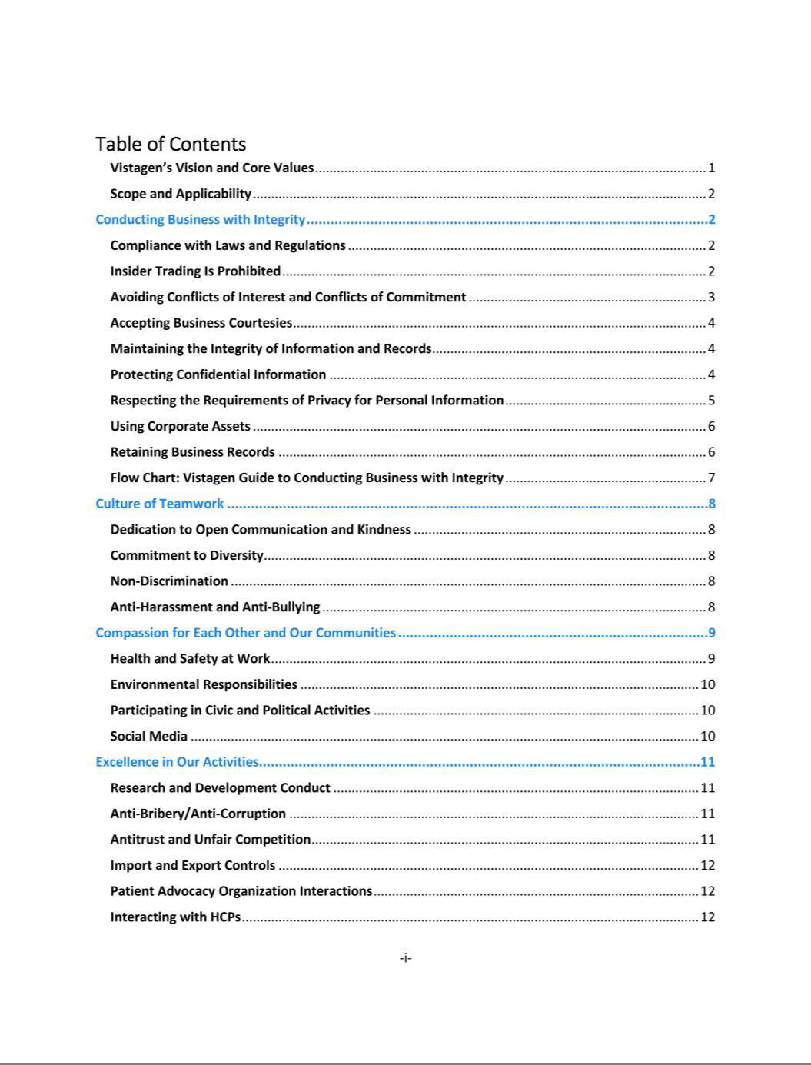



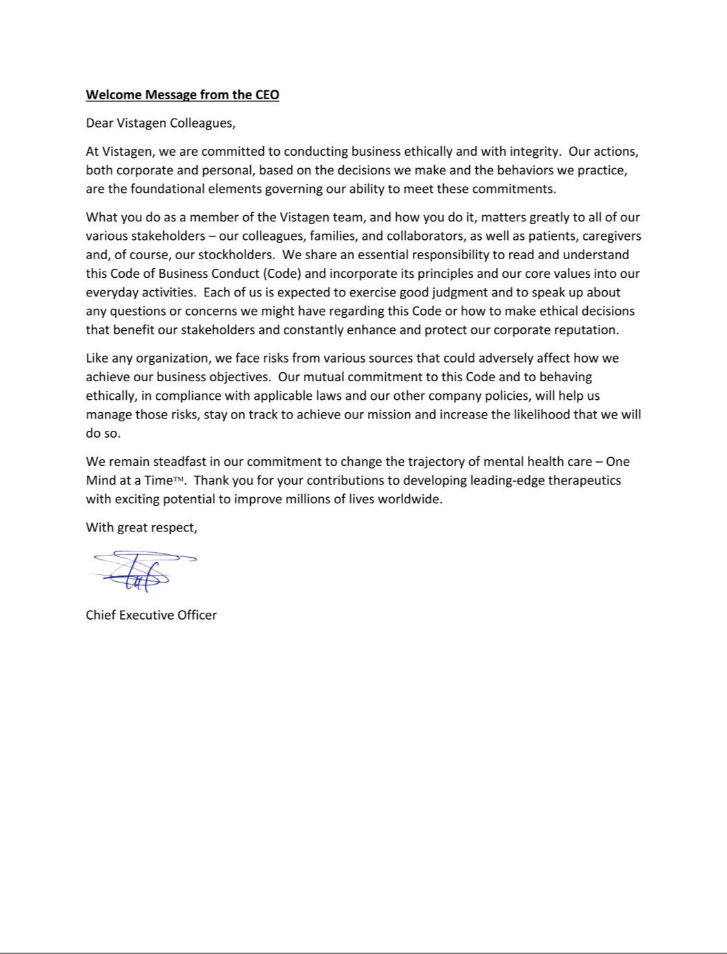

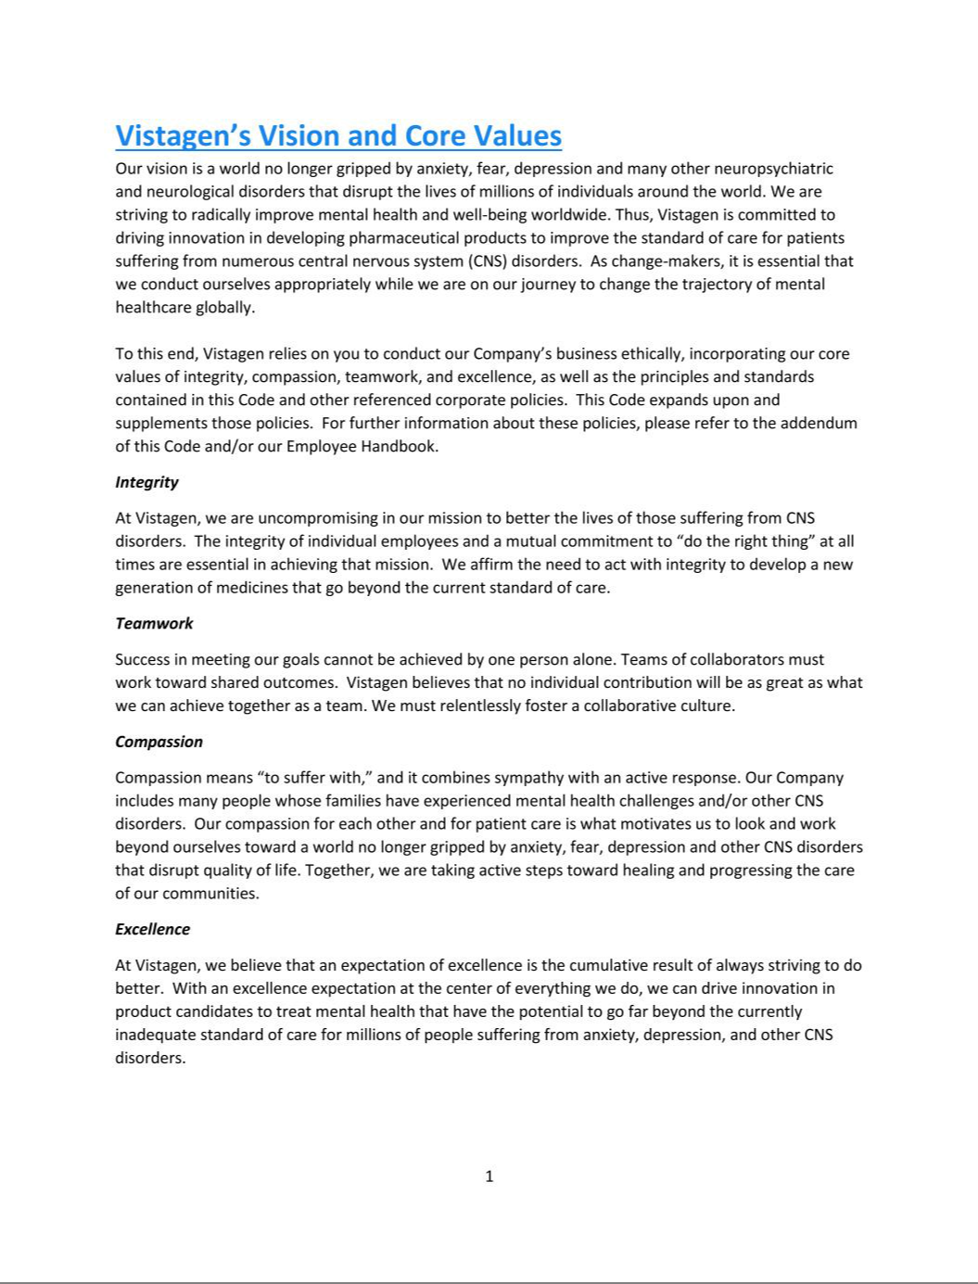

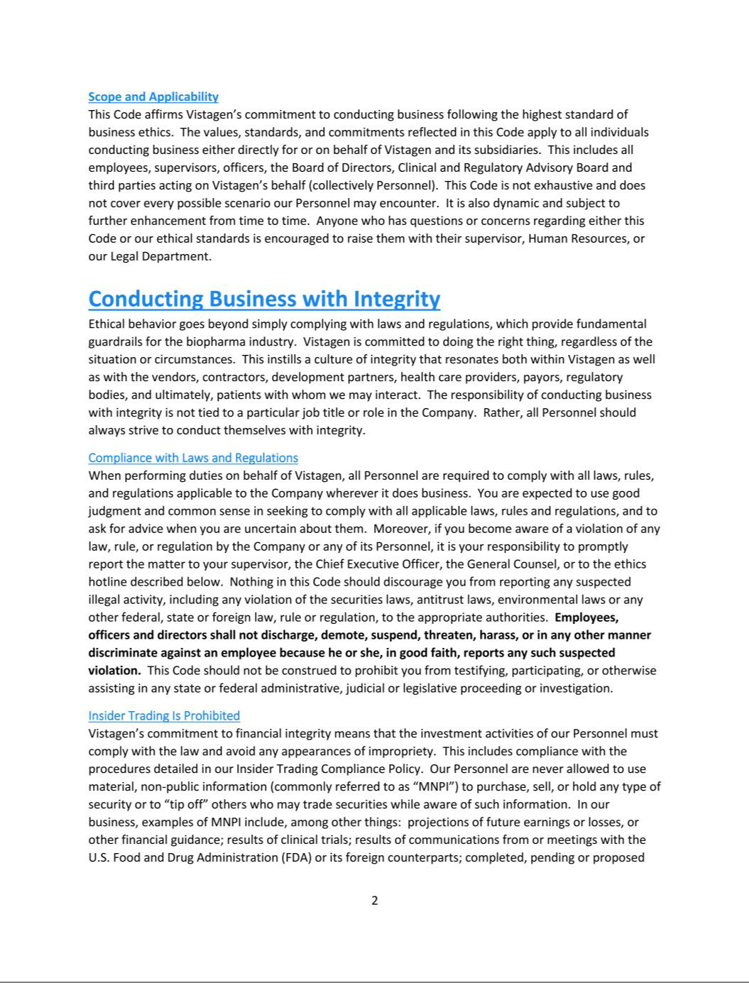

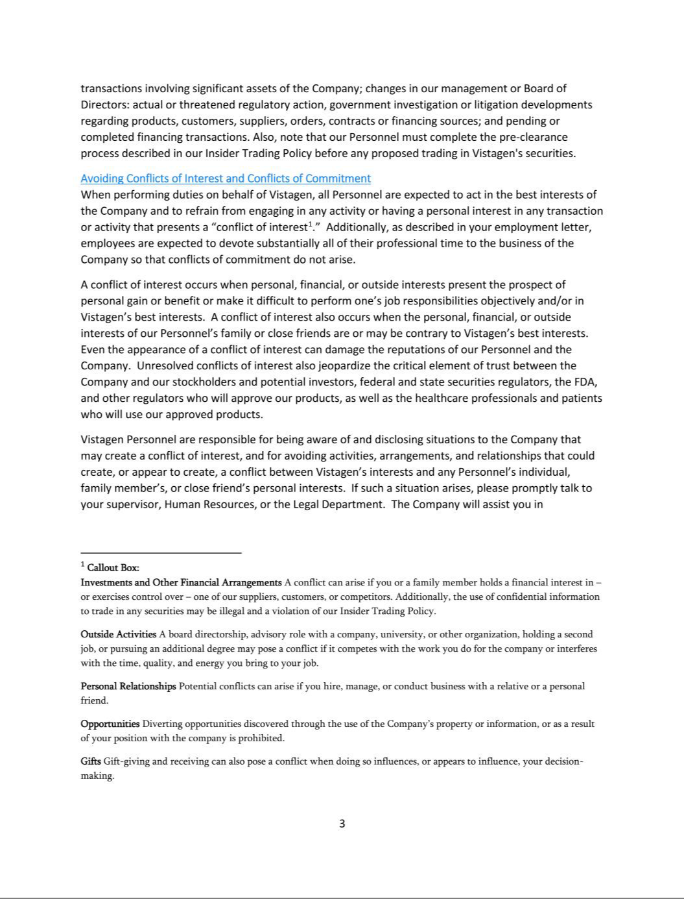

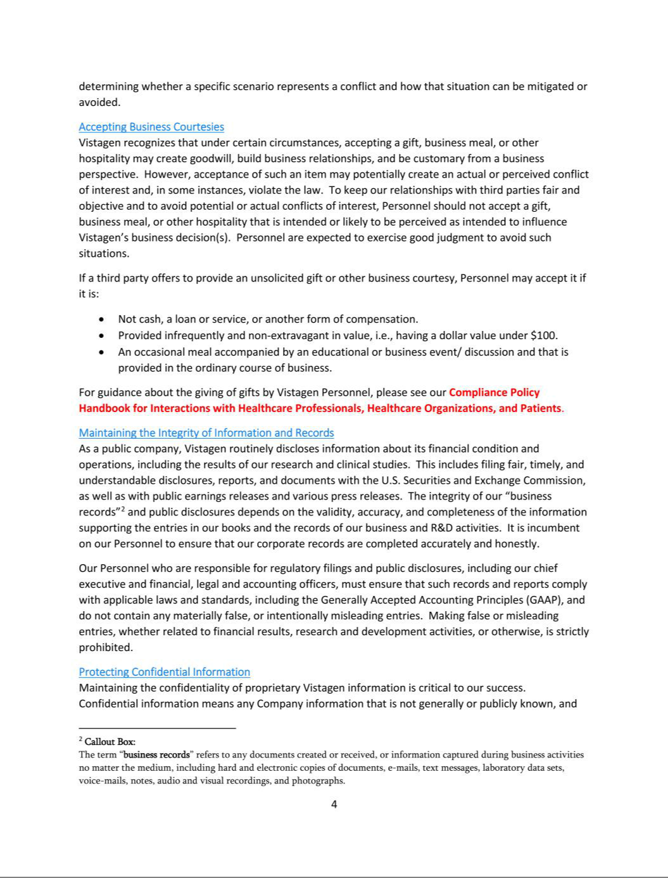

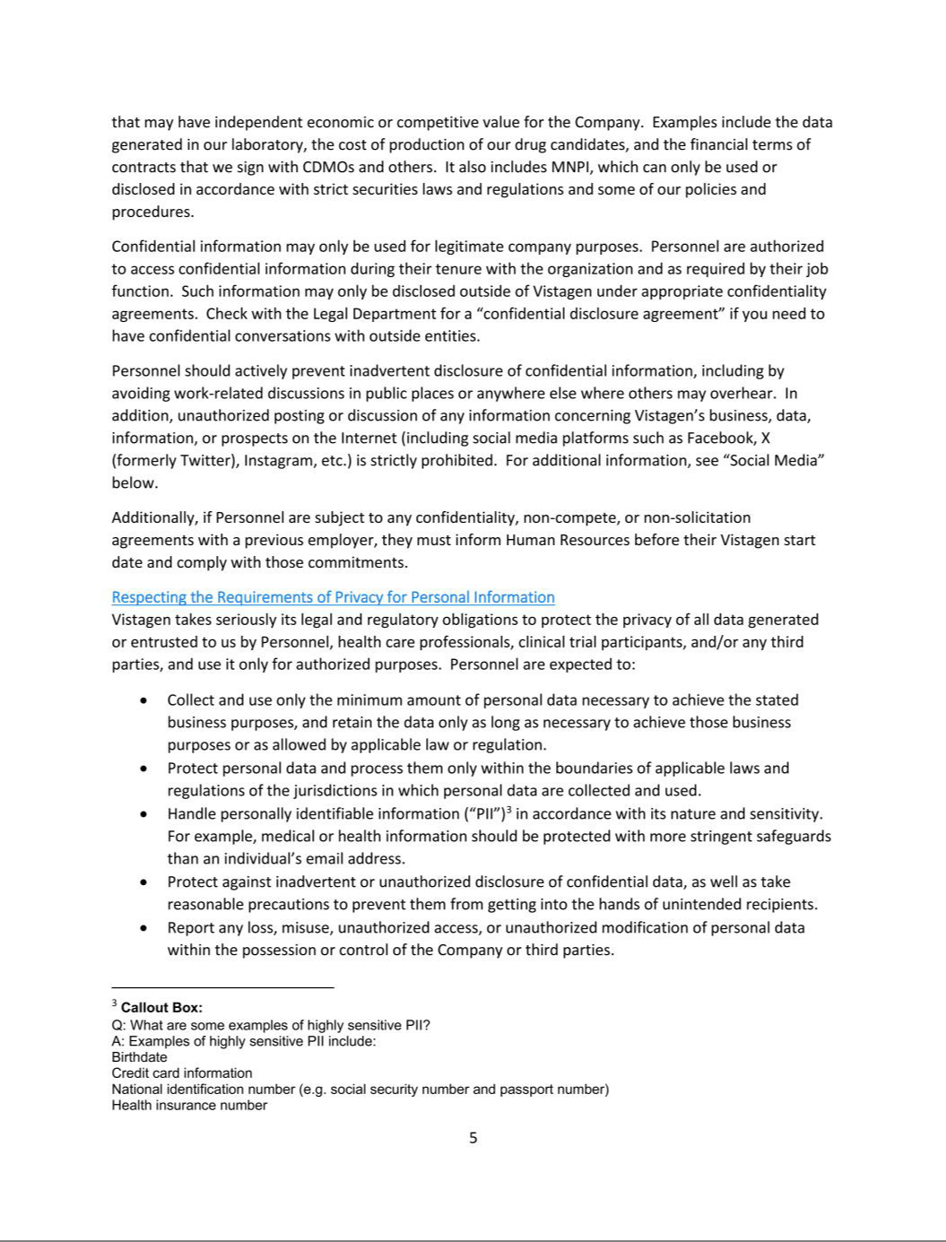

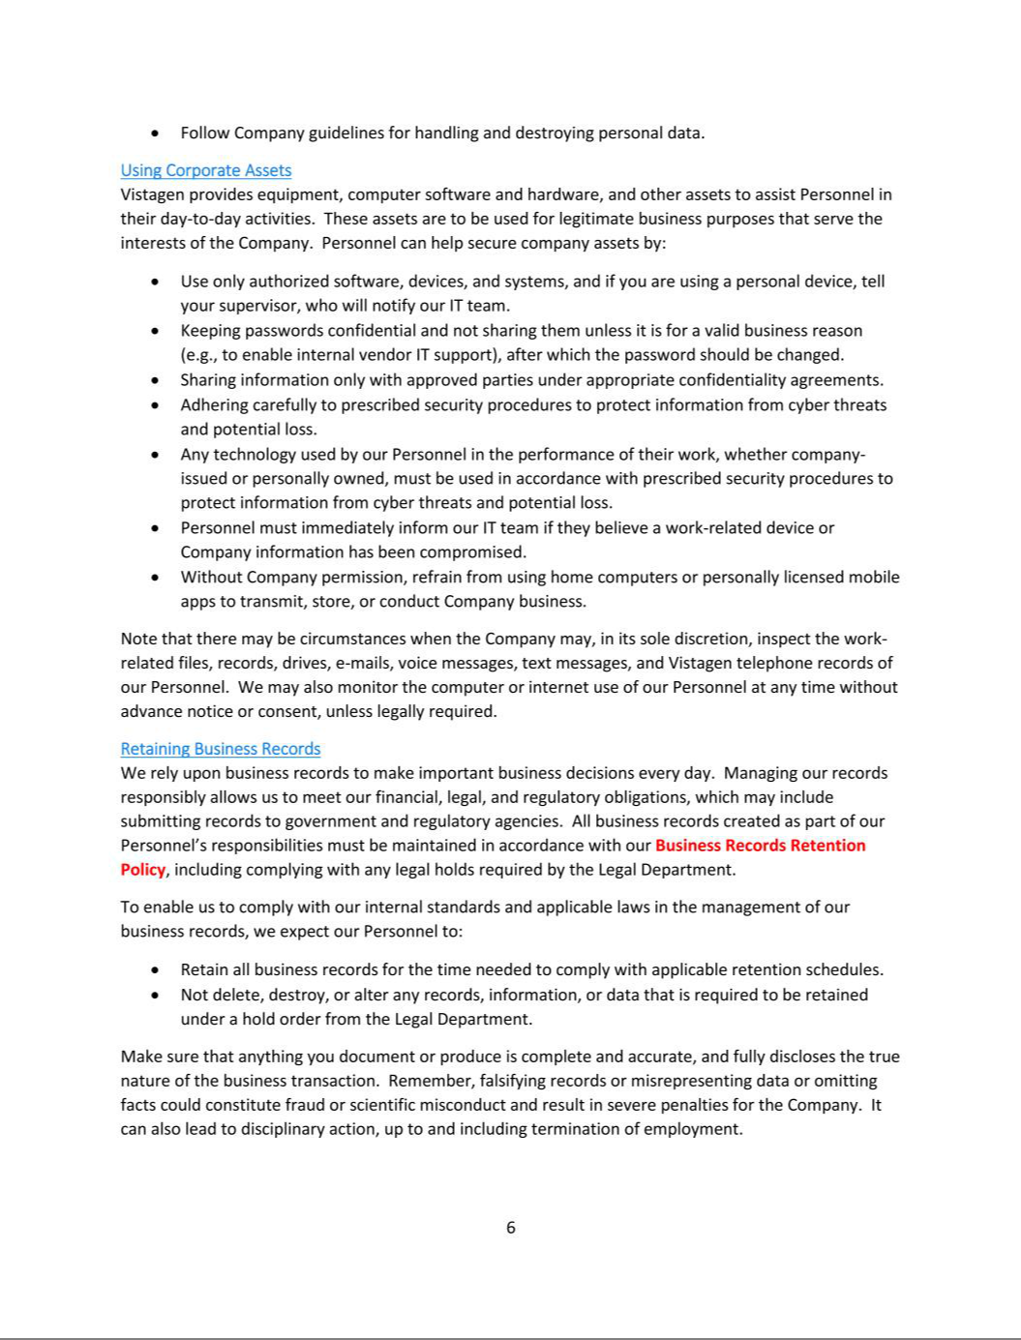

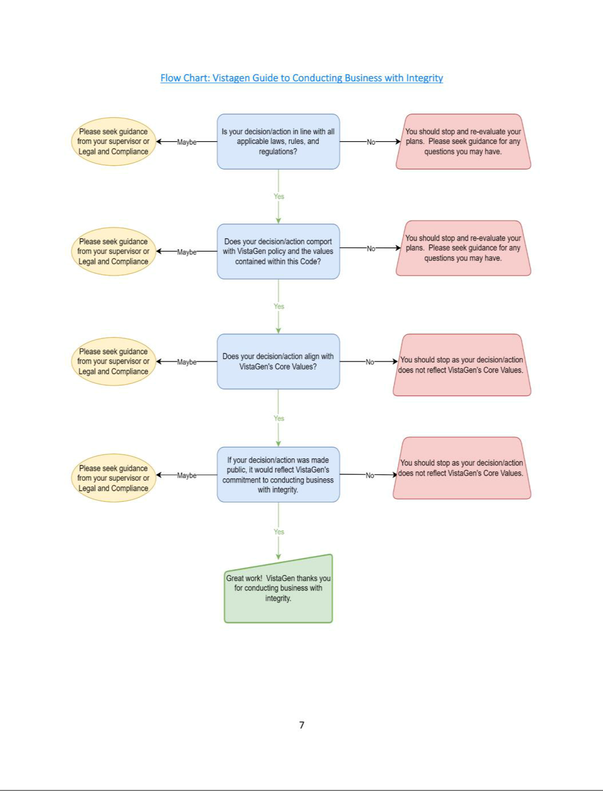

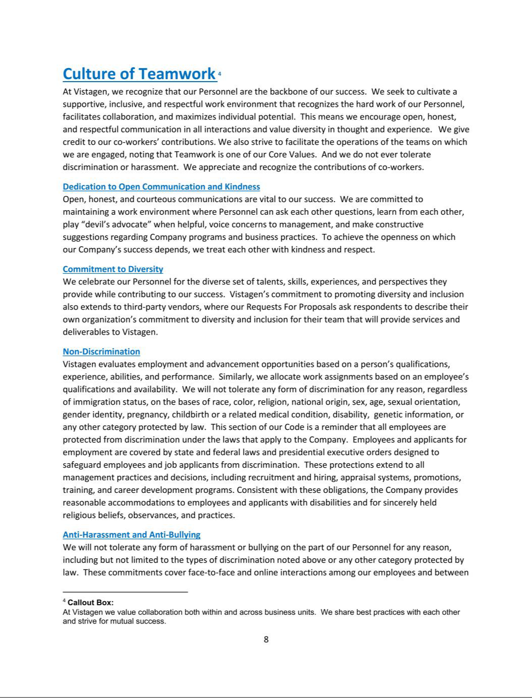

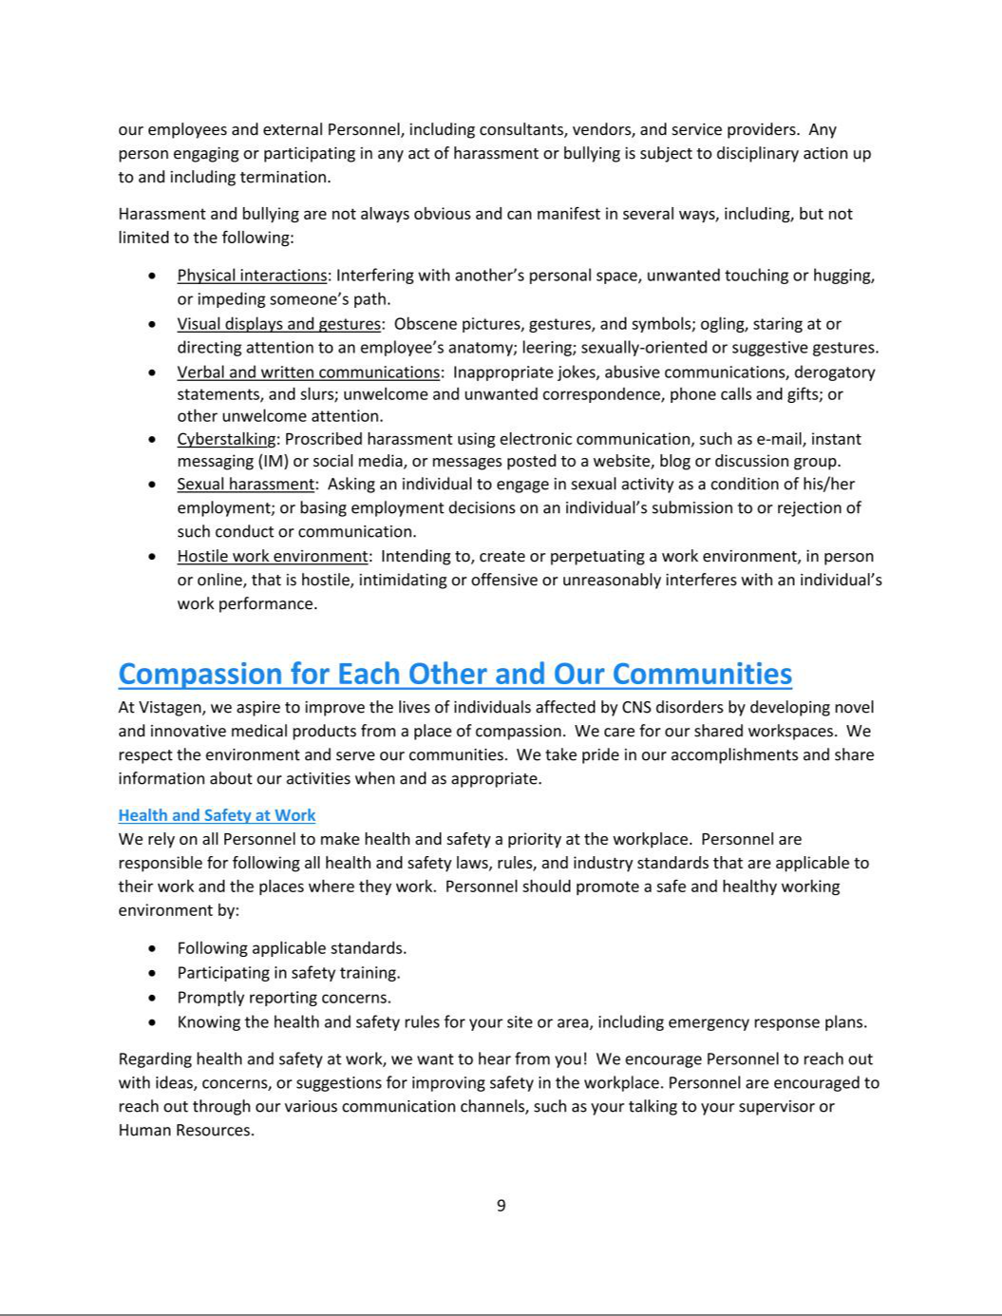

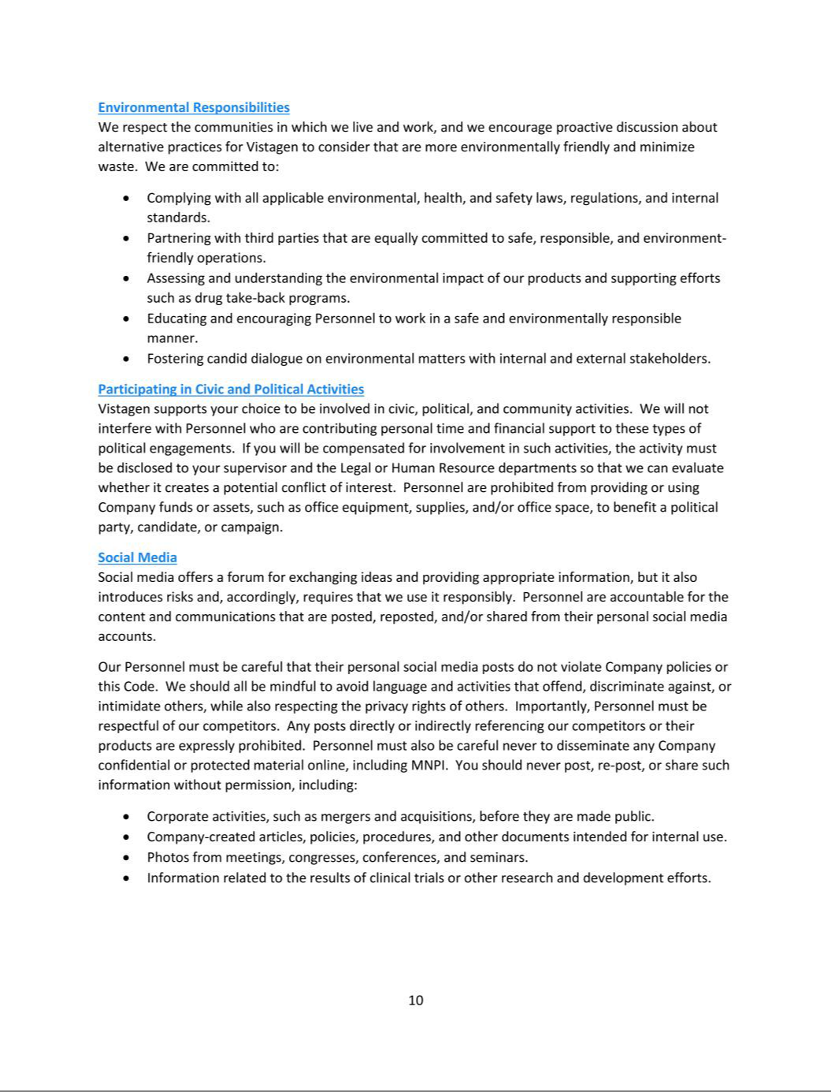

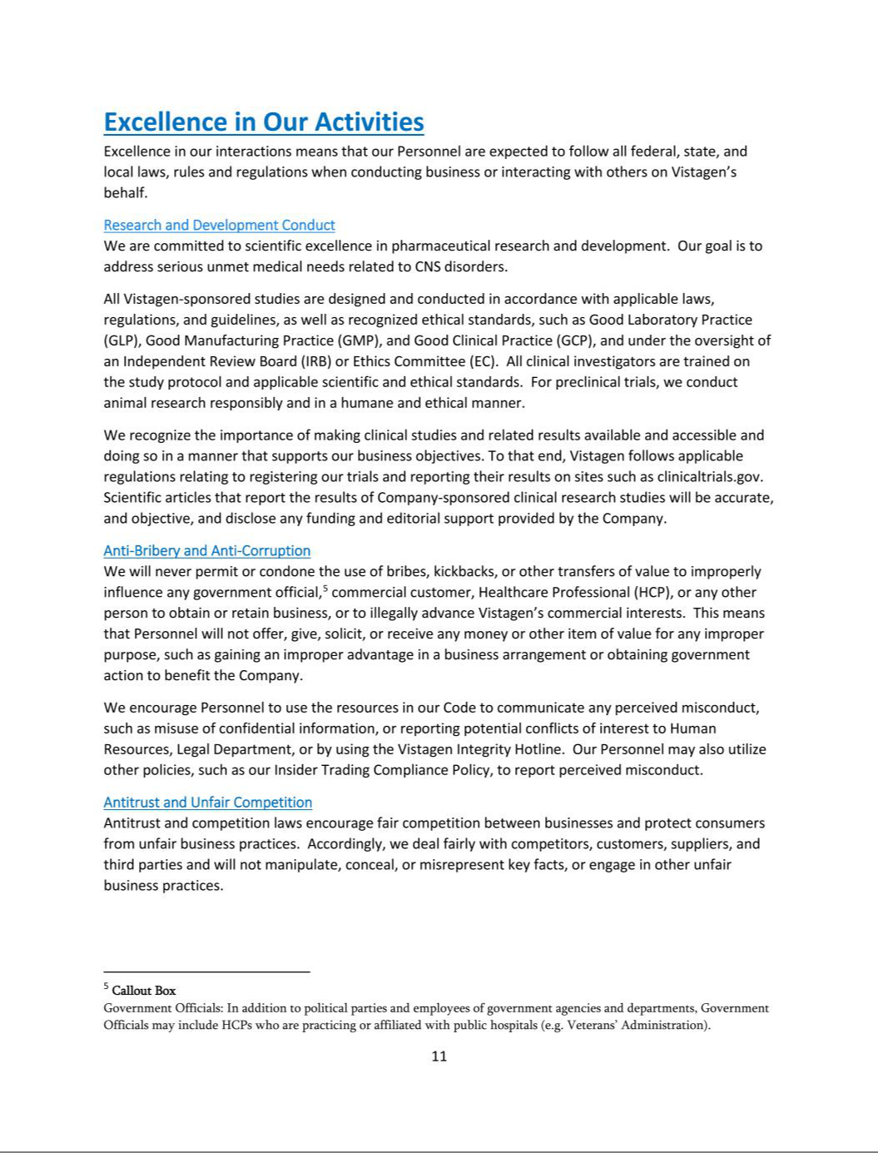

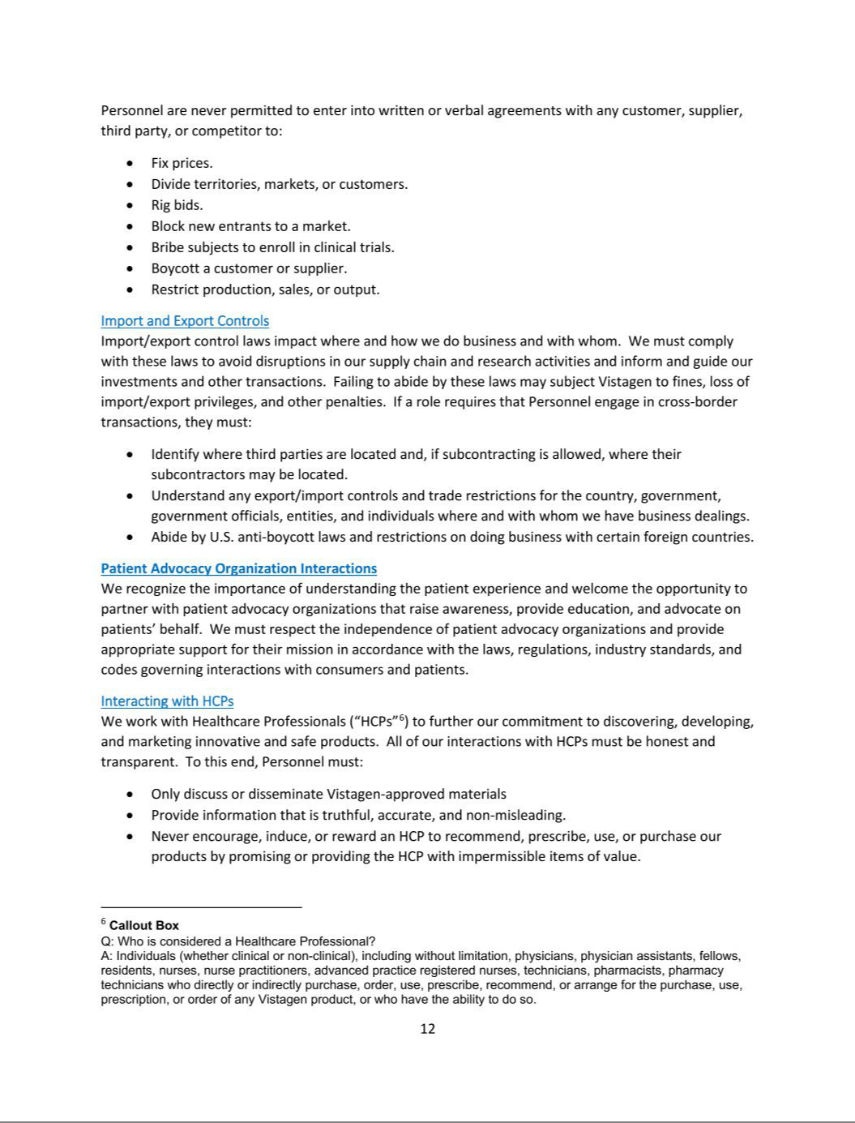

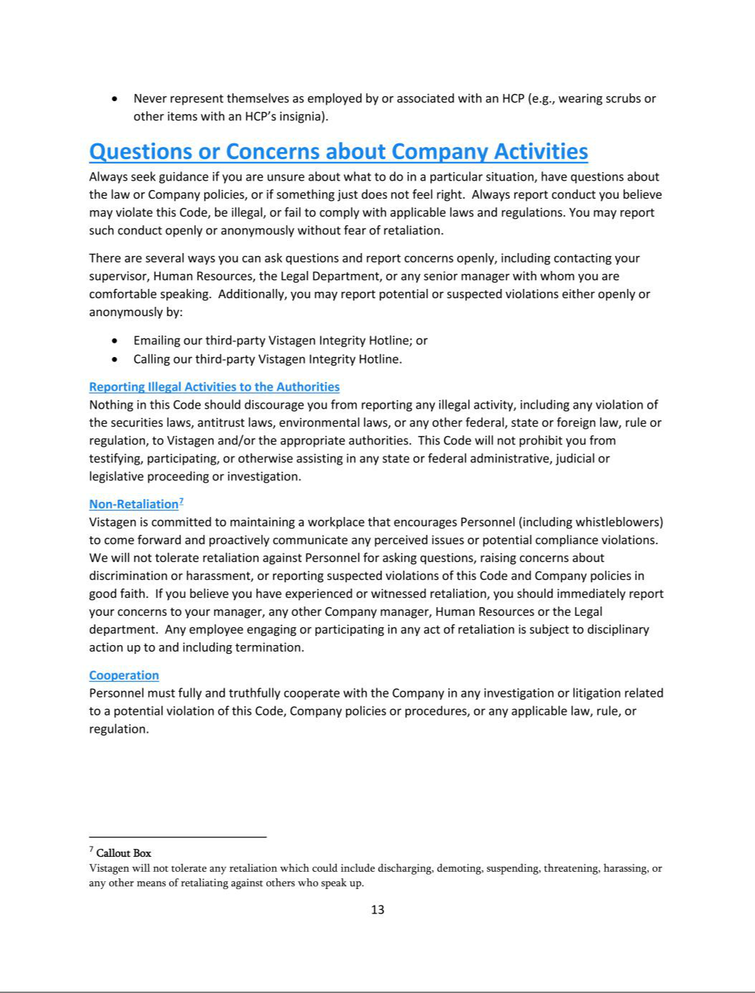

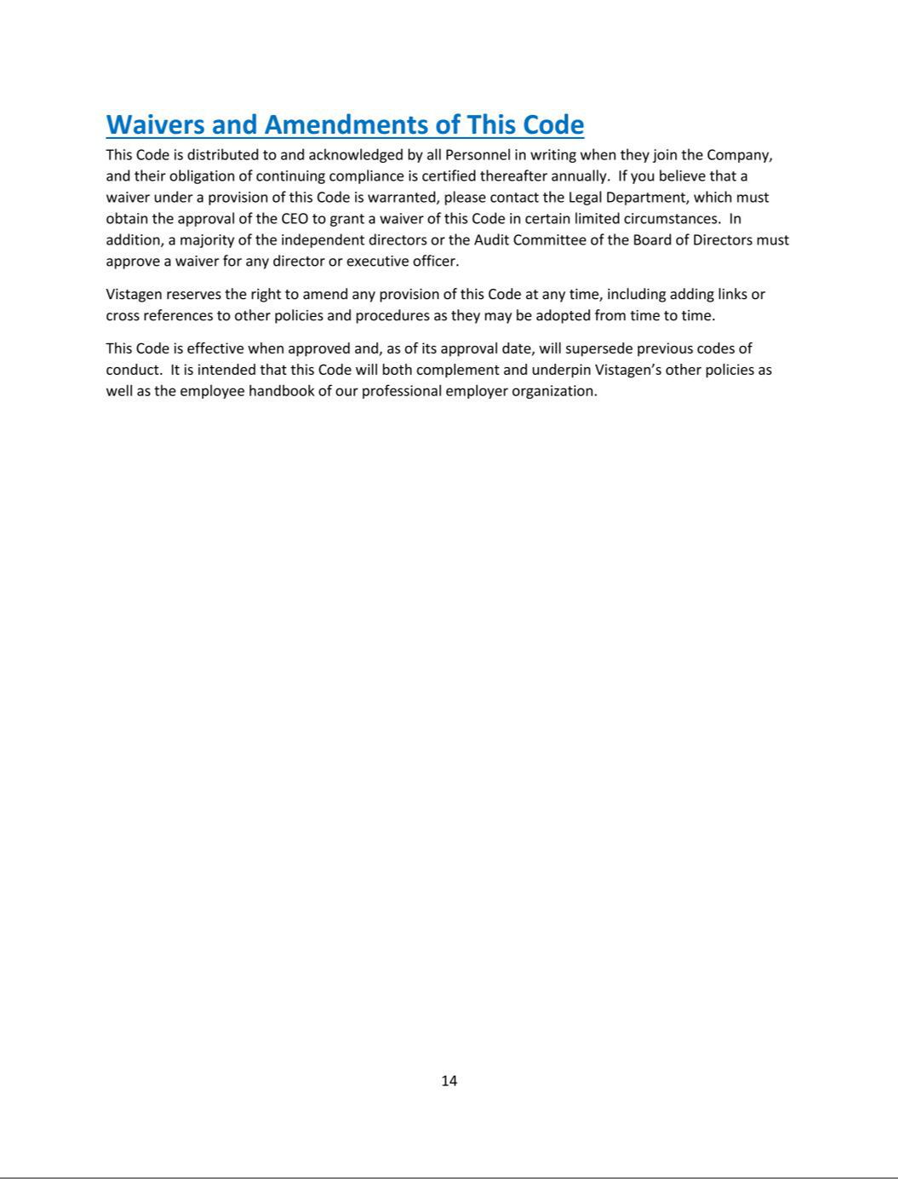



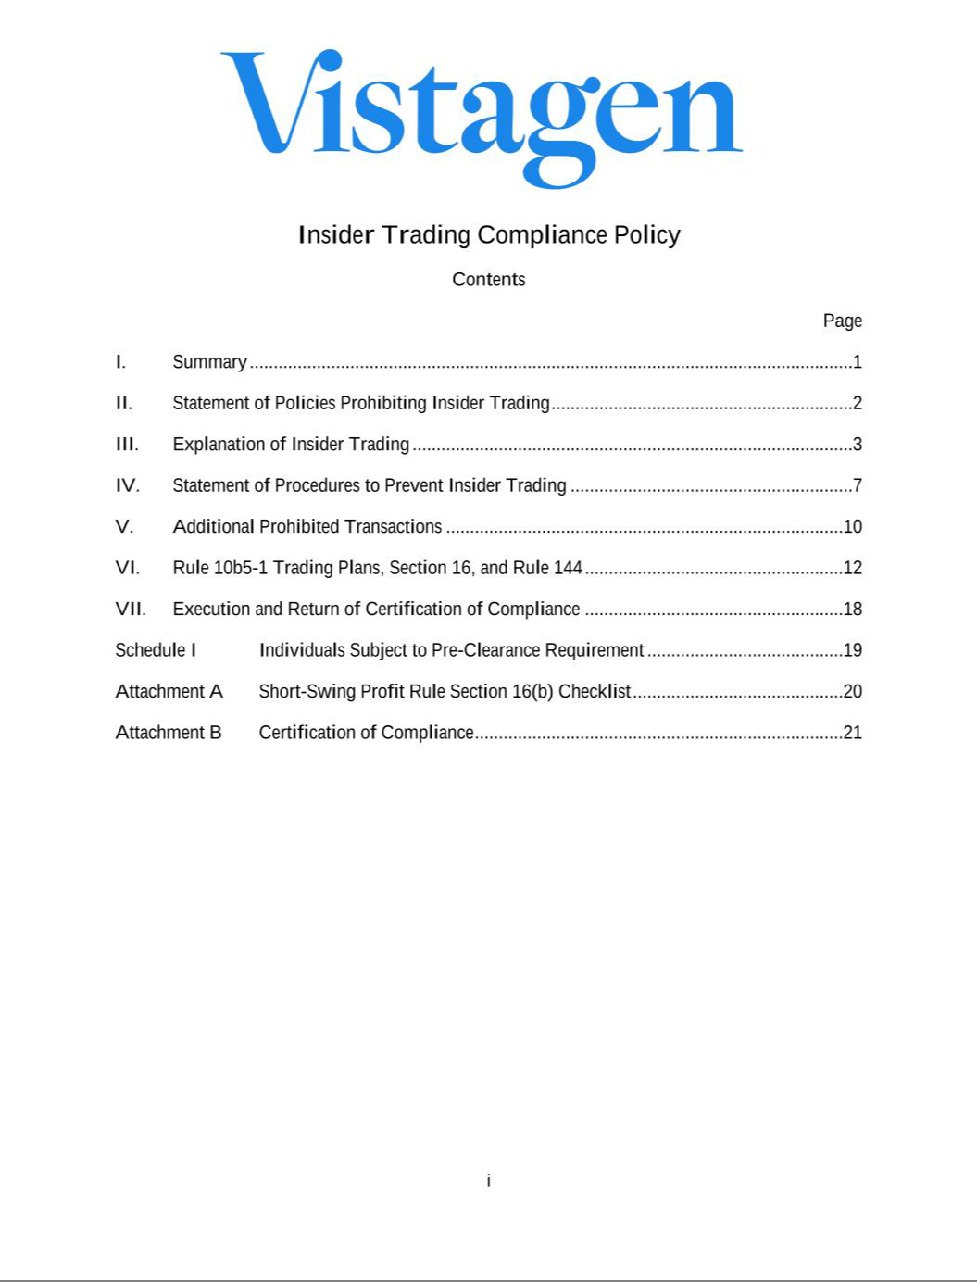

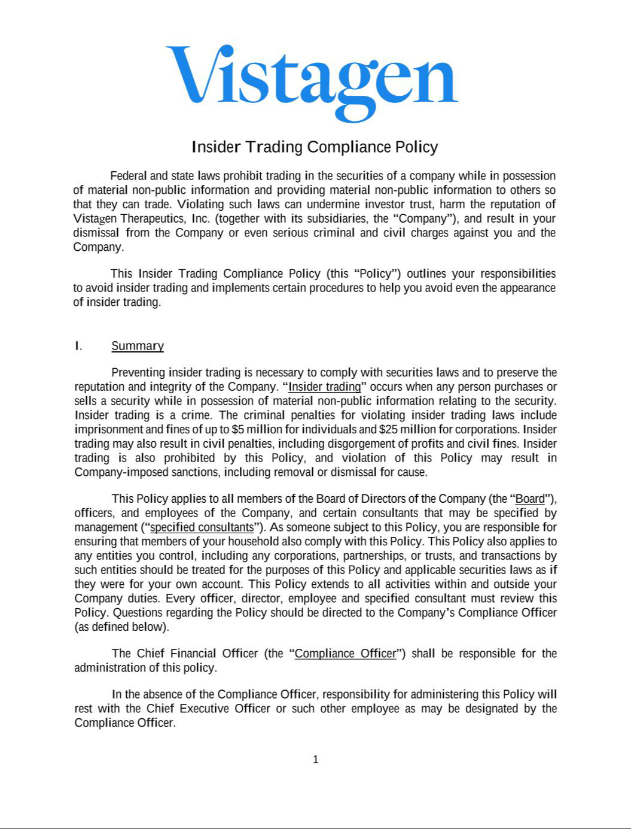

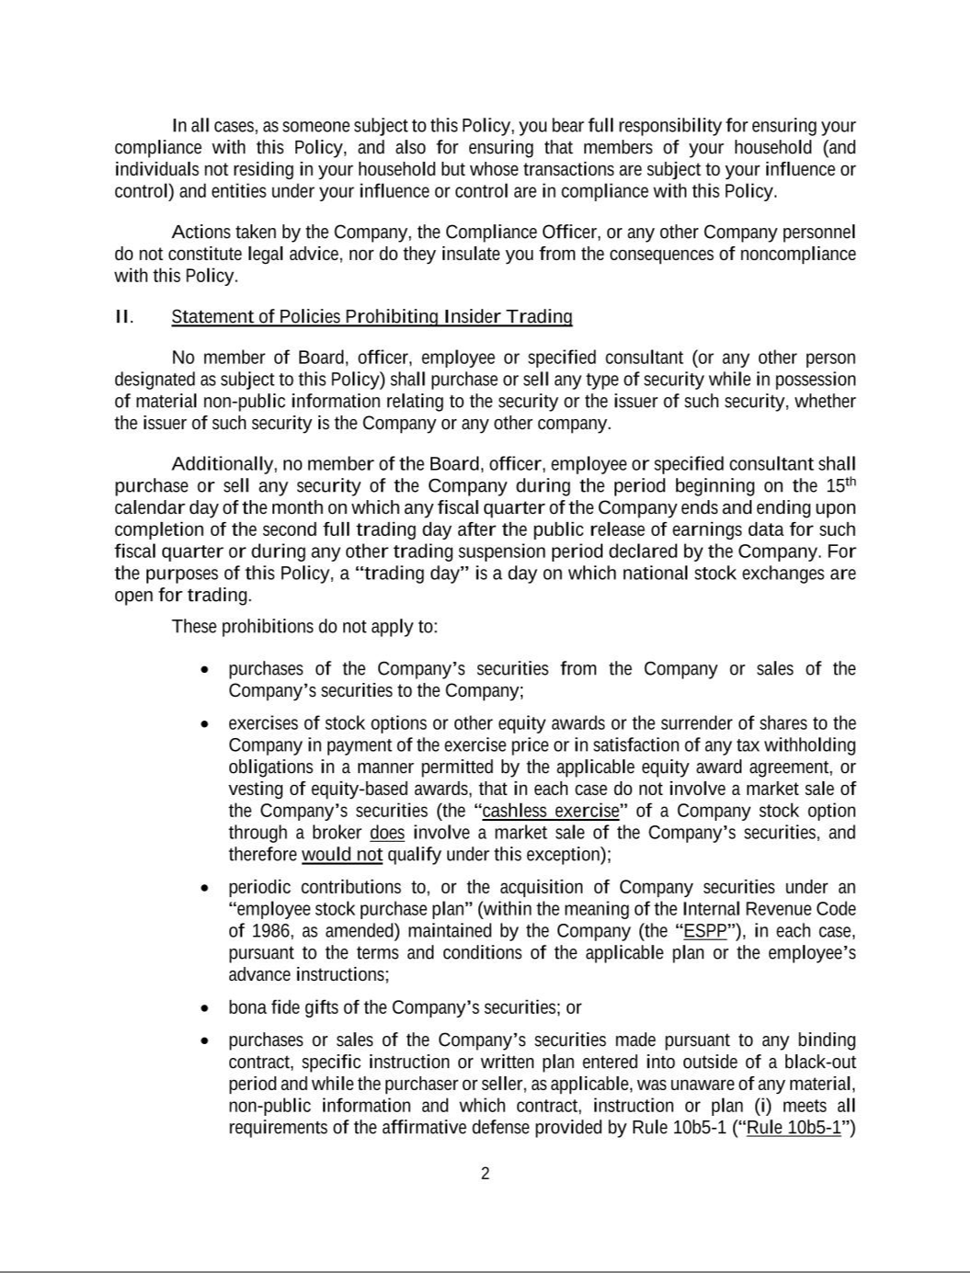

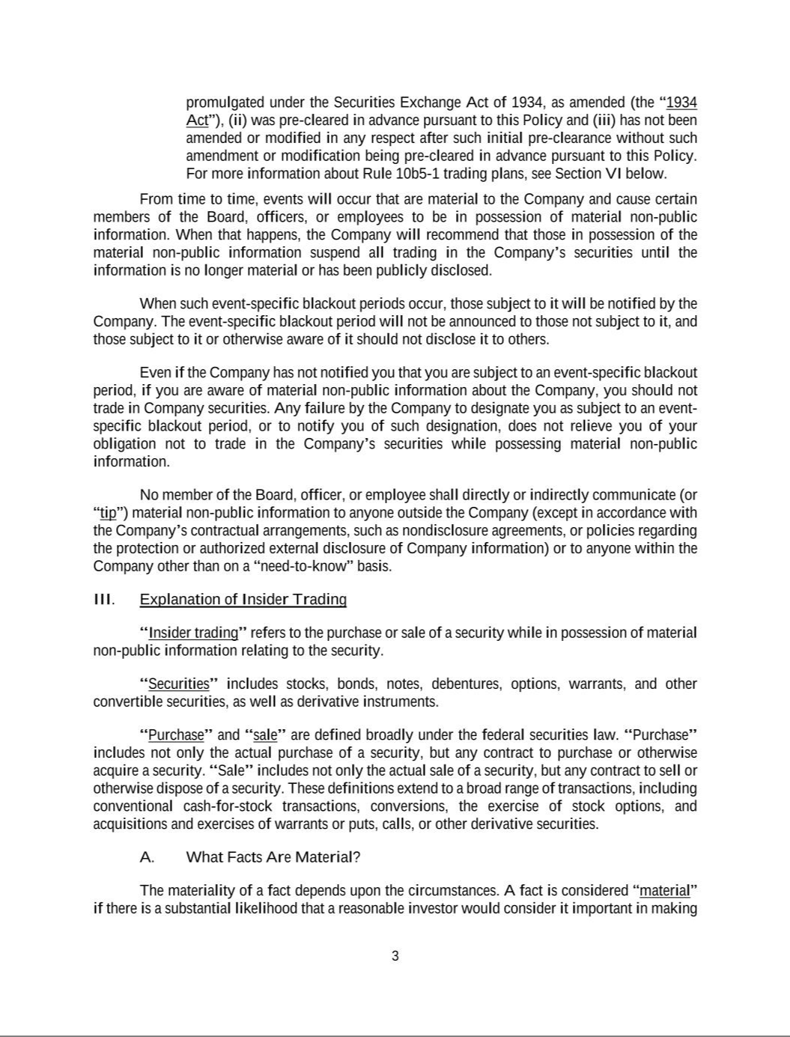

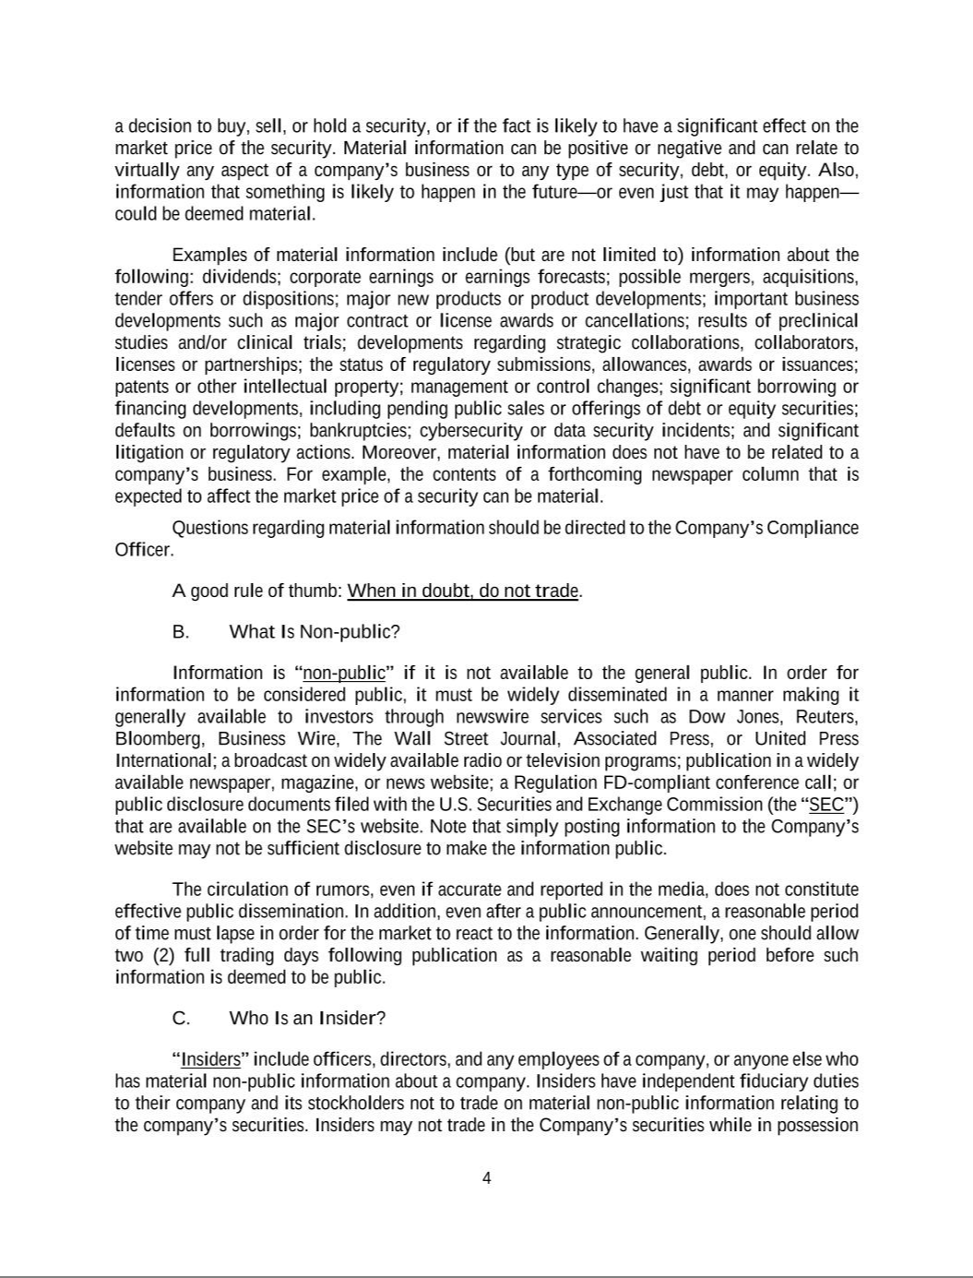

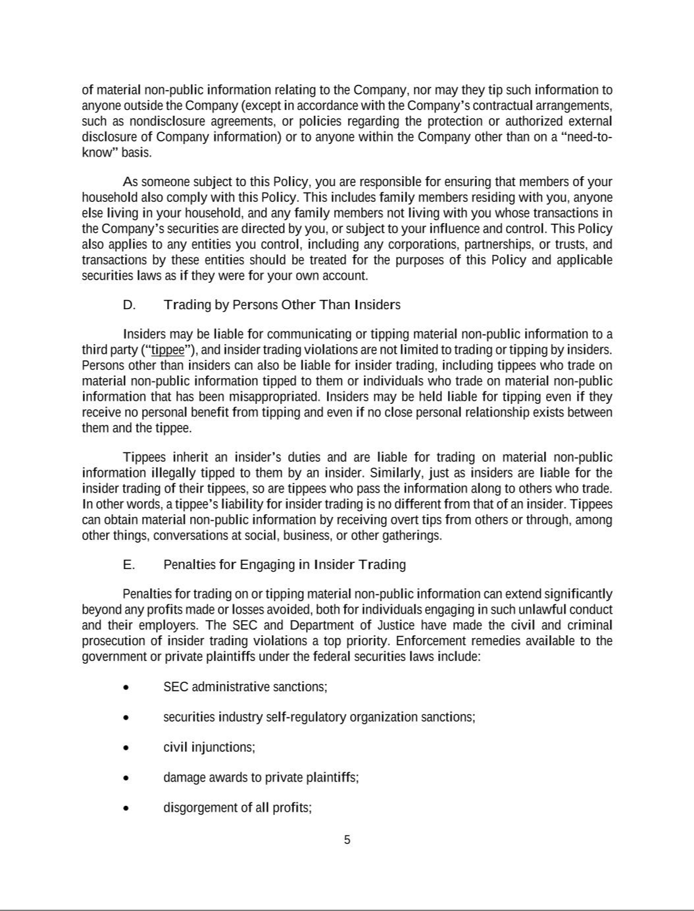

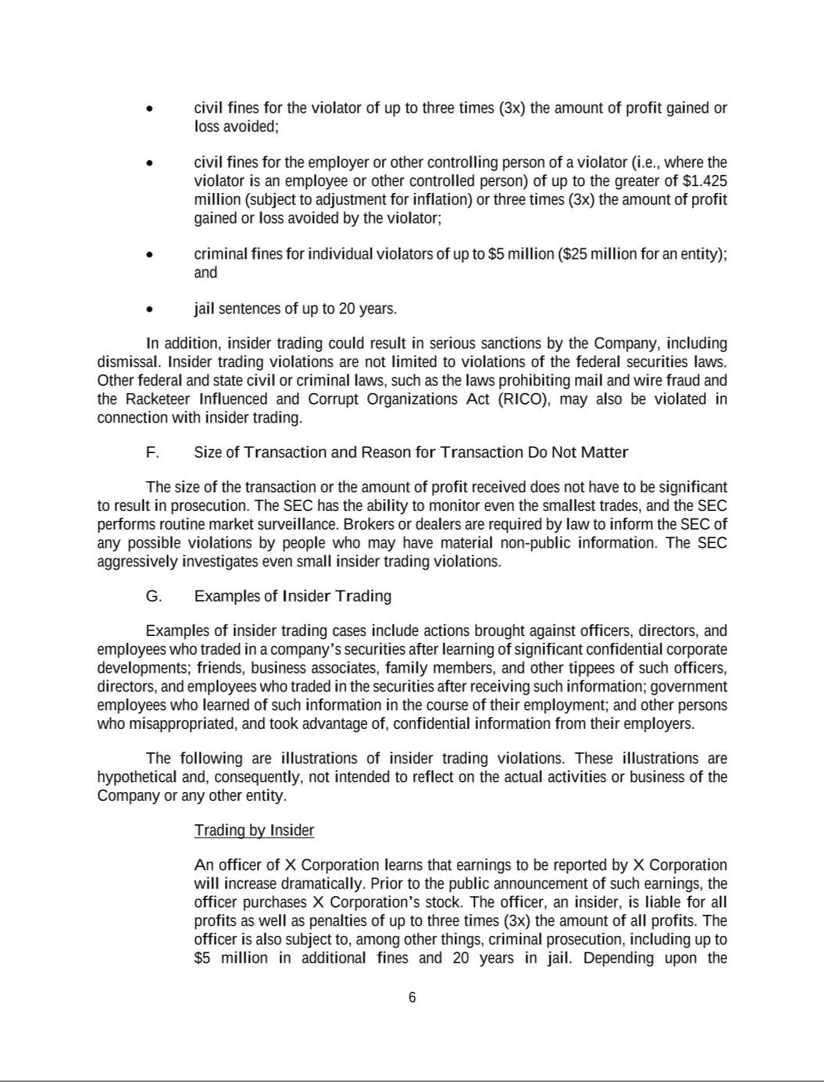

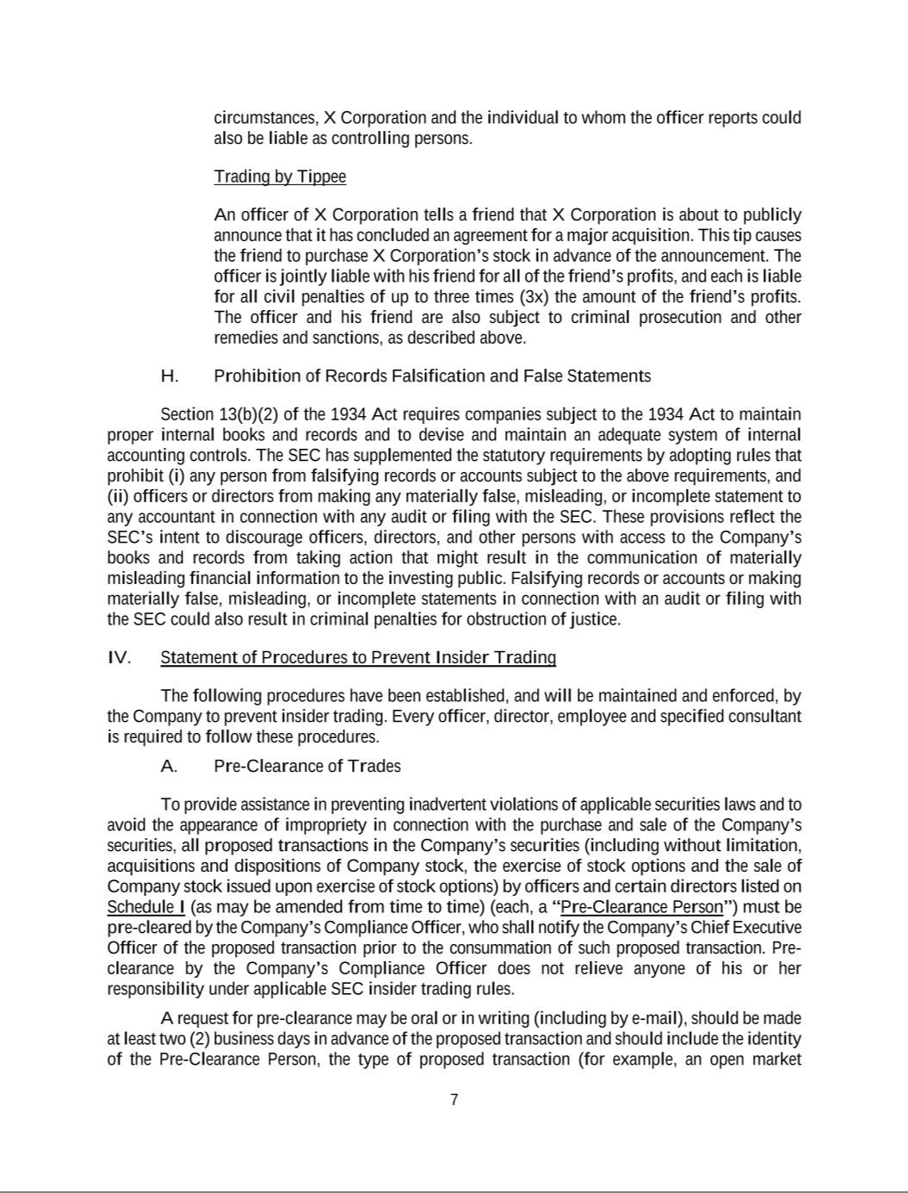

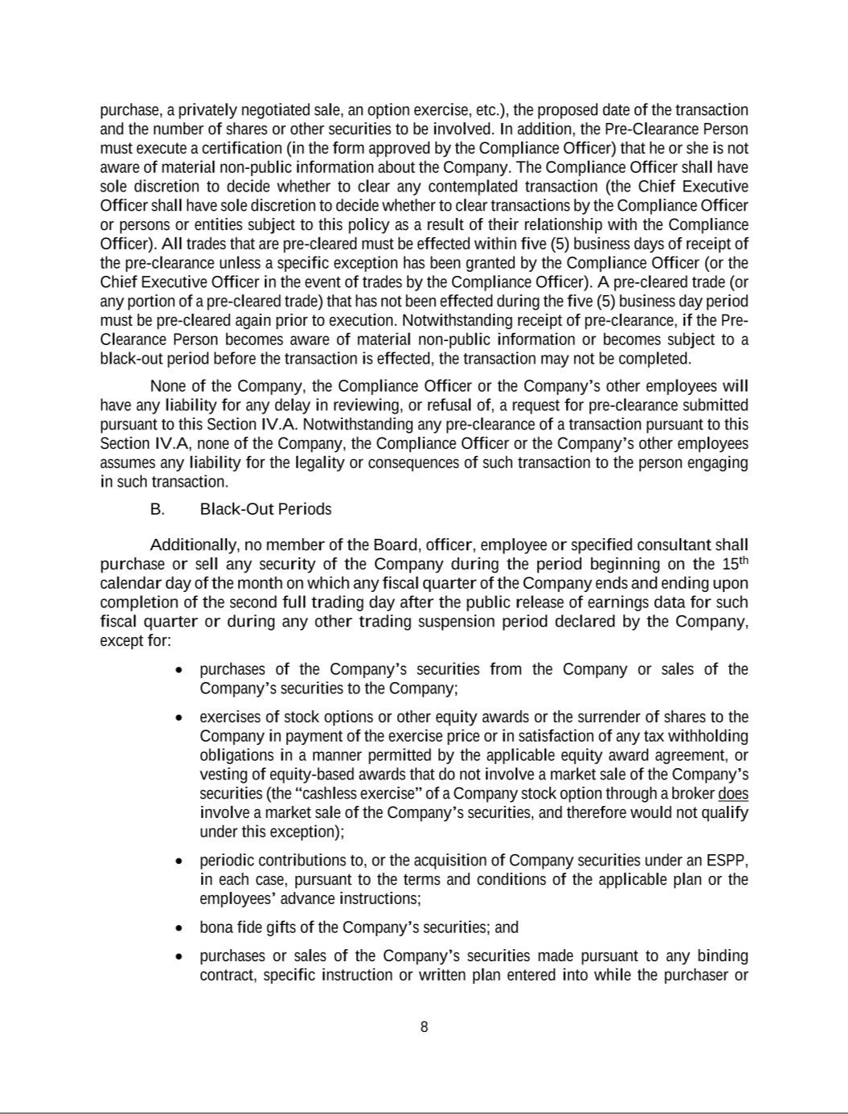

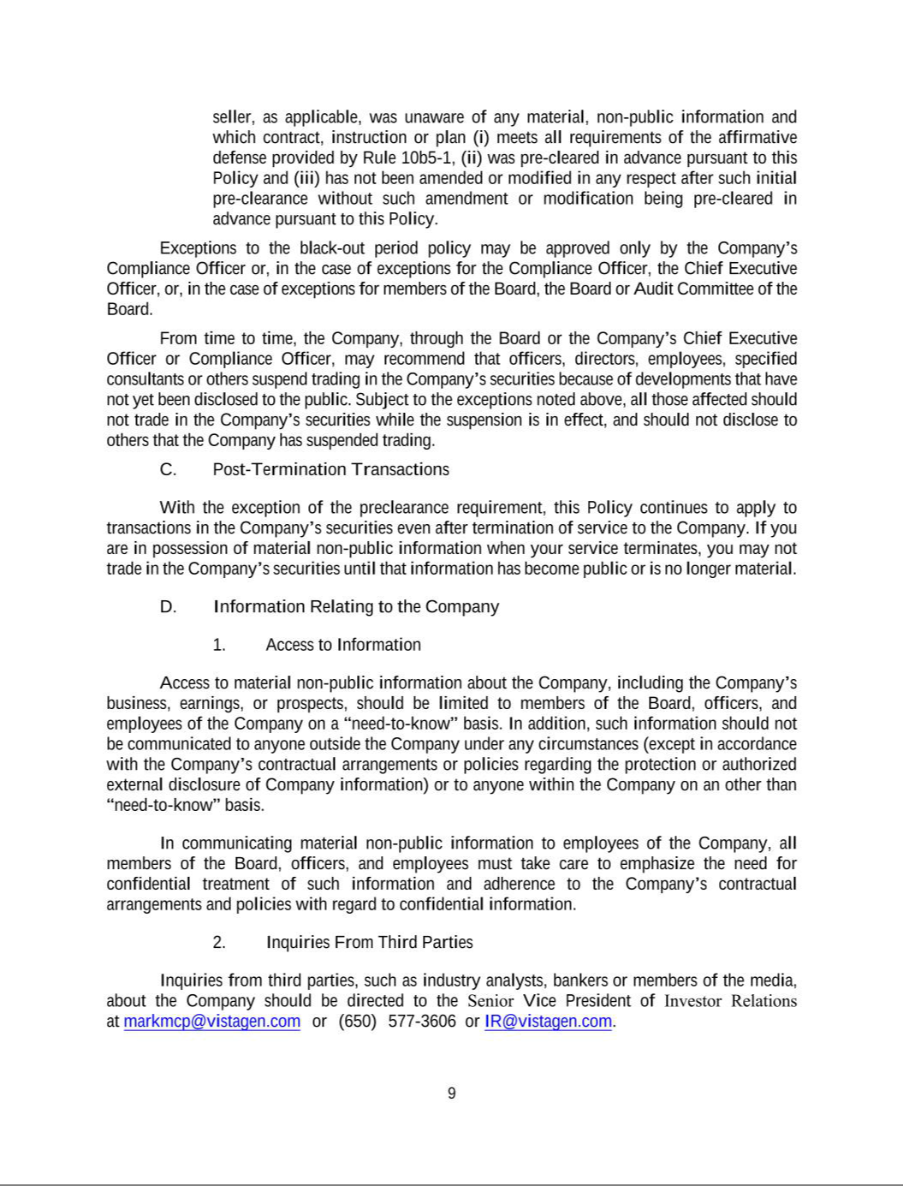

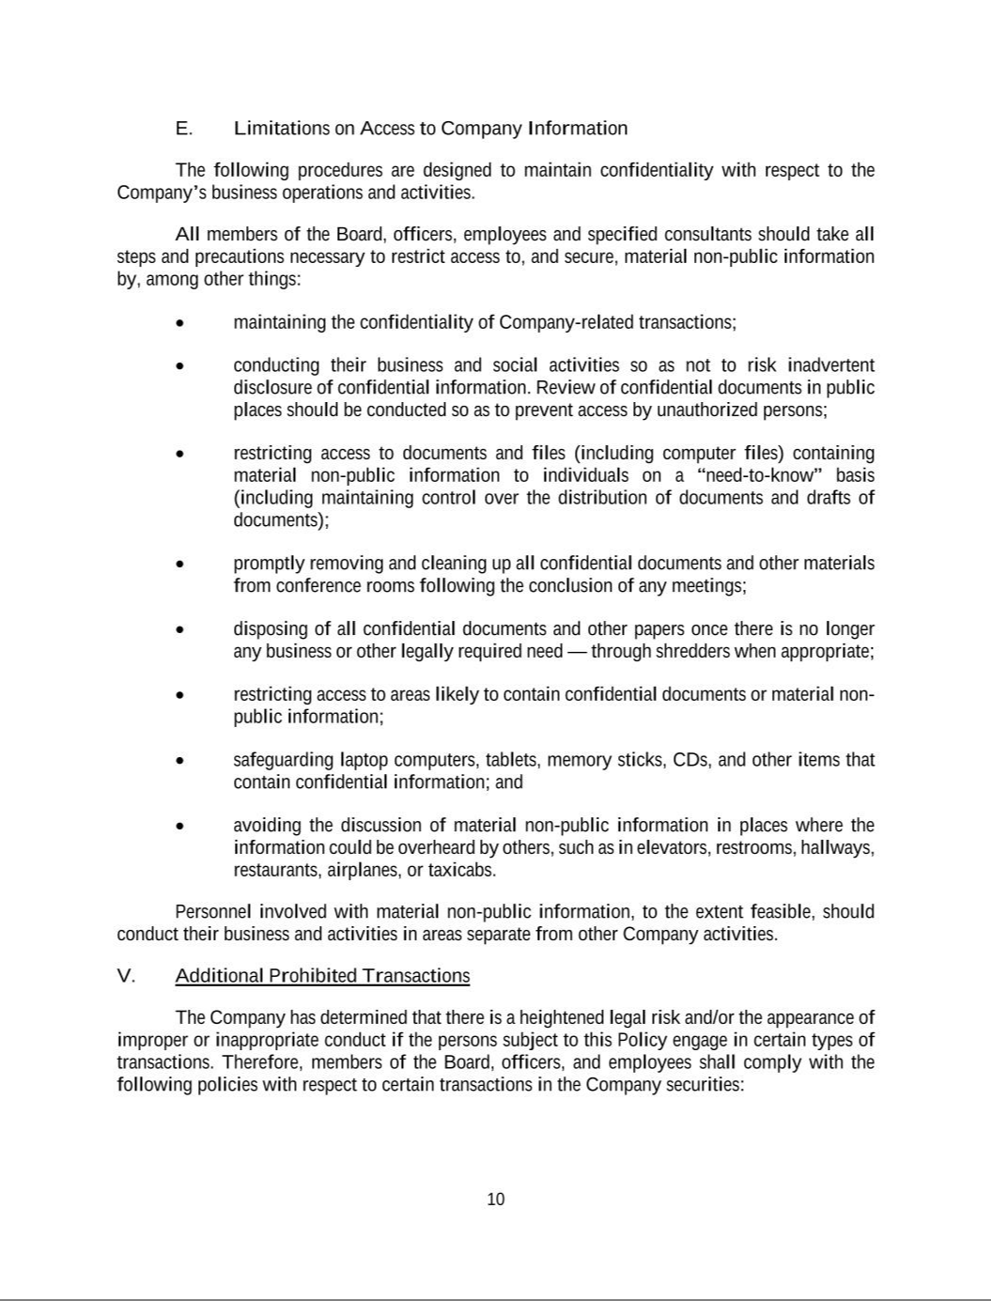

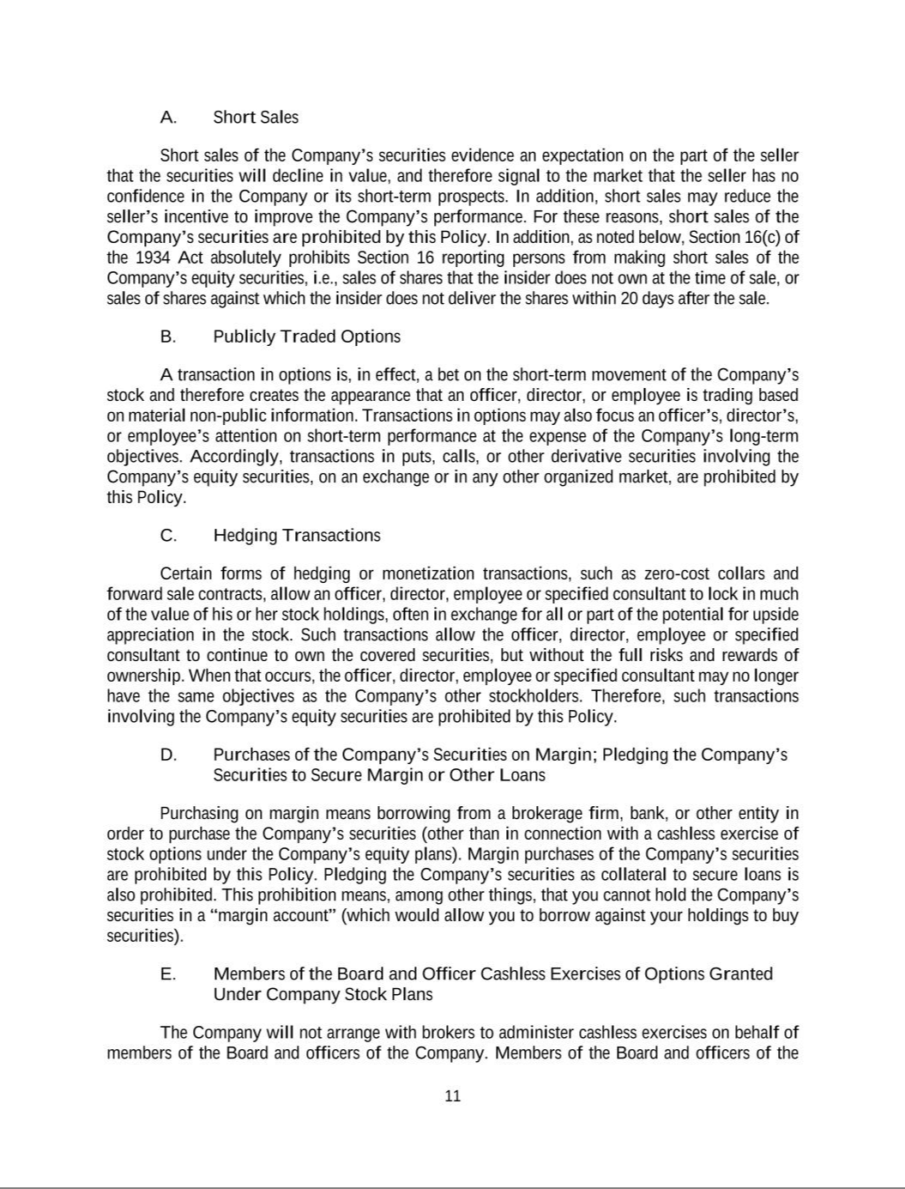

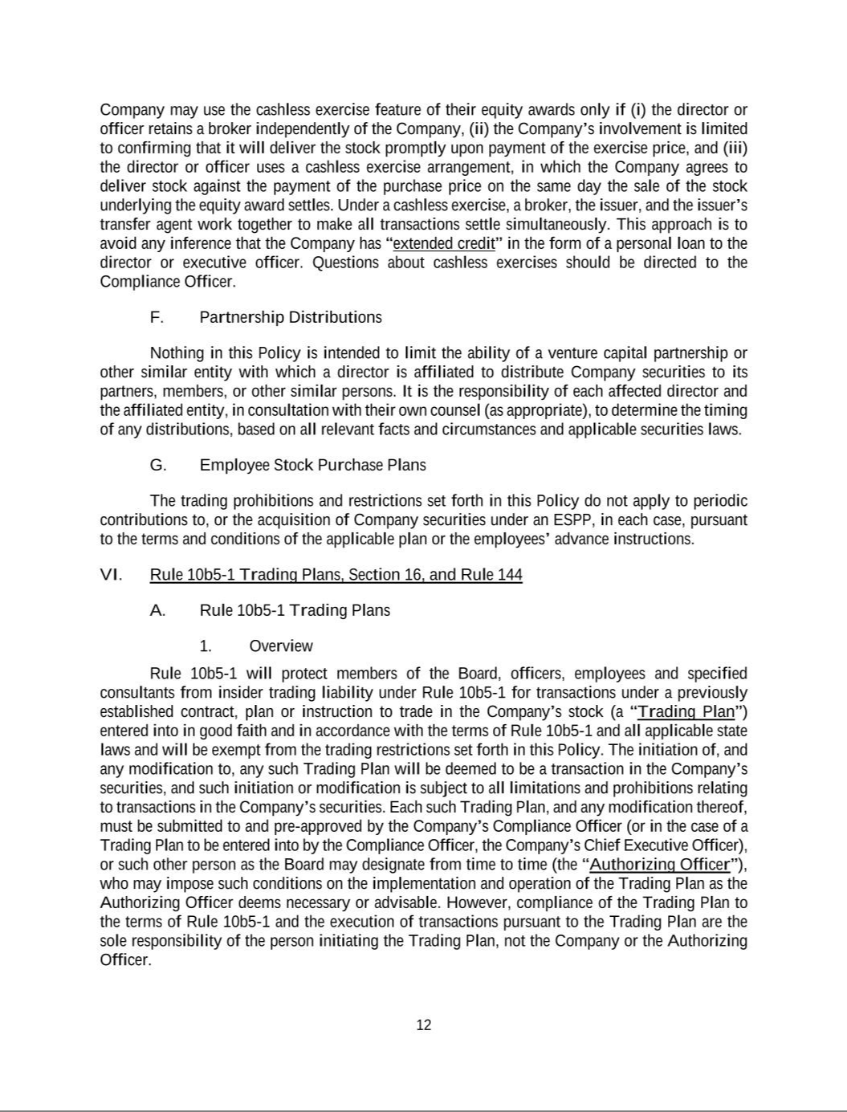

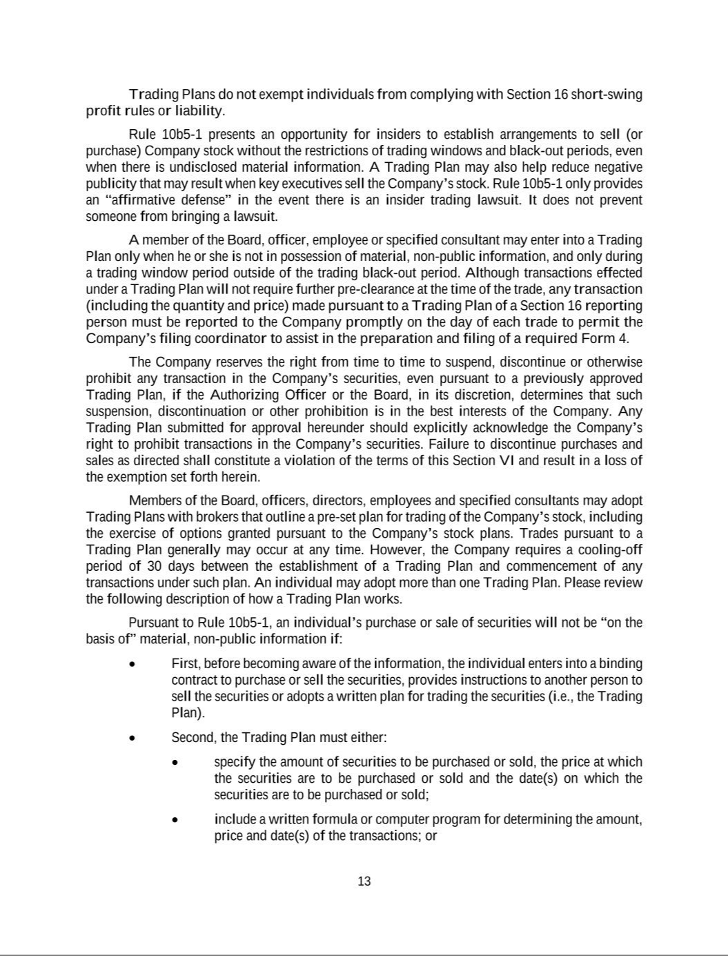

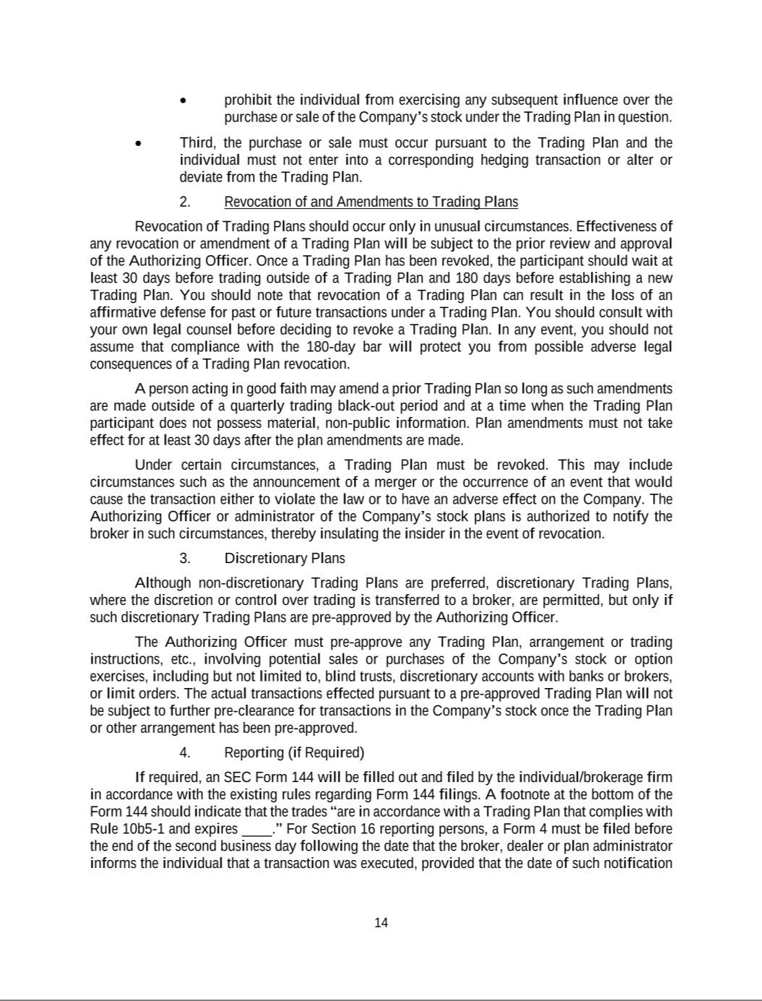

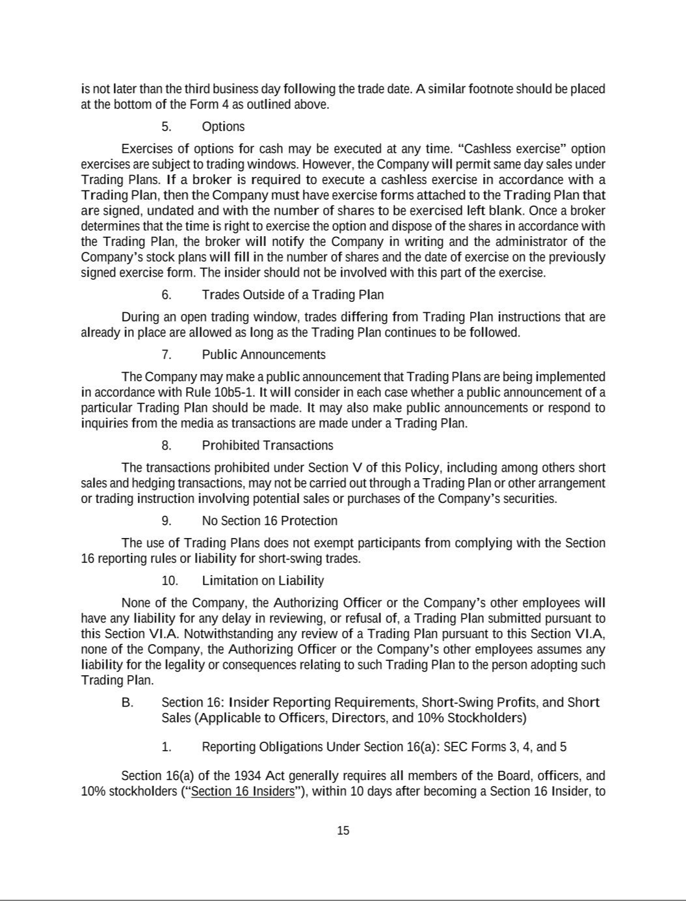

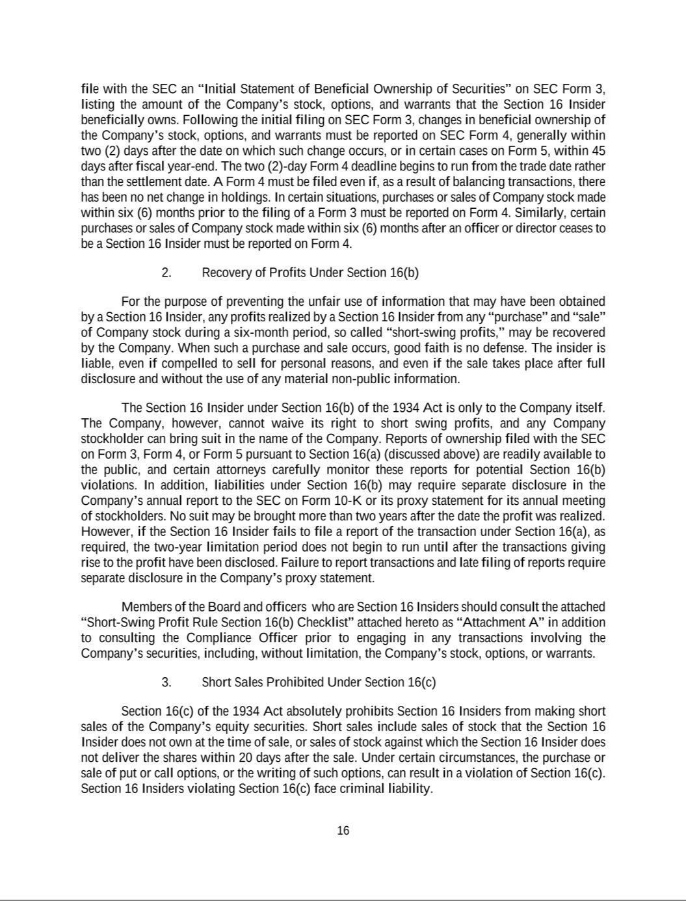

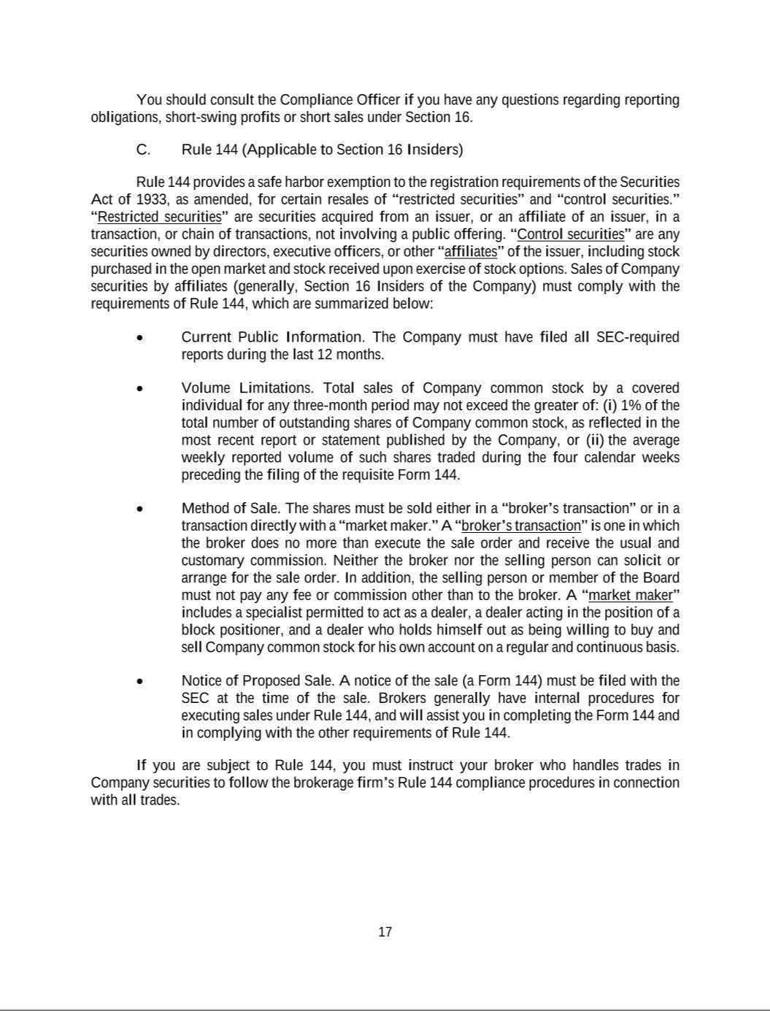







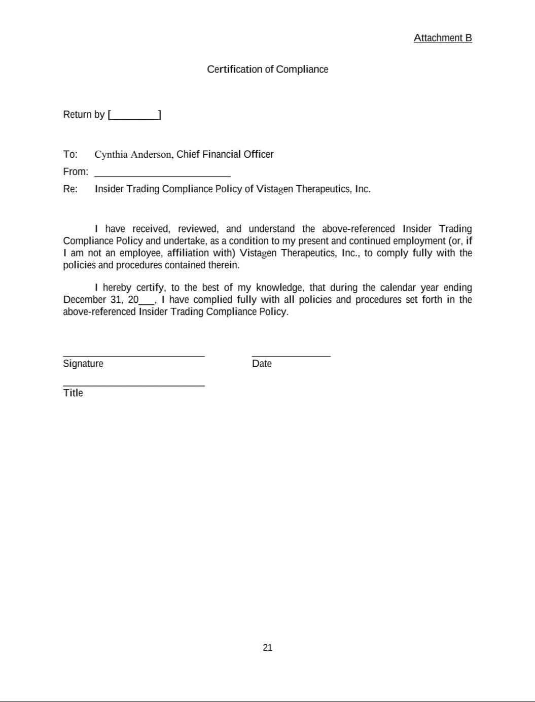

Exhibit 21.1

List of Subsidiaries

Vistastem, Inc., a California corporation

Pherin Pharmaceuticals, Inc., a Delaware corporation

CONSENT OF INDEPENDENT REGISTERED PUBLIC ACCOUNTING FIRM

We hereby consent to the incorporation by reference in the Registration Statements on Form S-8 (File Nos. 333-280246, 333-259799, 333-234026, 333-223556 and 333-208354) and Form S-3 (File Nos. 333-277041 and 333-270232) of Vistagen Therapeutics, Inc. of our report dated June 11, 2024, relating to the consolidated financial statements as of and for the year ended March 31, 2024, which appears in this Annual Report on Form 10-K.

/s/ WithumSmith+Brown, PC

San Francisco, California

June 17, 2025



Consent of Independent Registered Public Accounting Firm

We consent to the incorporation by reference in the registration statements (Nos. 333-277041 and 333-270232) on Form S-3 and registration statements (Nos. 333-280246, 333-259779, 333-234026, 333-223556, and 333-208354) on Form S-8 of our report dated June 17, 2025, with respect to the consolidated financial statements of Vistagen Therapeutics, Inc.

/s/ KPMG LLP

San Francisco, California

June 17, 2025

EXHIBIT 31.1

CERTIFICATION

I, Shawn K. Singh, certify that;

- I have reviewed this Annual Report on Form 10-K of Vistagen Therapeutics, Inc., a Nevada corporation;

- Based on my knowledge, this report, does not contain any untrue statement of a material fact or omit to state a material fact necessary to make the statements made, in light of the circumstances under which such statements were made, not misleading with respect to the period covered by the report;

- Based on my knowledge, the financial statements, and other financial information included in this report, fairly present in all material respects the financial condition, results of operations and cash flows of the registrant as of, and for, the periods presented in this report;

- The registrant’s other certifying officer(s) and I are responsible for establishing and maintaining disclosure controls and procedures (as defined in Exchange Act Rules 13a-15(e)) and internal control over financial reporting (as defined in Exchange Act Rules 13a-15(f) and 15d-15(f)) for the registrant and have:

  - Designed such disclosure controls and procedures, or caused such disclosure controls and procedures to be designed under our supervision, to ensure that material information relating to the registrant, including its consolidated subsidiaries, is made known to us by others within those entities, particularly during the period in which this report is being prepared;

  - Designed such internal control over financial reporting, or caused such internal control over financial reporting to be designed under our supervision, to provide reasonable assurance regarding the reliability of financial reporting and the preparation of financial statements for external purposes in accordance with generally accepted accounting principles;

  - Evaluated the effectiveness of the registrant’s disclosure controls and procedures and presented in this report our conclusions about the effectiveness of the disclosure controls and procedures, as of the end of the period covered by this report based on such evaluation; and

  - Disclosed in this report any change in the registrant’s internal control over financial reporting that occurred during the registrant’s most recent fiscal quarter (the registrant’s fourth fiscal quarter in the case of an annual report) that has materially affected, or is reasonably likely to materially affect, the registrant’s internal control over financial reporting; and

- The registrant’s other certifying officer(s) and I have disclosed, based on our most recent evaluation of internal control over financial reporting, to the registrant’s auditors and the audit committee of the registrant’s board of directors (or persons performing the equivalent functions):

  - All significant deficiencies and material weaknesses in the design or operation of internal control over financial reporting which are reasonably likely to adversely affect the registrant’s ability to record, process, summarize and report financial information; and

  - Any fraud, whether or not material, that involves management or other employees who have a significant role in the registrant’s internal control over financial reporting.

June 17, 2025 /s/ Shawn K. Singh

Shawn K. Singh, JD

Principal Executive Officer

EXHIBIT 31.2

CERTIFICATION

I, Cynthia L. Anderson, certify that:

- I have reviewed this Annual Report on Form 10-K of Vistagen Therapeutics, Inc., a Nevada corporation;

- Based on my knowledge, this report, does not contain any untrue statement of a material fact or omit to state a material fact necessary to make the statements made, in light of the circumstances under which such statements were made, not misleading with respect to the period covered by the report;

- Based on my knowledge, the financial statements, and other financial information included in this report, fairly present in all material respects the financial condition, results of operations and cash flows of the registrant as of, and for, the periods presented in this report;

- The registrant’s other certifying officer(s) and I are responsible for establishing and maintaining disclosure controls and procedures (as defined in Exchange Act Rules 13a-15(e)) and internal control over financial reporting (as defined in Exchange Act Rules 13a-15(f) and 15d-15(f)) for the registrant and have:

  - Designed such disclosure controls and procedures, or caused such disclosure controls and procedures to be designed under our supervision, to ensure that material information relating to the registrant, including its consolidated subsidiaries, is made known to us by others within those entities, particularly during the period in which this report is being prepared;

  - Designed such internal control over financial reporting, or caused such internal control over financial reporting to be designed under our supervision, to provide reasonable assurance regarding the reliability of financial reporting and the preparation of financial statements for external purposes in accordance with generally accepted accounting principles;

  - Evaluated the effectiveness of the registrant’s disclosure controls and procedures and presented in this report our conclusions about the effectiveness of the disclosure controls and procedures, as of the end of the period covered by this report based on such evaluation; and

  - Disclosed in this report any change in the registrant’s internal control over financial reporting that occurred during the registrant’s most recent fiscal quarter (the registrant’s fourth fiscal quarter in the case of an annual report) that has materially affected, or is reasonably likely to materially affect, the registrant’s internal control over financial reporting; and

- The registrant’s other certifying officer(s) and I have disclosed, based on our most recent evaluation of internal control over financial reporting, to the registrant’s auditors and the audit committee of the registrant’s board of directors (or persons performing the equivalent functions):

  - All significant deficiencies and material weaknesses in the design or operation of internal control over financial reporting which are reasonably likely to adversely affect the registrant’s ability to record, process, summarize and report financial information; and

  - Any fraud, whether or not material, that involves management or other employees who have a significant role in the registrant’s internal control over financial reporting.

June 17, 2025 /s/ Cynthia L. Anderson

Cynthia L. Anderson

Principal Financial Officer

EXHIBIT 32.1

CERTIFICATION PURSUANT TO 18 U.S.C. SECTION 1350,

AS ADOPTED PURSUANT TO

SECTION 906 OF THE SARBANES-OXLEY ACT OF 2002

Pursuant to 18 U.S.C. § 1350, as created by Section 906 of the Sarbanes-Oxley Act of 2002, the undersigned officer of Vistagen Therapeutics, Inc. (the “Company ”) hereby certifies, to such officer’s knowledge, that:

- the accompanying Annual Report on Form 10-K of the Company for the annual period ended March 31, 2025 (the “Report”) fully complies with the requirements of Section 13(a) or Section 15(d), as applicable, of the Securities Exchange Act of 1934, as amended; and

- the information contained in the Report fairly presents, in all material respects, the financial condition and results of operations of the Company.

June 17, 2025

/s/ Shawn K. Singh

Shawn K. Singh, JD

Principal Executive Officer

/s/ Cynthia L. Anderson

Cynthia L. Anderson

Principal Financial Officer

